**ESP 8266 Wifi Bee v.01 firmware update instructions**

When attempting to use the ESP 8266 Wifi Bee v.01 to send data from an EnviroDIY Mayfly device to the internet, I ran into the problem that the firmware on the Wifi Bee was out of date, and so many AT commands were not recognized. This prevented data from being sent to monitormywatershed.org, and even prevented me from changing the baud rate on the modem. To solve this problem I had to flash new firmware to the Wifi Bee, using the following steps, found in an ‘instructable’ guide online: <https://www.instructables.com/id/Program-Any-ESP8266-Boardmodule-With-AT-Commands-F/>

I also used the ESP8266 Non-OS AT Instruction Set at <https://www.espressif.com/en/support/download/overview>

* **Rachel Murray 31/07/2019**

**Hardware needed:**

ESP 8266 Wifi Bee v.01 (Arduino compatable) <https://www.dfrobot.com/product-1279.html>

Xbee USB Adapter <https://www.dfrobot.com/product-72.html> with USB connector cable.

**Software needed:**

Windows 10 (or other Windows conceivably. This might work on other OS too but I haven’t tried it)

‘Flash Download Tools’ from Espressif <https://www.espressif.com/en/support/download/other-tools>

Non-OS SDK 2.2.1 from Espressif

<https://www.espressif.com/en/support/download/sdks-demos>

**Step 1. Download the ‘Flash Download Tools’ from Espressif**

There is a program specifically designed by Espressif to update firmware on ESP 8266 devices. Download the script here: <https://www.espressif.com/en/support/download/other-tools>

You will need to extract this folder and launch the flash_download_tools.vx.x.x program.

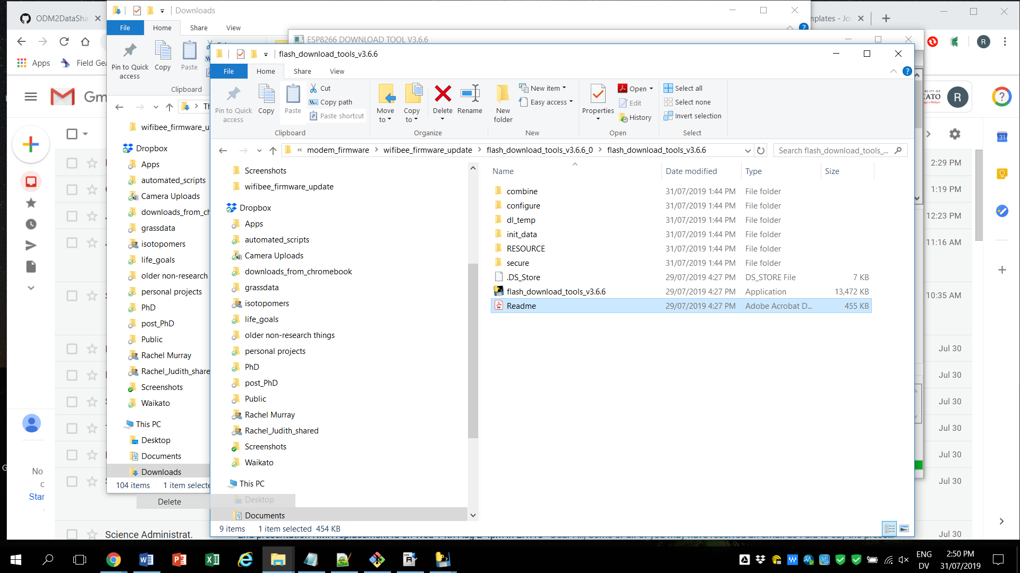

**Step 2. Download a suitable ‘Non-OS’ SDK from Expressif**

I was only able to get this to work with a specific version of the SDK, which was version 2.2.1. The SDK’s can be found at: <https://www.espressif.com/en/support/download/sdks-demos>.

**Step 3. Switch the Wifi Bee to UART mode, attach the Wifi bee to the xbee USB adapter and plug into the USB port.**

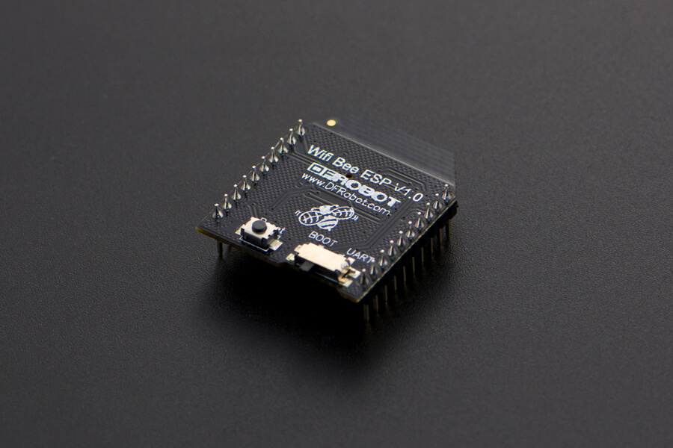 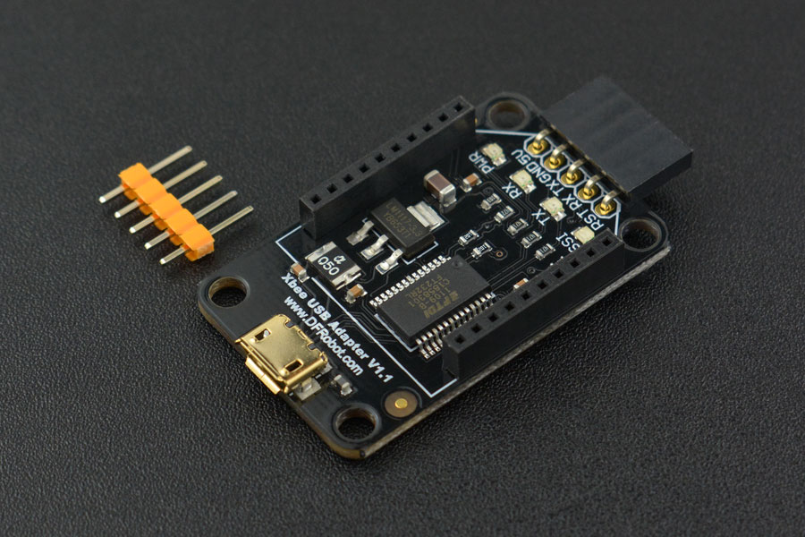

**Step 3. Launch the ‘Flash Download Tools’ and identify the flash size and other relevant details about the Wifibee**

If you don’t already know the flash size, crystal frequency, SPI speed and other details, these can be confirmed using the ‘Flash Download Tools.’ In ‘SPIDownload’ mode, specify the COM port of the USB adapter, assure that none of the download lines are checked, then press ‘Start’ and check the ‘Detected Info’ pane.

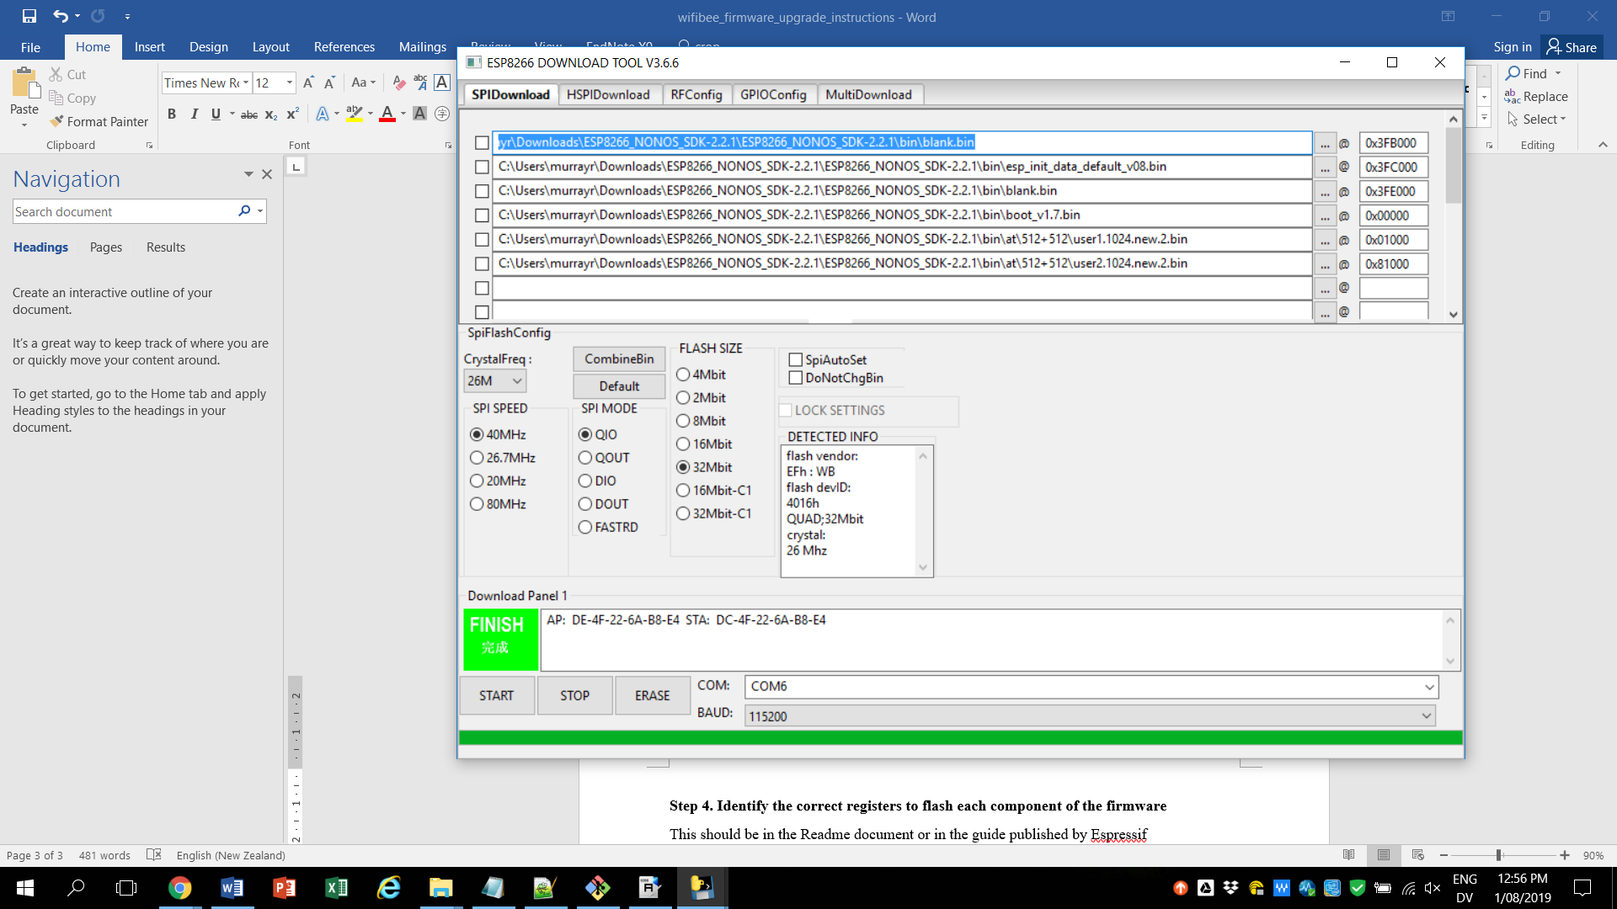

**Step 4. Identify the correct registers to flash each component of the firmware**

The correct register for each binary file should be specified in a Readme document included with the SDK download, specifically bin >>at>>readme.md. In my case, I had a 32 Mbit, 512KB+512KB Wifi bee so the registers in the Readme.md were:

boot_v1.2+.bin 0x00000

user1.1024.new.2.bin 0x01000

esp_init_data_default.bin 0x3fc000

blank.bin 0x7e000 & 0x3fe000

There is also an instruction set at <https://www.espressif.com/en/support/download/overview> called ‘ESP8266 Non-OS AT Instruction Set’ which indicates a set of registers. I didn’t use the register for the ‘user parameter area’ (as indicated in this guide) because I didn’t need that for my purposes:

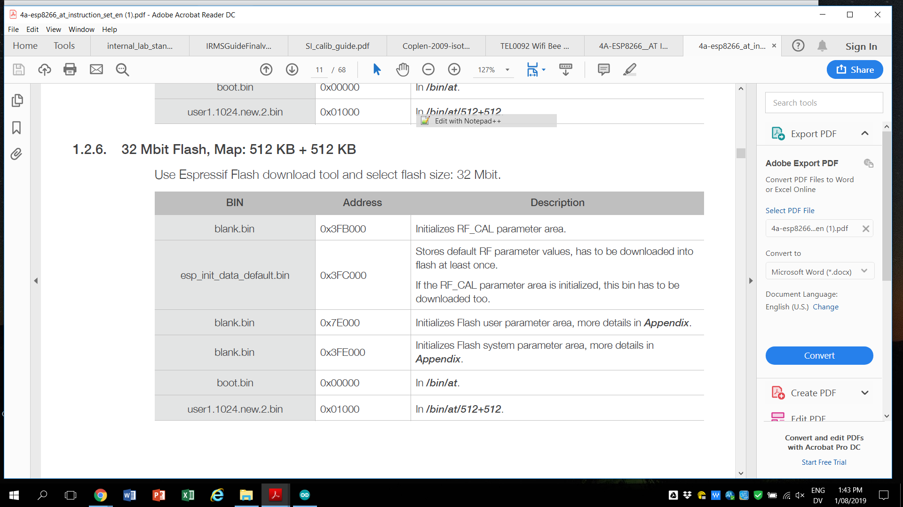

In the instructables guide, I was instructed to place the user2 file at 0x81000, so this is what I did.

**Step 5. Set up the firmware flashing tool to download the firmware to the correct registers**

Load the file names and hex codes into the GUI. In my case, I wrote the following to my Wifi Bee:

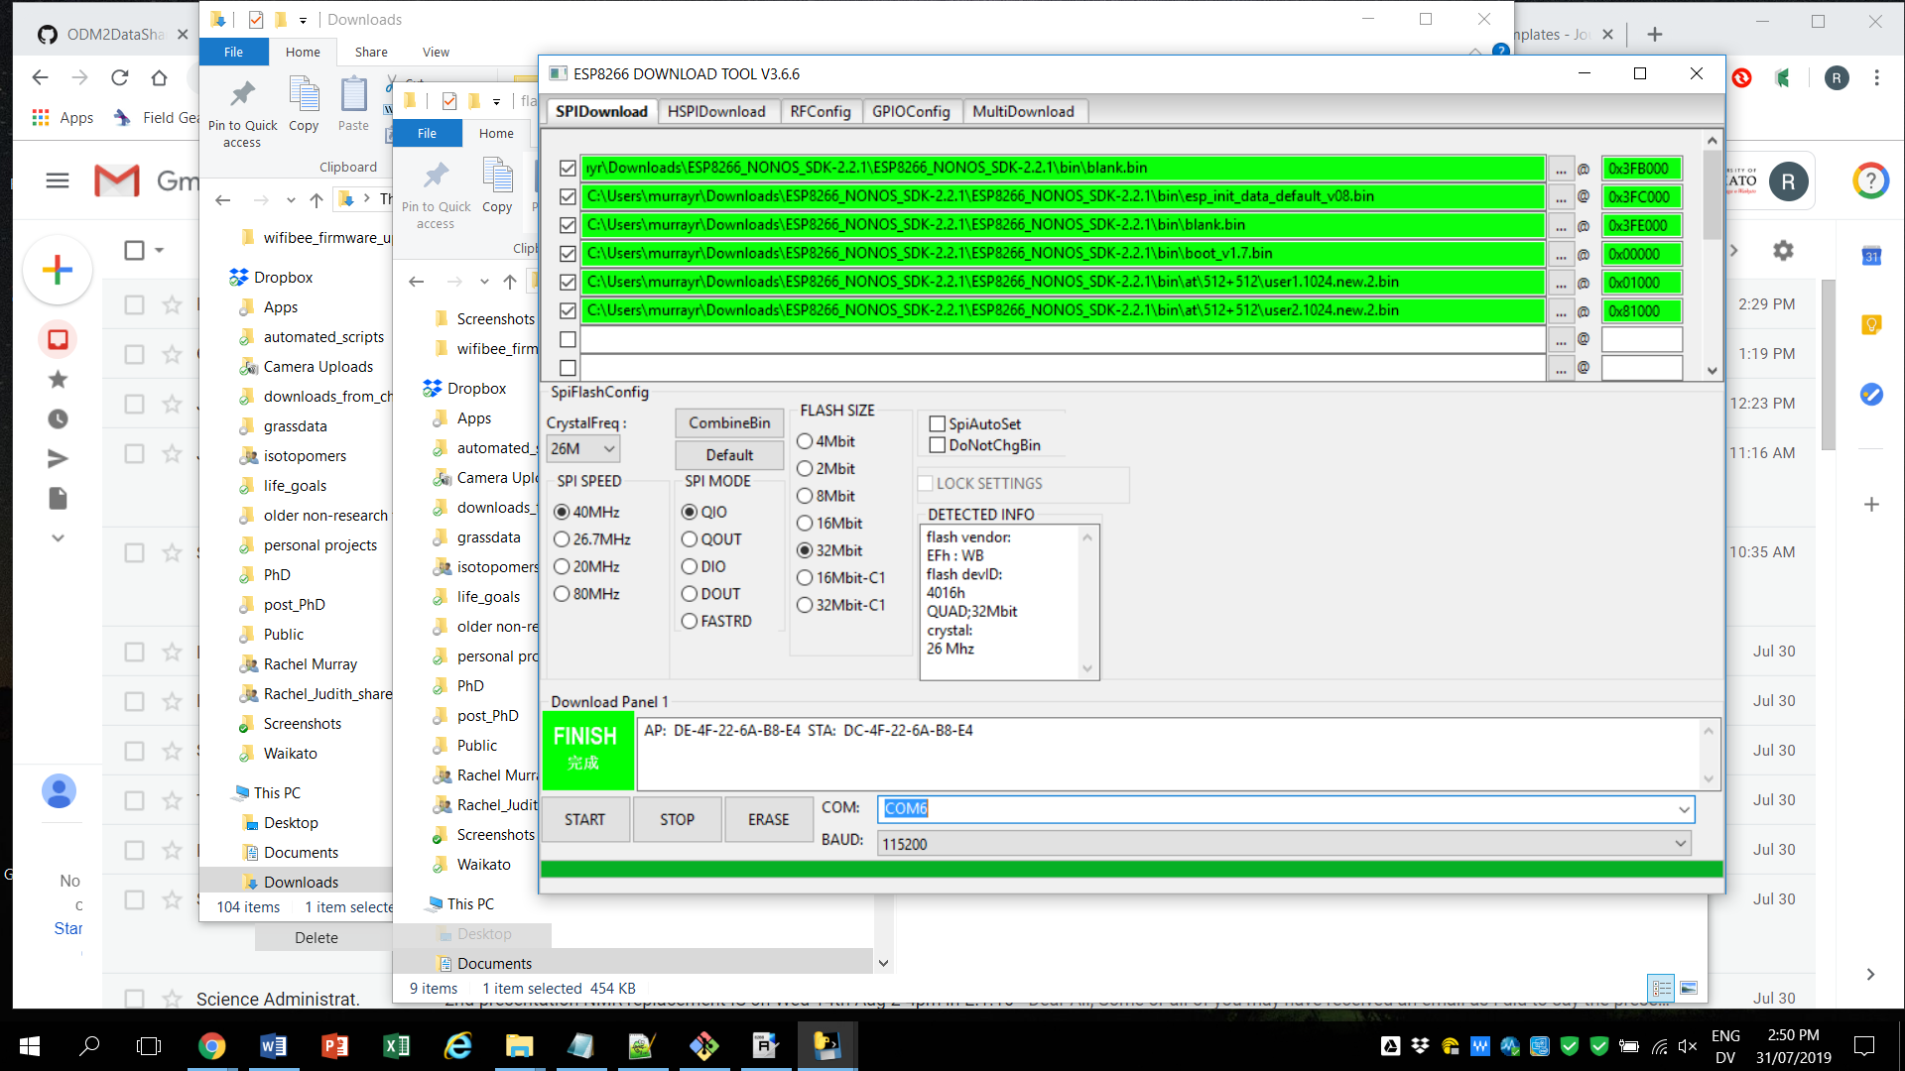

**Step 6. Unplug and re-plug Wifi Bee/USB adapter from the USB port**

Sometimes the flash download tool won’t work if you try to do too many operations without unplugging and re-plugging the Wifibee.

**Step 7. Possibly erase the old firmware first before flashing (?)**

I’m not sure this is necessary, but I kept flashing different versions of the firmware when trying to find something that worked, so I erased the wifibee between each attempt just in case. In order to erase the wifi bee you just use the ‘erase’ button. It should only take a few seconds. If successful, something resembling the following should be printed to the terminal window:

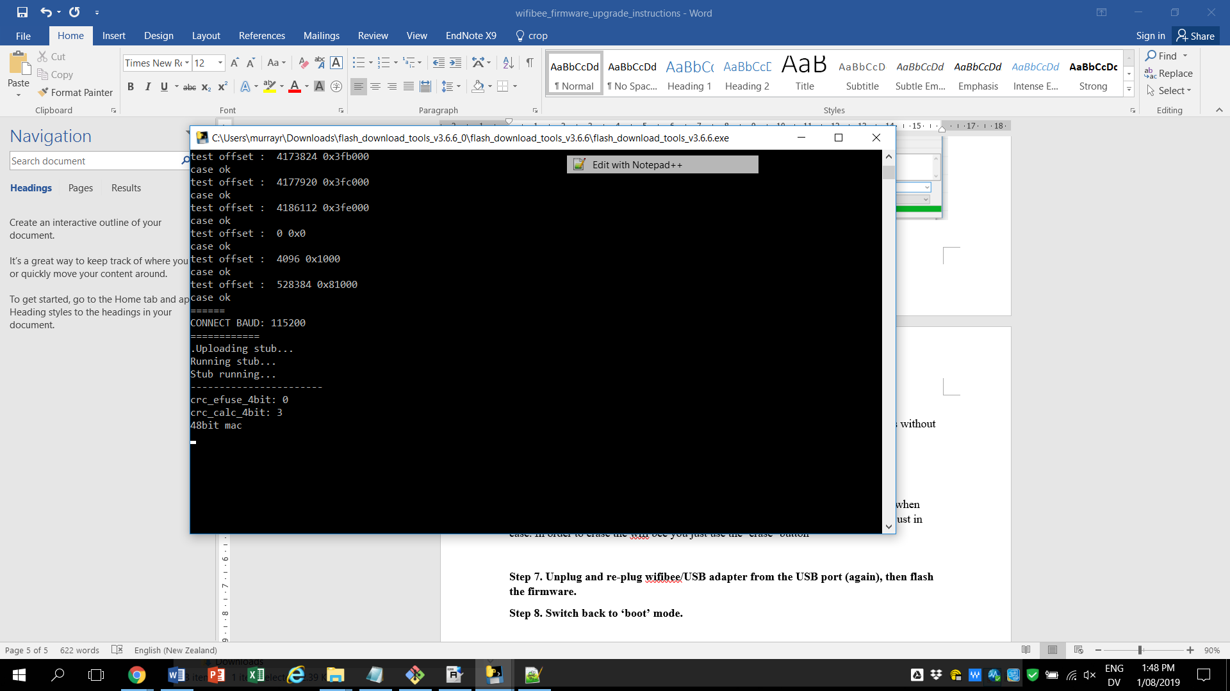

**Step 7. Unplug and re-plug wifibee/USB adapter from the USB port (again), then flash the firmware.**

Assure that all of the lines in the ‘Flash Download Tool’ are checked and selecting ‘Start.’ Check that the terminal window displays a message similar to the one above and that the little green box reads “Finish.”



**Step 8. Switch the Wifi Bee back to ‘BOOT’ mode.**



**Step 9. Test AT commands to confirm that firmware was downloaded correctly.**

The command ‘AT’ should return ‘OK,’ and ‘AT+GMR’ should return the new firmware version and details.

Additionally, I used the command ‘AT+UART_DEF=9600,8,1,0,0’ to set the baud rate on the Wifi bee to 9600.