**TM Forum Specification**

**Service Activation and Configuration API REST Specification**

**TMF640**

**Release 18.5.0**

**January 2019**

|  |  |
| --- | --- |
| **Latest Update: TM Forum Release 18.5.0** | **Member Evaluation** |
| **Version 4.0.0** | **IPR Mode: RAND** |

# NOTICE

Copyright © TM Forum 2019. All Rights Reserved.

This document and translations of it may be copied and furnished to others, and derivative works that comment on or otherwise explain it or assist in its implementation may be prepared, copied, published, and distributed, in whole or in part, without restriction of any kind, provided that the above copyright notice and this section are included on all such copies and derivative works. However, this document itself may not be modified in any way, including by removing the copyright notice or references to TM FORUM, except as needed for the purpose of developing any document or deliverable produced by a TM FORUM Collaboration Project Team (in which case the rules applicable to copyrights, as set forth in the [TM FORUM IPR Policy](http://www.tmforum.org/IPRPolicy/11525/home.html), must be followed) or as required to translate it into languages other than English.

The limited permissions granted above are perpetual and will not be revoked by TM FORUM or its successors or assigns.

This document and the information contained herein is provided on an "AS IS" basis and TM FORUM DISCLAIMS ALL WARRANTIES, EXPRESS OR IMPLIED, INCLUDING BUT NOT LIMITED TO ANY WARRANTY THAT THE USE OF THE INFORMATION HEREIN WILL NOT INFRINGE ANY OWNERSHIP RIGHTS OR ANY IMPLIED WARRANTIES OF MERCHANTABILITY OR FITNESS FOR A PARTICULAR PURPOSE.

Direct inquiries to the TM Forum office:

4 Century Drive, Suite 100

Parsippany, NJ 07054, USA

Tel No. +1 973 944 5100

Fax No. +1 973 998 7916

TM Forum Web Page: [www.tmforum.org](http://www.tmforum.org/)

# Table of Contents

NOTICE 2

Table of Contents 3

LIST OF TABLES 5

INTRODUCTION 6

Lifecycle of Service 7

Support of polymorphism and extension patterns 8

RESOURCE MODEL 9

Managed Entity and Task Resource Models 9

Service resource 9

Monitor resource 15

Notification Resource Models 17

Service Create Notification 18

Service Attribute Value Change Notification 19

Service State Change Notification 19

Service Delete Notification 19

Monitor Create Notification 20

Monitor Attribute Value Change Notification 20

Monitor State Change Notification 21

Monitor Delete Notification 21

API OPERATIONS 22

Operations on Service 22

List services 23

Retrieve service 23

Create service 24

Patch service 26

Delete service 28

Operations on Monitor 29

List monitors 29

Retrieve monitor 30

API NOTIFICATIONS 32

Register listener 32

Unregister listener 34

Publish Event to listener 34

Acknowledgements 36

Version History 36

Release History 36

Contributors to Document 36

# LIST OF TABLES

N/A

# INTRODUCTION

Services may be activated or configured by the Activation and Configuration API.

The following examples use the characteristic specification and the strongly typed patterns.

1) Using the characteristic specification pattern. When the characteristic specification pattern is used it is assumed that a service specification with the corresponding characteristic specifications exist.

|  |
| --- |
| "id" : "id1234567890",  "href" : "http//..",  "state" : "active",  "serviceSpecification":{  "id":"conferenceBridgeEquipment",  "href":"http: //serverlocation:port/catalogManagement/serviceSpecification /conferenceBridgeEquipment"  },  "characteristic":[  {  "name":"numberOfVc500Units",  "valueType": "integer",  "value":"1"  },  {  "name":"numberOfVc100Units",  "valueType": "integer",  "value":"2"  },  {  "name":"routerType",  "valueType": "string",  "value":"CiscoASR1000"  },  {  "name":"powerSupply",  "valueType": "string",  "value":"UK"  }  ]}  } |

2) Using the Strongly typed pattern. When the strongly typed pattern is used it is assumed that a corresponding YAML or JSON schema is defined for the Service.

|  |
| --- |
| {  "id" : "id1234567890",  "href" : "http//..",  "state" : "active",  "@type" : "conferenceBridgeEquipment",  "@schemaLocation" : "http://../conferenceBridgeEquipment.json",  "serviceSpecification":{  "id":"conferenceBridgeEquipment",  "href":"http: //serverlocation:port/catalogManagement/serviceSpecification /conferenceBridgeEquipment"  },  "numberOfVc500Units": "1",  "numberOfVc100Units": "2",  "routerType": "CiscoASR1000",  "powerSupply": "UK"  }  } |

## Lifecycle of Service

Here is the state machine diagram for a Service.

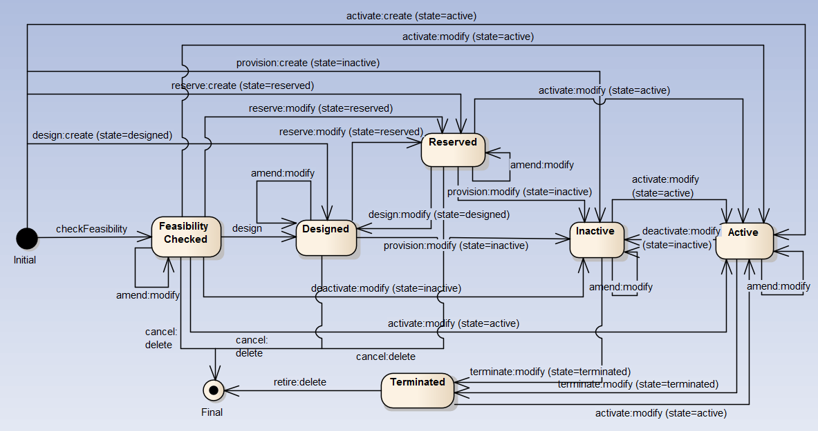

# Support of polymorphism and extension patterns

Support of polymorphic collections and types and schema based extension is provided by means of a list of generic meta-attributes that we describe below. Polymorphism in collections occurs when entities inherit from base entities, for instance a TypeAService or TypeBService inheriting properties from the base Service entity.

Generic support of polymorphism and pattern extensions is described in the TMF API Guidelines v3.0 Part 2 document.

The @type attribute provides a way to represent the actual class type of an entity. For example, within a list of Service instances some may be instances of TypeAService where other could be instances of TypeBService. The @type gives this information. All resources and sub-resources of this API have a @type attributes that can be provided when this is useful.

The @referredType can be used within reference entities (like for instance a RelatedParty object) to explicitly denote the actual entity type of the referred class. Notice that in reference entities the @type, when used, denotes the class type of the reference itself, such as RelatedParty, and not the class type of the referred object. However, since reference classes are rarely sub-classed, @type is generally not useful in reference objects.

The @schemaLocation property can be used in resources to allow specifying user-defined properties of an Entity or to specify the expected characteristics of an entity.

The @baseType attribute gives a way to provide explicitly the base of class of a given resource that has been extended.

# RESOURCE MODEL

## Managed Entity and Task Resource Models

### Service resource

Service is a base class for defining the Service hierarchy. All Services are characterized as either being possibly visible and usable by a Customer or not. This gives rise to the two subclasses of Service: CustomerFacingService and ResourceFacingService.

**Resource model**

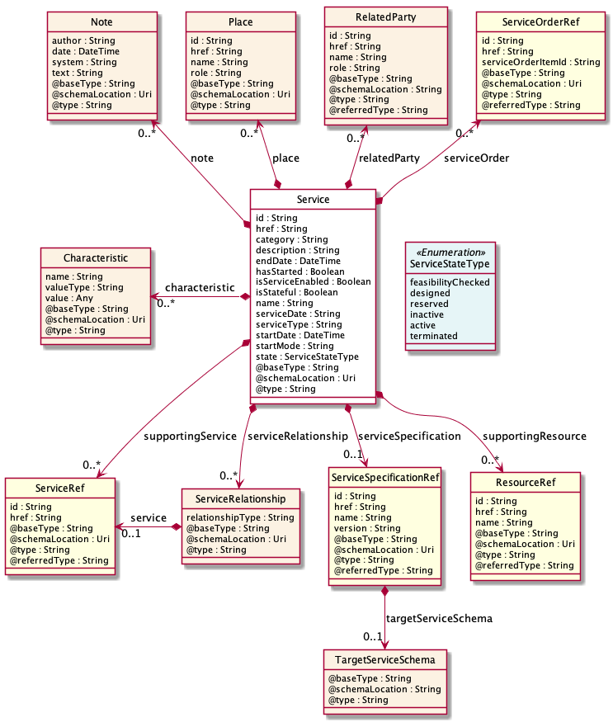

**Field descriptions**

*Service* fields

|  |  |
| --- | --- |
| category | A string. Is it a customer facing or resource facing service. |
| description | A string. Free-text description of the service. |
| endDate | A date time (DateTime). Date when the service ends. |
| hasStarted | A boolean. If TRUE, this Service has already been started. |
| href | A string. Reference of the service. |
| id | A string. Unique identifier of the service. |
| isServiceEnabled | A boolean. If FALSE, this particular Service has NOT been enabled for use. |
| isStateful | A boolean. If TRUE, this Service can be changed without affecting any other services. |
| name | A string. Name of the service. |
| note | A list of notes (Note [*]). A list of notes made on this service. |
| place | A list of places (Place [*]). A list of places related to this service, e.g. where the service is installed, a delivery address for equipment, etc. |
| relatedParty | A list of related parties (RelatedParty [*]). A list of related party references (RelatedParty [1..*]). A related party defines party or party role linked to a specific entity. |
| serviceCharacteristic | A list of characteristics (Characteristic [*]). A list of characteristics that characterize this service (ServiceCharacteristic [*]). |
| serviceDate | A string. Date when the service was created (whatever its status). |
| serviceOrder | A list of service order references (ServiceOrderRef [*]). A list of service orders related to this service. |
| serviceRelationship | A list of service relationships (ServiceRelationship [*]). A list of service relationships (ServiceRelationship [*]). Describes links with other service(s) in the inventory (useful for describing relies-on, relies-from between CFS for example). |
| serviceSpecification | A service specification reference (ServiceSpecificationRef). The specification from which this service was instantiated. |
| serviceType | A string. Business type of the service. |
| startDate | A date time (DateTime). Date when the service starts. |
| startMode | A string. This attribute is an enumerated integer that indicates how the Service is started, such as: 0: Unknown; 1: Automatically by the managed environment; 2: Automatically by the owning device; 3: Manually by the Provider of the Service; 4: Manually by a Customer of the Provider; 5: Any of the above. |
| state | A service state type (ServiceStateType). The life cycle state of the service, such as: feasibilityChecked, designed, reserved, active, inactive, terminated. |
| supportingResource | A list of resource references (ResourceRef [*]). A list of supporting resources (SupportingResource [*]).Note: only Service of type RFS can be associated with Resources. |
| supportingService | A list of service references (ServiceRef [*]). A list of supporting services (SupportingService [*]). A collection of services that support this service (bundling, link CFS to RFS). |

*Characteristic* sub-resource

Describes a given characteristic of an object or entity through a name/value pair.

|  |  |
| --- | --- |
| name | A string. Name of the characteristic. |
| value | An any (Any). The value of the characteristic. |
| valueType | A string. Data type of the value of the characteristic. |

*Note* sub-resource

Extra information about a given entity.

|  |  |
| --- | --- |
| author | A string. Author of the note. |
| date | A date time (DateTime). Date of the note. |
| system | A string. Describes the system from which the action related to this note was done. |
| text | A string. Text of the note. |

*Place* sub-resource

Place reference. Place defines the places where the products are sold or delivered.

|  |  |
| --- | --- |
| href | A string. Unique reference of the place. |
| id | A string. Unique identifier of the place. |
| name | A string. A user-friendly name for the place, such as [Paris Store], [London Store], [Main Home]. |
| role | A string. Role of the place, such as: [home delivery], [shop retrieval]). |

*RelatedParty* sub-resource

RelatedParty reference. A related party defines party or party role linked to a specific entity.

|  |  |
| --- | --- |
| @baseType | A string. When sub-classing, this defines the super-class. |
| @referredType | A string. The actual type of the target instance when needed for disambiguation. |
| @schemaLocation | A string. A URI to a JSON-Schema file that defines additional attributes and relationships. |
| @type | A string. When sub-classing, this defines the sub-class entity name. |
| href | A string. Reference of the related party, could be a party reference or a party role reference. |
| id | A string. Unique identifier of a related party. |
| name | A string. Name of the related party. |
| role | A string. Role of the related party. |

*ServiceRelationship* sub-resource

Describes links with services of the same category (useful for bundled services).

|  |  |
| --- | --- |
| relationshipType | A string. The type of relationship (e.g. depends on, enables). |
| service | A service reference (ServiceRef). The service being referred to. |

*TargetServiceSchema* sub-resource

The reference object to the schema and type of target service which is described by service specification.

|  |  |
| --- | --- |
| @schemaLocation | A string. This field provides a link to the schema describing the target service. |
| @type | A string. Class type of the target service. |

*ResourceRef* relationship

|  |  |
| --- | --- |
| @referredType | A string. The actual type of the target instance when needed for disambiguation. |
| href | A string. Reference of the supporting resource. |
| id | A string. Unique identifier of the supporting resource. |
| name | A string. Name of the resource supporting the service. |

*ServiceOrderRef* relationship

Service Order reference. Useful to understand the which was the Service order through which the service was instantiated in the service inventory.

|  |  |
| --- | --- |
| @referredType | A string. The actual type of the target instance when needed for disambiguation. |
| href | A string. Reference of the Service Order. |
| id | A string. Unique identifier of the Service Order. |
| serviceOrderItemId | A string. Unique identifier of the Service Order Item within a service order, not populated if this is a reference to a service order. |

*ServiceRef* relationship

Service reference, for when Service is used by other entities.

|  |  |
| --- | --- |
| @referredType | A string. The actual type of the target instance when needed for disambiguation. |
| href | A string. reference of the service. |
| id | A string. Id of the service. |

*ServiceSpecificationRef* relationship

Service specification reference: ServiceSpecification(s) required to realize a ProductSpecification.

|  |  |
| --- | --- |
| @referredType | A string. The actual type of the target instance when needed for disambiguation. |
| href | A string. Reference of the serviceSpecification. |
| id | A string. Unique identifier of the service specification. |
| name | A string. Name of the requiredServiceSpecification. |
| targetServiceSchema | A target service schema (TargetServiceSchema). A target service schema reference (TargetServiceSchemaRef). The reference object to the schema and type of target service which is described by service specification. |
| version | A string. Service specification version. |

**Json representation sample**

We provide below the json representation of an example of a 'Service' resource object

|  |
| --- |
| {  "id": "5351",   "href": "https://mycsp.com:8080/tmf-api/ServiceActivationAndConfiguration/v4/service/5351",   "serviceType": "Cloud",   "state": "Active",   "serviceDate": "2018-01-15T12:26:11.747Z",   "startDate": "2018-01-15T12:26:11.747Z",   "serviceCharacteristic": [  {  "name": "vCPE_IP",   "valueType": "object",   "value": {  "@type": "IPAddress",   "@schemaLocation": "https://mycsp.com:8080/tmf-api/schema/Service/IPAddress.schema.json",   "address": "193.218.236.21"  }  }  ],   "@type": "vCPE",   "@schemaLocation": "https://mycsp.com:8080/tmf-api/schema/Service/vCPE.schema.json",   "@baseType": "Service" } |

### Monitor resource

Monitoring of resources.

**Resource model**

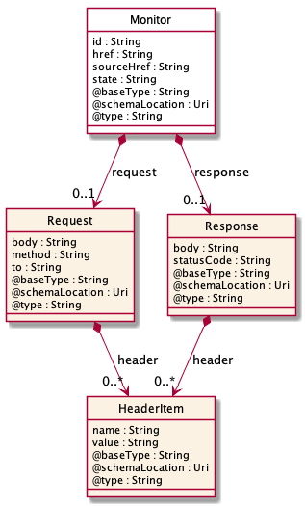

**Field descriptions**

*Monitor* fields

|  |  |
| --- | --- |
| href | A string. reference to this monitor. |
| id | A string. Identifier of an instance of the monitor. Required to be unique within the resource type. Used in URIs as the identifier for specific instances of a type. |
| request | A request (Request). Represents the request. |
| response | A response (Response). Represents the response. |
| sourceHref | A string. The monitored resource href. |
| state | A string. The Monitor state of the resource. InProgess, InError, Completed. |

*HeaderItem* sub-resource

An item typically included in a request or response.

|  |  |
| --- | --- |
| name | A string. The name of the header item, e.g. locale. |
| value | A string. The value of the header item, e.g. en-us. |

*Request* sub-resource

A response to a request.

|  |  |
| --- | --- |
| body | A string. The body of the request. For example for an HTTP request might contain content of a form . |
| header | A list of header items (HeaderItem [1..*]). Items included in the header of the request. For example for an HTTP request might contain requested locale, basic authentication. |
| method | A string. The protocol of the request, e.g. http. |
| to | A string. The target of the request, e.g. a URL for an HTTP request. |

*Response* sub-resource

A response to a request.

|  |  |
| --- | --- |
| body | A string. The body of the response. For example for an HTTP response might contain HTML for rendering. |
| header | A list of header items (HeaderItem [1..*]). Items included in the header of the response. For example for an HTTP response might contain negotiated locale. |
| statusCode | A string. The status of the response. For example for an HTTP response would be codes such as 200, 400, etc. |

**Json representation sample**

We provide below the json representation of an example of a 'Monitor' resource object

|  |
| --- |
| {  "id": "44555",   "href": "https://mycsp.com:8080/tmf-api/ServiceActivationAndConfiguration/v4/monitor/44555",   "state": "In Progress",   "request": {  "method": "http",   "to": "https://mycsp.com:5050/netAPIs/activate",   "body": "ACTIVATE BBAND 144445",   "header": [  {  "name": "locale",   "value": "en-us"  }  ]  },   "response": {  "statusCode": "344",   "body": "ACTIVATE BBAND 144445 REQUEST RECEIVED PENDING",   "header": [  {  "name": "locale",   "value": "en-us"  }  ]  },   "sourceHref": "https://mycsp.com:8080/tmf-api/ServiceActivationAndConfiguration/v4/service/5351",   "@type": "Monitor" } |

## Notification Resource Models

8 notifications are defined for this API

Notifications related to Service:  
 - ServiceCreateNotification  
 - ServiceAttributeValueChangeNotification  
 - ServiceStateChangeNotification  
 - ServiceDeleteNotification

Notifications related to Monitor:  
 - MonitorCreateNotification  
 - MonitorAttributeValueChangeNotification  
 - MonitorStateChangeNotification  
 - MonitorDeleteNotification

The notification structure for all notifications in this API follow the pattern depicted by the figure below.  
A notification resource (depicted by "SpecificNotification" placeholder) is a sub class of a generic Notification structure containing an id of the event occurence (eventId), an event timestamp (eventTime), and the name of the notification resource (eventType).   
This notification structure owns an event structure ("SpecificEvent" placeholder) linked to the resource concerned by the notification using the resource name as access field ("resourceName" placeholder).

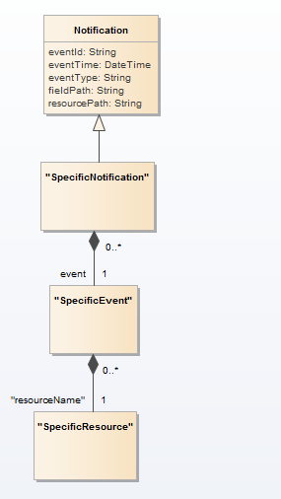

### Service Create Notification

Notification ServiceCreateNotification case for resource Service

**Json representation sample**

We provide below the json representation of an example of a 'ServiceCreateNotification' notification object

|  |
| --- |
| {  "eventId":"00001",  "eventTime":"2015-11-16T16:42:25-04:00",  "eventType":"ServiceCreateNotification",  "event": {  "service" :   {-- SEE Service RESOURCE SAMPLE --}  } } |

### Service Attribute Value Change Notification

Notification ServiceAttributeValueChangeNotification case for resource Service

**Json representation sample**

We provide below the json representation of an example of a 'ServiceAttributeValueChangeNotification' notification object

|  |
| --- |
| {  "eventId":"00001",  "eventTime":"2015-11-16T16:42:25-04:00",  "eventType":"ServiceAttributeValueChangeNotification",  "event": {  "service" :   {-- SEE Service RESOURCE SAMPLE --}  } } |

### Service State Change Notification

Notification ServiceStateChangeNotification case for resource Service

**Json representation sample**

We provide below the json representation of an example of a 'ServiceStateChangeNotification' notification object

|  |
| --- |
| {  "eventId":"00001",  "eventTime":"2015-11-16T16:42:25-04:00",  "eventType":"ServiceStateChangeNotification",  "event": {  "service" :   {-- SEE Service RESOURCE SAMPLE --}  } } |

### Service Delete Notification

Notification ServiceDeleteNotification case for resource Service

**Json representation sample**

We provide below the json representation of an example of a 'ServiceDeleteNotification' notification object

|  |
| --- |
| {  "eventId":"00001",  "eventTime":"2015-11-16T16:42:25-04:00",  "eventType":"ServiceDeleteNotification",  "event": {  "service" :   {-- SEE Service RESOURCE SAMPLE --}  } } |

### Monitor Create Notification

Notification MonitorCreateNotification case for resource Monitor

**Json representation sample**

We provide below the json representation of an example of a 'MonitorCreateNotification' notification object

|  |
| --- |
| {  "eventId":"00001",  "eventTime":"2015-11-16T16:42:25-04:00",  "eventType":"MonitorCreateNotification",  "event": {  "monitor" :   {-- SEE Monitor RESOURCE SAMPLE --}  } } |

### Monitor Attribute Value Change Notification

Notification MonitorAttributeValueChangeNotification case for resource Monitor

**Json representation sample**

We provide below the json representation of an example of a 'MonitorAttributeValueChangeNotification' notification object

|  |
| --- |
| {  "eventId":"00001",  "eventTime":"2015-11-16T16:42:25-04:00",  "eventType":"MonitorAttributeValueChangeNotification",  "event": {  "monitor" :   {-- SEE Monitor RESOURCE SAMPLE --}  } } |

### Monitor State Change Notification

Notification MonitorStateChangeNotification case for resource Monitor

**Json representation sample**

We provide below the json representation of an example of a 'MonitorStateChangeNotification' notification object

|  |
| --- |
| {  "eventId":"00001",  "eventTime":"2015-11-16T16:42:25-04:00",  "eventType":"MonitorStateChangeNotification",  "event": {  "monitor" :   {-- SEE Monitor RESOURCE SAMPLE --}  } } |

### Monitor Delete Notification

Notification MonitorDeleteNotification case for resource Monitor

**Json representation sample**

We provide below the json representation of an example of a 'MonitorDeleteNotification' notification object

|  |
| --- |
| {  "eventId":"00001",  "eventTime":"2015-11-16T16:42:25-04:00",  "eventType":"MonitorDeleteNotification",  "event": {  "monitor" :   {-- SEE Monitor RESOURCE SAMPLE --}  } } |

# API OPERATIONS

Remember the following Uniform Contract:

|  |  |  |
| --- | --- | --- |
| Operation on Entities | Uniform API Operation | Description |
| Query Entities | GET Resource | GET must be used to retrieve a representation of a resource. |
| Create Entity | POST Resource | POST must be used to create a new resource |
| Partial Update of an Entity | PATCH Resource | PATCH must be used to partially update a resource |
| Complete Update of an Entity | PUT Resource | PUT must be used to completely update a resource identified by its resource URI |
| Remove an Entity | DELETE Resource | DELETE must be used to remove a resource |
| Execute an Action on an Entity | POST on TASK Resource | POST must be used to execute Task Resources |
| Other Request Methods | POST on TASK Resource | GET and POST must not be used to tunnel other request methods. |

Filtering and attribute selection rules are described in the TMF REST Design Guidelines Part 1 document.

Notifications are also described in a subsequent section.

## Operations on Service

### List services

**GET /service?fields=...&{filtering}**

**Description**

This operation list service entities.  
Attribute selection is enabled for all first level attributes.  
Filtering may be available depending on the compliance level supported by an implementation.

**Usage Samples**

Here's an example of a request for retrieving services from the network.

|  |
| --- |
| **Request** |
| GET {apiRoot}/service?fields=id,name,state&serviceType=Cloud&state=Active Accept: application/json |
| **Response** |
| 200  [  {  "id": "5351",   "name": "vCPE serial 1355615",   "state": "Active"  },   {  "id": "5352",   "name": "vDPI serial 1355445",   "state": "Active"  } ] |

### Retrieve service

**GET /service/{id}?fields=...&{filtering}**

**Description**

This operation retrieves a service entity.  
Attribute selection is enabled for all first level attributes.  
Filtering on sub-resources may be available depending on the compliance level supported by an implementation.

**Usage Samples**

Here's an example of a request for retrieving a specific service from the network. The level of detail returned is minimal, according to what might be held in the network.

|  |
| --- |
| **Request** |
| GET {apiRoot}/service/5351 Accept: application/json |
| **Response** |
| 200  {  "id": "5351",   "href": "https://mycsp.com:8080/tmf-api/ServiceActivationAndConfiguration/v4/service/5351",   "serviceType": "Cloud",   "state": "Active",   "serviceDate": "2018-01-15T12:26:11.747Z",   "startDate": "2018-01-15T12:26:11.747Z",   "serviceCharacteristic": [  {  "name": "vCPE_IP",   "valueType": "object",   "value": {  "@type": "IPAddress",   "@schemaLocation": "https://mycsp.com:8080/tmf-api/schema/Service/IPAddress.schema.json",   "address": "193.218.236.21"  }  }  ],   "@type": "vCPE",   "@schemaLocation": "https://mycsp.com:8080/tmf-api/schema/Service/vCPE.schema.json",   "@baseType": "Service" } |

### Create service

**POST /service**

**Description**

This operation creates a service entity.

**Mandatory and Non Mandatory Attributes**

The following tables provides the list of mandatory and non mandatory attributes when creating a Service, including any possible rule conditions and applicable default values. Notice that it is up to an implementer to add additional mandatory attributes.

|  |  |
| --- | --- |
| Mandatory Attributes | Rule |

|  |  |  |
| --- | --- | --- |
| Non Mandatory Attributes | Default Value | Rule |
| category |  |  |
| description |  |  |
| endDate |  |  |
| hasStarted | blank |  |
| isServiceEnabled | false |  |
| isStateful |  |  |
| name |  |  |
| note |  |  |
| place |  |  |
| relatedParty |  |  |
| serviceCharacteristic |  |  |
| serviceDate | <date of POST> |  |
| serviceOrder |  |  |
| serviceRelationship |  |  |
| serviceSpecification |  |  |
| serviceType |  |  |
| startDate | <date of POST> |  |
| startMode |  |  |
| state |  |  |
| supportingResource |  |  |
| supportingService |  |  |

**Additional Rules**

The following table provides additional rules indicating mandatory fields in sub-resources or relationships when creating a Service resource.

| context | Mandatory Sub-Attributes |
| --- | --- |
| serviceOrder | id OR href |
| serviceSpecification | id OR href |
| relatedParty | id OR href, role |

**Usage Samples**

Here's an example of a request for activating a new service on the network.

|  |
| --- |
| **Request** |
| POST {apiRoot}/service Content-Type: application/json  {  "serviceType": "Cloud",   "serviceDate": "2018-01-15T12:26:11.747Z",   "startDate": "2018-01-15T12:26:11.747Z",   "serviceCharacteristic": [  {  "name": "vCPE_IP",   "valueType": "object",   "value": {  "@type": "IPAddress",   "@schemaLocation": "https://mycsp.com:8080/tmf-api/schema/Service/IPAddress.schema.json",   "address": "193.218.236.21"  }  }  ] } |
| **Response** |
| 201  {  "id": "5351",   "href": "https://mycsp.com:8080/tmf-api/ServiceActivationAndConfiguration/v4/service/5351",   "serviceType": "Cloud",   "state": "Active",   "serviceDate": "2018-01-15T12:26:11.747Z",   "startDate": "2018-01-15T12:26:11.747Z",   "serviceCharacteristic": [  {  "name": "vCPE_IP",   "valueType": "object",   "value": {  "@type": "IPAddress",   "@schemaLocation": "https://mycsp.com:8080/tmf-api/schema/Service/IPAddress.schema.json",   "address": "193.218.236.21"  }  }  ],   "@type": "vCPE",   "@schemaLocation": "https://mycsp.com:8080/tmf-api/schema/Service/vCPE.schema.json",   "@baseType": "Service" } |

### Patch service

**PATCH /service/{id}**

**Description**

This operation allows partial updates of a service entity. Support of json/merge (https://tools.ietf.org/html/rfc7386) is mandatory, support of json/patch (http://tools.ietf.org/html/rfc5789) is optional.  
  
Note: If the update operation yields to the creation of sub-resources or relationships, the same rules concerning mandatory sub-resource attributes and default value settings in the POST operation applies to the PATCH operation. Hence these tables are not repeated here.

**Patchable and Non Patchable Attributes**

The tables below provide the list of patchable and non patchable attributes, including constraint rules on their usage.

|  |  |
| --- | --- |
| Patchable Attributes | Rule |
| category |  |
| description |  |
| endDate |  |
| hasStarted |  |
| isServiceEnabled |  |
| isStateful |  |
| name |  |
| note |  |
| place |  |
| relatedParty |  |
| serviceCharacteristic |  |
| serviceDate |  |
| serviceOrder |  |
| serviceRelationship |  |
| serviceSpecification |  |
| serviceType |  |
| startDate |  |
| startMode |  |
| state |  |
| supportingResource |  |
| supportingService |  |

|  |  |
| --- | --- |
| Non Patchable Attributes | Rule |
| id |  |
| href |  |

**Usage Samples**

Here's an example of a request for updating a service in the network. In this example, a new state is set.

|  |
| --- |
| **Request** |
| PATCH {apiRoot}/service/5351 Content-Type: application/merge-patch+json  {  "state": "Suspended" } |
| **Response** |
| 200  {  "id": "5351",   "href": "https://mycsp.com:8080/tmf-api/ServiceActivationAndConfiguration/v4/service/5351",   "serviceType": "Cloud",   "state": "Suspended",   "serviceDate": "2018-01-15T12:26:11.747Z",   "startDate": "2018-01-15T12:26:11.747Z",   "serviceCharacteristic": [  {  "name": "vCPE_IP",   "valueType": "object",   "value": {  "@type": "IPAddress",   "@schemaLocation": "https://mycsp.com:8080/tmf-api/schema/Service/IPAddress.schema.json",   "address": "193.218.236.21"  }  }  ],   "@type": "vCPE",   "@schemaLocation": "https://mycsp.com:8080/tmf-api/schema/Service/vCPE.schema.json",   "@baseType": "Service" } |

### Delete service

**DELETE /service/{id}**

**Description**

This operation deletes a service entity.

**Usage Samples**

Here's an example of a request for deactivating a service in the network.

|  |
| --- |
| **Request** |
| DELETE {apiRoot}/service/5351 |
| **Response** |
| 204 |

## Operations on Monitor

### List monitors

**GET /monitor?fields=...&{filtering}**

**Description**

This operation list monitor entities.  
Attribute selection is enabled for all first level attributes.  
Filtering may be available depending on the compliance level supported by an implementation.

**Usage Samples**

Here's an example of a request for retrieving monitors for service activation.

|  |
| --- |
| **Request** |
| GET {apiRoot}/monitor?serviceType=Cloud&state=InProgress Accept: application/json |
| **Response** |
| 200  [  {  "id": "44555",   "href": "https://mycsp.com:8080/tmf-api/ServiceActivationAndConfiguration/v4/monitor/44555",   "state": "In Progress",   "request": {  "method": "http",   "to": "https://mycsp.com:5050/netAPIs/activate",   "body": "ACTIVATE BBAND 144445",   "header": [  {  "name": "locale",   "value": "en-us"  }  ]  },   "response": {  "statusCode": "344",   "body": "ACTIVATE BBAND 144445 REQUEST RECEIVED PENDING",   "header": [  {  "name": "locale",   "value": "en-us"  }  ]  },   "sourceHref": "https://mycsp.com:8080/tmf-api/ServiceActivationAndConfiguration/v4/service/5351",   "@type": "Monitor"  } ] |

### Retrieve monitor

**GET /monitor/{id}?fields=...&{filtering}**

**Description**

This operation retrieves a monitor entity.  
Attribute selection is enabled for all first level attributes.  
Filtering on sub-resources may be available depending on the compliance level supported by an implementation.

**Usage Samples**

Here's an example of a request for retrieving a specific monitor for service activation.

|  |
| --- |
| **Request** |
| GET {apiRoot}/monitor/44555 Accept: application/json |
| **Response** |
| 200  {  "id": "44555",   "href": "https://mycsp.com:8080/tmf-api/ServiceActivationAndConfiguration/v4/monitor/44555",   "state": "In Progress",   "request": {  "method": "http",   "to": "https://mycsp.com:5050/netAPIs/activate",   "body": "ACTIVATE BBAND 144445",   "header": [  {  "name": "locale",   "value": "en-us"  }  ]  },   "response": {  "statusCode": "344",   "body": "ACTIVATE BBAND 144445 REQUEST RECEIVED PENDING",   "header": [  {  "name": "locale",   "value": "en-us"  }  ]  },   "sourceHref": "https://mycsp.com:8080/tmf-api/ServiceActivationAndConfiguration/v4/service/5351",   "@type": "Monitor" } |

# API NOTIFICATIONS

For every single of operation on the entities use the following templates and provide sample REST notification POST calls.

It is assumed that the Pub/Sub uses the Register and UnRegister mechanisms described in the REST Guidelines part 1. Refer to the guidelines for more details.

## Register listener

**POST /hub**

**Description**

Sets the communication endpoint address the service instance must use to deliver information about its health state, execution state, failures and metrics. Subsequent POST calls will be rejected by the service if it does not support multiple listeners. In this case DELETE /api/hub/{id} must be called before an endpoint can be created again.

**Behavior**

Returns HTTP/1.1 status code 204 if the request was successful.

Returns HTTP/1.1 status code 409 if request is not successful.

**Usage Samples**

Here's an example of a request for registering a listener.

|  |
| --- |
| **Request** |
| POST /api/hub  Accept: application/json  {"callback": "http://in.listener.com"} |
| **Response** |
| 201  Content-Type: application/json  Location: /api/hub/42  {"id":"42","callback":"http://in.listener.com","query":null} |

## Unregister listener

**DELETE /hub/{id}**

**Description**

Clears the communication endpoint address that was set by creating the Hub.

**Behavior**

Returns HTTP/1.1 status code 204 if the request was successful.

Returns HTTP/1.1 status code 404 if the resource is not found.

**Usage Samples**

Here's an example of a request for un-registering a listener.

|  |
| --- |
| **Request** |
| DELETE /api/hub/42  Accept: application/json |
| **Response** |
| 204 |

## Publish Event to listener

**POST /client/listener**

**Description**

Clears the communication endpoint address that was set by creating the Hub.

Provides to a registered listener the description of the event that was raised. The /client/listener url is the callback url passed when registering the listener.

**Behavior**

Returns HTTP/1.1 status code 201 if the service is able to set the configuration.

**Usage Samples**

Here's an example of a notification received by the listener. In this example “EVENT TYPE” should be replaced by one of the notification types supported by this API (see Notification resources Models section) and EVENT BODY refers to the data structure of the given notification type.

|  |
| --- |
| **Request** |
| POST /client/listener  Accept: application/json  {  "event": {  EVENT BODY  },  "eventType": "EVENT_TYPE"  } |
| **Response** |
| 201 |

For detailed examples on the general TM Forum notification mechanism, see the TMF REST Design Guidelines Part 1 document.

# Acknowledgements

## Version History

|  |  |  |  |
| --- | --- | --- | --- |
| **Release Number** | **Date** | **Release led by:** | **Description** |
| Version 1.0.0 | 12 Nov 2015 | Pierre Gauthier  TM Forum | Submitted for Fx15.5 |
| Version 1.0.1 | 12 Nov 2015 | Alicja Kawecki  TM Forum | Updated cover, header; minor formatting/style corrections prior to publishing |
| Version 1.0.2 | 02 May 2016 | Alicja Kawecki,  TM Forum | Updated cover, footer, Notice to reflect TM Forum Approved status |
| Version 4.0.0 | 14 Jan 2019 | Jonathan Goldberg  Amdocs  [Jonathan.Goldberg@amdocs.com](mailto:Jonathan.Goldberg@amdocs.com) | Schema alignment for NaaS APIs |

## Release History

|  |  |  |  |
| --- | --- | --- | --- |
| **Release Number** | **Date** | **Release led by:** | **Description** |
| 15.5.1 | 02 May 2016 | Alicja Kawecki,  TM Forum | Updated to reflect TM Forum Approved Status |
| 18.5.0 | 14 Jan 2019 | Jonathan Goldberg  Amdocs  [Jonathan.Goldberg@amdocs.com](mailto:Jonathan.Goldberg@amdocs.com) | Schema alignment for NaaS APIs |

## Contributors to Document

|  |  |
| --- | --- |
| Andrew Forth | Amdocs |
| August-Wilhelm Jagau | Ericsson |
| Pierre Gauthier | TM Forum |
| Jonathan Goldberg | Amdocs |