ntrp Board

Area Room Redesign

STATUS  Proposed |  | OWNER  Desktop product |  | LAST UPDATED  July 21, 2026

Authors | ntrp product design
Reviewers | Live mockup review
Related docs | animation-plans/004-area-room-motion-boundary.md
Scope | Area Room static mockup hierarchy, responsive behavior, and motion boundaries

1. Abstract
Area Room becomes one focused workspace for a single durable area: its current outcome, actionable asks, open loops, activity, evidence, and related context. The redesign reuses Home's app rail, removes ambiguous creation and messaging controls, avoids the permanent dashboard collision, and uses Chat's icon-only Area details inspector.
The interface must remain readable at the 958 x 758 review viewport, survive narrow and short windows, preserve the production Area detail contract, and reuse Board shell, surface, typography, status, and motion primitives. It does not redesign server persistence or the production React implementation.

2. Goals and Non-Goals
Goals | Non-goals
Keep one Area readable at 958 x 758 with no resting overlap. | Redesign Area persistence, tools, or server policy.
Make asks, work, evidence, and recovery actions understandable. | Place every operational subsystem on the resting canvas.
Reuse Board shell, typography, surfaces, statuses, and motion. | Add a new motion runtime or decorative animation system.
Make Area details explicit, reversible, and closed by default. | Port unvalidated mockup markup directly into production.

3. Background and Problem Statement
The rejected mockup rendered a 288px Area-only rail, a 646px room, and a permanently open 352px operations panel. At 958px wide, the panel covered most of the room, clipped actions and text, and left a 1437px scroll document made of six competing dashboard sections. It also hard-coded light appearance and omitted native shell navigation.
The resting composition keeps Home's shared app rail and one Area Room workspace. Attention stays above a single internal scroll plane. There is no duplicate Area-only rail, generic settings link, vague creation action, or resting composer. Area details is closed by default and appears from the right only after the shared icon trigger.

4. Proposed Architecture

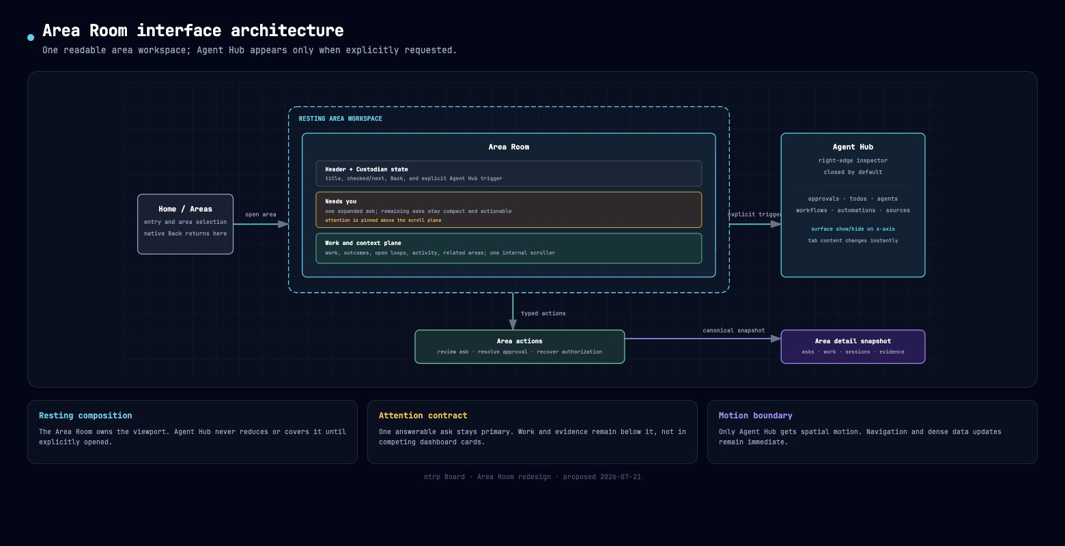
Figure 1. Area Room surface hierarchy and data-flow boundaries.

Core components

Component | Responsibility | Primary storage | Failure behavior
Entry boundary | Home owns Area selection; native Back returns there. | Area overview snapshot | Area Room never duplicates global navigation.
Area Room | Present title, Custodian state, attention, work, and related context. | Area detail snapshot | Shows textual empty/error states without inventing work.
Attention deck | Keep one ask answerable and remaining asks compact. | Area asks | Actions remain local to the affected ask.
Work plane | Render outcomes, work items, loops, and sessions in one scroller. | Area work and sessions | Independent sections can be absent without breaking layout.
Area details | Inspect approvals, agents, workflows, automations, and sources on demand. | Global operational projections | Closed by default; room remains usable if unavailable.

5. Request Lifecycle
- 1. The user opens an Area from Home; the route identifies one area key and Back returns to the canonical Area selection surface.
- 2. The Area detail boundary validates the key and returns title, agent state, asks, work, sessions, related areas, and evidence metadata.
- 3. The room resolves autonomy, attention, interrupts, last check, next check, and run budget before presenting controls.
- 4. The view promotes one answerable ask, then presents the canonical work snapshot and reference material in one scroll plane.
- 5. Replies, resolutions, work updates, and scoped messages call typed Area actions; optimistic decorative state is not treated as truth.
- 6. Agent runs and external writes remain behind existing automation, authorization, and approval boundaries; failures stay visible as words.
- 7. The Area detail snapshot refreshes, the interface preserves focus, and Area details exposes operational activity or grouped sources on demand.

6. API and Data Contracts

Primary data contract

Field | Type | Required | Description
area_key | string | Yes | Stable Area identifier used for fetches and mutations.
title | string | Yes | Human-readable Area title; truncates safely under pressure.
agent | object or null | No | Custodian availability, last/next check, and run state.
asks | AreaAsk[] | Yes | Up to three active asks with typed actions and rationale.
work | AreaWorkSnapshot | Yes | Canonical outcomes and work items.
sessions | AreaSession[] | Yes | User activity for the Area; agent channel excluded from the list.
related | string[] | Yes | Related Area keys resolved through the overview snapshot.

Contract guarantees

- The Area detail snapshot is the single rendering input. UI selection never overwrites server work or ask state.
- Mutations use stable Area, ask, outcome, work-item, session, and tool-call identifiers supplied by the existing contracts.
- Updates retain expected timestamps or stable keys where the production action requires compare-and-swap behavior.
- Area details is an operational projection, not a second source of truth; sources remain provenance for the selected work or turn.
The live interface contract is represented by the Area API types and the production AreaRoom components.
Mockup contract: docs/mockups/board-area-room.html; production reference: apps/desktop/src/features/areas/components/AreaRoom.tsx.

7. Consistency, Idempotency, and Replay

Area Room renders the latest fetched snapshot. Duplicate UI events must not invent completion; typed server actions and expected timestamps decide mutation outcomes. Reopening Area details or changing its tab is local, reversible state and never replays work.
Scenario | Expected behavior | Reasoning
Area details unavailable | Room remains complete; trigger communicates unavailable state. | The inspector is supplementary, not structural.
Area mutation fails | Restore input and show a visible failed result or toast. | No optimistic decoration may claim completion.
Narrow or short viewport | Keep title, ask actions, scroller, and Hub trigger reachable. | Attention and action remain usable under pressure.
Snapshot changes during interaction | Refresh from the authoritative Area detail and preserve local focus where valid. | Server state wins; UI selection is reversible.

8. Security and Privacy Considerations

- Area details and Area controls expose only capabilities already authorized by the runtime; consequential actions continue to require approval.
- The room shows concise summaries by default. Full transcripts, evidence, and exact diffs remain behind explicit drill-in controls.
- Credentials never appear in the room. Auth-required states provide a visible recovery action without exposing tokens.
- Area details is closed by default, autonomy remains explicit, and no external action runs from decorative controls.
- The redesign changes presentation only; existing Area, session, memory, source, and automation retention rules remain authoritative.

9. Operational Readiness
Signal | SLO or alert | Owner | Launch gate
Resting overlap | 0 overlaps at 958 x 758, 958 x 600, and 740px width | Desktop | Required
Primary action visibility | All ask actions remain visible without horizontal clipping | Product design | Required
Keyboard and focus | Back, asks, work scroller, Hub, tabs, and close are reachable | Desktop | Required
Motion duration | Only shared under-300ms UI motion; no tab-content motion | Design systems | Required
Regression suite | All mockup contract tests pass | Desktop | Required
Rollout constraint: Static mockup approval precedes any production port; the current production Area components stay unchanged until the browser review passes.

10. Alternatives Considered

Alternative | Why it was considered | Why it was not selected
Permanent three-column dashboard | Everything appears simultaneously. | The details panel covers the room at the review viewport.
Responsive docked Hub | Keeps operational state visible on wide screens. | Creates two different resting hierarchies and still compresses the room.
Six Hub tabs | Direct access to every subsystem. | Icon-only navigation is opaque; information is too fragmented.
Decorative section entrances | Could make the redesign feel new. | Frequent functional data should not move for style.

11. Open Questions
- Validate whether one expanded ask plus two compact rows remains sufficient with real three-ask payloads.
- Validate the Area details width against the production resizable inspector before porting the mockup.
- Validate short-window density at 958 x 600 and narrow-window behavior below 740px.
- Confirm whether related Areas remain useful at the end of the work plane or should stay exclusively on Home.

12. Decision and Next Steps
Approve the shared-shell composition. First ship the static mockup and regression contracts, then browser-test resting, Area details, dark, narrow, and short states. Port only validated hierarchy and motion decisions into production; retain rollback by keeping the current production Area components unchanged during mockup review.
Milestone | Deliverable | Exit criteria
M1 | Aligned static Area Room shell and resting hierarchy | No overlap; native chrome and full Area contract present
M2 | Area details inspector and restrained motion | Right-edge open/close works; tab content is immediate
M3 | Pressure and interaction verification | Wide, narrow, short, dark, keyboard, and reduced-motion checks pass
M4 | Production port decision | User approves the live mockup and named differences are documented

Use footnotes for definitions, assumptions, or terms that need precision without interrupting the main narrative.

