

Business Process Automation with Red Hat JBoss BPM Suite

Scenario: Federal Employee Name change process

To legally change their name, US citizens have to notify many government agencies and private organizations. The process requires to make a name change is complex, fragmented, and inconsistent across organizations. These inconsistencies can cause delays in services to citizens and can also have financial impacts.

For example, prior to filing for taxes, citizens who need to change their name have to file Form SS-5 so that there is no difference between the name on the tax filing and the system of record at the Internal Revenue Service (IRS). If there is any discrepancy, the IRS will notify the applicant by letter and delay tax refunds until the discrepancy is resolved.

In the public sector, having a consistent process that is driven by intelligent business rules, human task-based activities, and integration with external agencies will minimize the burden on applicants. The process automation will provide a consistent, intelligent, and repeatable sequence of events. This demonstration shows a streamlined process for a name change.

Functional highlights

The proof of concept for the name change demonstration provides the following functionality:

- Initiate the Name Change Application using a user interface
- Assign a task to clerk to verify documents and to enter the new name
- Update the system of record at the Office of Personnel Management (OPM)
- If documents are invalid or insufficient, inform the applicant
- If the documents are valid, inform the Department of Homeland Security (DHS)
- Apply business rules to verify eligibility for auto social security number (SSN) card application
- Inform the Social Security Administration or apply for a new SSN card on the basis of eligibility rules

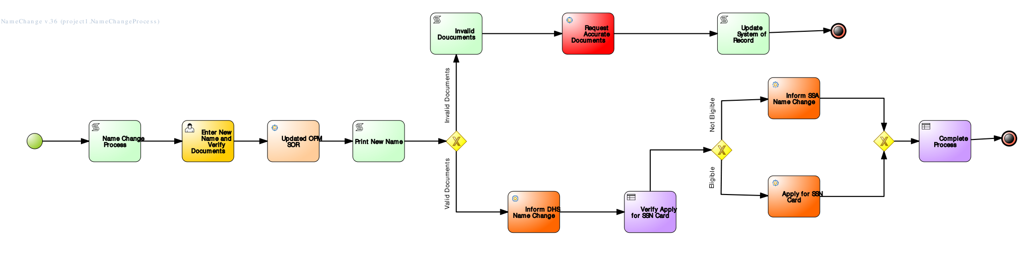

Technical highlights

The proof of concept demonstrates usage of platform capabilities that combine human and system interactions needed to fulfill end-to-end business automation process.

Below are some of the technical features used in the demonstration:

- BPMN2.0 compliant business process that captures and automates business process
- Out of the box integration with JAX-WS (wsdl) web services
- Out of the box integration with JAX-RS (RESTFul) web services
- Integration with set of business rules grouped by drools ruleflow group
- Conditional processing on the basis of rules and data
- Custom integration nodes for additional flexibility and leveraging legacy systems and databases
- Divergent gateway to demonstrate process control

Benefits of the JBoss BPM Suite

Using the Red Hat JBoss BPM Suite, clients in the public sector can more quickly and efficiently achieve organizational goals by automating their business processes. They’ll reduce redundancy, human errors, and mis-communication. Customers will be able to implement process models, express business rules more quickly, and comply with SOA architecture out of the box. Customers will be able to create custom nodes for integration with legacy and external systems.

