**No Green Stars Part II: Effects of Color Contrast, the "Greenest" Blackbody, and Why There are No Violet Stars!**

In my [first post](http://nogreenstars.blogspot.com/2013/03/why-are-there-no-green-stars.html), I described why there are no green stars in the night sky. I'm assuming you've read that post before this one, so please do if you haven't yet. As a reminder, the main conclusion was "there are no green stars because the blackbody function is very broad, and the cone cell responsible for sensing green overlaps substantially with the other two cones cells." There's just no temperature a blackbody can have that produces a substantial amount of light in the green portion of the spectrum, but not in the other parts of the visual spectrum. It's not that strongly peaked.

However, there are some people who claim to see some green stars in the sky. A couple examples are [Almach](http://stars.astro.illinois.edu/sow/almach.html) and [Antares B](http://www.textbookleague.org/103feyn.htm). While these observers claim to see these stars as green, all photographs reveal them as white or [blue](http://www.caelumobservatory.com/outgoing/skynights/handouts/20101225-1.html). What's going on? The likely explanation for these two is that while they are truly blue-white, they have orange or red companions and can appear green due to the [color contrast effect](http://facweb.cs.depaul.edu/sgrais/color_context.htm). A particularly compelling illustration was provided by French chemist [Michel Chevreul](http://en.wikipedia.org/wiki/Chevreul), who did pioneering work on color contrasts:

[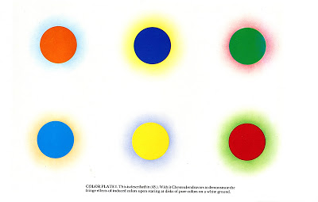](http://2.bp.blogspot.com/-gfQxQwUBl9U/UXhH9uxvxII/AAAAAAAACBw/m7nWFiA6K4k/s1600/chevreul_colors.jpg)

While the motivation for Chevreul's work came from his directorship of [Gobelins Manufactory](http://en.wikipedia.org/wiki/Gobelins_Manufactory) and focus on tapestry dyes, the same principle applies to simultaneous viewing of stars of different spectral types. Look at the bottom right color plate in the above illustration and imagine a relatively smaller white-blue main sequence star against the ruddy brilliance of an evolved [red supergiant](http://en.wikipedia.org/wiki/Red_supergiant). It isn't surprising the smaller white star would look green!

There is one example of a single star that some have claimed to look green, but has no orange/red companion, and that is Beta Librae (as noted by [Phil Plait](http://blogs.discovermagazine.com/badastronomy/2008/08/28/followup-green-objects-in-space/#.UXhC8CvEqp0)). [Beta Librae](http://en.wikipedia.org/wiki/Beta_Librae), also known as [Zubeneschamali](http://stars.astro.illinois.edu/sow/zubenel.html), is a B8 (hot!) main sequence star located in the constellation Libra.

Before I looked up the exact temperature of the star, I had a thought. For a minute, let's take the claim that Beta Librae has a green tinge seriously and entertain the possibility that perhaps there is some narrow temperature range where a star may appear green.**What is the greenest possible blackbody temperature?** This isn't simply a problem of determining at what wavelength the energy flux of a blackbody peaks.

As I stressed in my last post, you must consider: 1) the visual wavelength sensitivity of each color-sensing cone and 2) the fact that your eyes (and astronomical instruments for that matter) are sensitive to  *photons* rather than to energy. The peak of a blackbody in energy flux is different from the peak in photon flux. In the figure below I've plotted several blackbodies in terms of relative energy brightness (solid lines) and photon brightness (dashed lines). To orient you, our Sun has an effective blackbody temperature of about 5800 K.

[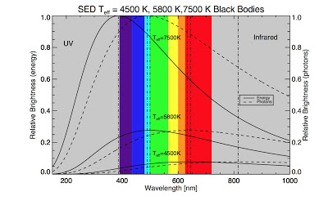](http://4.bp.blogspot.com/-4rYX2RV6eYc/UXlU5TJF0II/AAAAAAAACB8/G6GUdolEBIU/s1600/blackbody_radiation_photons.png)

The way I tackled this problem was to generate several hundred different blackbody functions (in terms of photon brightness) from 100K to 40,000K (main-sequence stars are roughly 3,000+ K). I then convolved (combined) the results from these with the wavelength sensitivity of human cone cells. As a reminder, our eyes contain three sets of cone cells: S, M, and L, sensitive to blue, green, and red light, respectively.

|  |
| --- |
| [avelength-dependent sensitivity of cone cells](http://4.bp.blogspot.com/-ps2tu8KWxwA/UXlWlWOTEEI/AAAAAAAACCU/6pF91PghJi4/s1600/cone_highlight.png) |
| The highlighted region is where the green cone is the most sensitive. |

I formulated a custom measure I call the "greendex", which is simply the ratio of the number of photons  in the visual range where the green cone is the most sensitive to the number of photons in the rest of the visual range. I weighted according to wavelength-dependent cone sensitivity and normalized to unity. This is a bit more advanced than simply finding a peak in the energy or photon distribution. Here are the results, showing the "greendex" as a function of blackbody temperature:

|  |
| --- |
| [http://1.bp.blogspot.com/-zkimawho0-8/UXlZEFjfenI/AAAAAAAACCo/o4vns3wIt2U/s400/greendex_convolved1.png](http://1.bp.blogspot.com/-zkimawho0-8/UXlZEFjfenI/AAAAAAAACCo/o4vns3wIt2U/s1600/greendex_convolved1.png) |
| The "greendex" plot shows why there are no green - or violet - stars. |

Note that the colors I have overlaid on the plot are merely estimates for what color the blackbodies at the relevant temperature would appear to our eyes (informed by the [color temperature](http://en.wikipedia.org/wiki/Color_temperature) page on Wikipedia). I have to admit I was a bit surprised when I plotted this baby up. It's true that I did expect the "peak" to be fairly flat - what I didn't expect was the plot to be flat throughout wavelength space after ~5000 K. The graph behavior continues all the way through 40,000 K (not shown), which is basically the upper limit for main sequence photospheric temperatures. This plot shows quite clearly why we don't see any green *or* purple stars in the night sky. Let me explain.

At the lowest temperatures, the peak of the blackbody is in the non visual infrared range, but as we get above about 1,000 K, even thought the majority of the photons are in the infrared, we start to get visually perceptible red photons from the  short-wavelength "tail" of the distribution.  We move more and more of the photons into the visual range as we increase the temperature. The actual point at which the "greendex" "peaks" is 8600 K, though this is not a very strong peak. Not coincidentally, the temperature at which the greatest number of green photons are produced is also the temperature at which roughly equal numbers of red and blue photons are also produced - creating a *white* star rather than a green one.

Now, as we get hotter the blackbody peak shifts into the invisible UV range, but we *still* have a white-blue star. This is because the slope of the long-wavelength tail of the blackbody, (called the [Rayleigh-Jeans tail](http://en.wikipedia.org/wiki/Rayleigh-Jeans_law" \t "_blank)) is very shallow. It's even more shallow in terms of photons than in terms of energy. What this means is that a blackbody only weakly becomes bluer the hotter it gets because it continues to produce copious amounts of green, yellow, orange, and red photons, which register in your green and red cones. In reality, I expect you'd have to have a blackbody much hotter than the hottest star to make it look violet to your eyes.

Okay, but what about our old friend Beta Librae? I looked up it's temperature and it's about 12,700 K - pretty far off from my peak of 8600 K. So, honestly, I have no idea why it looks green to some people. But remember this, stars aren't actually perfect blackbodies. Atomic [absorption](http://en.wikipedia.org/wiki/Absorption_(electromagnetic_radiation)" \t "_blank) (and molecular absorption at lower temperatures) takes a bit out of certain parts of the stellar spectrum, though this effect is muted for high temperature stars. There's also [limb darkening](http://en.wikipedia.org/wiki/Limb_darkening" \t "_blank), and the effect of stellar rotation. Rapidly rotating stars are hotter at the poles and cooler at the equator due to [centrifugal forces](http://en.wikipedia.org/wiki/Centrifugal_force" \t "_blank). Actually, Beta Librae is a pretty [rapid rotator](http://adsabs.harvard.edu/abs/2002ApJ...573..359A" \t "_blank), spinning over 100 times more rapidly than the Sun. There's also the possibility that the apparent greenish tinge some observers see in Beta Librae has nothing to do with the intrinsic properties of the star. If anyone has any more information or insight into this problem I'd be happy to hear it.

*\*In case anyone is curious, I also have versions of the "greendex" plot that show the measure in terms of energy, in addition to photons:*

[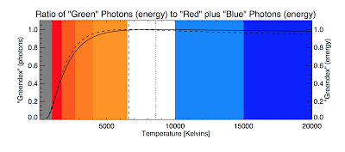](http://1.bp.blogspot.com/-3I12shM9AtA/UXlnNPmDwmI/AAAAAAAACC0/AD5UsTeN0xk/s1600/greendex_convolved2.png)

*In this case, the peak is shifted to 6600 K rather than 8600 K, and the greendex "tail" is a bit less flat in terms of energy. However, I maintain that the photon measure is more relevant to this problem.*