Appendix B – Configuration

Setting up WS-Security
The user credentials are transferred between client application and framework via WS-Security on each webservice call.
For this, WS-Security has to be set up by adding a file axis-wss4j.xml to folder merge with the following content:
<requestFlow>
<handler type="java:org.apache.ws.axis.security.WSDoAllReceiver">
<parameter name="action" value="UsernameToken"/>
<parameter name="passwordCallbackClass"
value="de.fiz.escidoc.common.util.security.server.PWCallback"/>
<parameter name="passwordType" value="PasswordText" />
<parameter name="addUTElement" value="NonceCreated" />
</handler>
</requestFlow>
When executing the EJB XDoclet task, this requestFlow definition will be merged into each webservice deployment descriptor.
Note: WS-Security requires the WSS4J implementation. Make sure the jar file wss4j.jar is contained in escidoc.ear/axis.war/WEB-INF/lib.

Setting up JBoss AOP
Authentication / Authorization of the current user is realized by AOP interception whenever an EJB is calling a method in one of its service classes.
JBoss AOP interception has to be set up in the eSciDoc framework via the following steps:
- Create new folder escidocAOP.aop in folder escidoc.ear.
- Create new folder META-INF in escidoc.ear/escidocAOP.aop.
- Add file jboss-aop.xml to escidoc.ear/escidocAOP.aop/META-INF with the following content:
<?xml version="1.0" encoding="UTF-8" standalone="yes"?>
<aop>
<pointcut expr="call(* de.fiz.escidoc.*.service.*-&gt;*(..))
AND !call(* de.fiz.escidoc.common.*-&gt;*(..))
AND within(de.fiz.escidoc.*.ejb.*Bean)" name="authorisation"/>
<bind pointcut="authorisation">
<interceptor class=
"de.fiz.escidoc.common.util.security.aop.SecurityInterceptor"/>
</bind>
</aop>

This defines the AOP pointcut authorization as follows:
- call(* de.fiz.escidoc.*.service.*->;*(..)): intercept any call to any method that is located in any class in a package that matches “de.fiz.escidoc.*.service.*”
- AND !call(* de.fiz.escidoc.common.*-&gt;*(..)): but don’t intercept calls into the common-package, since it only contains helper-classes
- AND within(de.fiz.escidoc.*.ejb.*Bean): and only intercept in case the call originates from a class named [*]Bean (which is the naming convention for EJBs in the eSciDoc project) residing in a package that matches “de.fiz.escidoc.*.ejb.*”

This pointcut is the bound to a call into Interceptor de.fiz.escidoc.common.util.security.aop.SecurityInterceptor.
- Add new component escidocAOP.aop to Escidoc/escidoc.ear/META-INF/application.xml:
<module>
<java>escidocAOP.aop</java>
</module>

Invoking JBoss AOP
JBoss AOP interception is achieved by bytecode manipulation. This means that the JBoss AOP compiler has to re-compile the class files, that are residing in escidoc.ear (which are already compiled by the Java compiler).
For this, the following Ant-task has been set up in build/helper-build.xml:
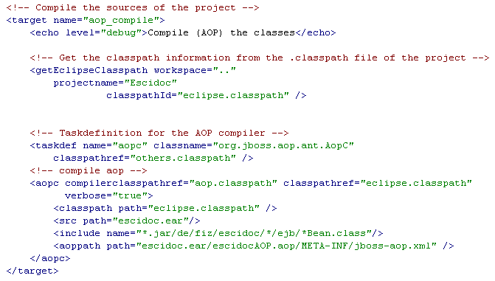
It recompiles all class files that are residing in escidoc.ear/*.jar/de/fiz/escidoc/*/ejb (where * means any number of characters) and which match the name *Bean.class.
This task has of course to be executed after the class files have been generated. This either happens by executing the compile-task (build/java-build.xml, task build) or by using Eclipse’s built-in compiler (e.g. by invoking “Refresh” after the executing XDoclet).
However, the AOP compiler has to be executed before deploying the ear file. After the AOP compiler run also a “Refresh” should be done on the folder escidoc.ear to notify Eclipse of the applied changes (the execution of the Ant-task can be set up to automatically invoke refresh after completion).
Note: The recompilation only affects the EJB classes. All other classes are left as created by the Java compiler and therefore a change in those classes does not require a new run of the AOP compiler or a redeployment. However, whenever changing an EJB (either directly – which should actually never happen – or via recreating it via XDoclet) the ear file should be undeployed, the AOP compiler task should be executed and then a redeployment should happen.
Once the Security concept has been finalized, policies should be created for all Webservice methods in the eSciDoc framework. At this point, the AOP compiler should be included in the Cruise Control build script to have Cruise Control test the Security aspect as well.

Adapting Axis to invoke initUser on EJB-create
The user credentials are as described above handed over to the framework via WS-Security. However, since Axis is accessing the system via EJB calls, the WS-Security information is not accessible any more once inside an EJB method.
Therefore the user credentials have to be injected into each EJB via calling the method initUser, which exists for each EJB of the eSciDoc framework (the method is defined in the XDoclet template build/xdoclet/bean.xdt, which is used to create the EJBs from the service classes).
The method should be invoked directly after the create-method of the EJB is invoked and before any other EJB method is invoked. For this the Axis class EJBProvider, which resides inside escidoc.ear/axis.war/WEB-INF/lib/axis-1.2.1.jar has to be changed in the following way:
- Add the following code directly before the return-statement in method createRemoteEJB and in method createLocalEJB:
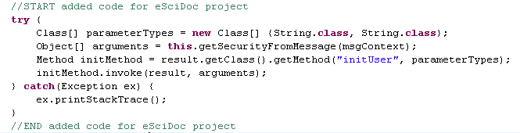
- Add private method getSecurityFromMessage:
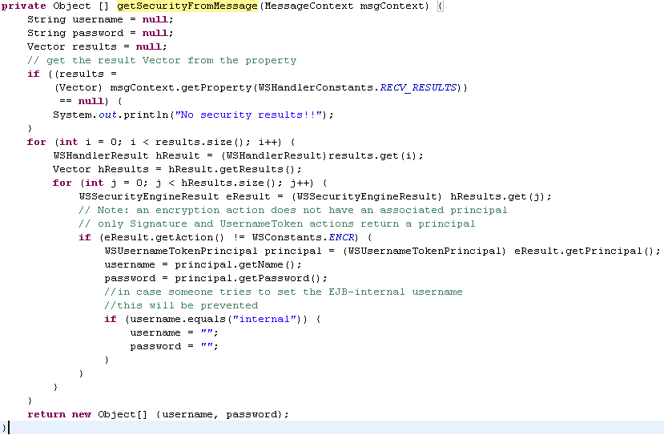
A changed version of this class can be found in common/src/org.apache.axis.providers.java. This class has to be compiled and then copied to axis-1.2.1.jar into the same package to replace the existing class-file.

Adapting Spring to invoke initUser on EJB-create
Similar to Axis, also Spring has to be extended to invoke initUser when it creates a new EJB.
For this the classes LocalStatelessEjbProxyFactoryBean and RemoteStatelessEjbProxyFactoryBean have been created, which are located in common/src/de.fiz.escidoc.common.util.service. The eSciDoc-specific Spring mapping has been set up to use these classes instead of the standard Spring EJB proxies when accessing EJBs.

