Overview
This document is a Technical Design document for the Interim component of the eSciDoc Technical Prototype.
The eSciDoc Technical Prototype is a proof-of-concept that the development tools and technologies proposed during the planning phase of the eSciDoc project fit together and are suitable for the eSciDoc requirements.
The intention of this document is to describe in detail how the Interim component described in the eSciDoc Prototype Functional Design will be implemented. The document should be detailed enough for the developer to base the development on it.
The Interim component is responsible for temporarily storing FOXML files until they are successfully into the Fedora repository. It will create a unique temporary ID for each temporarily stored file, which can be used to retrieve the file at a later point.
The scope of this document only comprises specifics for the Interim component. General technical details and assumptions are not included, but can be found in the document eSciDoc Prototype Technical Specification. Furthermore, no functional description is included in this document. For such information, please refer to the eSciDoc Prototype Functional Design document.

Implementation Details
This section describes the implementation details of the Interim component of the eSciDoc Technical Prototype.
First a class diagram with all classes that comprise the Interim component is provided. After that each class is described in details, including general information, variables and (public) methods. Finally the database tables that are needed for the Interim component are described.

Class Diagram
Figure 1 shows the class diagram for the Interim component of the eSciDoc Technical Prototype.
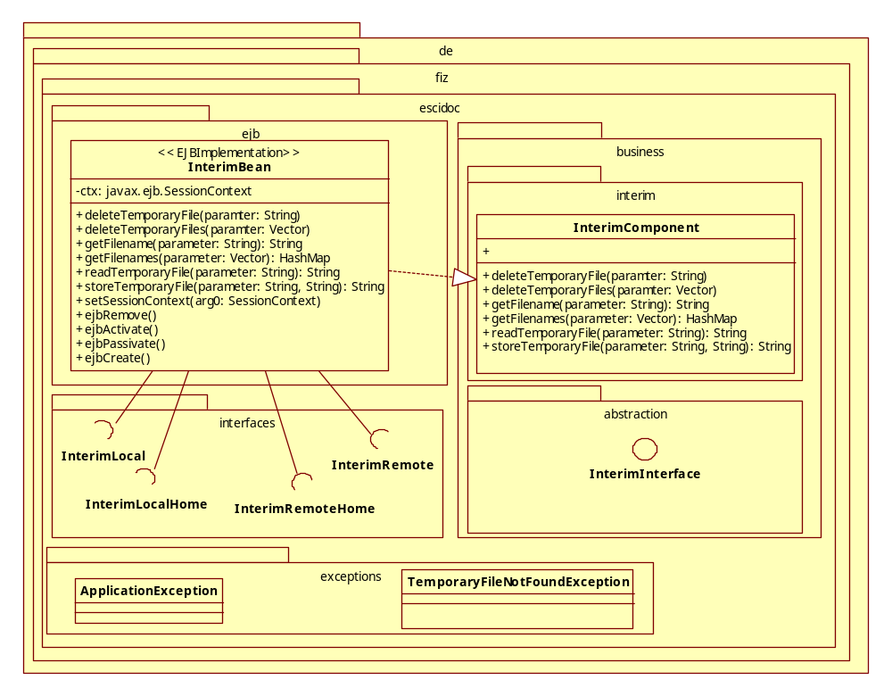
Figure 1: UML class diagram of Interim component

