Overview
This document is a Technical Design document for the Control component of the eSciDoc Technical Prototype.
The eSciDoc Technical Prototype is a proof-of-concept that the development tools and technologies proposed during the planning phase of the eSciDoc project fit together and are suitable for the eSciDoc requirements.
The intention of this document is to describe in detail how the Control component described in the eSciDoc Prototype Functional Design will be implemented. The document should be detailed enough for the developer to base the development on it.
The Control component is responsible for accepting requests, which are submitted by the user via the JSP pages of the View component, analysing and forwarding those requests to the respective component that should handle this kind of request. It will further receive the result of the request from the called component and forward it to the respective JSP in the View component to render the result to the user.
The scope of this document only comprises specifics for the Control component. General technical details and assumptions are not included, but can be found in the document eSciDoc Prototype Technical Specification. Furthermore, no functional description is included in this document. For such information, please refer to the eSciDoc Prototype Functional Design document.

Implementation Details
This section describes the implementation details of the Control component of the eSciDoc Technical Prototype.
First a class diagram with all classes that comprise the Control component is provided. After that each class is described in details, including general information, variables and (public) methods.

Class Diagram
Figure 1 shows the class diagram for the Control component of the eSciDoc Technical Prototype.
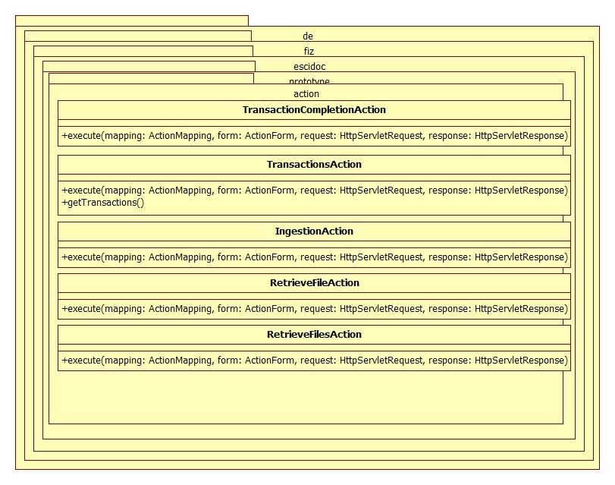
Figure 1: UML class diagram of Interim component

