Overview
This document is a Technical Design document for the Ingestion component of the eSciDoc Technical Prototype.
The eSciDoc Technical Prototype is a proof-of-concept that the development tools and technologies proposed during the planning phase of the eSciDoc project fit together and are suitable for the eSciDoc requirements.
The intention of this document is to describe in detail how the Ingestion component described in the eSciDoc Prototype Functional Design will be implemented. The document should be detailed enough for the developer to base the development on it.
The Ingestion component offers the functionality for what in terms of the prototype is called “ingestion”. An ingestion is the process of storing the content of a set of provided files in the Fedora repository.
The Ingestion component provides two synchronous public methods which allow the initial ingestion of a set of files and the continuation of a transaction that was created while ingesting a set of files at some earlier time. The Ingestion component collaborates with the Transaction and the Store components to accomplish this.
Inside the Ingestion component only the internal ids assigned to uploaded files and transactions are used. At no time is the actual content of an uploaded file or it’s original name used. Handling these is left to the Interim, Transaction, and Store components.
The scope of this document only comprises specifics for the Ingestion component. General technical details and assumptions are not included, but can be found in the document eSciDoc Prototype Technical Specification. Furthermore, no functional description is included in this document. For such information, please refer to the eSciDoc Prototype Functional Design document.

Implementation Details
This section describes the implementation details of the Ingestion component of the eSciDoc Technical Prototype.
First a class diagram with all classes that comprise the Ingestion component or are related to it is provided. After that each class is described in details, including general information, variables and methods.
Since the steps of the workflow to be executed by the Ingestion component need access to the stateless session beans of other components, all methods that are building blocks of the workflow are private methods of the stateless session bean of the Ingestion component.
The results of the two public methods are returned as instances of the class TransactionInfo, which is a Java Bean containing several pieces of information about the status of a transaction.

Class Diagram
Figure 1 shows the class diagram for the Ingestion component of the eSciDoc Technical Prototype.
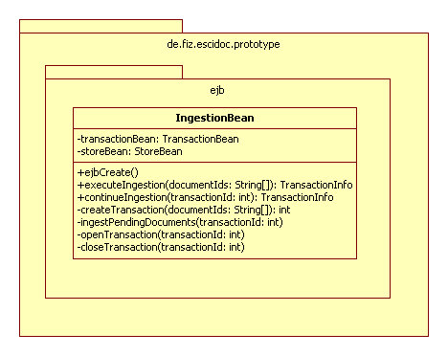
Figure 1: UML class diagram of Transaction component

