Overview
This document is a Technical Design document for the Store component of the eSciDoc Technical Prototype.
The eSciDoc Technical Prototype is a proof-of-concept that the development tools and technologies proposed during the planning phase of the eSciDoc project fit together and are suitable for the eSciDoc requirements.
The intention of this document is to describe in detail how the Store component described in the eSciDoc Prototype Functional Design will be implemented. The document should be detailed enough for the developer to base the development on it.
The Store component is responsible for permanent storing of the content of provided files in the Fedora repository.
The Store component provides one synchronous public method which allows the storage of one file that is mapped to a given temporary file-Id. The Store component collaborates with the Interim component to accomplish this.
The scope of this document only comprises specifics for the Store component. General technical details and assumptions are not included, but can be found in the document eSciDoc Prototype Technical Specification. Furthermore, no functional description is included in this document. For such information, please refer to the eSciDoc Prototype Functional Design document.

Implementation Details
This section describes the implementation details of the Store component of the eSciDoc Technical Prototype.
First a class diagram with all classes that comprise the Store component and with exception classes wich are used by the Store component is provided. After that each class is described in details, including general information, variables and (public)methods.

Class Diagram
Figure 1 shows the class diagram for the Store component of the eSciDoc Technical Prototype.
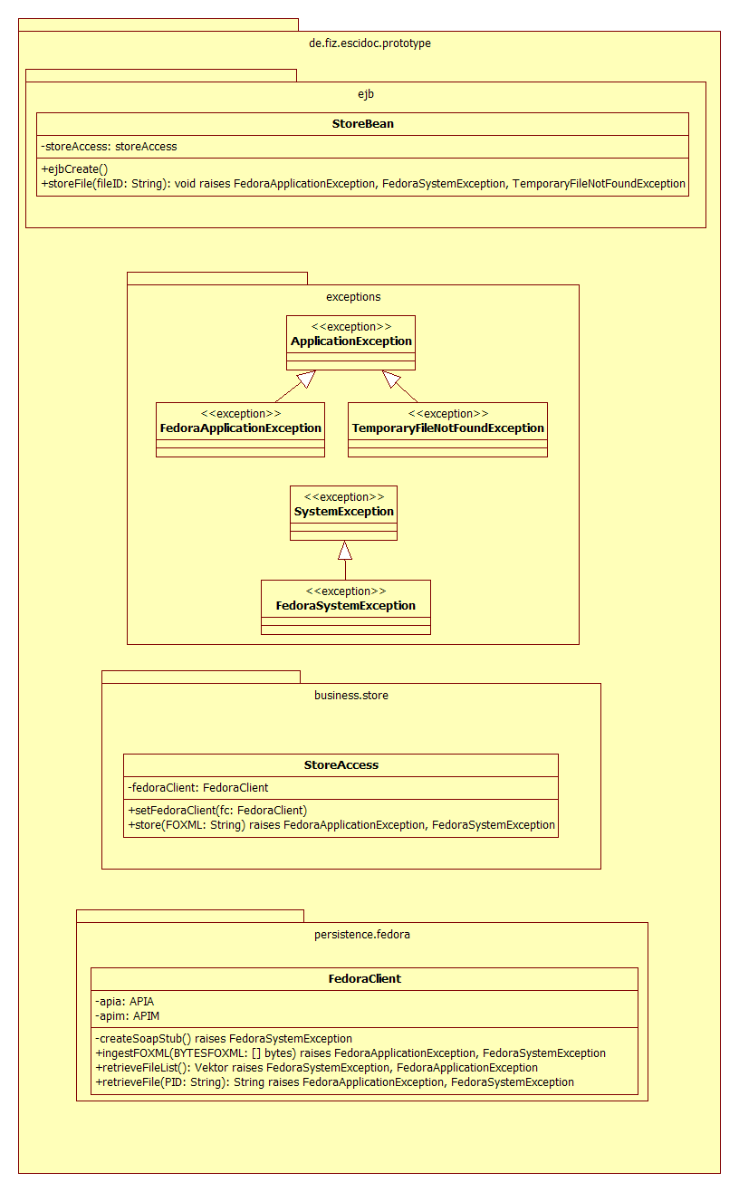
Figure 1: UML class diagram of Store component

