Using inclusive language and avoiding jargon

Handout (edit access for Kristina): <https://leidenuniv1-my.sharepoint.com/:w:/g/personal/companjenba_vuw_leidenuniv_nl/EernmWpIIVRIjXBxWBhwVDQBlH_hYN21nuqb8De9_BljlA?email=k.m.hettne%40library.leidenuniv.nl&e=SbxU43>

Ben: "Good morning, guys, welcome to this first session! Today we'll discuss some easy topics related to FAIR: FAIR Digital Objects. As you guys know, FAIR Digital Objects are regular Digital Objects, but they must be treated by the FAIR Wizard of Leiden to become FAIR Digital Objects. Only then can you use the DOIP to retrieve them. So let's have a look at the DOIP, which is obviously the most interesting part of the story."

# Context: why and what?

Why are we talking about using inclusive language and avoiding jargon? Because we want everyone to be able to learn – this is one of our core values as instructors.[1]

That requires creating a positive learning environment, which helps people concentrate on learning.

We want to avoid language and terms that exclude or demotivate learners.

Today we focus on inclusive language to create a more positive learning environment, although we should understand that there are many more aspects to including all learners in your teaching. For example, colour contrast and font size in websites and printed text are important if you expect learners to read the text, and so is wheelchair accessibility for physical gatherings.

Jargon and non-inclusive language can both demotivate learners – intentionally or unintentionally. Jargon is more strongly related to knowledge background, whereas non-inclusive language is more about learners' personal background.

## Positive learning environment

"A positive learning environment helps people concentrate on learning." (Motivation)

"Inclusivity is a key attribute of a positive learning environment." (EIA)

## EIA

Defining Equity (!= Equality), Inclusion, (Accessibility)

<https://carpentries.github.io/instructor-training/09-eia/index.html>

Speaking English here because not everyone understands Dutch may be seen as an effort to be more inclusive.

# Jargon

Jargon is defined as "special words or expressions used by a profession or group that are difficult for others to understand" by Apple's Dictionary app.

Using "jargonic" terms is not always bad: it can save time and make exchanging knowledge easier within a group of experts. However, not knowing these terms puts you outside the group. The feeling of exclusion can demotivate learners.

## Types of learners and their mental models

We may think of someone's understanding of a topic as their mental model and visualise it as a network of concepts and facts, connected by relationships:

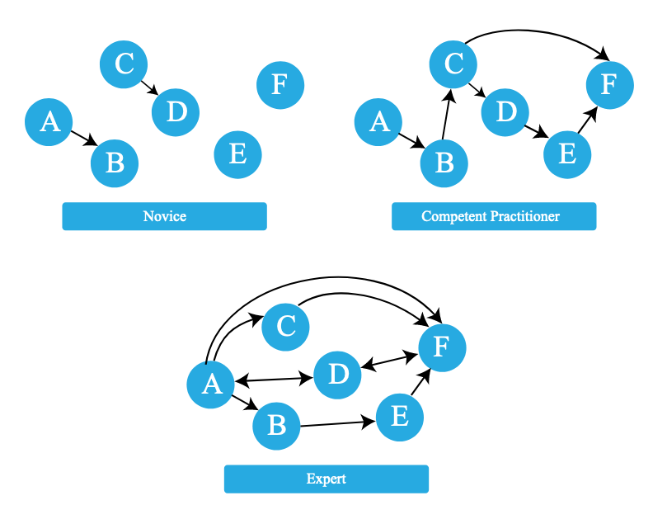

Novice learners do "not know what they don't know, i.e., they do not yet know what the key ideas in the domain are or how they relate."

Competent practitioners "have enough understanding for everyday purposes. They will not know all the details of how something works and their understanding may not be entirely accurate, but it is sufficient for completing normal tasks with normal effort under normal circumstances."

As a teacher you are usually an expert. Some things are natural to you that a novice or competent practitioner don't know are even relevant. A competent practitioner might have an imprecise or incorrect understanding of how certain concepts relate.

The expert awareness gap is the concept of an expert being unaware of gaps between a learner's understanding and their own. The expert awareness gap can lead to making explanations sound jargonic.

For all groups of learners: don't bombard learners with new concepts; build their mental model in increments. When teaching competent practitioners, who may have more incorrect connections, you may even need to remove and replace incorrect relations.

<https://carpentries.github.io/instructor-training/04-expertise/index.html>

One good practice in this respect is to pay attention to language that you use interchangeably. The mental model of learners may not include the relation(s) between the terms that are in your mental model.

To signal that you understand that not everything may be clear right away, here are two tips:

* Do not ask "Any questions?" but "What questions do you have?"  
  The latter more directly says that you expect questions may come up.
* Do not say your learners should "just do X" or say "Y is easy", as this strongly suggests learners should have mastered X and Y at the time of instruction.

## Examples of (avoiding) jargon

Explaining a concept using terms that have not been explained or that may mean different things to different learners:

In a programming course, we used the terms method and function interchangeably while demonstrating built-in functions, but this confused learners.

This became clear when we got questions about the differences between functions and methods. We confused them more by mentioning related concepts that were even more off-track, like object-oriented programming.

Instead, we should have focused on concepts that are relevant to functions (and methods), like inputs and outputs and how to call functions.

One question that surprised us a little was 'What are inputs and outputs?' – a good example of our expert awareness gap.

# Inclusive language

"As with other demotivation pitfalls, we can also think carefully about the language that we use and how we interact with our learners to avoid reinforcing systemic bias."

Inclusion: "Actively engaging traditionally excluded individuals and/or groups in processes, activities and decisions in a way that shares power. Inclusion promotes broad engagement, shared participation, and advances authentic sense of belonging through safe, positive, and nurturing environments." (EIA)

## Stereotypes

Copied from EIA:

Stereotypes are an established feature of human social cognition, in which a set of characteristics is associated with members of a group. Stereotypes:

* may be explicit (conscious and deliberate) or implicit (unconscious and automatic)
* guide what we notice about people
* guide how we interpret people’s behaviors
* can facilitate quick judgements in appropriate situations (e.g. stopping a child from driving a car)
* can lead to systematically negative attitudes and behaviors towards members of certain groups

Stereotypes are dangerous when they are explicit, but they are especially hazardous when they are implicit. This means that the people holding them may not be aware of them, even though their perceptions are guided by them.

**When Instructors have stereotypes about learners**, this may lead them to:

* call attention to differences unnecessarily
* give more or less attention to certain learners
* respond to questions differently for certain learners

**When learners experience stereotypes about themselves**, they may:

* develop a fixed mindset about aspects of their own capability
* experience increased cognitive load when reminded about a stereotype, interfering with the learning process. This is known as *stereotype threat*.

## What can we do about our own stereotypes?

* Get to know people from many different groups!
* Observe your own behavior, and build awareness of situations in which your perceptions and behaviors are influenced by stereotypes.
* Avoid calling attention to common stereotypes, even in a way that seems positive.

If you make a mistake, accept feedback, apologise and move on.

## Examples of (not) using inclusive language

Addressing a whole group using terms that not everyone feel apply to them

-> use more general terms to address the group, like "folks", "all" or "y'all"

Example: the Carpentries use the term Expert awareness gap instead of expert blind spot, because it's not about seeing, but noticing.

In our programming course, we used an example of using Python dictionaries that stressed how the UK is no longer in the European Union. Using this example was implicitly commenting on the politics of a different country. Even though one of our learners who was British said he didn't mind the reference to Brexit, it may make some learners uncomfortable and it distracted from explaining what dictionaries are useful for in Python.

See https://www.thiagi.com/games/2020/3/29/live-online-learning-activities-lolas for inspiration about types of activities

* avoiding jargon, knowing we use complex language
  + <https://xkcd.com/1133/>
  + [The Up-Goer Five Text Editor (splasho.com)](https://splasho.com/upgoer5/)
  + [Hemingway Editor (hemingwayapp.com)](https://hemingwayapp.com/)

# Tentative schedule

Parallel session:

09:50 Theory

Act

A4 with bullet points about theory, exercises on back

10:10 Explanation of exercises

Inclusive language:

10:20 Explanation of exercises

10:30 Exercises

PAGE 4

1. It may also be policy or even in the regulations, but it's good to actually want this.