Using inclusive language and avoiding jargon

Using inclusive language and avoiding jargon are ways to prevent excluding and demotivating learners.

They are part of a positive learning environment.

"A positive learning environment helps people concentrate on learning."

# Jargon

Jargon is "special words or expressions used by a profession or group that are difficult for others to understand" (Apple Dictionary)

Using "jargonic" terms can save time and make communication easier within a group of experts, but not knowing the terms puts you outside the group.

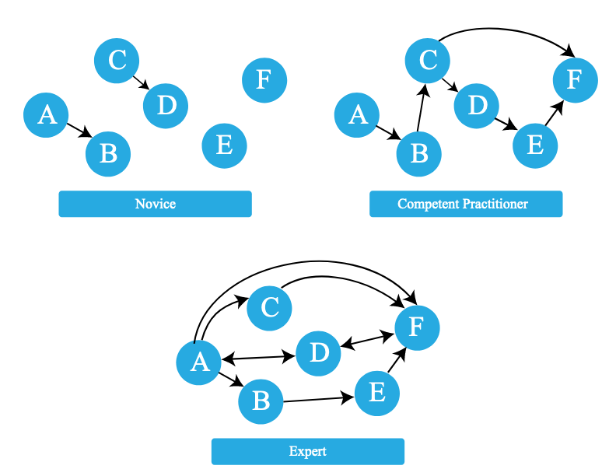Novice learners have an incomplete view of the domain. Competent practitioners have enough understanding for everyday purposes.

The expert awareness gap is the concept of an expert being unaware of gaps between a learner's understanding and their own.

Don't bombard learners with concepts; build their mental model in increments. Remove and replace incorrect relationships.

Pay attention to language that you use interchangeably, as your understanding of such terms may not fit with learners' mental models.

Signal that you expect questions and struggle:

1 Mental models at different levels of expertise

* Do not ask "Any questions?" but "What questions do you have?"
* Do not say your learners should "just do X" or say "Y is easy".

# Inclusive language

"[T]hink carefully about the language that we use and how we interact with our learners to avoid reinforcing systemic bias."

Inclusive language is one aspect of Equity, Inclusion and Accessibility (EIA).

Stereotypes are an established feature of human social cognition, in which a set of characteristics is associated with members of a group.

**When Instructors have stereotypes about learners**, this may lead them to:

* call attention to differences unnecessarily
* give more or less attention to certain learners
* respond to questions differently for certain learners

What to do about our stereotypes?

* Get to know people from many different groups!
* Qr code

  Description automatically generatedObserve your own behavior, and build awareness of situations in which your perceptions and behaviors are influenced by stereotypes.
* Avoid calling attention to common stereotypes, even in a way that seems positive.

If you make a mistake, accept feedback, apologise and move on.

Most text is copied verbatim from The Carpentries' Instructor Training, specifically:

* <https://carpentries.github.io/instructor-training/04-expertise/index.html>
* <https://carpentries.github.io/instructor-training/08-motivation/index.html>
* <https://carpentries.github.io/instructor-training/09-eia/index.html>