**Economics of the Tesla Powerwall for a San Francisco Homeowner**

**Eric Scott, Mar. 1 2016**

**Project Idea**

SolarCity will begin selling the Tesla Powerwall to customers in early-mid 2016. The main value proposition is that the battery is a backup energy provider that can supply electricity if the grid goes down.

While there is potential for energy cost savings for the homeowner, the sales team strictly does not promise this. If the customer wishes, they can switch over to a time-of-use (TOU) rate plan with their utility (if offered) and allow SolarCity to cycle the battery for energy cost savings. SolarCity – I presume – has built a control system that will perform this function. The control system would need information about the homeowner’s annual load profile, the utility rate schedule and the battery performance characteristics. SolarCity is only offering the 10kWh Tesla Powerwall (weekly cycling), and will limit any cycling to 40 times per year.

By focusing on the back-up generation, there is no financial payback for the customer – only peace of mind. This got me interested in the larger problem of battery economics. Does it make financial sense for the average homeowner to buy a Tesla Powerwall?

**The Data**

I used a dataset available on the [OpenEI](http://en.openei.org/wiki/Main_Page) webpage. The dataset was a collection of .csv files for locations across the US describing bother [commercial and residential load profiles](http://en.openei.org/datasets/dataset/commercial-and-residential-hourly-load-profiles-for-all-tmy3-locations-in-the-united-states) for an entire year. The load profiles are based on a combination of models and survey information for statistical reference.

I used only a subset of the dataset (BASE model for residential homeowners). In this subset there were 936 .csv files for regions in the US. I selected the file for San Francisco (“USA_CA_San.Francisco.Intl.AP.724940_TMY3_BASE.csv”). This file provides a breakdown for energy consumption in hourly bins for an entire year. I choose the San Francisco region because that’s where I live and wanted to see if it makes sense for a homeowner here to buy a battery. Also I’m more familiar with the utility’s (PG&E) rate schedules for residential customers.

**Regular (Tiered) Rate Schedule**

First I wanted to first get a sense of what a customer pays for electricity on the standard tiered rate plan from PG&E. The utility refers to this as [*Electric Schedule E-1*](http://www.pge.com/tariffs/tm2/pdf/ELEC_SCHEDS_E-1.pdf) and charges customers based on their usage compared to the baseline. The baseline differs between summer (May1-Oct31) and winter (Nov1-Apr30), as well as territory (different geographical locations have different baselines).

San Francisco is in PG&E baseline territory T, so residential customers on the E-1 schedule have a summer baseline of 7 kWh/day, and a winter baseline of 8 kWh/day.

From these baselines, we can determine total daily charge from the rate schedule. The tiered structure is broken down by:

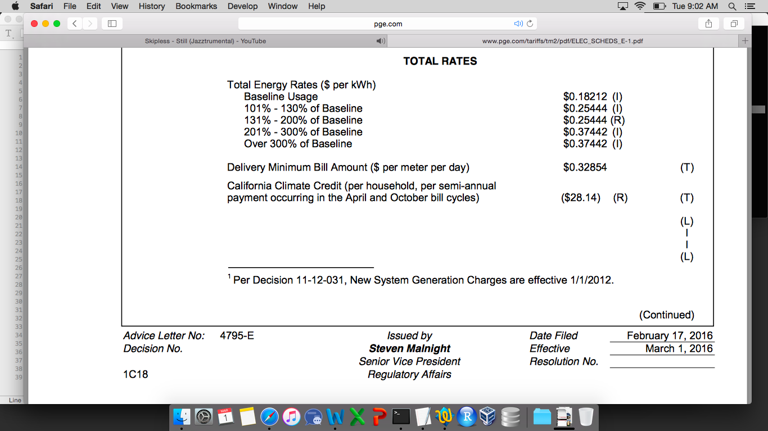

Where the total daily charge is the higher of the total energy rate charges or the delivery minimum bill amount (about $0.33 per meter per day). I looked only at the bundled rate. With the rate plan established, I imported the San Francisco dataset into a pandas dataframe. From there I cleaned up the energy data and ran it through an algorithm to calculate total daily electricity cost according to the E-1 schedule:

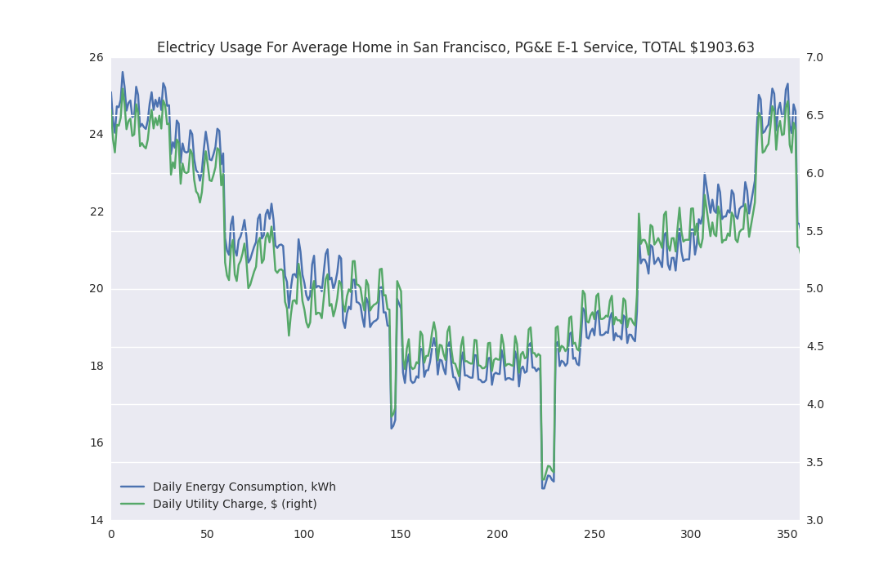

The plot above shows the daily average energy usage (blue) and the daily electricity cost (green). The total electricity cost for the average residential homeowner in San Francisco with one meter on their property is **$1903.63.**

**Time-of-Use (TOU) Rate Schedule**

PG&E is adapting to the modernizing grid. They have a variety of new rate plans for customers to modify electricity consumption to meet their changing needs (EV charging, rooftop solar PV, community aggregation, etc). One new offering is the time-of-use plan (TOU), referred to as [*Electric Schedule E-6*](http://www.pge.com/tariffs/tm2/pdf/ELEC_SCHEDS_E-6.pdf)*.*

On a TOU plan, the customer’s electricity cost varies not only as a percent of the baseline for each season, but not also per time of day. PG&E has split the rate plan up to charge more during critical times when demand is high (peak times) and to charge less when demand is low (off-peak times). The new plan charges electricity according to:

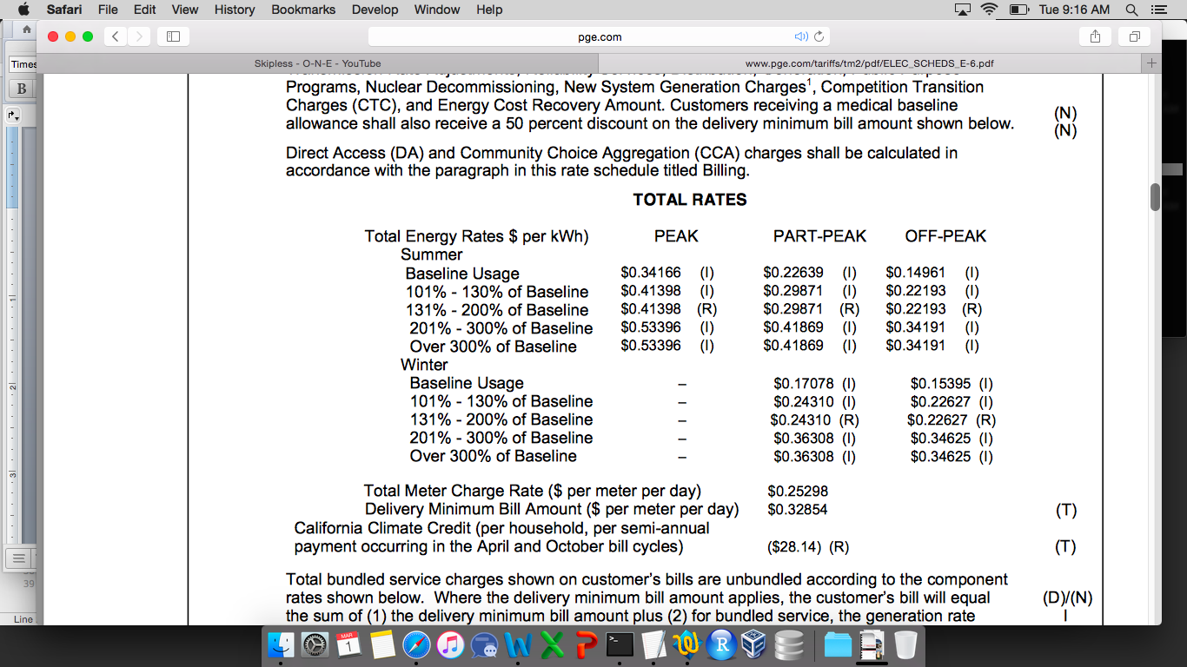

Similar to the E-1 rate plan, the total daily charge is the higher of the total energy rates charge or the delivery minimum bill amount. Again I imported the dataset into a pandas dataframe. The algorithm for the TOU plan is more complicated than the standard tiered structure.

Plotting the total charge and daily consumption:

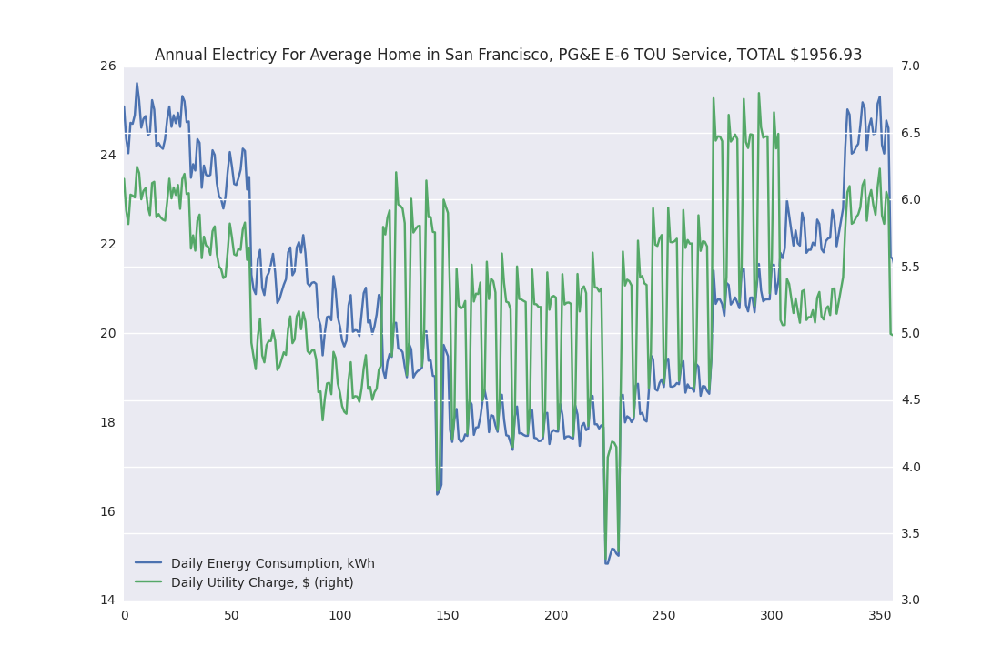

The plot above has some key distinctions from the E-1 schedule. First is the change in seasonal charges. In the tiered plan, the daily cost followed the usage closely. Now we see the charges are relatively much higher in the summer and lower in the winter. The total cost of electricity for the average residential homeowner in San Francisco on the E-6 schedule is **$1956.93.**

It makes sense that the costs for the two plans are so similar – and slightly higher on the E-6 plan. The customer is incentivized on the E-6 plan to modify their consumption to avoid peak and partial-peak hours.

**Adding the Tesla Powerwall**

Next I added the battery into the model. For the tiered service (E-1), adding a battery will not reduce electricity costs, it will increase them. The rate structure in the tiered tariff does not change for different times of the day. The battery is also not 100% efficient. If we put in 1 kWh of storage we don’t get 1 kWh out. Due to losses inside the battery, we would get only about 0.92 kWh out from 1 kWh input (92% round-trip efficiency for the Powerwall). So by using the battery in the tiered rate structure, we don’t have the opportunity for lower energy rates and actually increase the total energy used – and therefore increase the total electricity cost (not to mention the battery cost).

We can however use the battery to shift our consumption to different times of the day. Normally residential customers use electricity the most during the evenings. PG&E has structured their TOU plan to incentivize homeowners to avoid using electricity during these high demand hours. A homeowner might use a battery to take advantage of the TOU plan by simply:

1. charging the battery during off-peak price times early in the morning
2. discharging the battery during peak price times in the evening

**Battery Specifications**

I’m assuming the homeowner is going to buy a [Tesla Powerwall](https://www.teslamotors.com/powerwall), a rechargeable lithium-ion battery. This homeowner lives in the San Francisco Bay Area and does not have a rooftop PV system. The battery in my model is the 6.4 kWh model designed for daily cycling. This battery from Tesla has a continuous power of 2 kW and max power of 3.3 kW. The round-trip efficiency is 92%, costs $3000 and does not include an inverter or installation. The battery has a 5000 cycle lifetime and 10 year warranty.

Doing a little analysis on the TOU algorithm, the maximum amount of peak-time energy used during the entire year is 5.907 kWh. That is, for the summer season between 1pm and 7pm, the most energy consumed for the average home is 5.907 kWh. The Powerwall has a 92% round-trip efficiency so applying this, we need to input 6.421 kWh of energy into the battery to get the 5.907 kWh needed for peak-time usage. The 6.4 kWh can meet this requirement almost perfectly.

Next looking at the original dataset, over the entire year the maximum energy used during the an hour was 1.987 kWh. Assuming this demand was constant over the entire hour, our max power requirement is about 2 kW. The 6.4 kWh Powerwall is again almost perfectly designed for this.

**Powerwall Model**

The battery model uses the technical characteristics above following the simple dispatch strategy:

* If the battery is not full, charge at the max power capacity (3kW) between 1am and 3am until full
* If energy is available, discharge from the battery to meet demand for:
  + Energy needed between 1pm and 7pm, Monday to Friday during the summer
  + Energy needed between 5pm and 8pm, Saturday to Sunday during the summer
  + Energy needed between 5pm and 8pm, Monday to Friday during the winter

This will offset all peak-time and weekend partial-peak time charges in the summer, and all winter partial-peak charges. I added the battery model into the TOU algorithm, which added a layer of complexity.

To account for the 92% round-trip efficiency, I applied a 96% efficiency to all energy flowing into the battery, and another 96% to all outgoing energy from the battery (0.96*0.96 ~ 0.92). Running the model I tracked the state of charge (SoC) of the battery. The SoC is the current level of the battery as a percent of its maximum capacity. Showing a plot of the battery SoC for January gives a good sense about the energy transactions occurring each week:

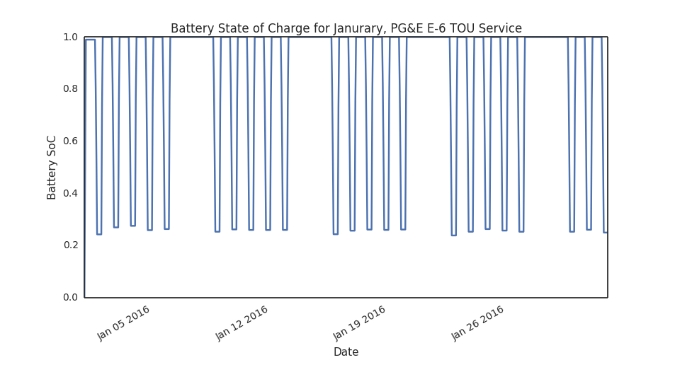

The SoC curve shows 5 cycles per week, where charging happens between 1am and 3am at the max power rating (3.3 kW), and discharging happens at the required power demanded from 5pm to 8pm. The summer month of July shows more battery usage with cycling 7 days a week:

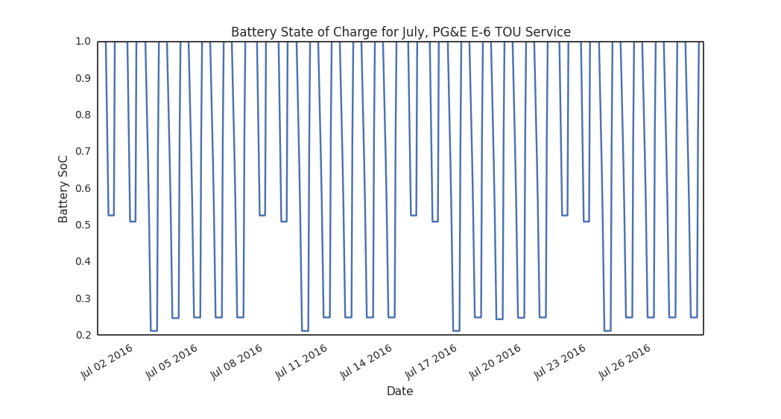

And we can see the battery dispatch for the entire year:

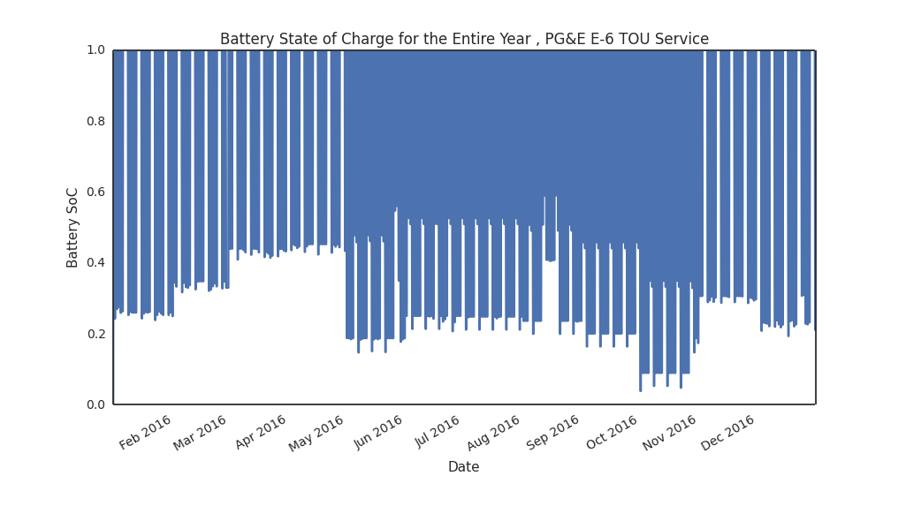

The winter and summer seasons are distinguishable from this plot. The SoC stays above 20% for the majority of the year and only dips below a few times during the early and late summer. We can view energy usage and cost under the TOU plan with a Tesla Powerwall:

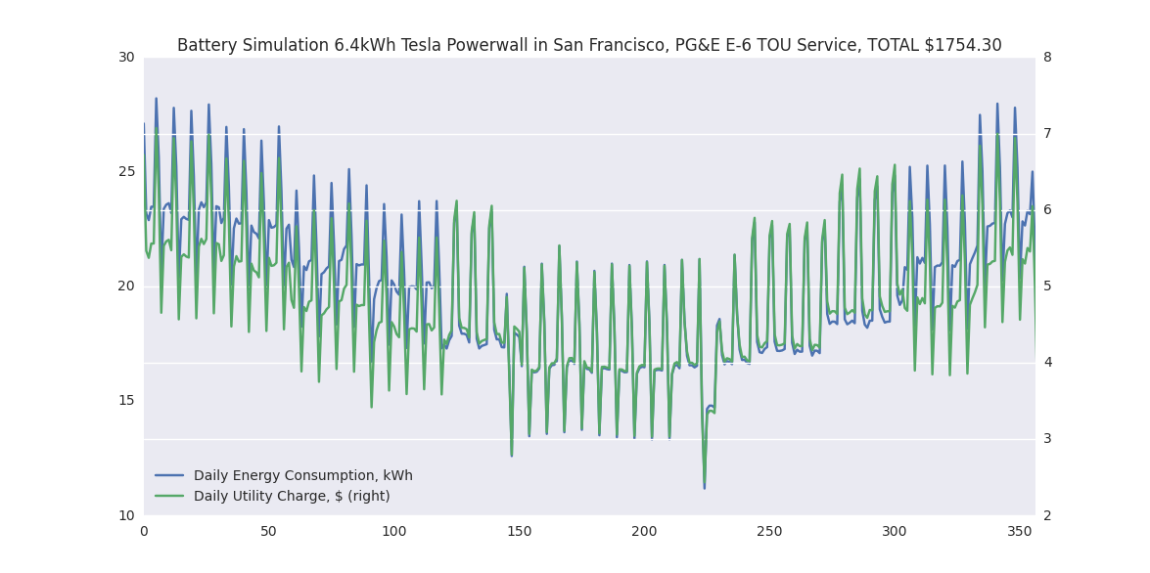

The total annual cost of electricity on the TOU plan with a Powerwall is $1754.30.

**Economics of Residential Battery Storage in San Francisco**

Comparing the TOU daily charges with the battery and without:

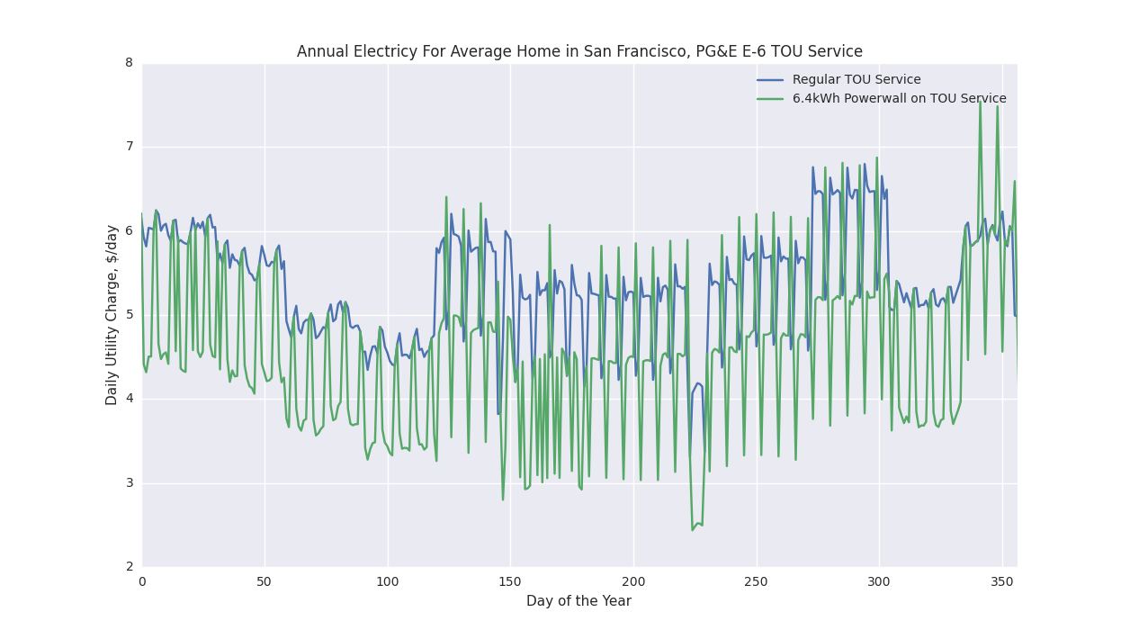

We get a sense of the difference by adding a Powewall in the figure above. It looks like the average homeowner will only save about $1 - $1.50 per day in electricity charges by using the battery during weekdays. To determine whether the project makes financial sense, we can do a net-present value analysis.

The 6.4 kWh Powerwall has a 5000 cycle lifetime. If we assume 1 cycle per day (and 365 cycles per year) that works out to about 13 year lifetime. We’ll assume the battery doesn’t break between installation and end-of-life.

The NPV will forecast out ‘cash flows’ as electricity cost savings each year. The cost savings ‘cash flow’ will be between the tiered rate plan E-1 ($1903.63 cost per year) and the TOU E-6 rate with a Powerwall ($1754.30 cost per year). The savings in the first year from the Powerwall on a TOU plan is $149.33. I’m going to compare the Powerwall model to E-1 cost because E-6 without a Powerwall costs more than E-1 ($1956.93 for E-6 and no Powerwall). Using E-6 would overstate the savings.

Other assumptions include a discount rate of 10%, battery degradation rate of 1% per year, utility price escalation rate of 2% per year, total balance of system equipment cost of $1500 (one-time) and installation costs of $1000 (one-time). The total upfront cost required in year 0 is $5500.

I’m assuming the inverter will outlast the lifetime of the battery. I’m also assuming a control system is built in that will charge and discharge at the appropriate times. I’ve ignored taxes, depreciation and assumed there is no salvage value for any of the equipment after 13 years. The following bar graph shows how the NPV changes over time given the assumptions:

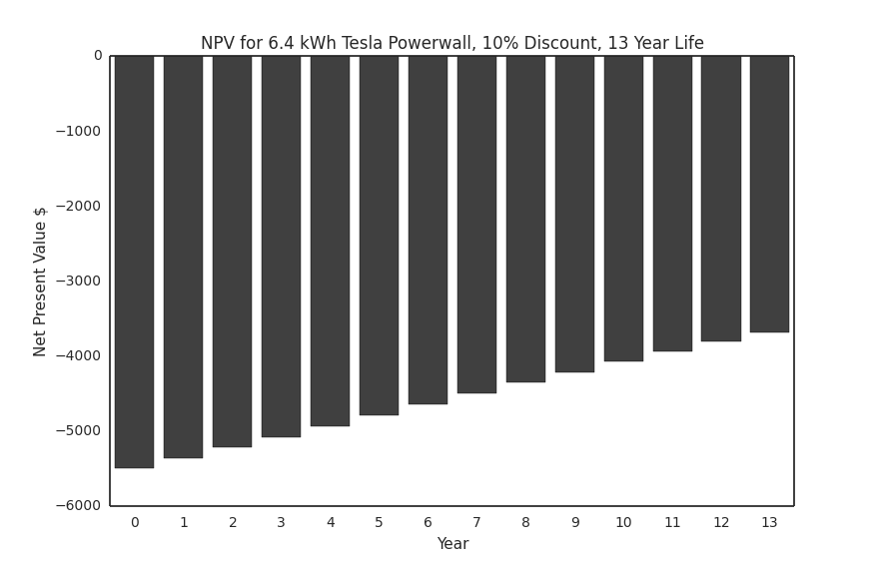

The total NPV at the end-of-life of the battery is -$3687.85. We can play around with the assumptions to see what would bring the NPV positive.

Two key assumptions are the discount rate and utility price escalation rate. A [UC Davis report](http://eec.ucdavis.edu/files/02-06-2014-The-Future-of-Electricity-Prices-in-California-Final-Draft-1.pdf) has shown that under aggressive carbon pricing for GHG emissions we could see utility price escalations upwards of 5%.

Also, the discount rate was assumed the standard 10%. However a [Fraunhofer Institute report](http://bpie.eu/uploads/lib/document/attachment/142/Discount_rates_in_energy_system-discussion_paper_2015_ISI_BPIE.pdf) shows that a viable discount rate for residential appliances in the EU (for energy efficiency applications) is around 6%. Under these modified assumptions we can see a positive NPV:

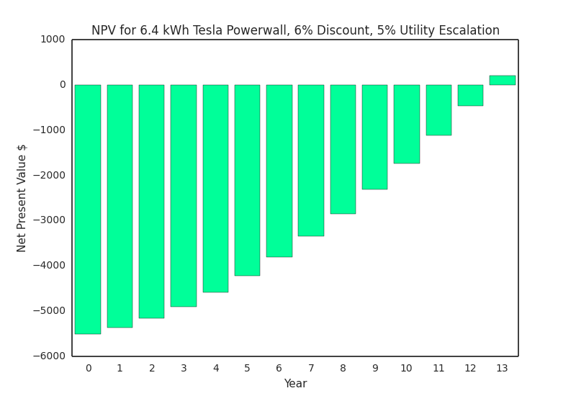

This scenario is highly unlikely however. This assumes an extremely high utility price escalation rate – something unlikely to happen in the immediate future. Under the standard assumptions, the upfront costs for the equipment and installation are simply too great compared to the savings offered by the battery system. Therefore as it stands, installing a 6.4 kWh Tesla Powerwall to shift residential energy consumption on PG&E’s TOU E-6 rate plan is not a financially sound decision to make for the average homeowner in San Francisco.

**Not Economically Viable But…**

There are two key caveats to the conclusion that could help bring the NPV positive. The first is in the form of major incentives, rebates, or tax credits for energy storage. For example, the CPUC (California Public Utilities Commission) mandated a program called the ‘[Self Generation Incentives Program](http://www.pge.com/en/mybusiness/save/solar/sgip.page)’ that would provide $1.46/Watt for battery storage projects. Unfortunately, applications for the SGIP incentive closed on February 23, 2016. This method (subsidies) is not sustainable and offers at best a temporary solution to the high upfront cost required.

The alternative, preferable way to improve the economics of residential battery storage is through creative and progressive utility tariffs which would allow battery systems to provide additional grid services. Additional grid services opens up new opportunities for additional revenue streams for a residential battery system. This is currently being studied by research groups such as the [Rocky Mountain Institute](http://www.rmi.org/electricity_battery_value) and is of great interest to companies in the clean energy space.