 Canary Latch Handbook
Copyright 2015 Antonio Jesús Sánchez Padial
DISCLAIMER
CanaryMod, Minecraft and Latch are property of their respective owners, and the author of this handbook has no relationship at all with them.
Screenshots of those products are shown only with illustrative purpose, and their content belong to their owners.

What is CanaryMod?
CanaryMod is a Minecraft server mod that allows to give support to Plugins.
You can find more information at http://canarymod.net/page/about

What is Latch?
Latch is an amazing service by Eleven Paths (a Telefonica company) that allows service providers to offer an additional security layer to their users, who can block some of the offered services, or their full account using their smartphones.

So, what's CanaryLatch?
CanaryLatch is a plugin that allows players to block their Minecraft account on a CanaryMod server.
The theft of games accounts is a rising trend in the online world, and Minecraft is one of the most known social games on Earth, specially as it's very popular between children and young teenagers.
CanaryLatch can also be used as an additional security layer for Parental Control, although in the present version allows to control only one account per smartphone. Next versions will allow to manage differente accounts.

Dungeon Master's Handbook
Ok, ok, I know that is not the right title, but probably you understood this sections is targeted to Server admins.
I'll supose you have a basic knowledge of your operating systems, just enough to have CanaryMod installed and running. If you need help with these tasks you can refer to CanaryMod rich documentation at http://canarymod.net/books/
You have to be able also to set environmental variables in your system.

Installing CanaryLatch

Step 1. Download jar file
Download last release of CanaryLatch from our github repo at: https://github.com/escueladebits/canary_latch/releases
All you need is the binary canary_latch.jar, but as CanaryLatch is licensed under LGPL v2.1 you'll find there all the sourcecode with complete freedom to use, read, share and modify.

Step 2. Move to CanaryMod plugins folder
All that CanaryMod needs to find the plugin is that you put the downloaded jar file inside Canary's plugins folder.
You did it! CanaryLatch is installed in your CanaryMod server but that's not enough to start using it.

Dependencies

Step 3. Download libraries
CanaryLatch was written in Java, as well as CanaryMod. Don't worry about it because if you're running a CanaryMod server you have Java installed and running on your machine.
Furthermore it needs a short list of libraries (including Latch Java SDK) installed in your system, so you'll have to download them and place them in a library where you have write permissions.
All you need to do is create a libs folder in your system and download there each of the next jar files:
Library | Min version | Download from | File name
Async Http Client | 1.6.3 | http://mvnrepository.com/artifact/com.ning/async-http-client/1.6.3 | async-http-client-1.6.3.jar
Google Gson | 2.3.1 | http://search.maven.org/#artifactdetails|com.google.code.gson|gson|2.3.1|jar | gson-2.3.1.jar
VisualIllusions Utils | 1.3.0 | http://repo.canarymod.net/net/visualillusionsent/viutils/1.3.0/ | viutils-1.3.0.jar
Latch Java SDK | 0.9.0 | https://github.com/ElevenPaths/latch-sdk-java/releases | latch-0.9.0.jar

Step 4. Set CLASSPATH
You have to add all those libraries to your CLASSPATH environmental variables, make sure you add the full path file in it.
You have to add also the CanaryMod jar file to the CLASSPATH.
If you are in doubts to set CLASSPATH in your system, there are several tutorials in the Internet.

CanaryLatch setup

Step 5. Create a Latch account
You'll need a Latch account to offer the service. Just go to https://latch.elevenpaths.com/www/ and registe+r as a developer (even if you're not one).
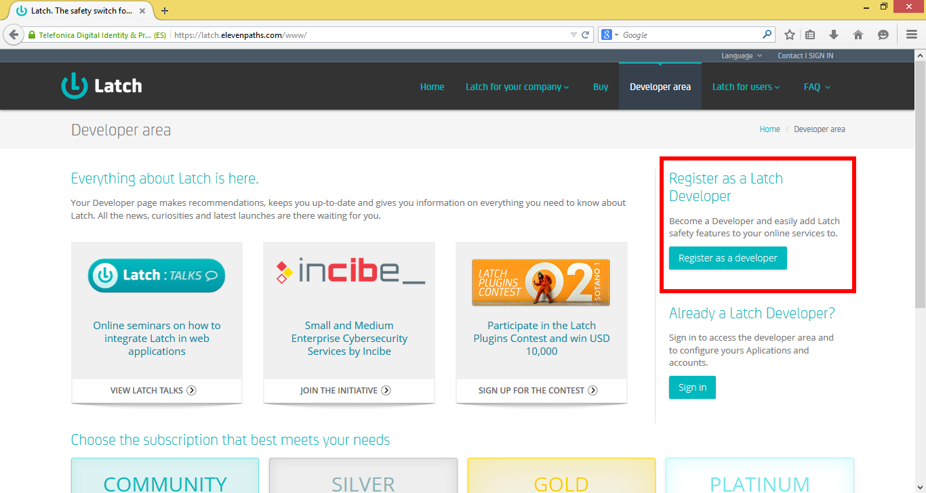
To accomplish the registering process you will have to follow the usual email confirmation process. Make sure your email provider doesn't block communications wit support@latch.elevenpaths.com; global email providers as gmail seem less likely to show this annoying behaviour.

Step 6. Create a new service
Sign in in the latch site using your brand new account. Select My Applications in the left menu and there go to Add a new service.
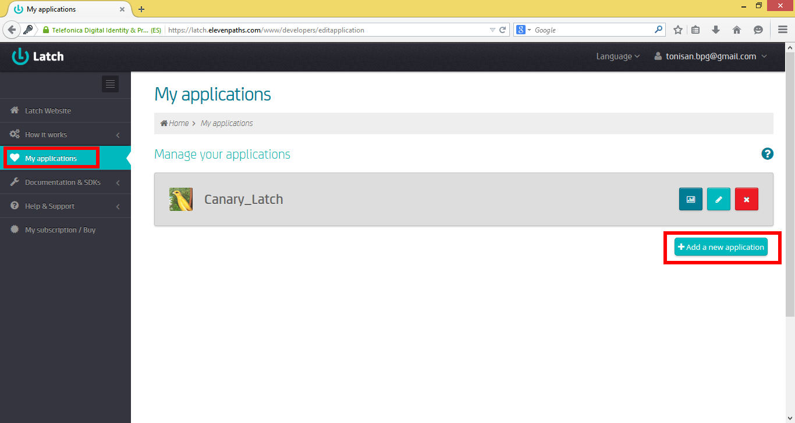
Give a name to the service. Take into account that this name will be used by your players to block/unblock their accounts, so they should be able to identify your server with that name.
Once you name the service you will access its Edit screen. There you can add a picture. Follow the same criteria stated for the name, as the picture will be shown to your players too; and will allow them to identify your CanaryMod server between other Latch services they could be using.
Feel free to use the CanaryLatch logo (find it at https://github.com/escueladebits/canary_latch/blob/master/logoCanaryLatch.png). I'll be glad you do so, but probably your users may not know what it is about.
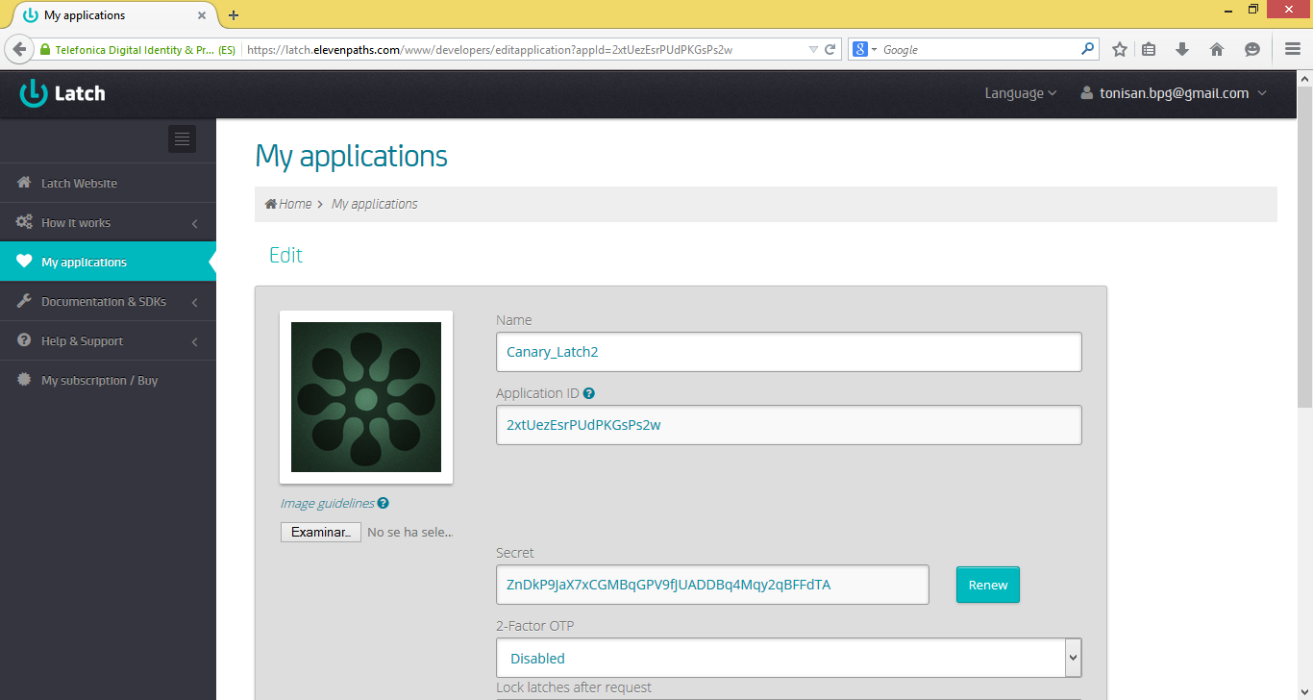
In that screen you will find the application ID and the secret key too. You will use them to setup the CanaryLatch plugin in your server.

CanaryLatch configuration

Step 7. Download and edit config file
Download CanaryLatch config file from https://raw.githubusercontent.com/escueladebits/canary_latch/master/default.CanaryLatch.cfg
Copy it to the config/CanaryLatch folder in your CanaryMod server. Create the folder if it doesn't exist yet. Rename the file to CanaryLatch.cfg. Don't hesitate to overwrite any existing file with that name.
Edit the file with your favourite text editor (did I hear vim?) and remove the <APPLICATION_ID> and <SECRET_KEY> tags. Put the weird chars and numbers strings from the latch application site in their respective places.
That's almost all. You're ready to launch it.

Starting your server
If you use to launch your CanaryMod server running something like java -jar CanaryMod.jar from your command line, because of the way Java treat jar files in your CLASSPATH.
Instead of that launch it using java net.canarymod.Main from the server folder.

Admin Commands
There's only one command available from the server command line.
latch_update
Params: 0
The CanaryLatch plugin connects every few minutes to the latch service asking what players are allowed still to keep playing. Using this command you can force the plugin to connect inmediatly and kick any player whose latch status had changed to off since last update.

Player's Handbook
As a player connecting to a CanaryMod server you can take advantage of CanaryLatch plugin to add a security layer to your account, allowing you to block it when you aren't connected to the server, difficulting thefts and impersonations.
It can also be useful as an extra Parental Control layer. Don't hesitate to contact your server admin if you are interested in this service.

Create a Latch account
You'll need a Latch account to access to any service using latch. You can create your account at https://latch.elevenpaths.com/www/register following the easy and detailed steps the Latch team provide there.

Install Latch
Now you need the Latch App in your smartphone, download and install from your favourite platform app market.
Once it is installed, you will have to sign in using your Latch account

Pairing your Minecraft account
To start modifying the status of your CanaryMod account using your Latch app in your smartphone you have to follow the next steps:
- Connect to your CanaryMod server starting Minecraft using the account you want to pair with Latch.
- Open the Latch app in your smartphone and select Add new service.
- The smartphone will show you a password, we call it the latch token.
- Back to your Minecraft session, run /latch_pair <token> in the chat.
- In a few seconds the new service will appear in your phone. You're ready to block/unblock your CanaryMod account it using it.

Blocking/unblocking the account
You can block/unblock your account using the small keylock icon next to the Canary server service in your smartphone.
Once it's blocked you (or anyother) won't be able to connect to the server until the keylock is open.
If you block the account while someone is playing, she will be able to keep playing until the system status is updated. By default this happen every few minutes, though it can be forced to happen inmediatly using the /latch_update command.

Player Commands
/latch_pair
Params: 1
The CanaryLatch plugin connects every few minutes to the latch service asking what players are allowed still to keep playing. Using this command you can force the plugin to connect inmediatly and kick any player whose latch status had changed to off since last update.
/latch_unpair
Params: 0
The CanaryLatch plugin connects every few minutes to the latch service asking what players are allowed still to keep playing. Using this command you can force the plugin to connect inmediatly and kick any player whose latch status had changed to off since last update.
/latch_update
Params: 0
The CanaryLatch plugin connects every few minutes to the latch service asking what players are allowed still to keep playing. Using this command you can force the plugin to connect inmediatly and kick any player whose latch status had changed to off since last update.

