Paper zero: Emily code

Emily Darling

July 27, 2015

This is an R Markdown document. Markdown is a simple formatting syntax for authoring HTML, PDF, and MS Word documents. For more details on using R Markdown see <http://rmarkdown.rstudio.com>.

This code plots the parameter estimates for the top models predicting bleaching probablity from historical environmental variables. Lines indicator 95% confidence intervals; filled circles represent variables with 95% confidence intervals that do not cross zero (dashed line).

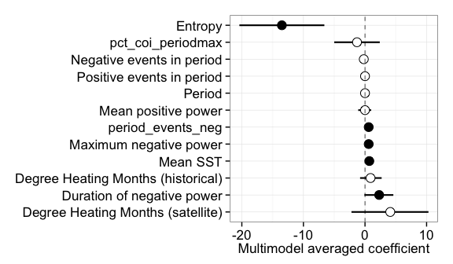

You can also embed plots, for example:

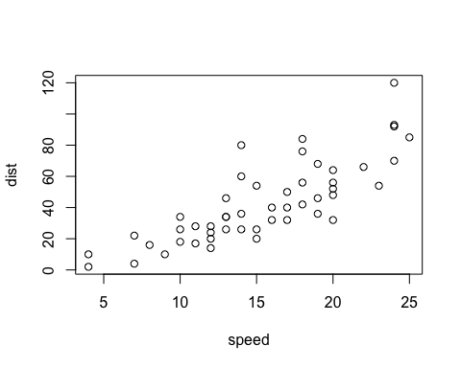

Note that the echo = FALSE parameter was added to the code chunk to prevent printing of the R code that generated the plot.