ESDC Fortify SCA 18.20 Install Guide

IT Security Engineering

Enterprise Operations

Version: 0.2

Date: 25/09/2019

|  |  |  |  |
| --- | --- | --- | --- |
| Version | Report Date | Author | Description |
| 0.1 | 04/09/2019 | Jordan Hoskins | Draft |
| 0.2 | 25/09/2019 | Jordan Hoskins | Update |

Table of Contents

Fortify SCA Installation 4

Get Software 4

Install Wizard 4

Installing Certificates for SCA Plugins (needed to connect to Fortify SSC) 6

# Fortify SCA Installation

## Get Software

* 1. Access \\hrdc-drhc.net\nc_common-commun$\IITB-DGIIT\TSD-DST\AE-AI\ITS-STI\ITSPF-CPSTI\ITS\IT Security Tools\Micro Focus\Fortify

Note: If you do not have access please let [Jordan.hoskins@hrsdc-rhdcc.gc.ca](mailto:Jordan.hoskins@hrsdc-rhdcc.gc.ca) know.

* 1. Navigate to \Fortify(SCA) Static Code Analyzer – software
  2. Locate Fortify_SCA_and_Apps_18.20_Windows.zip
  3. Extract to a location of your choice in C:
  4. Navigate to extraction folder. Run Fortify_SCA_and_Apps_18.20_windows_x64.exe

## Install Wizard

1. Click Next.
2. Accept License Agreement
3. Choose installation Dir – Default should be ok (remember it – will need it later)
4. Select Components:
   1. 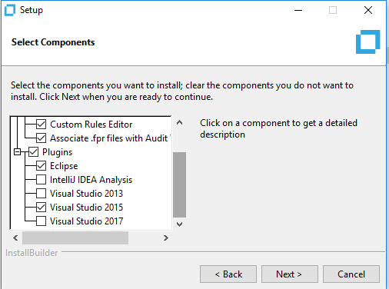
5. Choose Plugins for your environment.
6. Select Path to License folder (Provided by ITSEC)
7. Server Settings:
   1. 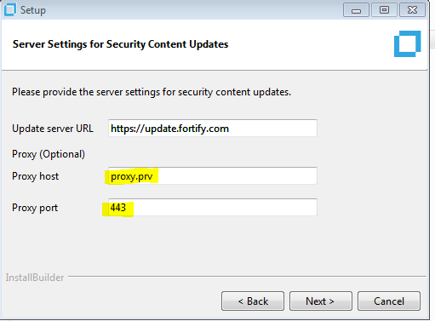
8. SCA Migration – Select NO.
9. (Optional) You can install sample projects if you wish.
10. Click Next to Install
11. Once Installation is Complete – Check “Update security content after installation”
    1. 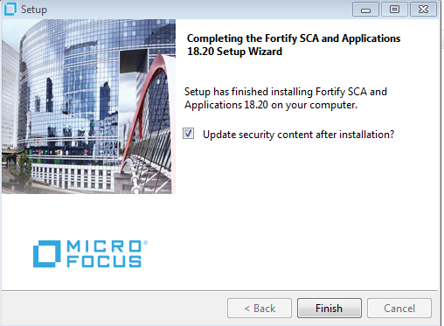

## Installing Certificates for SCA Plugins (needed to connect to Fortify SSC)

1. Go to IE and open <https://mlapesd4289.hrdc-drhc.net:8443/ssc/login.jsp#!/>
2. Install the self-signed certificate (if you havent already), save it as a trusted root certification authorities
3. Go to >Internet Options > Content > certificates
4. Navigate to Trusted Root Certification Authorities tab
5. Find the newly installed certificate – will be named MLAPESD4289.hrdc-drhc.net
6. Click and export to a location of your choice (remember this location)
7. Open cmd as administrator
8. Run these commands:
   1. cd "<*sca_install_dir*>\jre\bin"
      1. *where <sca_install_dir> is where the fortify sca is installed. Ex: C:\Fortify\Fortify_sca_18.20\...*
   2. keytool -import -alias SSC -keystore ..\lib\security\cacerts –file "YourCertFile.cer" –trustcacerts
      1. *where “YourCertFile.cer” is the one exported from IE*
      2. *default password for store is “changeit”*
   3. cd “<java 1.8 install dir>\bin”
      1. example: mine is C:\Program Files\Java\jre8\bin OR whichever one Eclipse is using.
   4. keytool -import -alias SSC -keystore ..\lib\security\cacerts –file "YourCertFile.cer"-trustcacerts
      1. *where “YourCertFile.cer” is the one exported from IE*
      2. *default password for store is “changeit”*