SATHEE FEATURE ANALYSIS
Feature Intelligence Document for JNV and Sainik School AI Tutor Planning
Purpose
This document lists the important SATHEE product features identified from extracted screenshots. The focus is feature understanding, not competitor benchmarking or startup strategy.

1. SATHEE Overview
SATHEE is a preparation platform that combines learning resources, mock tests, analytics, and guided study support. The most useful product ideas for a JNV/Sainik platform are its analytics, mock feedback, topic diagnosis, guided learning, and progress tracking features.

2. Key SATHEE Features Identified
SATHEE Feature | Primary Use | JNV/Sainik Relevance
Performance Dashboard | Progress visibility | Student and parent reporting
Weakness Analysis | Improvement targeting | Weak-topic practice
Topic Analysis | Granular diagnosis | Adaptive revision
Mock Analysis | Post-test feedback | Readiness tracking
Guided Mode | Structured learning path | Younger student discipline
Quiz System | Daily practice | Concept reinforcement
Study Planning | Preparation organization | Exam-date planning

3. Feature-by-Feature Breakdown

Performance Dashboard
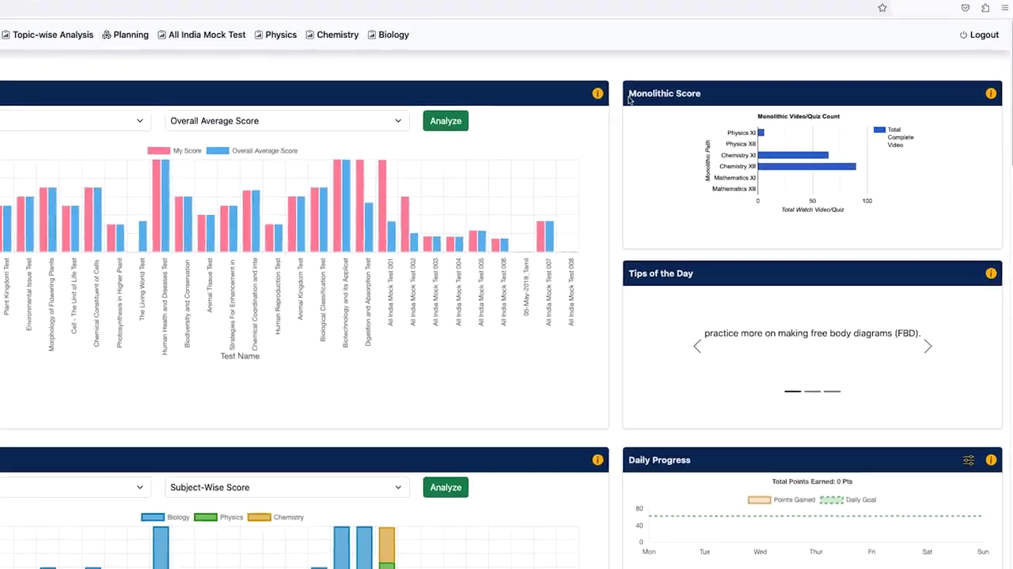 | What it does  - Shows student progress and learning activity  - Displays score movement and performance indicators  - Brings key learning metrics into one view  - Helps students understand preparation status quickly  Can be useful for JNV/Sainik  - JNV/Sainik student dashboard  - Parent progress reporting  - Daily preparation tracking

Weakness and Strength Analysis
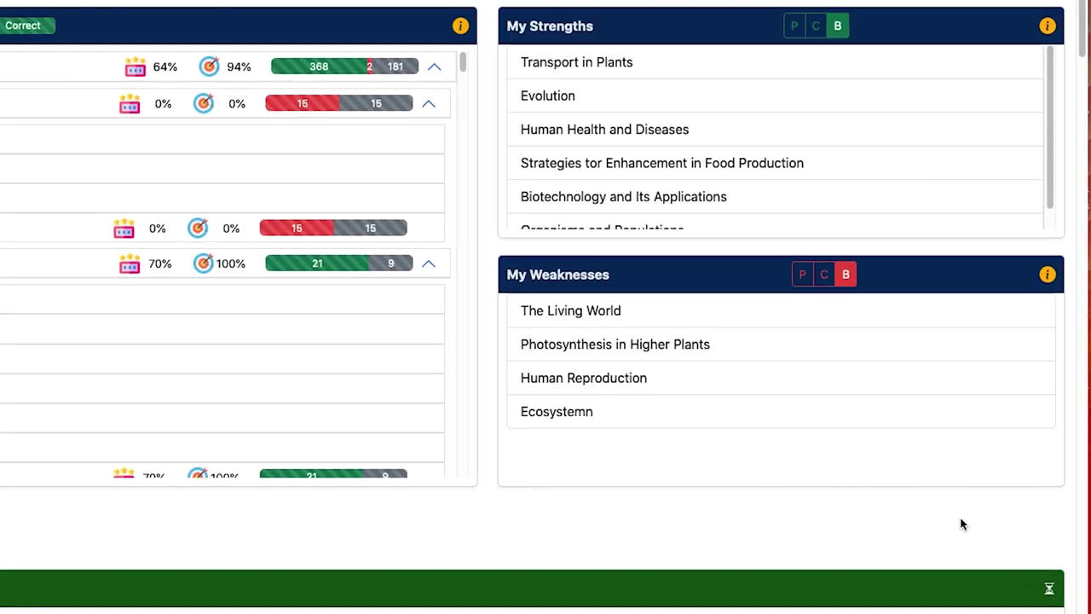 | What it does  - Identifies weak and strong learning areas  - Converts attempt data into improvement signals  - Helps students focus on topics needing attention  - Supports targeted revision instead of random practice  Can be useful for JNV/Sainik  - Weak-area tracking  - Personalized practice sets  - Student improvement reports

Topic-Wise Analysis
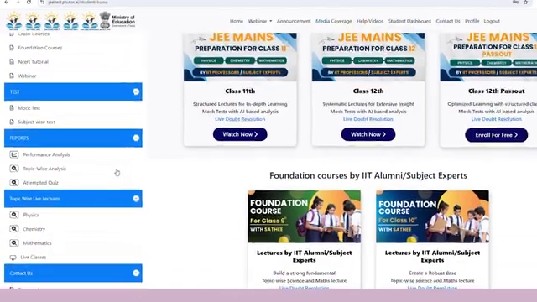 | What it does  - Breaks performance down by topic  - Highlights topic-level score and accuracy  - Supports focused revision planning  - Makes syllabus gaps easier to identify  Can be useful for JNV/Sainik  - Adaptive practice engine  - Smart revision planning  - Chapter/topic mastery tracking

Subject-Wise Mock System
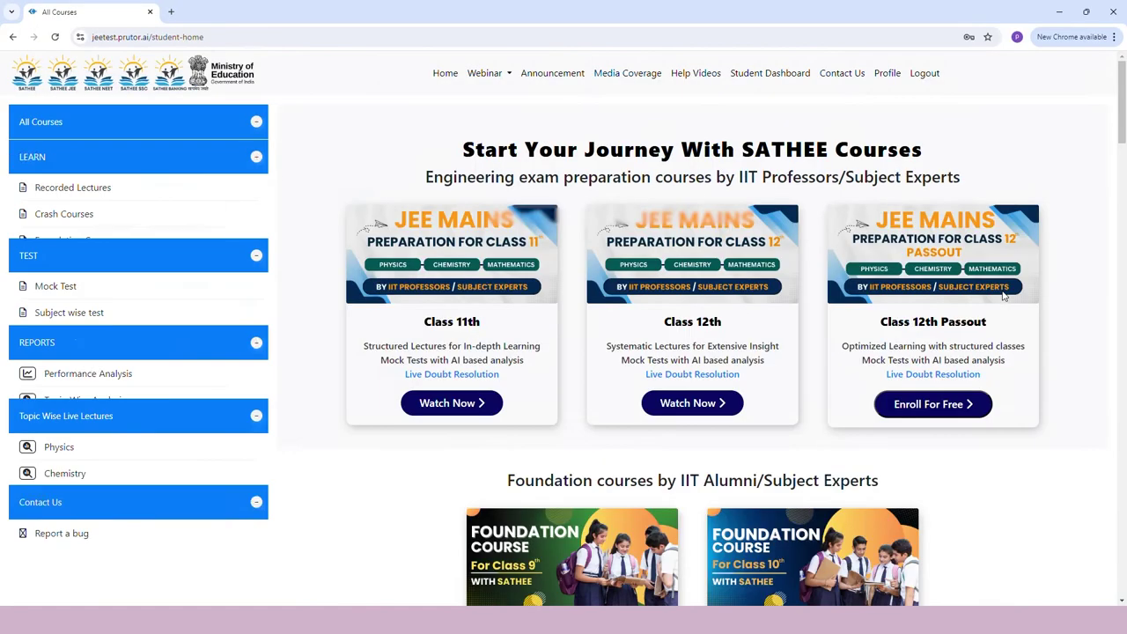 | What it does  - Organizes tests by subject  - Shows subject-level performance differences  - Helps students isolate weak subjects  - Supports sectional preparation  Can be useful for JNV/Sainik  - Math, Reasoning, Language, GK analysis  - Section-wise mock tests  - Subject-specific improvement plans

Guided Learning Mode
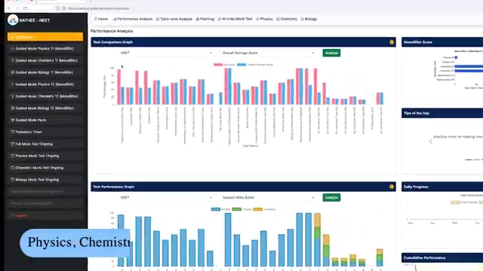 | What it does  - Provides a structured learning flow  - Guides students step by step  - Reduces confusion about what to study next  - Creates a more disciplined study experience  Can be useful for JNV/Sainik  - Younger JNV/Sainik aspirants  - Daily guided preparation path  - Low-supervision self-study model

Mock Test Analysis
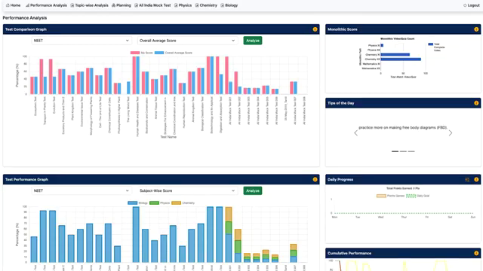 | What it does  - Analyzes performance after mock tests  - Shows score, accuracy, and attempt quality  - Helps students understand mistakes  - Turns mocks into improvement feedback  Can be useful for JNV/Sainik  - JNV/Sainik full mock reports  - Readiness score after each mock  - Mistake-based practice recommendations

Quiz System
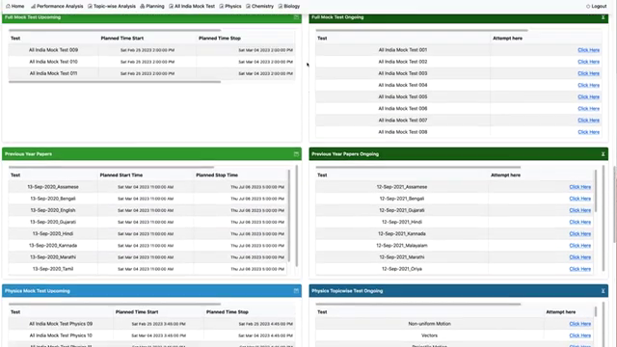 | What it does  - Provides short practice-based assessments  - Allows quick checking of understanding  - Supports repeated low-friction practice  - Can be used for topic or concept revision  Can be useful for JNV/Sainik  - Daily quiz habit  - Concept revision  - Micro-practice before full mocks

Daily Progress Tracking
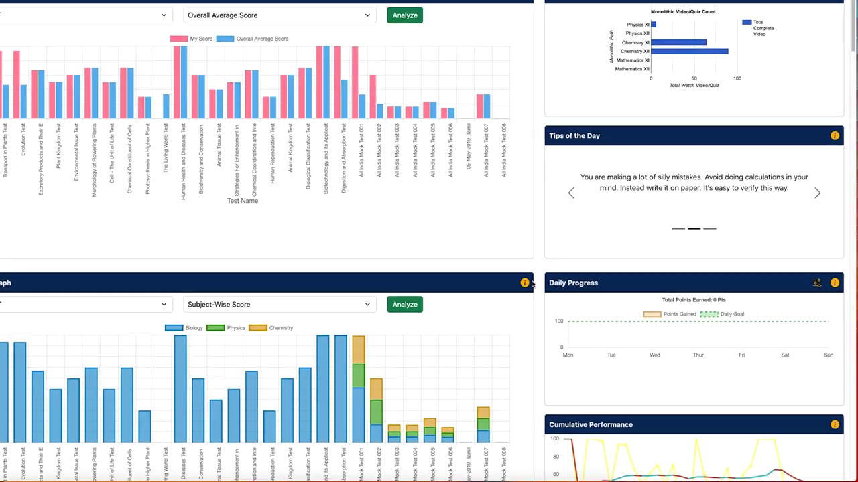 | What it does  - Tracks day-to-day learning activity  - Shows consistency and completed tasks  - Encourages repeat usage  - Makes preparation progress visible  Can be useful for JNV/Sainik  - Student streaks  - Parent-facing weekly reports  - Daily study goals

Personalized Study Planning
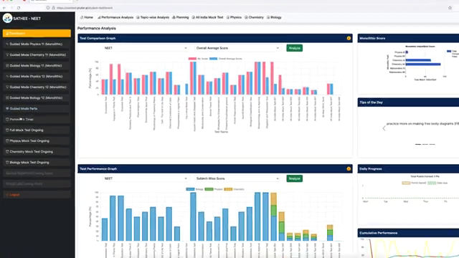 | What it does  - Helps organize study activity  - Supports planned preparation instead of ad hoc practice  - Can connect weak areas with next study tasks  - Improves preparation discipline  Can be useful for JNV/Sainik  - JNV/Sainik study calendar  - Weak-topic based planning  - Exam-date preparation schedule

Performance Comparison
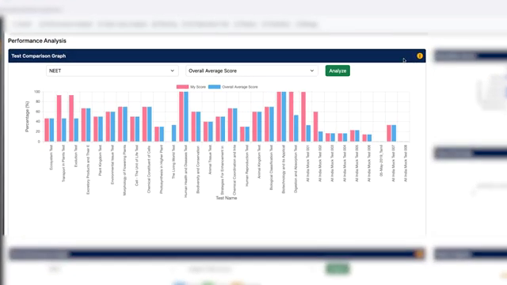 | What it does  - Compares student performance against others  - Creates benchmark awareness  - Helps students understand relative standing  - Can motivate improvement through peer comparison  Can be useful for JNV/Sainik  - Rank band system  - Peer comparison after mocks  - Preparation competitiveness indicator

Live Session Interface
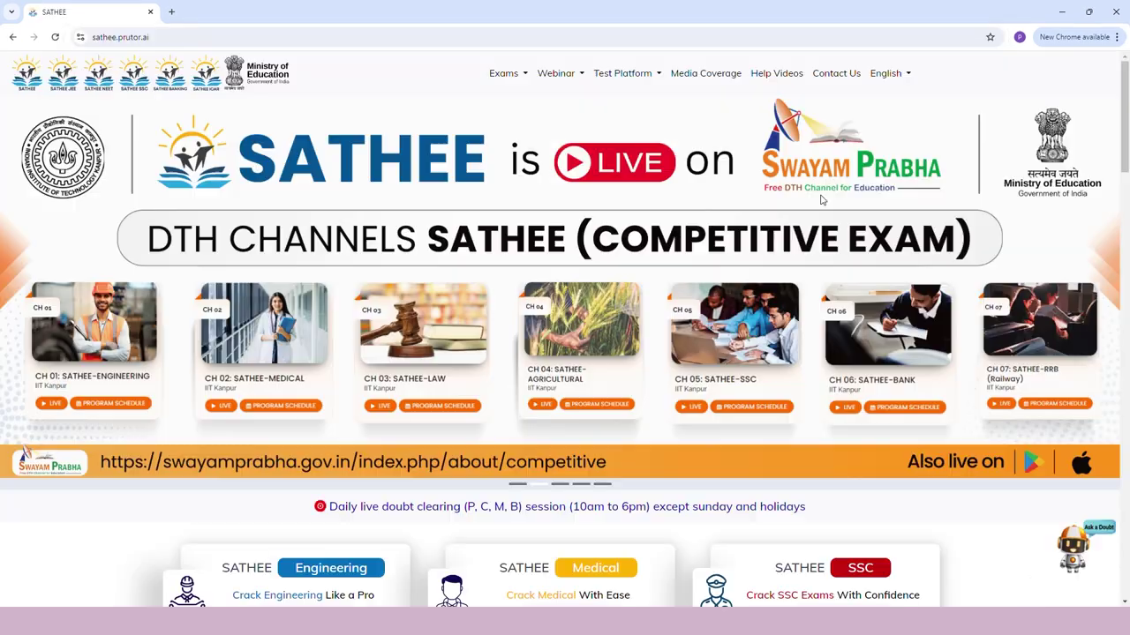 | What it does  - Shows live or scheduled learning sessions  - Supports expert-led interaction  - Can help students access guided explanations  - Useful for doubt-clearing or special sessions  Can be useful for JNV/Sainik  - Optional doubt sessions  - Exam strategy webinars  - Recorded mentor support later

4. Short Product Takeaway
The strongest SATHEE patterns for JNV/Sainik use are: mock-based diagnosis, weak-area tracking, topic-wise revision, guided study flow, and parent-visible progress. These features are practical, explainable, and directly linked to student improvement.

