GAME

(**Gestures Animated Motion Entertainment**)

*Desire. Experience. Rejoice.*

***Concept:***

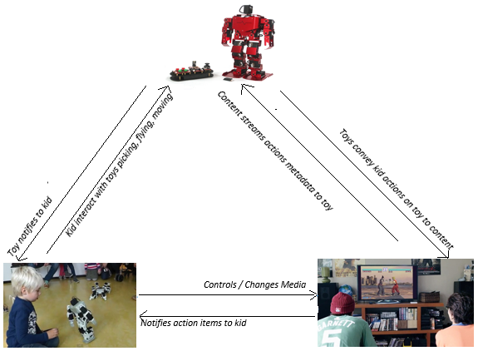

***(Closed Loop Ecosystem)***

*Architecture :*

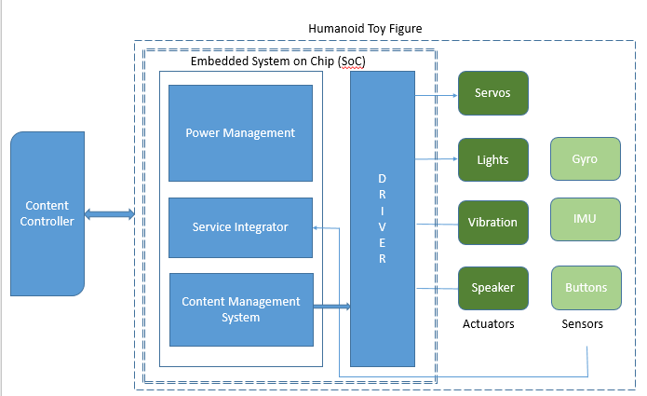

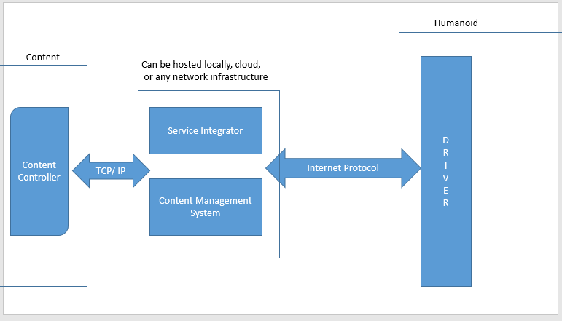

**Deliverables:**

**Baseline 1**:    Design the complete blueprint of the system on paper. Identify the key components required. Divide the system into hardware and software components and identify the features to be implemented

**Baseline 2**:  Set up a communication medium between the hardware and software. Process a media file to accumulate content reactive data. Make the hardware components respond to different inputs.

**Baseline 3:**  Test the system till this step on a raw scale

**Reach Goals** –

**Reach 1:**   Design and build a body enclosure for the hardware in the form of humanoid toy figure.

**Reach 2:**  Embed the hardware into the built body to form a prototype of the humanoid

**Reach 3:**   Visual experience of complete system with media file and hardware on the humanoid.

Baseline goals are to develop a system consisting of software and hardware at a breadboard /crude level. Reach goals are to make the system as explained in **motivation** and **goal** sections of this document which is the significant step in bringing out a complete product.

**Relations / Features**

|  |  |  |  |
| --- | --- | --- | --- |
| **Relation** | **Feature** | **Status** | **Baseline / Reach** |
| 1. Content -> Toy | * Streams metadata for imitation | Done | Baseline |
| 1. Child -> Toy | * Responds by lifting / flying /pressing | Done | Baseline |
| 1. Child -> Content | * Changes Content | Done | Baseline |
| 1. Content -> Child | * Notifies child to do action on toy | Done | Baseline |
| 1. Toy -> Content | * Sends child’s control action to controller | In Progress | Reach |
| 1. Toy -> Child | * Vibrates / request for interaction | In Progress | Reach |
| 1. Additional Feature | * Add more interaction interfaces | In Progress | Reach |
| 1. Additional Feature | * Add movement of toy by wheels | In Progress | Reach |

***Team :***

SSZ

Stuart Helgeson

Sarath Vadakkepat

Zairah Sahaf