**ESE 5190: Lab 1**

Description and working of the embedded system:

The sensor APDS-9960 keeps on looking for an object to come in its proximity. As soon as the sensor detects the proximity, it sends a signal to the microcontroller to inform about the proximity detection. On proximity detection, the microcontroller then rolls dice i.e. generates random values between 1 and 6 using random. randint() function. Microcontroller displays this value on the screen by typing it, to keep log of all values. The microcontroller waits for the detection of proximity i.e. it’s not going to count it as more than 1 roll request even if we place our hands nears the sensor for long time. For example, if we keep our hand near sensor for say 10 seconds or even more, it’s going to count it as a single input and will roll out dice only once. To roll the dice, we need to place our hands near the sensor every time we want to roll the dice.

Picture of the embedded system:

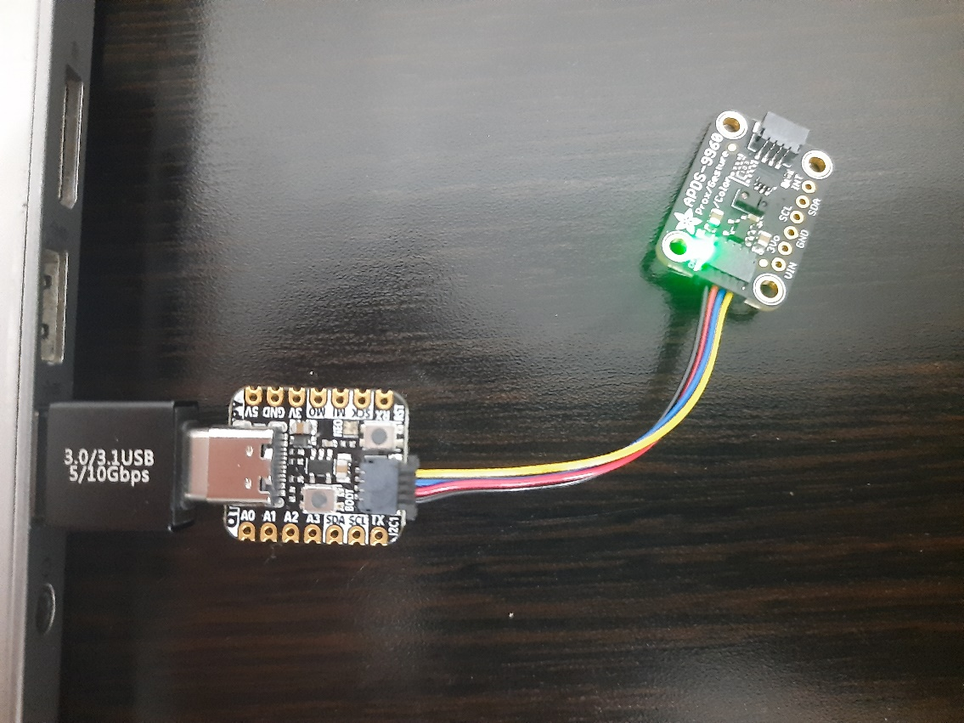

Flow diagram of the embedded system:

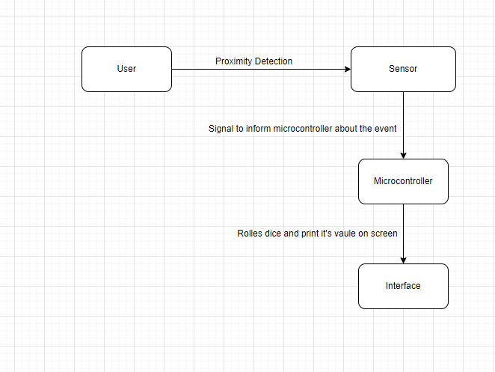

Output on CircuitPython REPL:

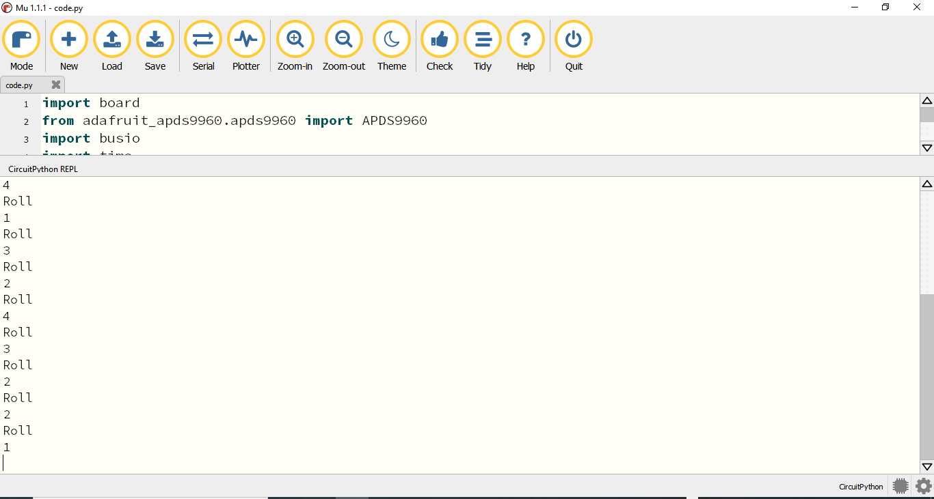

Dice value printed on the screen as log:

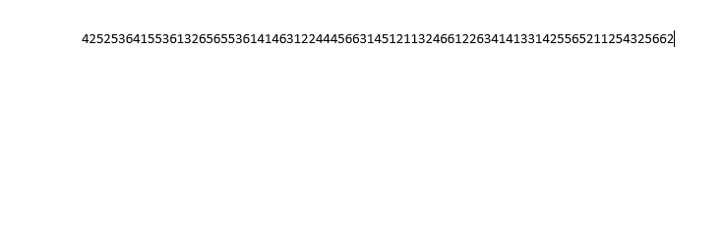

*Note: The sensor values are collected in real-time. The system waits for the user to move the obstacle to avoid rolling the dice multiple time in 1 go.*