Configuration 1

Configuration 1 was about running scenario 1 with 10 users and scenario 2 with 2 users. The follwing graphs show the resulting times the ’server’ needed to response:
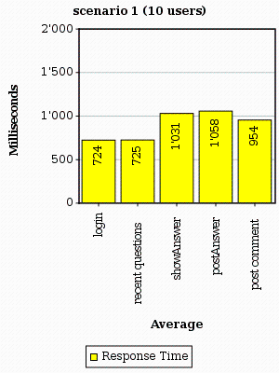
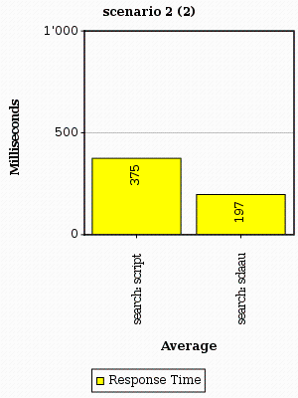

Note that there didn't occur any errors while running configuration 1.

Configuration 2

Configuration 2 was about running scenario 1 with 100 users and scenario 2 with 20 users. You can see the charts below:
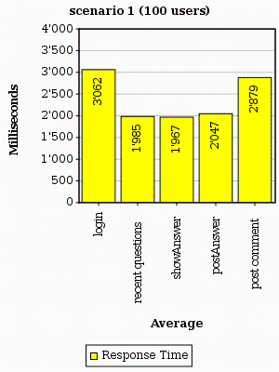
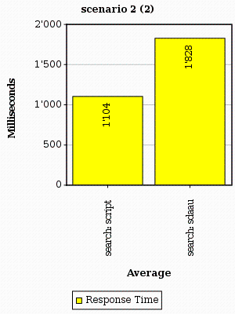

In this second scenario, there were many errors in all the different tasks because the server wasn't able to handle all requests. jMeter described the error as following:

Response code: Non HTTP response code: java.net.SocketTimeoutException
Response message: Non HTTP response message: Read timed out

Summary

As we've seen during the usability tests earlier in the lecture that our application has been very (very very) slow, we thought about possibilities to speed up the system. One approach was to replace the ArrayLists in which we've stored all users and posts up until then. Those are now replaced by HashMaps. The benefit of this change was huge. Another change we've introduced to improve the speed of our knowledge base was to show similar questions (at the bottom of each question page) just on demand as the search engine took some time to look for these posts.

As a consequence of the results above, we should introduce other improvements to speed up the application. One them could be to cache posts in order to reduce the time needed to load the questions, their answers and their comments.

