**Project Requirements**

**Project Name: Mensa@Unibe**

**Team: 7 –** Jan Binzegger, Marc Dojtschinov, Andreas Hohler, Sàndor Török

**Customer: Bledar Aga**

Revision History

| **Version** | **Date** | **Revision Description** |
| --- | --- | --- |
| .01 | 26.09.2013 | Initial documentation |
| .02 |  |  |
| .. |  |  |
| 1.0 |  |  |
|  |  |  |
|  |  |  |

Date: September 25, 2013

# Introduction

## Purpose

The mensa application has the purpose to serve as a portable and quick accessible menu list with additional features on most Android devices.

It will provide a rating system which will enable users to share there opinion about the daily meal. This will ensure a pleasant lunchtime with a good meal.

Also it will be possible to share the menu trough existing social media as WhatsApp or Facebook. With that you can show your friends, what you recommend to eat that day.

Another purpose is the fast reachability of the nearest mensa when hungry, which will be fulfilled with by including GPS tracking.

## Stakeholders

Our Stakeholders are Android using students from the University of Bern (16'000 Students 2012, Average 75% Android users, 5% having no mobile phone => circa 11'400 potential Users), the different mensas of Bern (10 mensas, 7 of them serve menus) and the customer himself.

## Definitions

Definitions

## System overview

Content

1.Introduction 3

1.1Purpose 3

1.2Stakeholders 3

1.3Definitions 3

1.4System overview 3

1.5References 3

2Overall description 4

2.1Use cases 4

2.1.1First case 4

2.1.2Second case 4

2.2Actor characteristics 4

3Specific requirements 5

3.1Functional requirements 5

3.2Non-functional requirements 5

2.Diagram 6

3.Use cases 7

## References

We will refer to the https://github.com/lexruee/Mensa-Unibe-Webservice for our menu data.

We will be using the ActionBarSherlock http://actionbarsherlock.com/ to provide compatibility for earlier versions of Android.

# Overall description

## Use cases

[Diagram for use cases] (draw it with draw.io, we do it after all the use cases were described!)

### First case

First case

### Second case

Second case

## Actor characteristics

Actor characteristics

# Specific requirements

## Functional requirements

Functional requirements

## Non-functional requirements

Non-functional requirements

# Diagram

Draw a diagram that shows how your use cases are related to each other.

We recommend using the following authoring tool: www.draw.io

***EXAMPLE***

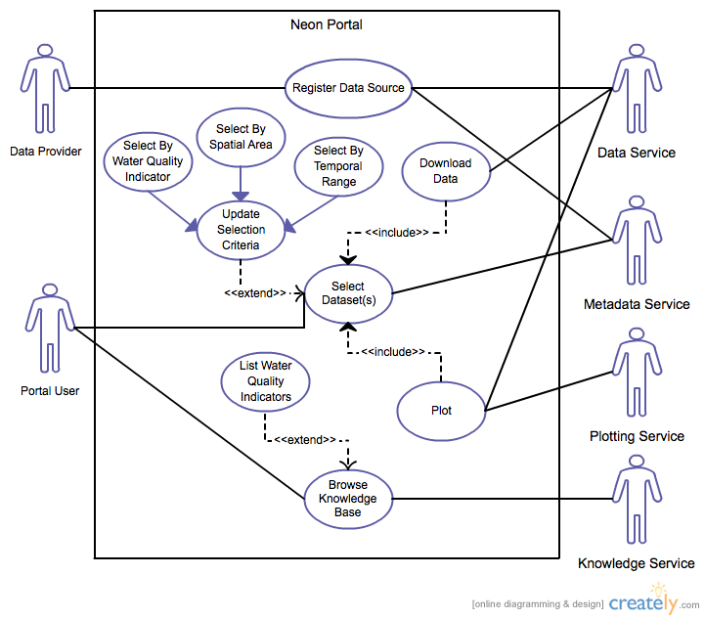

# Use cases

***EXAMPLE***

1. **Withdraw Cash** (Enter a short name for the Use Case using an active verb phrase)
   1. **Actors**

Customer

[An actor is a person or other entity external to the software system being specified who interacts with the system and performs use cases to accomplish tasks. Different actors often correspond to different user classes, or roles, identified from the customer community that will use the product. Name the actor that will be initiating this use case (primary) and any other actors who will participate in completing the use case (secondary).]

* 1. **Description**

As a customer I want to withdraw money from my account.

[Provide a brief description of the reason for and outcome of this use case.

Format: As a [user role] I want to [goal] (so I can [reason])]

* 1. **Trigger**

Customer inserts ATM card.

[Identify the event that initiates the use case. This could be an external business event or system event that causes the use case to begin, or it could be the first step in the normal flow.]

* 1. **Pre-conditions**
     1. Customer has active deposit account with ATM privileges
     2. Customer has an activated ATM card

[List any activities that must take place, or any conditions that must be true, before the use case can be started. Number each pre-condition.]

* 1. **Post-conditions**

1. Customer receives cash
2. Customer account balance is reduced by the amount of the withdrawal and transaction fees

[Describe the state of the system at the conclusion of the use case execution. Should include both *minimal guarantees* (what must happen even if the actor’s goal is not achieved) and the *success guarantees* (what happens when the actor’s goal is achieved. Number each post-condition.]

* 1. **Main Scenario**

1. Customer inserts ATM card
2. Customer enters PIN
3. System prompts customer to enter language performance English or Spanish
4. System validates if customer is in the bank network
5. System prompts user to select transaction type
6. Customer selects Withdrawal From Checking
7. System prompts user to enter withdrawal amount
8. …
9. System ejects ATM card

[Provide a detailed description of the user actions and system responses that will take place during execution of the use case under **normal, expected** conditions. This dialog sequence will ultimately lead to accomplishing the goal stated in the use case name and description.]

* 1. **Alternative Scenarios**

4a. Customer is not in the bank network

1. System will prompt customer to accept network fee
2. Customer accepts
3. Use Case resumes on step 5

4b. Customer is not in the bank network

1. System will prompt customer to accept network fee
2. Customer declines
3. Transaction is terminated
4. Use Case resumes on step 9 of normal flow

[Document branches from the main flow to handle special conditions (also known as extensions). For each alternative flow reference the branching step number of the normal flow and the condition which must be true in order for this extension to be executed.]

* 1. **Special Requirements**

User validation (step 4) cannot take more then 30 seconds.

[Identify any additional requirements, such as nonfunctional requirements, for the use case that may need to be addressed during design or implementation. These may include performance requirements or other quality attributes.]

* 1. **Notes**
     1. What is the maximum size of the PIN that a use can have?

[List any additional comments about this use case or any remaining open issues or TBDs (To Be Determined) that must be resolved.]