**Project Requirements**

**Project Name: Mensa@Unibe**

**Team: 7 –** Jan Binzegger, Marc Dojtschinov, Andreas Hohler, Sàndor Török

**Customer: Bledar Aga**

Revision History

| **Version** | **Date** | **Revision Description** |
| --- | --- | --- |
| .01 | 26.09.2013 | Initial documentation |
| .02 |  |  |
| .. |  |  |
| 1.0 |  |  |
|  |  |  |
|  |  |  |

Date: September 26, 2013

# Introduction

## Purpose

Purpose

## Stakeholders

Stakeholders

## Definitions

Definitions

## System overview

Content

1. Introduction 2

1.1 Purpose 2

1.2 Stakeholders 2

1.3 Definitions 2

1.4 System overview 2

1.5 References 2

2 Overall description 3

2.1 Use cases 3

2.1.1 First case 3

2.1.2 Second case 3

2.2 Actor characteristics 3

3 Specific requirements 4

3.1 Functional requirements 4

3.2 Non-functional requirements 4

2. Diagram 5

3. Use cases 6

## References

References

# Overall description

## Use cases

[Diagram for use cases] (draw it with draw.io, we do it after all the use cases were described!)

### First case

First case

### Second case

Second case

## Actor characteristics

Actor characteristics

# Specific requirements

## Functional requirements

### Client

* Overview of mensa

After Starting a List of Mensas need to be provided.

* Details about menu of current day

After a Click on a specific Mensa you should see the Menu of the day and be able to switch on an upcoming day.

* Find closest mensa

Provide a Feature to find the closest Mensa.

* Way of reach a given Mensa

Provide a Feature to find a specific Mensa.

* Favorite mensa

Provide a possibility to mark a Mensa as favorite and make sure there is quick access to it.

* Get notified if menu matches some criteria in my favorite mensa
* Read English translation of a menu

Provide a translation to the German Mensa.

* Set user name

You should be able to have a nickname.

* Choose friends

A feature to add /delete Friends.

* Notifications

Implement Notifications for invitations/messages from friends and favorite Menus. Doing so also implement an option to disable specific notifications.

* Mark Mensa where the user plans to go for lunch

A way of marking a Mensa at a given time. And notification if a friend will be there at the same time.

* Rate a Menu

Implement a Rating System (Stars) and Comments.

* The Weekly Menu of all Mensa have to available offline after the first synchronization process with the server after a new weekly menu was uploaded.

### Server

* Provide up to date information about all mensas including menus, location
* (Provide a user Database )

## Non-functional requirements

Product Requirements:

* Novice User should be able to learn the app navigation within minutes.
* Client Server Communication need to work properly and available provided 24 hours 7 days a week. The only Exception is scheduled server maintenance.
* The storage used on the smartphone should be kept under 10 MB in the alpha version (if more feature will be added this amount can increase)
* The Application need to run stable on all Android devices with Jelly Bean (4.1or higher).

Implementation Requirements:

# Diagram

Draw a diagram that shows how your use cases are related to each other.

We recommend using the following authoring tool: www.draw.io

***EXAMPLE***

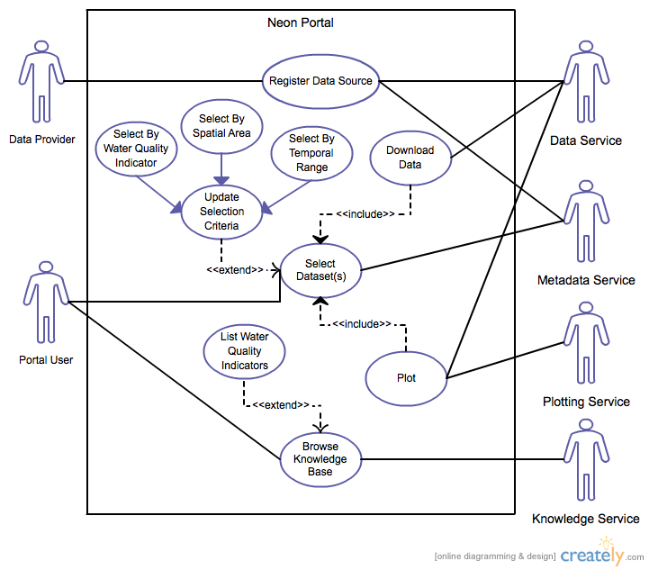

# Use cases

***EXAMPLE***

1. **Withdraw Cash** (Enter a short name for the Use Case using an active verb phrase)
   1. **Actors**

Customer

[An actor is a person or other entity external to the software system being specified who interacts with the system and performs use cases to accomplish tasks. Different actors often correspond to different user classes, or roles, identified from the customer community that will use the product. Name the actor that will be initiating this use case (primary) and any other actors who will participate in completing the use case (secondary).]

* 1. **Description**

As a customer I want to withdraw money from my account.

[Provide a brief description of the reason for and outcome of this use case.

Format: As a [user role] I want to [goal] (so I can [reason])]

* 1. **Trigger**

Customer inserts ATM card.

[Identify the event that initiates the use case. This could be an external business event or system event that causes the use case to begin, or it could be the first step in the normal flow.]

* 1. **Pre-conditions**
     1. Customer has active deposit account with ATM privileges
     2. Customer has an activated ATM card

[List any activities that must take place, or any conditions that must be true, before the use case can be started. Number each pre-condition.]

* 1. **Post-conditions**

1. Customer receives cash
2. Customer account balance is reduced by the amount of the withdrawal and transaction fees

[Describe the state of the system at the conclusion of the use case execution. Should include both *minimal guarantees* (what must happen even if the actor’s goal is not achieved) and the *success guarantees* (what happens when the actor’s goal is achieved. Number each post-condition.]

* 1. **Main Scenario**

1. Customer inserts ATM card
2. Customer enters PIN
3. System prompts customer to enter language performance English or Spanish
4. System validates if customer is in the bank network
5. System prompts user to select transaction type
6. Customer selects Withdrawal From Checking
7. System prompts user to enter withdrawal amount
8. …
9. System ejects ATM card

[Provide a detailed description of the user actions and system responses that will take place during execution of the use case under **normal, expected** conditions. This dialog sequence will ultimately lead to accomplishing the goal stated in the use case name and description.]

* 1. **Alternative Scenarios**

4a. Customer is not in the bank network

1. System will prompt customer to accept network fee
2. Customer accepts
3. Use Case resumes on step 5

4b. Customer is not in the bank network

1. System will prompt customer to accept network fee
2. Customer declines
3. Transaction is terminated
4. Use Case resumes on step 9 of normal flow

[Document branches from the main flow to handle special conditions (also known as extensions). For each alternative flow reference the branching step number of the normal flow and the condition which must be true in order for this extension to be executed.]

* 1. **Special Requirements**

User validation (step 4) cannot take more then 30 seconds.

[Identify any additional requirements, such as nonfunctional requirements, for the use case that may need to be addressed during design or implementation. These may include performance requirements or other quality attributes.]

* 1. **Notes**
     1. What is the maximum size of the PIN that a use can have?

[List any additional comments about this use case or any remaining open issues or TBDs (To Be Determined) that must be resolved.]