**Project Requirements**

**Project Name: Mensa@Unibe**

**Team: 7 –** Jan Binzegger, Marc Dojtschinov, Andreas Hohler, Sàndor Török

**Customer: Bledar Aga**

Revision History

| **Version** | **Date** | **Revision Description** |
| --- | --- | --- |
| .01 | 26.09.2013 | Initial documentation |
| .02 | 01.10.2013 | Andi & Sàndor merged, use cases |
| 1.0 | 02.10.2013 | All parts merged (Jan & Marc) |
| 1.01 | 08.10.2013 | new Use Cases added, some deleted, diagram redrawn |
|  |  |  |
|  |  |  |

Date: October 8, 2013

Content

1. Introduction 3

1.1 Purpose 3

1.2 Stakeholders 3

1.3 System overview 3

1.4 References 4

2 Overall description 5

2.1 Use cases 5

2.1.1 List of all mensas 6

2.1.2 Details about menu of current day 7

2.1.3 Details about menu of the coming days 8

2.1.4 Find closest mensa 9

2.1.5 Way to reach a given mensa 10

2.1.6 See current day menu of favorite canteen 11

2.1.7 Get notified if menu matches some criteria in my favorite canteen 12

2.1.8 Read English translation of a menu 13

2.1.9 Set user name **Fehler! Textmarke nicht definiert.**

2.1.10 Choose friends **Fehler! Textmarke nicht definiert.**

2.1.11 Delete a friend **Fehler! Textmarke nicht definiert.**

2.1.12 Enable/disable notifications for friends **Fehler! Textmarke nicht definiert.**

2.1.13 Choose where I plan to go for lunch and get notification if a friend joins me 15

2.1.14 Rate menu I have eaten 16

2.1.15 Check how people rated a certain menu 17

2.2 Actor characteristics 18

3 Specific requirements 18

3.1 Functional requirements 18

3.1.1 Client 18

3.1.2 Server 19

3.2 Non-functional requirements 19

# Introduction

## Purpose

The mensa application has the purpose to serve as a portable and quick accessible menu list with additional features on most Android devices.

It will provide a rating system which will enable users to share there opinion about the daily meal. This will ensure a pleasant lunchtime with a good meal.

Also it will be possible to share the menu trough existing social media as WhatsApp or Facebook. With that you can show your friends, what you recommend to eat that day.

Another purpose is the fast reachability of the nearest mensa when hungry, which will be fulfilled with by including GPS tracking.

## Stakeholders

Our stakeholders are Android using students from the University of Bern (16'000 students 2012, average 75% Android users, 5% having no mobile phone => circa 11'400 potential users), the different mensas of Bern (10 mensas, 7 of them serve menus) and the customer himself.

Our direct customer is Bledar Aga. He needs a perfectly working app within the time schedule.

## System overview

A brief system overview, what functions should be implemented in the application.

* Overview of mensa

After Starting a List of Mensas need to be provided.

* Details about menu of current day

After a Click on a specific Mensa you should see the Menu of the day and be able to switch on an upcoming day.

* Find closest mensa

Provide a Feature to find the closest Mensa.

* Way of reach a given Mensa

Provide a Feature to find a specific Mensa.

* Favorite mensa

Provide a possibility to mark a Mensa as favorite and make sure there is quick access to it.

* Get notified if menu matches some criteria in my favorite mensa
* Read English translation of a menu

Provide a translation to the German Mensa.

* Set user name, save settings

You should be able to have a nickname.

The settings should be saved online or local

* Share a menu

Use existing social networks (like Facebook, WhatsApp, normal text messages) to share a menu (invite other people)

* Notifications

Implement Notifications for invitations/messages from friends and favorite Menus. Doing so also implement an option to disable specific notifications.

* Mark Mensa where the user plans to go for lunch

A way of marking a Mensa at a given time. And notification if a friend will be there at the same time.

* Rate a Menu

Implement a Rating System (Stars) and Comments.

* The Weekly Menu of all Mensa have to available offline after the first synchronization process with the server after a new weekly menu was uploaded.

## References

We will refer to https://github.com/lexruee/Mensa-Unibe-Webservice for our menu data.

We will be using the ActionBarSherlock http://actionbarsherlock.com/ to provide compatibility for earlier versions of Android.

# Overall description

## Use cases

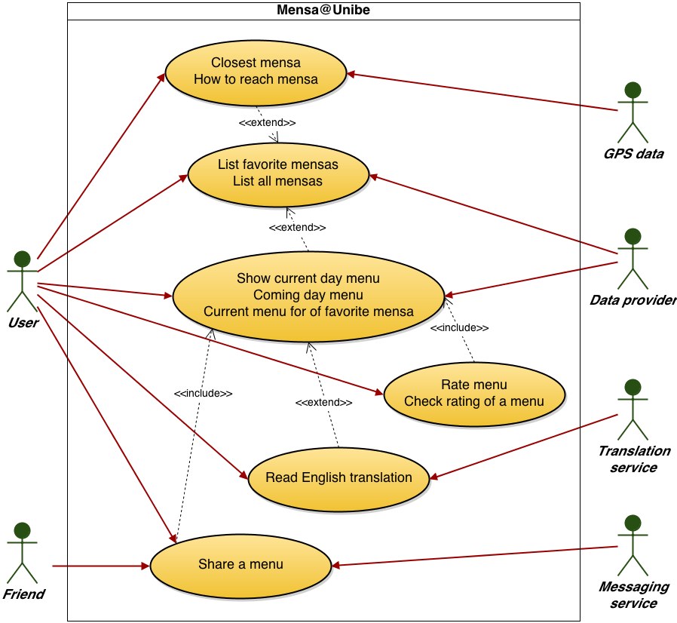

### List of all mensas

1. **Actors**

User

1. **Description**

As a costumer, I want to see a complete list, with all mensas of the campus.

1. **Trigger**

User starts the App and sees the home-screen with the list.

1. **Pre-conditions**
2. First start: User has an active internet connection.
3. **Post-conditions**
4. User sees a list of all mensas.
5. User can choose one mensa.
6. **Main scenario**
7. User opens the app
8. System shows a list of all mensas
9. User choose a mensa
10. System shows brief information about the mensa and options
11. **Alternative scenarios**

2a. System has no internet connection

* 1. System tries to get a cached list of the mensas
  2. System shows the cached list of the mensas

2b. System has no internet connection

1. System tries to get a cached list of the mensas
2. No cached version available
3. System shows error message
4. **Special requirements**
5. Parse the list of mensas
6. **Notes**

* -

### Details about menu of current day

1. **Actors**

User

1. **Description**

As a user I want to see details about the menus served at a given mensa in the current day.

1. **Trigger**

User hits the “Current Day Menu” button of the actual mensa

1. **Pre-conditions**
2. User chose the mensa
3. **Post-conditions**
4. User sees the served menus of the current day
5. **Main scenario**
6. User wants to see the served menus
7. System shows details of the served menus
8. **Alternative scenarios**

1a. User has no internet connection

* 1. System tries to get a cached version
  2. Cached version available, shows it

1b. User has no internet connection

1. System tries to get a cached version
2. No cached version available
3. System shows error message
4. **Special requirements**
5. Parse the data about served menus
6. **Notes**

* -

### Details about menu of the current week

1. **Actors**

User

1. **Description**

As a user I want to see details about the menus served at a given mensa of the current week.

1. **Trigger**

User hits the “Current Week Menu” button of the actual mensa

1. **Pre-conditions**
2. User chose the mensa
3. **Post-conditions**
4. User sees the served menus of the current day
5. **Main scenario**
6. User wants to see the served menus
7. System shows details of the served menus
8. **Alternative scenarios**

1a. User has no internet connection

* 1. System tries to get a cached version
  2. Cached version available, shows it

1b. User has no internet connection

1. System tries to get a cached version
2. No cached version available
3. System shows error message
4. **Special requirements**
5. Parse the data about served menus
6. **Notes**

* -the menus are only available from Monday till Friday. The menu of the next week will be published on the weekend (to prove)

### Find closest mensa

1. **Actors**

User

1. **Description**

As a user I want to know which is the closest mensa

1. **Trigger**

User hits the “Get Closest Mensa” button.

1. **Pre-conditions**
2. User has enabled GPS
3. System has the permission to use the GPS data
4. **Post-conditions**
5. User sees the distances to all mensas
6. **Main scenario**
7. User wants to see the closest menu
8. System calculates the distances to all mensas with the GPS data
9. System shows the distances to all mensas
10. **Alternative scenarios**

2a. System has no permission to use the GPS data

* 1. System asks for permission to use GPS data
  2. User gives the permission to the system
  3. Back to main scenario

2b. System has no permission to use the GPS data

1. System asks for permission to use GPS data
2. User declines
3. System shows error message

2c. GPS is not enabled on the device

1. System asks to enable the GPS
2. User enables the GPS
3. Back to main scenario

2d. GPS is not enabled on the device

1. System asks to enable the GPS
2. User does not enable the GPS
3. System shows error message
4. **Special requirements**
5. Permission to use the GPS data
6. Calculate distances with coordinates
7. **Notes**

* -

### Way to reach a given mensa

1. **Actors**

User

1. **Description**

As a user I want to know how to reach a given mensa

1. **Trigger**

User hits the “Show Mensa Map” button.

1. **Pre-conditions**
2. User has an active internet connection
3. User has enabled GPS
4. System has the permission to use GPS data
5. **Post-conditions**
6. User sees a map with all maps and can choose one.
7. **Main scenario**
8. User wants to know how to reach a given mensa
9. System shows all mensas on a Map
10. User clicks on one mensa
11. System shows the way to that given mensa
12. **Alternative scenarios**

1a. User has no internet connection

* 1. System shows error message

1b. GPS is disabled

1. System asks user to enable GPS
2. User enables GPS
3. Go back to main scenario

1c. GPS is disabled

1. System asks user to enable GPS
2. User declines
3. System shows error message

1d. System has no permission to use the GPS data

1. System asks for permission to use GPS data
2. User gives the permission to the system
3. Back to main scenario

1e. System has no permission to use the GPS data

1. System asks for permission to use GPS data
2. User declines
3. System shows error message
4. **Special requirements**
5. Use Google Maps for leading and showing the way

### See current day menu of favorite canteen

1. **Actors**

User

1. **Description**

As a user I want see the current day menu of a canteen from my favorites list

1. **Trigger**

User navigates to favorites list

1. **Pre-conditions**
   1. User added at least one canteen to favorites list
   2. Favorite canteens have menu for current day
2. **Post-conditions**

User sees the current menu of the given favorite mensa

1. **Main Scenario**
   1. User navigates to favorites list
   2. System lists favorite canteens
   3. System checks for current day menus of the favorite canteens (or retrieve cached version)
   4. System shows list of current day menus of the favorite mensas.
2. **Alternative Scenarios**

1a. There are no canteens in favorites list

* + 1. System prompts user to add canteens to favorites list
    2. User selects favorite canteens
    3. Use Case resumes on step 2

1b. There are no canteens in favorites list

* + 1. System prompts User to add canteens to favorites list
    2. User declines
    3. Use Case finish

3a. There is no current day menu for the canteens

* + 1. System prompts user to update menu database
    2. User accepts
    3. Use Case resumes on step 3

3b. There is no current day menu for the canteens

* + 1. System prompts user to update menu database
    2. User declines
    3. Use Case finish

1. **Special Requirements**

System lookup and insert (step 4 and 5) cannot take more then 2 seconds.

1. **Notes**

What to do if alternative scenarios are finishing with user declines? - TBD

### Get notified if menu matches some criteria in my favorite canteen

1. **Actors**

User

1. **Description**

As a user I want to get notified if a menu served at my favorite canteen matches some criteria

1. **Trigger**

A menu matches some criteria set by the user

1. **Pre-conditions**
   1. User set already at least one criteria
   2. User set at least one favorite canteen
   3. A menu matches a previously set criteria
   4. Matching menu is in a favorite canteen
2. **Post-conditions**
   1. User receives a notification
3. **Main scenario**
   1. User sets a criteria for a favorite canteen
   2. System saves the criteria in interests data
   3. When menus are updated, system looks if a menu matches a criteria from interests data
   4. If a menu meets a criteria, system looks if this is a menu of a favorite canteen
   5. If it is a menu of a favorite canteen, system notifies user
4. **Alternative Scenarios**

3a. There is no interests data available

* + 1. Use Case finish

1. **Special Requirements**
2. **Notes**

Do not notify user if the availability of menu is already passed

Notify user just once

If there are more notifications, group them in one

### Read English translation of a menu

1. **Actors**

User

1. **Description**

As a user I want to be able to read the English translation of a menu

1. **Trigger**

User clicks the English language button on the menu view

1. **Pre-conditions**
   1. at least one menu has an English translation
2. **Post-conditions**
   1. system presents English translation of current menu
3. **Main Scenario**
   1. User navigates to menu view
   2. System presents the current menus
   3. System checks if English translation is available for currently viewed menus
   4. System inserts language button to presented menus
   5. User clicks language button
   6. System loads the corresponding English translations
   7. System presents the English version of the menus
4. **Alternative Scenarios**

3a. There is no English translation available for none of the menus

* + 1. Use Case finish

1. **Special Requirements**
2. **Notes**

How to get translations for menus? - TBD

### Remember my settings

1. **Actors**

User

Data provider (secondary)

1. **Description**

As a user I want to be able to set my user name and I want that the system remembers my favorite mensas, set criterias and menu ratings.

1. **Trigger**

No user identification is set

1. **Pre-conditions**
   1. the user doesn't have an identification set up
2. **Post-conditions**
   1. system saves user identification
3. **Main Scenario**
   1. System prompts user to let identify by a given account
   2. User accepts
   3. User saves identification
   4. System saves user data and updates the data.
4. **Alternative Scenarios**

1a. User declines to set up an ID

* + 1. Use Case finish

1. **Special Requirements**
   1. user name has to be unique identifier
2. **Notes**
   1. What is the best way to not annoy the user? -TBD
   2. Asking for email address? –TBD
   3. Asking for account data?-TBD
   4. Needed for menu reviews
   5. Choose a username or use the public nickname of the chosen identification.

### Share a menu, where I plan to go for lunch

1. **Actors**

User (primary)

Friends of the user (secondary)

1. **Description**

As a user I want to suggest my friends where to go for lunch. If they want to join me, they should answer to the message

1. **Trigger**

User clicks share button on canteen where he plans to go for lunch or on a menu

1. **Pre-conditions**
   1. Planned canteen is open at the specified time
   2. User has at least one messaging / social app
2. **Post-conditions**
   1. System launches the messaging app
   2. System inserts menu and mensa data in the message
3. **Main Scenario**
   1. User navigates to the current day menu of a specific mensa
   2. User clicks share lunch
   3. System prompts to choose app to share with
   4. User chooses app
   5. System inserts menu and mensa data in the message
   6. User can add a personal message part
   7. User sends message
   8. Friend receives message
4. **Alternative Scenarios**

6a. User declines to use an app

* + 1. Use Case finish

9a. User does not send the message

* + 1. Use Case finish

1. **Special Requirements**

API to other Apps / social networks(?)

1. **Notes**

The message should contain a link to the mensa or the address of the mensa to let the friend check where the location is.

### Rate menu I have eaten

1. **Actors**

User

1. **Description**

As a user I want to be able to rate a menu I have eaten

1. **Trigger**

User clicks rating stars on viewed menu

1. **Pre-conditions**
   1. User has set up a user name
   2. There is a list with current and past week menus
   3. The menu is available to eat or it was available in the past week
2. **Post-conditions**
   1. System saves rating for menu
   2. System updates rating for menu database
3. **Main Scenario**
   1. User navigates to current and past week menu view
   2. System presents menu list
   3. User clicks rating stars on a menu
   4. System saves rating for corresponding menu
   5. System updates rating data for menu database
4. **Alternative Scenarios**

3a. User has not set up user name

* + 1. System prompts user to set up a user name
    2. User sets up user name
    3. Use Case resume on step 4

3b. User has not set up user name

* + 1. System prompts user to set up a user name
    2. User declines
    3. Use Case finish

4a. User rated already the same menu before

* + 1. System overwrites old rating of user
    2. Use Case resume on step 5

1. **Special Requirements**

User shouldn't be able to rate a menu which will be available in the future, hence user did not try the corresponding menu

1. **Notes**
   1. -

### Check how people rated a certain menu

1. **Actors**

User

1. **Description**

As a user I want to be able to check how other people rated a certain menu

1. **Trigger**

User navigates to menu view

1. **Pre-conditions**
   1. A menu has at least one rating
2. **Post-conditions**

System presents rating of corresponding menu

1. **Main Scenario**
   1. User navigates to menu view
   2. System loads menu list
   3. System loads rating for corresponding menus
   4. System presents menu list with ratings
2. **Alternative Scenarios**

3a. Corresponding menu has no rating

* + 1. System presents corresponding menu 0 rating
    2. Use Case resume on step 4

1. **Special Requirements**

Menu rating database should contain an arithmetic mean of the overall ratings

1. **Notes**
   1. How to achieve the arithmetic mean?
   2. Compute in database, when a rating is updated?

## Actor characteristics

The average user is a student or an employee of the University of Bern. He regularly eats in one of the mensas of the University. He is above the average intelligence and likes to have a fast way to get information about the served menus. He should be familiar with using an app on a smartphone.

We except, that the most users will be normal students with common knowledge about the usage of smartphones an apps.

# Specific requirements

## Functional requirements

### Client

* Overview of mensa

After Starting a List of Mensas need to be provided.

* Details about menu of current day

After a Click on a specific Mensa you should see the Menu of the day and be able to switch on an upcoming day.

* Find closest mensa

Provide a Feature to find the closest Mensa.

* Way of reach a given Mensa

Provide a Feature to find a specific Mensa.

* Favorite mensa

Provide a possibility to mark a Mensa as favorite and make sure there is quick access to it.

* Get notified if menu matches some criteria in my favorite mensa
* Read English translation of a menu

Provide a translation to the German Mensa.

* Set user name, save settings

You should be able to have a nickname.

The settings should be saved online or local

* Share a menu

Use existing social networks (like Facebook, WhatsApp, normal text messages) to share a menu (invite other people)

* Notifications

Implement Notifications for invitations/messages from friends and favorite Menus. Doing so also implement an option to disable specific notifications.

* Mark Mensa where the user plans to go for lunch

A way of marking a Mensa at a given time. And notification if a friend will be there at the same time.

* Rate a Menu

Implement a Rating System (Stars) and Comments.

* The Weekly Menu of all Mensa have to available offline after the first synchronization process with the server after a new weekly menu was uploaded.

### Server

* Provide up to date information about all mensas including menus, location
* (Provide a user Database )

## Non-functional requirements

* Novice User should be able to learn the app navigation within minutes.
* Client-Server-Communication needs to work properly and availability provided 24 hours 7 days a week. The only exception would be scheduled server maintenance.
* The storage used on the smartphone should be kept under 10 MB in the alpha version (if more feature will be added this amount can increase)
* The Application needs to run stable on all Android devices with Jelly Bean (4.1 or higher).
* Personal data on the server should be treated with the current security standards
* The Implementation should meet the ISO/IEC 9126 standard

(<http://de.wikipedia.org/wiki/ISO/IEC_9126>)

* The user-event-response time should be under 0.1 seconds (Exception: data synchronization with Server Mensa plan and loading maps)
* Data traffic should be kept under 1MB / Usage doesn’t include traffic caused by watching the maps.