**Project Requirements**

**Project Name: Mensa@Unibe**

**Team: 7 –** Jan Binzegger, Marc Dojtschinov, Andreas Hohler, Sàndor Török

**Customer: Bledar Aga**

Revision History

| **Version** | **Date** | **Revision Description** |
| --- | --- | --- |
| .01 | 26.09.2013 | Initial documentation |
| .02 |  |  |
| .. |  |  |
| 1.0 |  |  |
|  |  |  |
|  |  |  |

Date: September 25, 2013

# Introduction

## Purpose

Purpose

## Stakeholders

Stakeholders

## Definitions

Definitions

## System overview

Content

1.Introduction 3

1.1Purpose 3

1.2Stakeholders 3

1.3Definitions 3

1.4System overview 3

1.5References 3

2Overall description 4

2.1Use cases 4

2.1.1First case 4

2.1.2Second case 4

2.2Actor characteristics 4

3Specific requirements 5

3.1Functional requirements 5

3.2Non-functional requirements 5

2.Diagram 6

3.Use cases 7

## References

References

# Overall description

## Use cases

[Diagram for use cases] (draw it with draw.io, we do it after all the use cases were described!)

### First case

First case

### See the current day menu of my favorite canteen

### Get notified if menu matches some criteria in my favorite canteen

### Read English translation of a menu

### Set my user name

### Choose friends

### Delete a friend

### Enable/disable notifications for friends

### Choose where I plan to go for lunch and get notification if a friend joins

### Rate a menu I have eaten

### Check how people rated a certain menu

## Actor characteristics

Actor characteristics

# Specific requirements

## Functional requirements

Functional requirements

## Non-functional requirements

Non-functional requirements

# Diagram

Draw a diagram that shows how your use cases are related to each other.

We recommend using the following authoring tool: www.draw.io

***EXAMPLE***

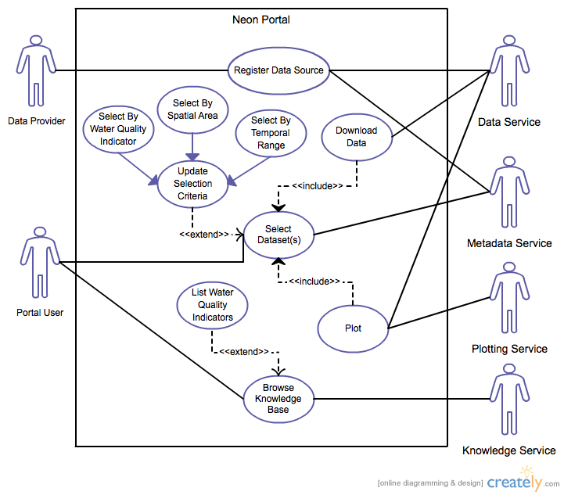

# Use cases

1. **See current day menu of favorite canteen**
   1. **Actors**

User

* 1. **Description**

As a user I want see the current day menu of a canteen from my favorites list

* 1. **Trigger**

User navigates to favorites list

* 1. **Pre-conditions**
     1. User added at least one canteen to favorites list
     2. Favorite canteens have menu for current day
  2. **Post-conditions**

Insert menu for current day to the specified canteens

* 1. **Main Scenario**
     1. User navigates to favorites list
     2. System lists favorite canteens
     3. System checks for current day menus of favorite canteens
     4. System inserts current day menu to every canteen in this list
  2. **Alternative Scenarios**

1a. There are no canteens in favorites list

* + - 1. System prompts user to add canteens to favorites list
      2. User selects favorite canteens
      3. Use Case resumes on step 2

1b. There are no canteens in favorites list

* + - 1. System prompts User to add canteens to favorites list
      2. User declines
      3. Use Case finish

2a. There is no current day menu for the canteens

* + - 1. System prompts user to update menu database
      2. User accepts
      3. Use Case resumes on step 3

2b. There is no current day menu for the canteens

* + - 1. System prompts user to update menu database
      2. User declines
      3. Use Case finish
  1. **Special Requirements**

System lookup and insert (step 4 and 5) cannot take more then 2 seconds.

* 1. **Notes**
     1. What to do if alternative scenarios are finishing with user declines? - TBD

1. **Get notified if menu matches some criteria in my favorite canteen**
   1. **Actors**

User

* 1. **Description**

As a user I want to get notified if a menu served at my favorite canteen matches some criteria

* 1. **Trigger**

A menu matches some criteria set by the user

* 1. **Pre-conditions**
     1. User set already at least one criteria
     2. User set at least one favorite canteen
     3. A menu matches a previously set criteria
     4. Matching menu is in a favorite canteen
  2. **Post-conditions**
     1. User receives a notification
  3. **Main scenario**
     1. User sets a criteria for a favorite canteen
     2. System saves the criteria in interests data
     3. When menus are updated, system looks if a menu matches a criteria from interests data
     4. If a menu meets a criteria, system looks if this is a menu of a favorite canteen
     5. If it is a menu of a favorite canteen, system notifies user
  4. **Alternative Scenarios**

3a. There is no interests data available

* + - 1. Use Case finish
  1. **Special Requirements**
  2. **Notes**

Do not notify user if the availability of menu is already passed

Notify user just once

If there are more notifications, group them in one

1. **Read English translation of a menu**
   1. **Actors**

User

* 1. **Description**

As a user I want to be able to read the English translation of a menu

* 1. **Trigger**

User clicks the English language button on the menu view

* 1. **Pre-conditions**
     1. at least one menu has an English translation
  2. **Post-conditions**
     1. system presents English translation of current menu
  3. **Main Scenario**
     1. User navigates to menu view
     2. System presents the current menus
     3. System checks if English translation is available for currently viewed menus
     4. System inserts language button to presented menus
     5. User clicks language button
     6. System loads the corresponding English translations
     7. System presents the English version of the menus
  4. **Alternative Scenarios**

3a. There is no English translation available for none of the menus

* + - 1. Use Case finish
  1. **Special Requirements**
  2. **Notes**
     1. How to get translations for menus? - TBD

1. **set user name**
   1. **Actors**

User

* 1. **Description**

As a user I want to be able to set my user name

* 1. **Trigger**

no user name is saved

* 1. **Pre-conditions**
     1. the user doesn't have a user name set up
  2. **Post-conditions**
     1. system saves user name
  3. **Main Scenario**
     1. System prompts user to set up a name
     2. User sets up the user name
     3. System saves user name data
  4. **Alternative Scenarios**

2a. User declines to set up a name

* + - 1. Use Case finish
  1. **Special Requirements**
     1. user name has to be unique identifier
  2. **Notes**
     1. What is the best way to not annoy the user? -TBD
     2. Asking for email address? -TBD
     3. Asking for accounts data?-TBD

1. **Choose friends**
   1. **Actors**

User

* 1. **Description**

As a user I want choose my friends which are using the Mensa app

* 1. **Trigger**

User clicks choose friends button

* 1. **Pre-conditions**
     1. User set up already a user name
     2. User has friends in his contact list which are using the Mensa app
  2. **Post-conditions**

System saves friends list data

* 1. **Main Scenario**
     1. User clicks choose friends button
     2. System checks user phone contacts, who are using the Mensa app
     3. System lists the matched contacts to choose from
     4. User selects contacts to add to friends list
     5. User clicks add button
     6. System saves the data to friends list
  2. **Alternative Scenarios**

2a. There are no contacts using Mensa app

* + - 1. System notifies user that no contacts matched
      2. System advises the user to let friends know about the app
      3. Use Case finish

4a. User have not selected any contacts

* + - 1. User clicks add button
      2. System prompts user to select contacts
      3. User accepts
      4. Use Case jumps to step 3

4a. User have not selected any contacts

* + - 1. User clicks add button
      2. System prompts user to select contacts
      3. User declines
      4. Use Case finish
  1. **Special Requirements**

In case the system is interrupted (an incoming phone call for ex.) step 4 should be saved, to be able to resume

* 1. **Notes**
     1. How to find out which contacts are using the Mensa app? - TBD

1. **Delete a friend**
   1. **Actors**

User

* 1. **Description**

As a user I want delete a person from my friends list

* 1. **Trigger**

User clicks delete friend button

* 1. **Pre-conditions**
     1. User has a friends list
  2. **Post-conditions**

System deletes person from friends list

* 1. **Main Scenario**
     1. User navigates to friends list
     2. System presents the list
     3. User clicks delete friend button
     4. System prompts confirm
     5. User accepts
     6. System deletes person from friends list
  2. **Alternative Scenarios**

4a. User declines confirm

* + - 1. Use Case finish
  1. **Special Requirements**
  2. **Notes**

1. **Enable/disable notifications for friends**
   1. **Actors**

User

* 1. **Description**

As a user I want to enable/disable which friends of mine get notifications when I plan to goo for lunch

* 1. **Trigger**

User checks enable/disable friends to get notifications check-box

* 1. **Pre-conditions**
     1. User has a friends list
  2. **Post-conditions**

System enables/disables notifications for selected friends

* 1. **Main Scenario**
     1. User navigates to friends list
     2. System presents the list
     3. User checks the enable/disable friend check-box
     4. User clicks confirms changes
     5. System enables/disables notifications for friends
  2. **Alternative Scenarios**

4a. User cancels changes

* + - 1. Use Case finish
  1. **Special Requirements**
  2. **Notes**

1. **Choose where I plan to go for lunch and get notification if a friend joins me**
   1. **Actors**

User (primary)

Friends of the user (secondary)

* 1. **Description**

As a user I want to let my friends know where I plan to go for lunch. If they want to join me, I want to be notified.

* 1. **Trigger**

User clicks mark button on canteen where he plans to go for lunch

* 1. **Pre-conditions**
     1. User has a friends list
     2. Notification is enabled at least for one friend
     3. Planned canteen is open at the specified time
  2. **Post-conditions**

System saves planned time and canteen

System notifies enabled persons from friends list

If a friend confirms to join, system sends a join notification

* 1. **Main Scenario**
     1. User navigates to canteens
     2. System presents the canteen list
     3. User clicks mark for lunch
     4. System asks for time
     5. User sets time
     6. System validates time
     7. System saves time and canteen
     8. System sets expiration time of notification
     9. System sends join notifications to enabled friends
     10. Friend receives notification
     11. Friend confirms join
     12. System sends join confirmation
     13. User receives confirmation
  2. **Alternative Scenarios**

6a. Planned canteen is closed at the specified time

* + - 1. System notifies user, that the time is not valid
      2. Use Case resume at step 4

9a. Friend declines to join

* + - 1. Use Case finish
  1. **Special Requirements**

If the notification would arrive to a friend after the expiration time, the notification should be dropped

* 1. **Notes**

1. **rate menu I have eaten**
   1. **Actors**

User

* 1. **Description**

As a user I want to be able to rate a menu I have eaten

* 1. **Trigger**

User clicks rating stars on viewed menu

* 1. **Pre-conditions**
     1. User has set up a user name
     2. There is a list with current and past week menus
     3. The menu is available to eat or it was available in the past week
  2. **Post-conditions**

System saves rating for menu

System updates rating for menu database

* 1. **Main Scenario**
     1. User navigates to current and past week menu view
     2. System presents menu list
     3. User clicks rating stars on a menu
     4. System saves rating for corresponding menu
     5. System updates rating data for menu database
  2. **Alternative Scenarios**

3a. User has not set up user name

* + - 1. System prompts user to set up a user name
      2. User sets up user name
      3. Use Case resume on step 4

3b. User has not set up user name

* + - 1. System prompts user to set up a user name
      2. User declines
      3. Use Case finish

4a. User rated already the same menu before

* + - 1. System overwrites old rating of user
      2. Use Case resume on step 5
  1. **Special Requirements**

User shouldn't be able to rate a menu which will be available in the future, hence user did not try the corresponding menu

* 1. **Notes**

1. **check how people rated a certain menu**
   1. **Actors**

User

* 1. **Description**

As a user I want to be able to check how other people rated a certain menu

* 1. **Trigger**

User navigates to menu view

* 1. **Pre-conditions**
     1. A menu has at least one rating
  2. **Post-conditions**

System presents rating of corresponding menu

* 1. **Main Scenario**
     1. User navigates to menu view
     2. System loads menu list
     3. System loads rating for corresponding menus
     4. System presents menu list with ratings
  2. **Alternative Scenarios**

3a. Corresponding menu has no rating

* + - 1. System presents corresponding menu 0 rating
      2. Use Case resume on step 4
  1. **Special Requirements**

Menu rating database should contain an arithmetic mean of the overall ratings

* 1. **Notes**
     1. how to achieve the arithmetic mean?
     2. Compute in database, when a rating is updated?