**Project Requirements**

**Project Name: Mensa@Unibe**

**Team: 7 –** Jan Binzegger, Marc Dojtschinov, Andreas Hohler, Sàndor Török

**Customer: Bledar Aga**

Revision History

| **Version** | **Date** | **Revision Description** |
| --- | --- | --- |
| .01 | 26.09.2013 | Initial documentation |
| .02 | 01.10.2013 | Andi & Sàndor merged, use cases |
| 1.0 | 02.10.2013 | All parts merged (Jan & Marc) |
| 1.01 | 07.10.2013 | new Use Cases added, some deleted, diagram redrawn |
|  |  |  |
|  |  |  |

Date: October 7, 2013

Content

1.Introduction 4

1.1Purpose 4

1.2Stakeholders 4

1.3System overview 4

1.4References 6

2Overall description 7

2.1Use cases 7

2.1.1List of all mensas 7

2.1.2Details about menu of current day 9

2.1.3Details about menu of the coming days 11

2.1.4Find closest mensa 13

2.1.5Way to reach a given mensa 16

2.1.6See current day menu of favorite mensa 18

2.1.7Get notified if menu matches some criteria in my favorite mensa 20

2.1.8Read English translation of a menu 23

2.1.9Remember my settings 25

2.1.10Share a menu 27

2.1.11Rate menu I have eaten 29

2.1.12Check how people rated a certain menu 32

2.2Actor characteristics 34

3Specific requirements 34

3.1Functional requirements 34

3.1.1Client 34

3.1.2Server 36

3.2Non-functional requirements 36

# Introduction

## Purpose

The mensa application has the purpose to serve as a portable and quick accessible menu list with additional features on most Android devices.

It will provide a rating system which will enable users to share there opinion about the daily meal. This will ensure a pleasant lunchtime with a good meal.

Also it will be possible to share the menu trough existing social media as WhatsApp or Facebook. With that you can show your friends, what you recommend to eat that day.

Another purpose is the fast reachability of the nearest mensa when hungry, which will be fulfilled with by including GPS tracking.

## Stakeholders

Our stakeholders are Android using students from the University of Bern (16'000 students 2012, average 75% Android users, 5% having no mobile phone => circa 11'400 potential users), the different mensas of Bern (10 mensas, 7 of them serve menus) and the customer himself.

Our direct customer is Bledar Aga. He needs a perfectly working app within the time schedule.

## System overview

A brief system overview, what functions should be implemented in the application.

* Overview of mensa

After Starting a List of Mensas need to be provided.

* Details about menu of current day

After a Click on a specific Mensa you should see the Menu of the day and be able to switch on an upcoming day.

* Find closest mensa

Provide a Feature to find the closest Mensa.

* Way of reach a given Mensa

Provide a Feature to find a specific Mensa.

* Favorite mensa

Provide a possibility to mark a Mensa as favorite and make sure there is quick access to it.

* Get notified if menu matches some criteria in my favorite mensa
* Read English translation of a menu

Provide a translation to the German Mensa.

* Set user name

You should be able to have a nickname.

* Choose friends

A feature to add /delete Friends.

* Notifications

Implement Notifications for invitations/messages from friends and favorite Menus. Doing so also implement an option to disable specific notifications.

* Mark Mensa where the user plans to go for lunch

A way of marking a Mensa at a given time. And notification if a friend will be there at the same time.

* Rate a Menu

Implement a Rating System (Stars) and Comments.

* The Weekly Menu of all Mensa have to available offline after the first synchronization process with the server after a new weekly menu was uploaded.

## References

We will refer to https://github.com/lexruee/Mensa-Unibe-Webservice for our menu data.

We will be using the ActionBarSherlock http://actionbarsherlock.com/ to provide compatibility for earlier versions of Android.

# Overall description

## Use cases

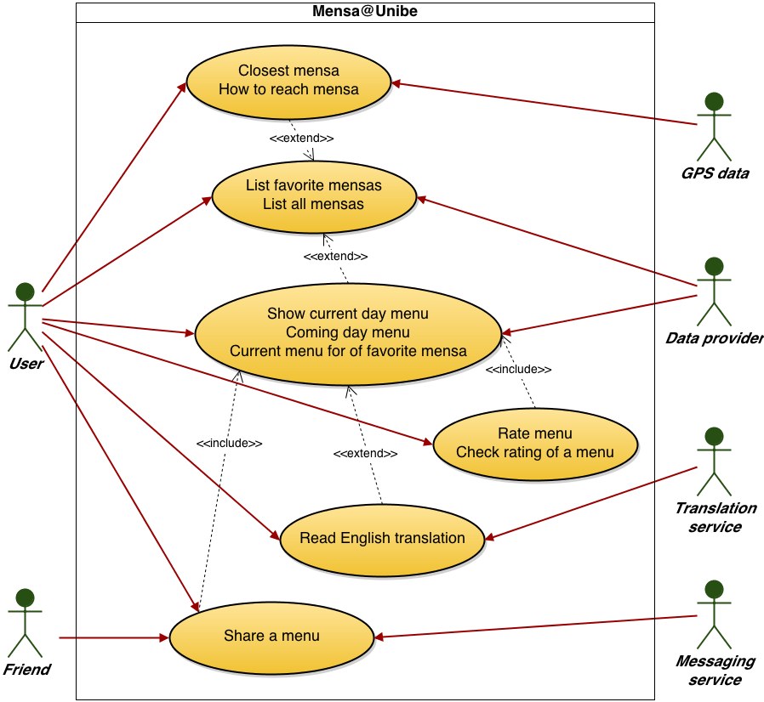

### List of all mensas

1. **Actors**

User

1. **Description**

As a costumer, I want to see a complete list, with all mensas of the campus.

1. **Trigger**

User starts the App and sees the home-screen with the list.

1. **Pre-conditions**
2. First start: User has an active internet connection.
3. **Post-conditions**
4. User sees a list of all mensas.
5. User can choose one mensa.
6. **Main scenario**
7. User opens the app
8. System shows a list of all mensas
9. User choose a mensa
10. System shows brief information about the mensa and options
11. **Alternative scenarios**

2a. System has no internet connection

* 1. System tries to get a cached list of the mensas
  2. System shows the cached list of the mensas

2b. System has no internet connection

1. System tries to get a cached list of the mensas
2. No cached version available
3. System shows error message
4. **Special requirements**
5. Parse the list of mensas
6. **Notes**

* -

### Details about menu of current day

1. **Actors**

User

1. **Description**

As a user I want to see details about the menus served at a given mensa in the current day.

1. **Trigger**

User hits the “Current Day Menu” button of the actual mensa

1. **Pre-conditions**
2. User chose the mensa
3. **Post-conditions**
4. User sees the served menus of the current day
5. **Main scenario**
6. User wants to see the served menus
7. System shows details of the served menus
8. **Alternative scenarios**

1a. User has no internet connection

* 1. System tries to get a cached version
  2. Cached version available, shows it

1b. User has no internet connection

1. System tries to get a cached version
2. No cached version available
3. System shows error message
4. **Special requirements**
5. Parse the data about served menus
6. **Notes**

* -

### Details about menu of the coming days

1. **Actors**

User

1. **Description**

As a user I want to see details about the menus served at a given mensa in the coming days.

1. **Trigger**

User hits the “Coming Days Menu” button of the actual mensa

1. **Pre-conditions**
2. User chose the mensa
3. **Post-conditions**
4. User sees the served menus of the current day
5. **Main scenario**
6. User wants to see the served menus
7. System shows details of the served menus
8. **Alternative scenarios**

1a. User has no internet connection

* 1. System tries to get a cached version
  2. Cached version available, shows it

1b. User has no internet connection

1. System tries to get a cached version
2. No cached version available
3. System shows error message
4. **Special requirements**
5. Parse the data about served menus
6. **Notes**

* -

### Find closest mensa

1. **Actors**

User

1. **Description**

As a user I want to know which is the closest mensa

1. **Trigger**

User hits the “Get Closest Mensa” button.

1. **Pre-conditions**
2. User has enabled GPS
3. System has the permission to use the GPS data
4. **Post-conditions**
5. User sees the closest mensa
6. **Main scenario**
7. User wants to see the closest menu
8. System calculates the closest mensa with the GPS data
9. System shows the closest mensa
10. **Alternative scenarios**

2a. System has no permission to use the GPS data

* 1. System asks for permission to use GPS data
  2. User gives the permission to the system
  3. Back to main scenario

2b. System has no permission to use the GPS data

1. System asks for permission to use GPS data
2. User declines
3. System shows error message

2c. GPS is not enabled on the device

1. System asks to enable the GPS
2. User enables the GPS
3. Back to main scenario

2d. GPS is not enabled on the device

1. System asks to enable the GPS
2. User does not enable the GPS
3. System shows error message
4. **Special requirements**
5. Permission to use the GPS data
6. Calculate distance with coordinates
7. **Notes**

* -

### Way to reach a given mensa

1. **Actors**

User

1. **Description**

As a user I want to know how to reach a given mensa

1. **Trigger**

User hits the “Show Way” button of the actual mensa

1. **Pre-conditions**
2. User chose the mensa
3. User has an active internet connection
4. User has enabled GPS
5. System has the permission to use GPS data
6. **Post-conditions**
7. User sees the way to a given mensa
8. **Main scenario**
9. User wants to know how to reach a given mensa
10. System shows the way with on a Map
11. **Alternative scenarios**

1a. User has no internet connection

* 1. System shows error message

1b. GPS is disabled

1. System asks user to enable GPS
2. User enables GPS
3. Go back to main scenario

1c. GPS is disabled

1. System asks user to enable GPS
2. User declines
3. System shows error message

1d. System has no permission to use the GPS data

1. System asks for permission to use GPS data
2. User gives the permission to the system
3. Back to main scenario

1e. System has no permission to use the GPS data

1. System asks for permission to use GPS data
2. User declines
3. System shows error message
4. **Special requirements**
5. Use Google Maps for leading and showing the way
6. **Notes**

* --

### See current day menu of favorite mensa

1. **Actors**

User

1. **Description**

As a user I want see the current day menu of a mensa from my favorites list

1. **Trigger**

User navigates to favorites list

1. **Pre-conditions**
   1. User added at least one mensa to favorites list
   2. Favorite mensas have menu for current day
2. **Post-conditions**

Insert menu for current day to the specified mensas

1. **Main Scenario**
   1. User navigates to favorites list
   2. System lists favorite mensas
   3. System checks for current day menus of favorite mensas
   4. System inserts current day menu to every mensa in this list
2. **Alternative Scenarios**

1a. There are no mensas in favorites list

* + 1. System prompts user to add mensas to favorites list
    2. User selects favorite mensas
    3. Use Case resumes on step 2

1b. There are no mensas in favorites list

* + 1. System prompts User to add mensas to favorites list
    2. User declines
    3. Use Case finish

3a. There is no current day menu for the mensas

* + 1. System prompts user to update menu database
    2. User accepts
    3. Use Case resumes on step 3

3b. There is no current day menu for the mensas

* + 1. System prompts user to update menu database
    2. User declines
    3. Use Case finish

1. **Special Requirements**

System lookup and insert (step 4 and 5) cannot take more then 2 seconds.

1. **Notes**

What to do if alternative scenarios are finishing with user declines? - TBD

### Get notified if menu matches some criteria in my favorite mensa

1. **Actors**

User

1. **Description**

As a user I want to get notified if a menu served at my favorite mensa matches some criteria

1. **Trigger**

A menu matches some criteria set by the user

1. **Pre-conditions**
   1. User set already at least one criteria
   2. User set at least one favorite mensa
   3. A menu matches a previously set criteria
   4. Matching menu is in a favorite mensa
2. **Post-conditions**
   1. User receives a notification
3. **Main scenario**
   1. User sets a criteria for a favorite mensa
   2. System saves the criteria in interests data
   3. When menus are updated, system looks if a menu matches a criteria from interests data
   4. If a menu meets a criteria, system looks if this is a menu of a favorite mensa
   5. If it is a menu of a favorite mensa, system notifies user
4. **Alternative Scenarios**

3a. There is no interests data available

* + 1. Use Case finish

1. **Special Requirements**
2. **Notes**

Do not notify user if the availability of menu is already passed

Notify user just once

If there are more notifications, group them in one

### Read English translation of a menu

1. **Actors**

User

1. **Description**

As a user I want to be able to read the English translation of a menu

1. **Trigger**

User clicks the English language button on the menu view

1. **Pre-conditions**
   1. at least one menu has an English translation
2. **Post-conditions**
   1. system presents English translation of current menu
3. **Main Scenario**
   1. User navigates to menu view
   2. System presents the current menus
   3. System checks if English translation is available for currently viewed menus
   4. System inserts language button to presented menus
   5. User clicks language button
   6. System loads the corresponding English translations
   7. System presents the English version of the menus
4. **Alternative Scenarios**

3a. There is no English translation available for none of the menus

* + 1. Use Case finish

1. **Special Requirements**
2. **Notes**

How to get translations for menus? - TBD

### Remember my settings

1. **Actors**

User (primary)

Data provider (secondary)

1. **Description**

As a user I want that the system remembers my favorite mensas, set criterias and menu ratings

1. **Trigger**

no user identification is saved

1. **Pre-conditions**
   1. the user doesn't have an identification set up
2. **Post-conditions**
   1. system saves user identification
3. **Main Scenario**
   1. System prompts user to let to identify by a given account
   2. User accepts
   3. System saves user identification
   4. System updates user database at Data provider
4. **Alternative Scenarios**

1a. User declines to set up an id

* + 1. Use Case finish

1. **Special Requirements**
   1. user name has to be unique identifier
2. **Notes**
   1. What is the best way to not annoy the user? -TBD
   2. Asking for accounts data?-TBD

### Share a menu

1. **Actors**

User (primary)

Friend (secondary)

1. **Description**

As a user I want to be able to easily suggest my friends where to go for lunch.

1. **Trigger**

User clicks share button on a menu

1. **Pre-conditions**
   1. User has at least one messaging app
2. **Post-conditions**
   1. System launches messaging app
   2. System inserts menu and mensa data in the message
3. **Main Scenario**
   1. User navigates to current menu list
   2. System presents the menu list
   3. User clicks share menu
   4. System prompts to choose app to share with
   5. User chooses app
   6. System inserts menu and mensa data in the message
   7. User sends message
   8. Friend receives message
4. **Alternative Scenarios**

4a. User declines to choose an app

* + 1. Use Case finish

7a. User does not send message

* + 1. Use Case finish

1. **Special Requirements**
2. **Notes**

The message should contain a link to mensa or the address of the mensa, to let the friend check where is the menu served

### Rate menu I have eaten

1. **Actors**

User

1. **Description**

As a user I want to be able to rate a menu I have eaten

1. **Trigger**

User clicks rating stars on viewed menu

1. **Pre-conditions**
   1. User has set up a user name
   2. There is a list with current and past week menus
   3. The menu is available to eat or it was available in the past week
2. **Post-conditions**
   1. System saves rating for menu
   2. System updates rating for menu database
3. **Main Scenario**
   1. User navigates to current and past week menu view
   2. System presents menu list
   3. User clicks rating stars on a menu
   4. System saves rating for corresponding menu
   5. System updates rating data for menu database
4. **Alternative Scenarios**

3a. User has not set up user name

* + 1. System prompts user to set up a user name
    2. User sets up user name
    3. Use Case resume on step 4

3b. User has not set up user name

* + 1. System prompts user to set up a user name
    2. User declines
    3. Use Case finish

4a. User rated already the same menu before

* + 1. System overwrites old rating of user
    2. Use Case resume on step 5

1. **Special Requirements**

User shouldn't be able to rate a menu which will be available in the future, hence user did not try the corresponding menu

1. **Notes**
   1. -

### Check how people rated a certain menu

1. **Actors**

User

1. **Description**

As a user I want to be able to check how other people rated a certain menu

1. **Trigger**

User navigates to menu view

1. **Pre-conditions**
   1. A menu has at least one rating
2. **Post-conditions**

System presents rating of corresponding menu

1. **Main Scenario**
   1. User navigates to menu view
   2. System loads menu list
   3. System loads rating for corresponding menus
   4. System presents menu list with ratings
2. **Alternative Scenarios**

3a. Corresponding menu has no rating

* + 1. System presents corresponding menu 0 rating
    2. Use Case resume on step 4

1. **Special Requirements**

Menu rating database should contain an arithmetic mean of the overall ratings

1. **Notes**
   1. How to achieve the arithmetic mean?
   2. Compute in database, when a rating is updated?

## Actor characteristics

The average user is a student or an employee of the University of Bern. He regularly eats in one of the mensas of the University. He is above the average intelligence and likes to have a fast way to get information about the served menus. He should be familiar with using an app on a smartphone.

We except, that the most users will be normal students with common knowledge about the usage of smartphones an apps.

# Specific requirements

## Functional requirements

### Client

* Overview of mensa

After Starting a List of Mensas need to be provided.

* Details about menu of current day

After a Click on a specific Mensa you should see the Menu of the day and be able to switch on an upcoming day.

* Find closest mensa

Provide a Feature to find the closest Mensa.

* Way of reach a given Mensa

Provide a Feature to find a specific Mensa.

* Favorite mensa

Provide a possibility to mark a Mensa as favorite and make sure there is quick access to it.

* Get notified if menu matches some criteria in my favorite mensa
* Read English translation of a menu

Provide a translation to the German Mensa.

* Set user name

You should be able to have a nickname.

* Choose friends

A feature to add /delete Friends.

* Notifications

Implement Notifications for invitations/messages from friends and favorite Menus. Doing so also implement an option to disable specific notifications.

* Mark Mensa where the user plans to go for lunch

A way of marking a Mensa at a given time. And notification if a friend will be there at the same time.

* Rate a Menu

Implement a Rating System (Stars) and Comments.

* The Weekly Menu of all Mensa have to available offline after the first synchronization process with the server after a new weekly menu was uploaded.

### Server

* Provide up to date information about all mensas including menus, location
* (Provide a user Database )

## Non-functional requirements

* Novice User should be able to learn the app navigation within minutes.
* Client-Server-Communication needs to work properly and availability provided 24 hours 7 days a week. The only exception would be scheduled server maintenance.
* The storage used on the smartphone should be kept under 10 MB in the alpha version (if more feature will be added this amount can increase)
* The Application needs to run stable on all Android devices with Jelly Bean (4.1 or higher).
* Personal data on the server should be treated with the current security standards
* The Implementation should meet the ISO/IEC 9126 standard

(<http://de.wikipedia.org/wiki/ISO/IEC_9126>)

* The user-event-response time should be under 0.1 seconds (Exception: data synchronization with Server Mensa plan and loading maps)
* Data traffic should be kept under 1MB / Usage doesn’t include traffic caused by watching the maps.