**Project Requirements**

Project Name: [working title]

Team: Team1

Customer: Andrea Caracciolo

Revision History

| Version | Date | Revision Description |
| --- | --- | --- |
| 0.01 | 7.10.2014 | First version after one client talk. |
|  |  |  |

Offene Fragen im Moment:

* Ist “Profil betrachten” (eines anderen Users) ein Unter-case von “Inspect Flats”?
* Ist “Manage visits” (und “manage enquiries”) ein Über-case von vielen anderen, z. B. “Visit löschen”, “neuen Visit anlegen”, “Visit verschieben”, “User um Bestätigung fragen” etc.?
* Welches Behaviour ist von User inherited? Ich finde es so stimmig, andere Meinungen? Fehlt etwas im Diagramm?
* Was ist mit der “Detaillierte Suche”-Funktion? Ist das ein Unter-case von “Flats suchen” oder ein eigener use case?
* Sind “Verkäufer (erstmals) kontaktieren” und “Nachricht beantworten” zwei verschiedene use cases von “User kontaktieren”?
* Advertiser und Searcher sind behinderte Namen
* sicher nicht die einzigen…

# Introduction

## Purpose

## Stakeholders

## Definitions

## System overview

## References

# Overall description

## Use cases

### Diagram

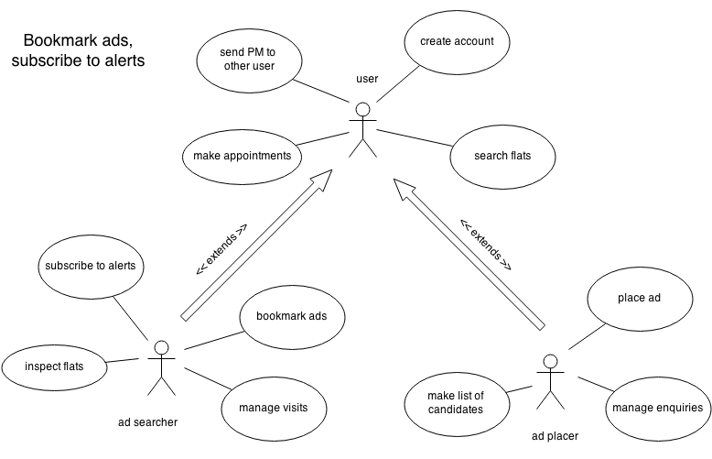

### B. Use Cases

**0. Create Account**

0.1 Actors

Users

0.2 Description

Users - advertisers and searchers both - want to use the opportunities of our platform and create an account.

0.3 Trigger

Visitor enters site and clicks on “create account”

0.4 Pre-conditions

1. No account with the same username or email address exists.
2. User has a valid email address.

0.5 Post-conditions

1. New account has been created in the DB.

0.6 Main Scenario

1. User visits our platform.
2. User clicks on “create account”.
3. User enters desired username, real name, email address.
4. System checks validity of entered data.
5. User gets redirected to start page, now logged in.

0.7 Alternative Scenarios

4a. Username already exists

1. User is prompted to enter another username. Continue with step 3.

4b. Email address faulty or already taken

1. User is prompted to enter another email address. Continue with step 3.

0.8 Special Requirements

User validation (Step 4) must not take more than 3 seconds.

0.9 Notes

Which characters are allowed in usernames?

Which character types are required in passwords?

**1. Search Flats**

1.1 Actors

Users

1.2 Description

Users enter some criteria of their choosing and are presented with all the flats in the DB satisfying all criteria.

1.3 Trigger

User clicks on “Search Flat”

1.4 Pre-conditions

1. User is properly logged in.

1.5 Post-conditions

1. User now sees a (possibly empty) list of flats.
2. User is shown a list of parameters by which s/he can further parametrise the results. (“detail search” option).

1.6 Main Scenario

1. User clicks “Search Flat”
2. User enters criteria, e.g. location (range), price range, type of rental
3. System checks DB for matching entries.
4. System returns matching entries in a list.

1.7 Alternative Scenarios

2a Minimal price higher than maximal price (maybe fix with an interactive tool that doesn’t allow this behaviour)?

1. System prompts user to re-enter a minimal and maximal price according to the rules. Continue with step 2.

2b User doesn’t enter any data, clicks on “search”

1. System returns all Flats in the DB. Flow continues with step 4.

1.8 Special Requirements

Displaying a list of 100 or less flats with thumbnails and text must not take more than 5 seconds.

1.9 Notes

Is the “detail search” a whole other use case?

**2. Send PM to other User**

2.1 Actors

Users (one advertiser, one searcher)

2.2 Description

A user has found a flat and wants to contact the ad placer. Or such an initial message has already been sent and someone replies to a message in their inbox.

2.3 Trigger

1. Searcher clicks on “contact advertiser” in a displayed ad or user clicks on “reply” when viewing a message in their inbox.

2.4 Pre-conditions

a1. User is currently looking at an active ad.

b1. At least one message has been sent between the two exact same accounts already.

b2. User is currently looking at one of these already sent messages.

2.5 Post-conditions

1. A copy of the sent message text is saved both in the sender’s “sent” folder as well as in the receiver’s “new messages” folder.
2. An email has been sent to the receiver’s email address informing him that he got a message.

2.6 Main Scenario

a1. User clicks on an ad for a flat.

a2. User clicks on “contact advertiser”.

a3. User enters text message *and maybe additional data (cell nr.?)*

a4. User clicks “send”.

a5. System validates input (non-empty message, valid cell nr. format etc.)

a6. System notifies sender that the message has been sent, and notifies the receiver.

b1. User clicks on “messages”.

b2. User clicks on one of the messages.

b3. User clicks on “reply”.

b4-7: see a3-6.

2.7 Alternative Scenarios

a5a: User doesn’t enter any text in message field.

1. System prompts user to enter text in message field. Continue with step a3.

a5b: User enters invalid cell phone number.

1. System prompts user to enter a valid cell phone number. Continue with step a3.

2.8 Special Requirements

Message must not be longer than 1’000 characters. Cannot contain images or files.

Every message and every reply must be connected to exactly two users.

2.9 Notes

Are the two cases (first contact/answering a message) two different use cases?

**3. Make Appointments**

3.1 Actors

3.2 Description

3.3 Trigger

3.4 Pre-conditions

3.5 Post-conditions

3.6 Main Scenario

3.7 Alternative Scenarios

3.8 Special Requirements

3.9 Notes

**4. Inspect Flat**

4.1 Actors

4.2 Description

4.3 Trigger

4.4 Pre-conditions

4.5 Post-conditions

4.6 Main Scenario

4.7 Alternative Scenarios

4.8 Special Requirements

4.9 Notes

**5. Manage Visits**

5.1 Actors

5.2 Description

5.3 Trigger

5.4 Pre-conditions

5.5 Post-conditions

5.6 Main Scenario

5.7 Alternative Scenarios

5.8 Special Requirements

5.9 Notes

**6. Bookmark Ads**

6.1 Actors

6.2 Description

6.3 Trigger

6.4 Pre-conditions

6.5 Post-conditions

6.6 Main Scenario

6.7 Alternative Scenarios

6.8 Special Requirements

6.9 Notes

**7. Subscribe to Alerts**

7.1 Actors

7.2 Description

7.3 Trigger

7.4 Pre-conditions

7.5 Post-conditions

7.6 Main Scenario

7.7 Alternative Scenarios

7.8 Special Requirements

7.9 Notes

**8. Place Ad**

8.1 Actors

8.2 Description

8.3 Trigger

8.4 Pre-conditions

8.5 Post-conditions

8.6 Main Scenario

8.7 Alternative Scenarios

8.8 Special Requirements

8.9 Notes

9. Create Account

**9. Manage Enquiries**

9.2 Description

9.3 Trigger

9.4 Pre-conditions

9.5 Post-conditions

9.6 Main Scenario

9.7 Alternative Scenarios

9.8 Special Requirements

9.9 Notes

**10. Make List of Candidates**

10.1 Actors

User (advertiser)

10.2 Description

As an ad placer I want to compile a list of the most promising candidates.

10.3 Trigger

User enters the internal message system and clicks on „add contact to favorite candidates“ or User browses to one of his advertisements and clicks next to the list of favorite candidates "add candidate"

10.4 Pre-conditions

a1. User is logged in

a2. User has at least one conversation

a4/ b1. User has at least one advertisement

b2. User has at least one conversation / one contact.

10.5 Post-conditions

The list must be properly extended by the added candidate

10.6 Main Scenario

a1. User visits internal message system.

a2. User selects a conversation.

a3. User clicks on "add user to favorite candidates"

a4. User selects one of his current advertisements

a5. User clicks on "add candidate"

b1. User visits one of his advertisements and browses to the list of favorite candidates

b2. User clicks on "add candidate"

b3. User chooses one of his contacts (only contacts he added or all users he had a conversation with lately?)

b4. User clicks on "add candidate"

10.7 Alternative Scenarios

a4: User has no advertisements.

1. Button "add candidate" isn't clickable, only the "cancel" button is.

b3: User has neither added contacts nor at least one conversation.

1. Button "add candidate" isn't clickable, only the "cancel" button is.

10.8 Special Requirements

Nonfunctional requirements:

1. The list is limited to 20 candidates

10.9 Notes

Are the two cases (add contact in message system/add contact at the advertisement) two different use cases?

## Actor characteristics

Specific requirements

## Functional requirements

## Non-functional requirements