**Project Requirements**

**Project Name:**

**Team: 4**

**Customer: Osmar**

Revision History

| **Version** | **Date** | **Revision Description** |
| --- | --- | --- |
| .01 | 1.10.14 | Client-Talk |
| .02 |  |  |
| .. |  |  |
| 1.0 |  |  |
|  |  |  |
|  |  |  |

Date: October 5, 2014

# Use Case Diagram

(Shared) apartment find-portal

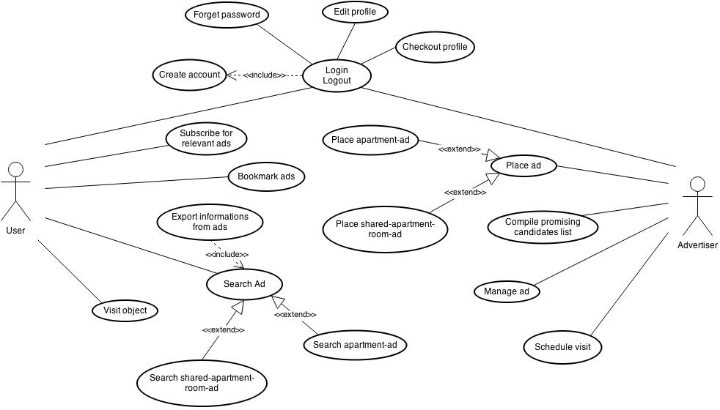

# Use cases

1. **Place ad**
   1. **Actors**

Advertiser

* 1. **Description**

As an ad-placer I want to put an ad on the search-(shared)-apartment-website.

[Provide a brief description of the reason for and outcome of this use case.

Format: As a [user role] I want to [goal] (so I can [reason])]

* 1. **Trigger**

The ad-placer clicks on the button “create an ad”.

[Identify the event that initiates the use case. This could be an external business event or system event that causes the use case to begin, or it could be the first step in the normal flow.]

* 1. **Pre-conditions**
     1. Ad-placer has an account
     2. Ad-placer must be logged in

[List any activities that must take place, or any conditions that must be true, before the use case can be started. Number each pre-condition.]

* 1. **Post-conditions**

1. Ad is on the website
2. Ad-placer will be informed if a user wants to visit the object in the ad

[Describe the state of the system at the conclusion of the use case execution. Should include both minimal guarantees (what must happen even if the actor’s goal is not achieved) and the success guarantees (what happens when the actor’s goal is achieved. Number each post-condition.]

* 1. **Main Scenario**

1. Advertiser creates an account
2. He sets up his profile
3. He clicks on “Save”
4. He clicks on the button “create an ad”
5. He gets asked if he wants to create an ad for a shared or a normal apartment
6. He chooses either “shared apartment” or “apartment”
7. He enters all necessary information of the adverted object
8. He describes the roommate of the adverted object if he has chosen “shared apartment”
9. He clicks the button “Save” so the ad will be saved in his account
10. On the website his ad can be seen/searched from the searcher

[Provide a detailed description of the user actions and system responses that will take place during execution of the use case under normal, expected conditions. This dialog sequence will ultimately lead to accomplishing the goal stated in the use case name and description.]

* 1. **Alternative Scenarios**

The advertiser does not enter the required data for the ad:

1. Advertiser creates an account
2. He sets up his profile
3. He clicks on the button “Create an ad”
4. He gets asked if he wants to create an ad for a shared or a normal apartment
5. He chooses “apartment”
6. He enters some of the necessary information of the adverted object
7. He clicks the button “Save”
8. He get asked to enter all necessary information
9. So he does
10. He clicks the button “Save” so the ad will be saved in his account
11. On the website his ad can be seen/searched from the searcher

[Document branches from the main flow to handle special conditions (also known as extensions). For each alternative flow reference the branching step number of the normal flow and the condition which must be true in order for this extension to be executed.]

* 1. **Special Requirements**

None

[Identify any additional requirements, such as nonfunctional requirements, for the use case that may need to be addressed during design or implementation. These may include performance requirements or other quality attributes.]

* 1. **Notes**

Some information must be entered to create an ad successfully.

[List any additional comments about this use case or any remaining open issues or TBDs (To Be Determined) that must be resolved.]

1. **Schedule ads**
   1. **Actors**

Ad-placer

* 1. **Description**

bla

* 1. **Trigger**

Bla

* 1. **Pre-Conditions**
     1. K
  2. **Post-Conditions**
     1. K
  3. **Main Scenario**
     1. K
  4. **Alternative Scenario**
     1. K
  5. **Special Requirements**

Bla

* 1. **Notes**

Bla

1. **Manage ad**
   1. **Actors**

Ad-placer

* 1. **Description**

bla

* 1. **Trigger**

Bla

* 1. **Pre-Conditions**
     1. K
  2. **Post-Conditions**
     1. K
  3. **Main Scenario**
     1. K
  4. **Alternative Scenario**
     1. K
  5. **Special Requirements**

Bla

* 1. **Notes**

Bla

1. **Search ad**
   1. **Actors**

User

* 1. **Description**

As a user I want to look through ads which fit my request.

* 1. **Trigger**

The user enters the properties of the object he wants to look for.

* 1. **Pre-Conditions**
     1. The user must have an account
  2. **Post-Conditions**
     1. The user has a list of his favorite ads
     2. The user now can contact the advertiser to visit the object
  3. **Main Scenario**
     1. He creates an account
     2. He sets up his profile
     3. He clicks on “Save”
     4. He enters all the properties of the object which he looks for
     5. A list of ads which satisfy his specifications is shown
     6. He clicks an ad
     7. The information of the object is shown
  4. **Alternative Scenario**

The user does not have an account yet:

* + 1. He enters all the properties of the object he looks for
    2. A list of ads which satisfy his specifications is shown
    3. He clicks on an ad
    4. The information of the object is shown except for the information of the advertiser

There no object which matches the user’s specifications:

* + 1. He enters all the properties of the object he looks for
    2. A blank list is shown
  1. **Special Requirements**

None

* 1. **Notes**
     1. To be able to see the contact information of the advertiser the user must have an account.
     2. If only a blank list is shown, the user has to change his specification.

1. **Compile promising candidates list**
   1. **Actors**

Ad-placer

* 1. **Description**

bla

* 1. **Trigger**

Bla

* 1. **Pre-Conditions**
     1. K
  2. **Post-Conditions**
     1. K
  3. **Main Scenario**
     1. K
     2. K
  4. **Alternative Scenario**
     1. K
  5. **Special Requirements**

Bla

* 1. **Notes**

Bla

1. **Create Account**
   1. **Actors**

Advertiser/User

* 1. **Description**

As an advertiser I want to be able to create ads, manage them and have an overview.

As a user I want to let the advertiser know that I am trustful.

* 1. **Trigger**

A click on the button “Create Account”

* 1. **Pre-Conditions**

None

* 1. **Post-Conditions**
     1. An account is created and the advertiser/user can set up his profile.
     2. Any time they go to the website they can login to manage their profile and ads (in case of an advertiser).
  2. **Main Scenario**
     1. Advertiser/User clicks on the button “Create Account”
     2. He is asked to enter a “User name”, an “Email” and a password
     3. He clicks “Register”
     4. He gets informed that his account is successfully created
  3. **Alternative Scenario**

User name already exists:

* + 1. Advertiser/User clicks on the button “Create Account”
    2. He is asked to enter a “User name” and an “Email” and a password
    3. He clicks “Register”
    4. He gets informed that the user name already exists.
  1. **Special Requirements**

None

* 1. **Notes**

Account can only be created if the user name does not exist yet.

1. **Edit profile**
   1. **Actors**

Advertiser/User

* 1. **Description**

As Advertiser/User I want to be able to adjust my profile.

* 1. **Trigger**

Click on “Edit Profile”

* 1. **Pre-Conditions**
     1. Advertiser/User must have an account
     2. He must login
  2. **Post-Conditions**
     1. Profile has been adjusted by the change the Advertiser/User has made
  3. **Main Scenario**
     1. Advertiser/User logs in
     2. He clicks on “Edit Profile”
     3. He changes his email address
     4. He clicks on “Save”
  4. **Alternative Scenario**

The Advertiser/User does not use his account anymore:

* + 1. Advertiser/User logs in
    2. He clicks on “Edit Profile”
    3. He clicks on “Delete Account”
    4. He gets asked if he really wants to delete his account
    5. He clicks “Confirm”
    6. He gets informed that his account has been deleted successfully
  1. **Special Requirements**

None

* 1. **Notes**

None

1. **Check-out profile**
   1. **Actors**

Ad-placer

* 1. **Description**

bla

* 1. **Trigger**

Bla

* 1. **Pre-Conditions**
     1. K
  2. **Post-Conditions**
     1. K
  3. **Main Scenario**
     1. K
  4. **Alternative Scenario**
     1. K
  5. **Special Requirements**

Bla

* 1. **Notes**

Bla

1. **Bookmark ads**
   1. **Actors**

Ad-placer

* 1. **Description**

bla

* 1. **Trigger**

Bla

* 1. **Pre-Conditions**
     1. K
  2. **Post-Conditions**
     1. K
  3. **Main Scenario**
     1. K
  4. **Alternative Scenario**
     1. K
  5. **Special Requirements**

Bla

* 1. **Notes**

Bla

1. **Export information from ad**
   1. **Actors**

Ad-placer

* 1. **Description**

bla

* 1. **Trigger**

Bla

* 1. **Pre-Conditions**
     1. K
  2. **Post-Conditions**
     1. K
  3. **Main Scenario**
     1. K
  4. **Alternative Scenario**
     1. K
  5. **Special Requirements**

Bla

* 1. **Notes**

Bla

1. **Subscribe for relevant ads**
   1. **Actors**

Ad-placer

* 1. **Description**

bla

* 1. **Trigger**

Bla

* 1. **Pre-Conditions**
     1. K
  2. **Post-Conditions**
     1. K
  3. **Main Scenario**
     1. K
  4. **Alternative Scenario**
     1. K
  5. **Special Requirements**

Bla

* 1. **Notes**

Bla

1. **Visit object**
   1. **Actors**

User

* 1. **Description**

As a user I want to contact the advertiser and visit the object.

* 1. **Trigger**

Fill out the contact-formula

* 1. **Pre-Conditions**
     1. User must have an account
     2. User must be logged in
  2. **Post-Conditions**
     1. User gets an answer when he can visit the object
  3. **Main Scenario**
     1. User logs in
     2. He enters the properties of the object he looks for
     3. A list of ads which matches the user’s specification is shown
     4. He clicks on an ad
     5. The information is presented to the user
     6. He fills out the contact-formula
     7. He clicks “Send”
     8. He gets informed that his enquiry was successful
  4. **Alternative Scenario**
     1. User enters the properties of the object he looks for
     2. A list of ads which matches the user’s specification is shown
     3. He clicks on an ad
     4. The information is presented to the user
     5. He fills out the contact-formula
     6. He clicks “Send”
     7. He gets asked to login before sending an enquiry
     8. So he does or otherwise he creates an account
     9. He tries again to click “Send”
     10. He gets informed that his enquiry was successful
  5. **Special Requirements**

None

* 1. **Notes**

Before sending an enquiry the user must be logged in, so must has an account.

If not he has to create one.