Project Requirements
Project Name: Shared Apartments Web Platform
Team: 4
Customer: Osmar

Revision History
Version | Date | Revision Description
 | 1.10.14 | Client-Talk
 | 08.10.14 | Gather Project Requirements

Date: October 6, 2014

Software Requirements Specification

Introduction

Purpose
The aim of the web site is to provide a platform to search for a shared apartment. Currently, several websites explicitly serve this purpose. Usually, they provide only basic functionalities like placing and browsing ads for shared apartments.
The customer wants to provide a platform, which serves this purpose as well, but which provides further features, more similar to those provided by real estate platforms.

Stakeholders
The customer is a private person, who has some real estate business as his clients. Currently, they have not made explicit plans how to use this website to generate income, but he mentioned that he might change his opinion on this point.

Definitions

System overview
The Spring Web Flow framework was chosen as an environment to implement the desired website. Separation of model, view and controller will be assured by utilizing the Spring web model-view-controller (MVC) and data storage and access will be controlled by Spring Data JPA

References

Overall Description

Use Case Diagram

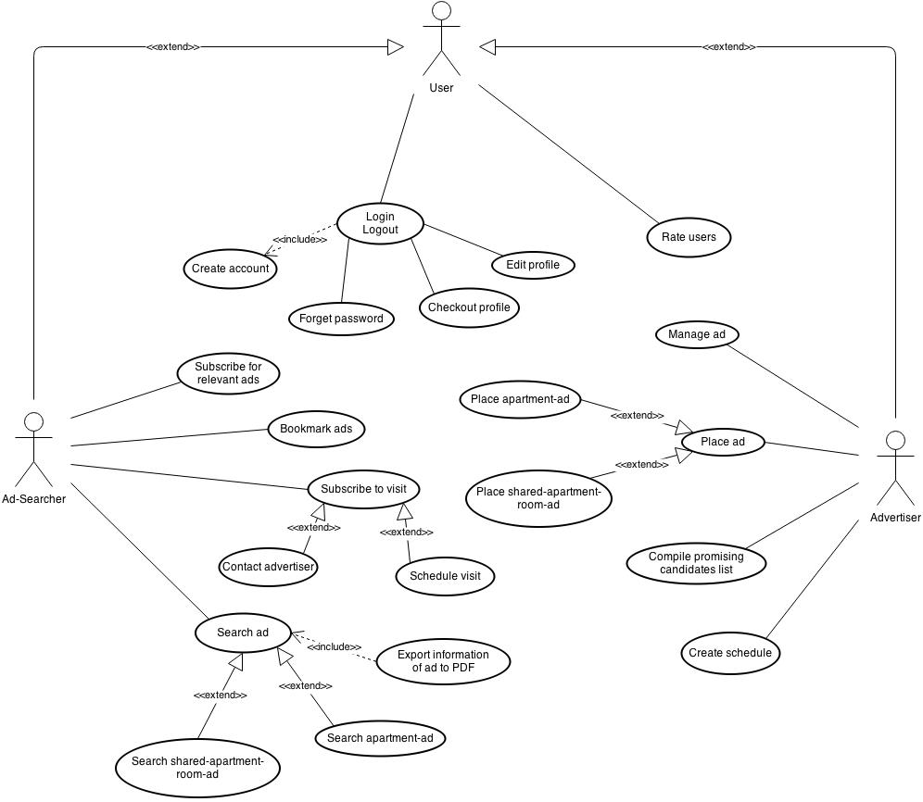

Use cases
- Place ad

  - Actors
User (advertiser)

  - Description
As user I want to place an ad on the website.

  - Trigger
The user clicks on the button “place an ad”.

  - Pre-conditions
    - User has an account
    - User must be logged into the system

  - Post-conditions
    - Ad is on the website
    - Ad-placer will be informed when a user wants to visit the advertised object

  - Main Scenario
    - User clicks on the button “create an ad”
    - System asks the user to choose what he wants to place
    - User chooses either “shared apartment” or “apartment”
    - System prompts the form to be filled in
    - User enters all necessary information of the advertised object
    - User enters additional non-mandatory information if he likes to do so
    - User clicks onto "Save"
    - System checks that all mandatory information is given.
    - System asks the user to confirm
    - User confirms by clicking onto "Save" again
    - System saves everything and places the ad
    - System returns to start page

  - Alternative Scenarios

7a User did not enter all mandatory information:
- System prompts the message "pleas fill in all mandatory fields"
- User fills in all mandatory fields
- Normal scenario goes on from point 6

7b User did not enter all mandatory information
- System prompts the message "please fill all mandatory fields"
- User fills some mandatory fields.
- Normal scenario goes on from point 6

9a. User wants to make some changes after clicking onto "save"
- User clicks into a field he wants to edit
- User mutates the field
- User mutates other fields he wants to edit
- Scenario goes on from point 6

9b. User wants to cancel the ad placement
- User clicks onto "Cancel"
- System asks user whether he is sure about canceling and discarding all
- User clicks onto "cancel" again
- System returns to start page

9b.3a: User does not want to cancel
- User clicks into a field
- Scenario goes on from point 6

9b.3a. User does not want to cancel
- User clicks onto "save"
- Scenario goes on from point 8

  - Special Requirements
None

  - Notes
Some information must be entered to create an ad successfully.

- Create schedule to manage visit

  - Actors
User (Advertiser)

  - Description
As a user I want to manage the visits to my placed apartment(s)/room(s)

  - Trigger
User clicks onto "create schedule"

  - Pre-Conditions
    - User has an account
    - User has placed at least one ad
    - User is logged in

  - Post-Conditions
    - User can see his schedule
    - Other users can see the schedule and subscribe

  - Main Scenario
    - User clicks onto "create schedule"
    - System prompts the user with a timetable
    - User clicks into slots to declare them as "I am free"
    - User clicks into "I am free" slots to delete
    - User clicks onto "save"
    - System asks "are you sure?"
    - User clicks onto "save" again to confirm.
    - System saves the timetable
    - System returns to start page

  - Alternative Scenarios
5.User wants to edit before saving
- User does not click onto "save" again but into a time slot
- Scenario goes on from point 3

  - Special Requirements
None

  - Notes
None

- Manage ads

  - Actors
User (advertiser)

  - Description
As a user I want to manage my ads

  - Trigger
User clicks onto "manage ads"

  - Pre-Conditions
    - User has an account
    - User has placed at least one ad
    - User is logged in

  - Post-Conditions
    - System saves the changes

  - Main Scenario
    - User clicks onto "manage ads"
    - System shows a list with all ads the user has placed
    - User clicks onto an ad to manage it
    - System shows the edit-ad mask
    - User edits what he likes to edit
    - User clicks onto "Save"
    - System asks "Are you sure? Please confirm"
    - User clicks onto "Save" again
    - System saves the ad and returns to the list

  - Alternative Scenarios
6. User wants to see preview before saving
- User clicks onto "Preview"
- System provides a preview of the ad
- User clicks onto "close preview"
- scenario goes on from point 4

  - Special Requirements
None

  - Notes
None

- Search ad

  - Actors
User

  - Description
As a user I want to search the website for ads which fit my request.

  - Trigger
The user clicks onto "search"

  - Pre-Conditions
    - The user has an account

  - Post-Conditions
    - The user has a list of ads that meet his properties
    - The user can contact the advertisers to visit the objects

  - Main Scenario
    - User clicks onto "search"
    - System prompts a form to fill in
    - User enters city and radius in which to search
    - User enters the properties of the object he looks for
    - User clicks onto "show list"
    - System provides a list of all objects that mach the properties
    - User clicks onto an object to see them

  - Alternative Scenarios
In alternative scenario point 3: return to list after adding or stay on profile?
2. User want to search with the map
- User clicks onto "change to map view"
- System shows a map of Switzerland with all available rooms and apartments
- User chooses/adapts the properties of the object which he looks for
- User zooms onto the desired area
- System refreshes the map and only shows the places that mach the properties
- User clicks onto the icon of an object to see it

2.6 User wants to have a list of the matching objects
- User enters city and radius
- User clicks onto "show list"
- Scenario goes on from point 6

6. No ad match the search properties
- System shows error message "No ads match your search. Please adapt"
- System returns to filled form
- Scenario goes on from point 4

  - Special Requirements
None

  - Notes
None

- Compile promising candidates list

  - Actors
User (advertiser)

  - Description
As an advertiser I want to compile a list of most promising candidates for a placed ad

  - Trigger
User clicks onto star symbol

  - Pre-Conditions
    - User has an account
    - User has placed at least one ad
    - User is logged in
    - The placed ad has a schedule

  - Post-Conditions
    - System provides a list of the chosen candidates

  - Main Scenario

    - User clicks onto "manage ads"
    - System provides a list with all ads the user has placed
    - User opens an ad
    - System shows the ad
    - User clicks onto "show candidates"
    - System provides a list of candidates (that subscribed for the schedule) for the ad
    - User clicks onto the star symbol of candidates to ad them to his favorites for this ad
    - System shows a button "show favorites"
    - User clicks onto this button
    - System shows the candidates added to the favorites
    - User can export the list

  - Alternative Scenario
7. User wants to examine candidates before adding them
- User clicks onto the name of a candidate
- System shows the profile of the candidate
- User ads it by clicking onto the star symbol or returns to the list by clicking onto "back to list"
- Scenario goes on from point 7

  - Special Requirements
None

  - Notes
In alternative scenario point 3: return to list after adding or stay on profile?

- Create Account

  - Actors
User (all)

  - Description
As an advertiser I want to be able to create ads, manage them and have an overview.
As a user I want to let the advertiser know that I am trustful.

  - Trigger
A click on the button “Create Account”

  - Pre-Conditions
None

  - Post-Conditions
    - An account is created and the advertiser/user can set up his profile.
    - Any time they go to the website they can login to manage their profile and ads (in case of an advertiser).

  - Main Scenario
    - Advertiser/User clicks on the button “Create Account”
    - He is asked to enter a “User name”, an “Email” and a password
    - He clicks “Register”
    - He gets informed that his account is successfully created

  - Alternative Scenario
User name already exists:
    - Advertiser/User clicks on the button “Create Account”
    - He is asked to enter a “User name” and an “Email” and a password
    - He clicks “Register”
    - He gets informed that the user name already exists.

  - Special Requirements
None

  - Notes
Account can only be created if the user name does not exist yet.

- Edit profile

  - Actors
Advertiser/User

  - Description
As Advertiser/User I want to be able to adjust my profile.

  - Trigger
Click on “Edit Profile”

  - Pre-Conditions
    - Advertiser/User must have an account
    - He must login

  - Post-Conditions
    - Profile has been adjusted by the change the Advertiser/User has made

  - Main Scenario
    - Advertiser/User logs in
    - He clicks on “Edit Profile”
    - He changes his email address
    - He clicks on “Save”

  - Alternative Scenario
The Advertiser/User does not use his account anymore:
    - Advertiser/User logs in
    - He clicks on “Edit Profile”
    - He clicks on “Delete Account”
    - He gets asked if he really wants to delete his account
    - He clicks “Confirm”
    - He gets informed that his account has been deleted successfully

  - Special Requirements
None

  - Notes
None

- Check-out profile

  - Actors
Ad-placer

  - Description
bla

  - Trigger
Bla

  - Pre-Conditions
    - K

  - Post-Conditions
    - K

  - Main Scenario
    - K

  - Alternative Scenario
    - K

  - Special Requirements
Bla

  - Notes
Bla

- Bookmark ads

  - Actors
Ad-placer

  - Description
bla

  - Trigger
Bla

  - Pre-Conditions
    - K

  - Post-Conditions
    - K

  - Main Scenario
    - K

  - Alternative Scenario
    - K

  - Special Requirements
Bla

  - Notes
Bla

- Export information from ad

  - Actors
Ad-placer

  - Description
bla

  - Trigger
Bla

  - Pre-Conditions
    - K

  - Post-Conditions
    - K

  - Main Scenario
    - K

  - Alternative Scenario
    - K

  - Special Requirements
Bla

  - Notes
Bla

- Subscribe for relevant ads

  - Actors
Ad-placer

  - Description
bla

  - Trigger
Bla

  - Pre-Conditions
    - K

  - Post-Conditions
    - K

  - Main Scenario
    - K

  - Alternative Scenario
    - K

  - Special Requirements
Bla

  - Notes
Bla

- Visit object

  - Actors
User

  - Description
As a user I want to contact the advertiser and visit the object.

  - Trigger
Fill out the contact-formula

  - Pre-Conditions
    - User must have an account
    - User must be logged in

  - Post-Conditions
    - User gets an answer when he can visit the object

  - Main Scenario
    - User logs in
    - He enters the properties of the object he looks for
    - A list of ads which matches the user’s specification is shown
    - He clicks on an ad
    - The information is presented to the user
    - He fills out the contact-formula
    - He clicks “Send”
    - He gets informed that his enquiry was successful

  - Alternative Scenario
    - User enters the properties of the object he looks for
    - A list of ads which matches the user’s specification is shown
    - He clicks on an ad
    - The information is presented to the user
    - He fills out the contact-formula
    - He clicks “Send”
    - He gets asked to login before sending an enquiry
    - So he does or otherwise he creates an account
    - He tries again to click “Send”
    - He gets informed that his enquiry was successful

  - Special Requirements
None

  - Notes
Before sending an enquiry the user must be logged in, so must has an account.
If not he has to create one.

Requirements

Functional
- Any person could register into the system by filling up a form and so become "a user". This is obligatory in order to use the system. The registration process includes creating a username and a password for each user.
- A user who wants to use the system will need to fill in a username and password in order log in to the system.
- A user should be able to log out of the system.
- A user should be able to place an ad for property/room for rent.
- Users should be able to add photos to their ads.
- Users should be able to enlarge photos to watch them.
- A user should be able to search the ads according to his preferences (area, price etc.)
- A user, who is interested in a property, can add it as a bookmark.
- A user should be able to filter the followers according to their visible data and to his/her preferences.
- Users should be able to schedule a visit for seeing a property through the system.
- A user should be able to select which of his personal data will be available to other users.
- Users should be able to rate one another for reliability.
- The system should be able to generate a PDF from an ad.
- The system should be able to alert users about new, relevant ads.
- The Application must include a map, on which all the available properties for rent will be presented.
- Users should be able to send each other messages inside the system.
- The system should allow the user to send emails: either by connecting to the users mail application or through an integrated email system.
- The system should be able to send important messages (i.e. someone is interested in an ad, someone has set an appointment etc.) to its users by email.

Non-functional
Product requirements:
- System should work on every OS and with every browser.
- Photos quality should be good.
- Ads could be placed in German, French, Italian and Rumantsch.
- No two users could have the same username.
- The registration process should not take (for the average user) longer than 3 minutes.
- Logging into the system (once username and password had been typed in) should not take longer than 3 seconds.
- The System shall have an availability of 999/1000 or 99% (This means that out of every 1000 requests for a service, 999 must be satisfied).

Organisational requirements:
- The system must store all the users and ads in a data base.
- The system should be usable by people from all over Switzerland.
- The first release of the system (version 1) must be ready by November 5th.
- The second release of the system must be ready by December 3rd.

External requirements:
- Users should be able to access their personal data and ads at any time to inspect and edit it.
- The users' personal data should be well protected.

