Project Requirements
Project Name: Shared Apartments Web Platform
Team: 4
Customer: Osman
Revision History
Version | Date | Revision Description
 | 1.10.14 | Client-Talk
 | 08.10.14 | Gather Project Requirements
 | 13.10.14 | Fluidui conversation

Date: October 6, 2014

Contents

1 Introduction 2
1.1 Purpose 2
1.2 Stakeholders 2
1.3 Definitions 2
1.4 System overview 2
1.5 References 2
2 Overall Description 3
2.1 Use Case Diagram 3
2.2 Use cases 4
3 Requirements 14
3.1 Functional 14
3.2 Non-functional 15
3.2.1 Product requirements 15
3.2.2 Organisational requirements 15
3.2.3 External requirements 15

Software Requirements Specification

Introduction

Purpose
The aim of the web site is to provide a platform to search for a shared apartment. Currently, several websites explicitly serve this purpose. Usually, they provide only basic functionalities like placing and browsing ads for shared apartments.
The customer wants to provide a platform, which serves this purpose as well, but which provides further features, more similar to those provided by real estate platforms.

Stakeholders
(users, team, customer)
The customer is a private person, who has some real estate business and private people as costumers. Currently, he has no plans to use this website to generate income, but he explicitly mentioned that he might change his opinion on this point.

Definitions
User: anybody who uses the system, Searcher and Advertiser
User (searcher/advertiser): User, but especially searcher/advertiser meant
Advertiser: Only user whose intention is to place an ad or manage them
Searcher: Ad-Searcher, only user whose intention is to look for an object/ad
Object: (Shared-) Apartment-Ad

Technical Details
The Spring Web Flow framework was chosen as an environment to implement the desired website. Separation of model, view and controller will be assured by utilizing the Spring web model-view-controller (MVC) and data storage and access will be controlled by Spring Data JPA

Overall Description

Use Case Diagram

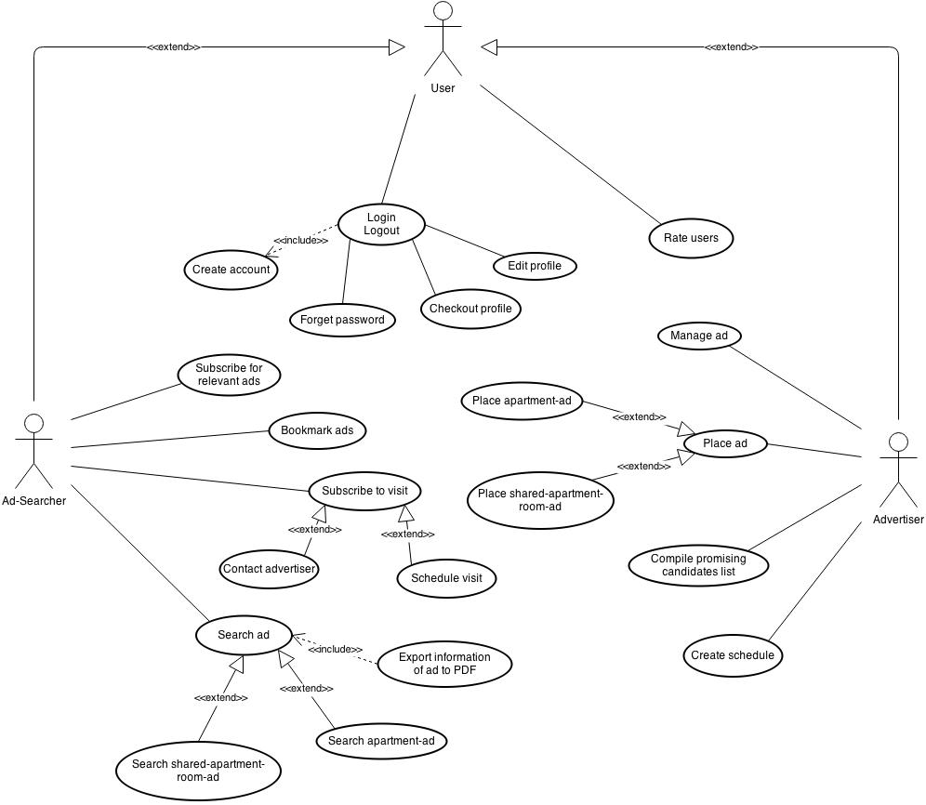
Shared Apartment Web Platform

Use cases
- Place ad
  - Actors
User (Advertiser)

  - Description
As advertiser I want to place an ad on the website.

  - Trigger
The advertiser clicks the register “Place Ad”.

  - Pre-conditions
    - User (advertiser) has an account
    - User (advertiser) must be logged in

  - Post-conditions
    - Ad is on the website
    - Advertiser will be informed when a user (ad-searcher) wants to visit the advertised object

  - Main Scenario
    - Advertiser goes to the register "Place Ad"
    - Advertiser fills out the required information about the object to be advertised
    - Advertiser enters additional non-mandatory information if he likes to do so
    - Advertiser clicks onto "Save"
    - System checks that all mandatory information is given.
    - System asks the advertiser to confirm
    - Advertiser confirms by clicking onto "Save" again
    - System saves everything and places the ad
    - System returns to start page

  - Alternative Scenarios
3a. Advertiser wants to cancel the ad placement
- Advertiser clicks onto "Cancel"
- System asks the advertiser whether he is sure to cancel and discard all
- Advertiser clicks onto "Yes"
- System returns to start page

5a. Advertiser did not enter all mandatory information
- System prompts the message "Pleas fill out all mandatory field"
- Advertiser fills out all mandatory fields
- Use Case resumes at step 4

6a. Advertiser wants to make some changes after clicking onto "Save"
- Advertiser clicks into a field he wants to edit
- Advertiser mutates the field
- Use Case resumes at step 4

  - Special Requirements
None

  - Notes
Some information must be entered to create an ad successfully.

- Create schedule to manage visit
  - Actors
User (Advertiser)

  - Description
As advertiser I want to manage the visits to my placed apartment(s)/room(s)

  - Trigger
Advertiser clicks onto "Create Schedule"

  - Pre-Conditions
    - User (advertiser) has an account
    - User (advertiser) must be logged in
    - Advertiser has placed at least one ad

  - Post-Conditions
    - Advertiser can see his schedule
    - Other ad-searcher can see the schedule and subscribe

  - Main Scenario
    - Advertiser clicks onto "Create Schedule"
    - A window pops out with a calendar and fields for setting intervals for visits
    - Advertiser clicks on a date
    - Advertiser selects start- and end-time of one interval
    - Advertiser clicks onto "Save"
    - System asks whether the advertiser is sure or not
    - Advertiser clicks onto "Yes" to confirm
    - System saves the timetable
    - System returns to start page

  - Alternative Scenarios
6a. Advertiser wants to edit before saving
- Instead of clicking “Yes” the advertiser clicks onto "No"
- Use Case resumes at step 3

  - Special Requirements
None

  - Notes
None
- Manage ads
  - Actors
User (Advertiser)

  - Description
As advertiser I want to manage my ads

  - Trigger
Advertiser clicks onto "Manage ad"

  - Pre-Conditions
    - User (advertiser) has an account
    - User (advertiser) must be logged in
    - Advertiser has placed at least one ad

  - Post-Conditions
    - System saves the changes

  - Main Scenario
    - Advertiser clicks the tab “My Page”
    - Advertiser clicks on “My Ads”
    - System shows a list with all the ads the advertiser has placed
    - Advertiser clicks onto an ad to be managed
    - System shows the ad
    - Advertiser clicks onto “Edit”
    - System shows the edit-ad mask
    - Advertiser edits the ad
    - Advertiser clicks onto "Save"
    - System asks whether the advertiser is sure or not
    - Advertiser clicks onto "Yes" to confirm
    - System saves the changes and returns to the list

  - Alternative Scenarios
8a. Advertiser wants to see preview before saving
- Advertiser clicks onto “Preview”
- System provides a preview of the ad
- Advertiser clicks onto “Close preview”
- Use Case resumes at step 9

  - Special Requirements
None

  - Notes
None

- Search ad
  - Actors
User (Ad-Searcher)

  - Description
As searcher I want to look for a website which provides the ads which fit my requests.

  - Trigger
The searcher clicks onto the tab "Search Ad"

  - Pre-Conditions
    - The user (searcher) has an account
    - The user (searcher) must be logged in

  - Post-Conditions
    - The searcher is shown a list of ads that meets his properties
    - The searcher can contact the advertisers to visit the objects

  - Main Scenario
    - Searcher clicks the tab “Search Ad”
    - System shows a site where the searcher can enter his search-criteria
    - Searcher enters his requirements about the object he looks for
    - Searcher clicks onto "Search"
    - System provides a list with all objects that matches the requirements
    - Searcher clicks onto an object to see it

  - Alternative Scenarios
2a. Searcher wants to see the ads on the map-view
- Searcher clicks onto “Map View”
- System shows a map of Switzerland with all available rooms and apartments
- Searcher enters the requirements of the object he looks for
- Searcher zooms onto the desired area
- System refreshes the map and only shows the ads in places that match the criteria
- Searcher clicks onto the icon of an object to see it

4a. No ad matches the entered search-criteria
- System shows the error message “No ad matches your criteria. Please adapt.”
- Searcher clicks “OK” to return to the search-site with the filled search-criteria
- Searcher changes the search-criteria
- Use Case resumes at step 4

  - Special Requirements
None

  - Notes
None

- Compile promising candidates list
  - Actors
User (Advertiser)

  - Description
As advertiser I want to compile a list of most promising candidates for a placed ad

  - Trigger
Advertiser clicks onto "star"

  - Pre-Conditions
    - User (advertiser) has an account
    - User (advertiser) must be logged in
    - Advertiser has placed at least one ad

  - Post-Conditions
    - System provides a list of the marked candidates

  - Main Scenario
    - Advertiser clicks the tab “My Page”
    - Advertiser clicks onto “My Ads”
    - Advertiser clicks onto the ad he wants to create a list of favorite candidates for
    - System shows the ad
    - Advertiser clicks onto "Show Candidates"
    - System provides a list of candidates (who subscribed for the schedule) for the ad
    - Advertiser clicks onto the "star" of candidates to add them to his favorites for the ad
    - Advertiser clicks "OK"
    - System return to the ad
    - Advertiser clicks onto "Favorite Candidates"
    - System shows the candidates added to the favorites
    - Advertiser can export the list by clicking onto "Export List"

  - Alternative Scenario
6a. Advertiser wants to examine candidates before adding them
- Advertiser clicks onto the name of a candidate
- System shows the profile of the candidate
- Acvertiser adds the candidate to favorites by clicking onto "star" to add the candidate to his favorites or returns to the list by clicking onto "Go Back"
- System shows all candidates and the examined one now is marked too
- Use Case resumes at step 7

  - Special Requirements
None

  - Notes
None

- Create Account
  - Actors
User

  - Description
As advertiser I want to be able to create ads, manage them and have an overview of my ads.
As searcher I want to let the advertiser know that I am trustful.

  - Trigger
Fill out the Registration-Form on the Login-Site and clicking on "Register"

  - Pre-Conditions
    - The username entered must be unique

  - Post-Conditions
    - An account is created and the user can set up his profile by clicking the tab "Profile".
    - User is able to log in, search for ads, place ads, edit his profile, manage his ads and log out.

  - Main Scenario
    - User fills out the Registration-Form with unique username, email and a password
    - User clicks onto "Register"
    - System prompts the information that the account is successfully created
    - User clicks onto "Close"
    - User is on the main site of the website

  - Alternative Scenario
2a. Username already exists
- System promts the information that the entered username already exists next to the field "Username"
- User enters another username
- User clicks onto "Register"
- If the entered username is unique, Use Case resumes at step 3
Else Use Case goes back to step a

  - Special Requirements
None

  - Notes
Account can only be created if the username does not exist yet.

- Edit profile
  - Actors
User

  - Description
As user I want to be able to adjust my profile.

  - Trigger
User clicks in the field he wants to edit in the tab "Profile"

  - Pre-Conditions
    - User has an account
    - User must be logged in

  - Post-Conditions
    - System has saved the changes the user has made in his profile

  - Main Scenario
    - User clicks the tab “Profile”
    - System shows user's profile, where user can click into the field he wants to change
    - User clicks in the field
    - User makes changes
    - User clicks on “Save”
    - System shows user's profile with the changes

  - Alternative Scenario
2a. User does not use his account anymore
- User clicks on “Delete Account”
- System asks the User whether he is sure he wants to delete his account.
- User clicks “Yes" to confirm
- System informes the User that his account has been deleted successfully
- User clicks “OK”
- User is on the Login page

  - Special Requirements
None

  - Notes
None

- Check-out profile
  - Actors
User

  - Description
As a user I want to look at the profile of an advertiser or a candidate

  - Trigger
User clicks on the name of another user

  - Pre-Conditions
    - User has an accont
    - User must be logged in

  - Post-Conditions
    - System shows the user the profile of another user he wants to check

  - Main Scenario
    - Searcher clicks the tab "Search Ad"
    - Searcher fills out the search criterias of an object
    - System shows a list with objects which matches the search-criteria entered
    - Searcher clicks onto an interested object
    - System shows the object
    - Searcher clicks onto the name of the advertiser
    - System shows the profile of the advertiser

  - Alternative Scenario
    - Advertiser clicks the tab "My Page"
    - Advertiser clicks onto "My Ads"
    - System shows all ads the advertiser has placed
    - Advertiser clicks onto an ad
    - System shows the object
    - Advertiser clicks onto "Show Candidates"
    - System provides a list of candidates (who subscribed for the schedule) for the ad
    - Advertiser clicks onto a candidate-name
    - System shows the pofile of the candidate

  - Special Requirements
None

  - Notes
None

- Bookmark ads
  - Actors
User (Ad-Searcher)

  - Description
As searcher I want to be able to bookmark ads so they are saved and easy to find again

  - Trigger
User clicks onto "star" of an ad

  - Pre-Conditions
    - User (searcher) has an account
    - User (searhcer) must be logged in
    - Searcher has searched for ads

  - Post-Conditions
    - The ad is saved in the tab "My Favorites"

  - Main Scenario
    - Searcher clicks on an ad intrested
    - Searcher clicks onto the "star"
    - System saves the ad to the favorite list of the user

  - Alternative Scenario
    - Seracher already knows the ad
    - Searcher clicks directly on the "star"
    - Use Case resumes at step 3

  - Special Requirements
None

  - Notes
None

- Export information from ad
  - Actors
User (Ad-Searcher)

  - Description
As searcher I want to export the information of an ad as PDF

  - Trigger
Searcher clicks onto “Export as PDF”

  - Pre-Conditions
    - User (searcher) has an account
    - User (searcher) must be logged in
    - Searcher has seached for an ad
    - Seacher has clicked on an object
    - System shows the object

  - Post-Conditions
    - Searcher gets the information wanted as PDF
  - Main Scenario
    - Searcher clicks onto “Export as PDF”
    - Window pops out with all your folders
    - Searcher goes to the folder he wants to save the PDF
    - Seacher clicks "Save"
    - System exports the information as PDF
    - System returns to the ad

  - Alternative Scenario
None

  - Special Requirements
None

  - Notes
None

- Subscribe for relevant ads
  - Actors
User (Searcher)

  - Description
As searcher I want to be able to subscribe for relevant ads so I'm informed when something new is placed

  - Trigger
Searcher clicks onto “Subscribe criteria”

  - Pre-Conditions
    - User (searcher) has an account
    - User (searcher) must be logged in

  - Post-Conditions
    - System informs the searcher as soon as a new ad is placed which matches the criteria subscribed

  - Main Scenario
    - Searcher clicks the tab "Search Ad"
    - Searcher enters the search-criteria
    - Searcher clicks onto “Subscribe criteria”
    - System asks the searcher wheter he is sure he wants to subscribe to the criteria entered
    - Searcher clicks "Yes" to confirm
    - System informes the seacher “A new subscription is added”

  - Alternative Scenarios
4a. Searcher wants to edit his search-criteria
- Searcher clicks onto “No”
- System returns to the search-site which still contains the entered search-criteria
- Searcher edits the search-criteria
- Use Case resumes at step 3

6a. Searcher wants to unsubscribe specific search-criteria
- Searcher clicks the tab "My Page"
- Searcher clicks onto "My Subscriptions"
- System shows the list of subscriptions
- Seacher clicks onto "Delete" of the subscription he wants to unsubscribe
- System asks the seacher whether he is sure he wants to unsubscribe
- Searcher clicks "Yes" to confirm
- System showls the list of subscription without the just unsubscribed one

  - Special Requirements
None

  - Notes
None
- Subscribe to visit
  - Actors
User (Ad-Searcher)

  - Description
As searcher I want to make a date to visit the object

  - Trigger
Searcher clicks onto "Visit"

  - Pre-Conditions
    - User (searcher) has an account
    - User (searcher) must be logged in
    - Searcher has opened the ad of the desired object
  - Post-Conditions
    - Searcher gets an answer what time he can visit the object or
    - Seacher has informed the advertiser what time he will visit the object by choosing available visit-times, determined by the adveriser

  - Main Scenario
    - Searcher clicks onto "Visit"
    - Searcher choses one or more available date and time to visit the object, these are determined by the advertiser
    - Searcher clicks on "Subscribe"
    - System informs the searcher that his enquiry was successful

  - Alternative Scenario
    - Searcher doesn't have the time at the given appointments, so he writes a message to the advertiser
    - Searcher writes a small text in the contact-box
    - Searcher clicks on "Send"
    - System informs the searcher that his message has been sent successfully
    - Searcher has to wait for an answer from the advertiser

  - Special Requirements
None

  - Notes
None

Requirements

Functional
- Any person could register into the system by filling out a form and so become "a user". This is obligatory in order to use the system. The registration-form includes a username, an email and a password for each user.
- No two users could have the same username.
- A user who wants to use the system will need to fill in a username and password in order to log in to the system.
- A user should be able to log out of the system.
- A user should be able to place an ad for shared-/apartment for rent.
- Users should be able to add photos to their ads.
- Users should be able to enlarge photos to watch them.
- A user should be able to search the ads according to his preferences (area, price etc.)
- A user, who is interested in a property, should be able to add it as a bookmark.
- A user should be able to filter the followers according to their visible data and to his/her preferences.
- Users should be able to schedule a visit for seeing a property through the system.
- A user should be able to select which of his personal data will be available to other users.
- Users should be able to rate one another for reliability.
- The system should be able to generate a PDF from an ad.
- The system should be able to alert users about new, relevant ads.
- The Application must include a map, on which all the available properties for rent will be presented.
- Users should be able to send each other messages inside the system.
- The system should allow the user to send emails: either by connecting to the user’s mail application or through an integrated email system.
- The system should be able to send important messages (i.e. someone is interested in an ad, someone has set an appointment etc.) to its users by email.

Non-functional

Product requirements
- System should run on Google Chrome and Safari.
- Desktop and mobile version desirable.
- Ads could be placed in German, French, Italian and Rumantsch.
- The registration process should not take (for the average user) longer than 3 minutes.
- Logging into the system (once username and password had been typed in) should not take longer than 3 seconds.
- The System shall have an availability of 999/1000 or 99% (This means that out of every 1000 requests for a service, 999 must be satisfied).

Organisational requirements
- The system must store all the users and ads in a data base.
- The system should be usable by people from all over Switzerland.
- The first release of the system (version 1) must be ready by November 5th.
- The second release of the system must be ready by December 3rd.

External requirements
- Users should be able to access their personal data and ads at any time to inspect and edit it.
- The users' personal data should be well protected.

