**Project Proposal Name: ATC Madness**

**Project Description:**

ATC Madness is a game in which the user acts as an air-traffic controller and manages air traffic from a top-down view of an airport. The player will direct planes either to land or to take off such that they don’t collide, as well as doing so efficiently so their efficiency rating will not go down.

**Competitive Analysis:**

**Main idea:**

Deal with airplane landing, takeoff, and taxi requests in a sophisticated manner to gain a higher efficiency rating and ultimately not lose (by causing a collision).

**Similar Projects and Comparison Analysis**

**ATC Chaos:** Air traffic control game in which the user deals with up to 8 planes at once, and if the planes are not attended to, pilots’ stress levels increase, and chance of collision becomes higher.

<https://www.youtube.com/watch?v=PK4qFZIn4TI>

**Airport Madness: World Edition:** A game in which the user managers air traffic in the air and on ground. The player receives both a score for the number of planes helped, and an efficiency rating. In another game mode, the player can play against the clock.

<https://www.youtube.com/watch?v=9mSIJBelow4>

Ultimately, my game will be the same as the two mentioned above by requiring the user to manage both air traffic on the ground and in the air. My game will contain an efficiency rating, as well as award points to every plane that is attended to. The final score of the game will be based on the number of planes helped and the efficiency rating (due to how quickly the user handles requests). Instead of having a time trial game mode, my game will include an easy, medium, and hard mode which will increase the number of planes in the game over time, and decrease the number of parking spots in the airport that landing planes have available to them.

**Structural Plan:**

* Main game (contains info about how objects interact) will be on its own
* Each class will be in their own file, in a folder titled (Objects)

**Algorithmic Plan:**

The most complex component of the project will be the map generation which is random. To do this, I will set constraints for runways such that they cannot overlap with other objects on the map, and they must always have a path connected to the terminal so the planes can taxi there after landing. (Additionally, the background will be random as well as the runway images).

Each airplane will be an object, as well as each runway and each taxi path that directs to the terminal. This way, it will be clear when the plane is at which state of its journey (taxi, land, or takeoff points), and this state will be simply dictated by what coordinates it is currently at. At each state in their journey, the planes will have an interactive UI when selected so they can be directed toward their next destination. This will require the user to take note of which planes are where, so they can direct planes to their respective locations in soon enough time without collision. The user will also be able to speed up, slow down, or expedite the take off of planes in case of a close call (this will result in the decrease of the efficiency rating, as will taking too long to take certain actions).

**Timeline Plan:**

* Finish map generation by Wednesday 4/28
* Finish plane landing, taking off, traffic patterns by Friday 4/31
* Finish Transition screens by Friday 4/31
* Finish graphics by Tuesday 5/4
* Finish help mode and other priority extras (audio, etc) by Wednesday 5/5
* Finish least priority extras (e.g leaderboard and leaderboard I/O) by TP3

**Version Control**

* Everything is on drive.

**Module List (External)**

* Playsound (for sounds and audio)

**Storyboard:**

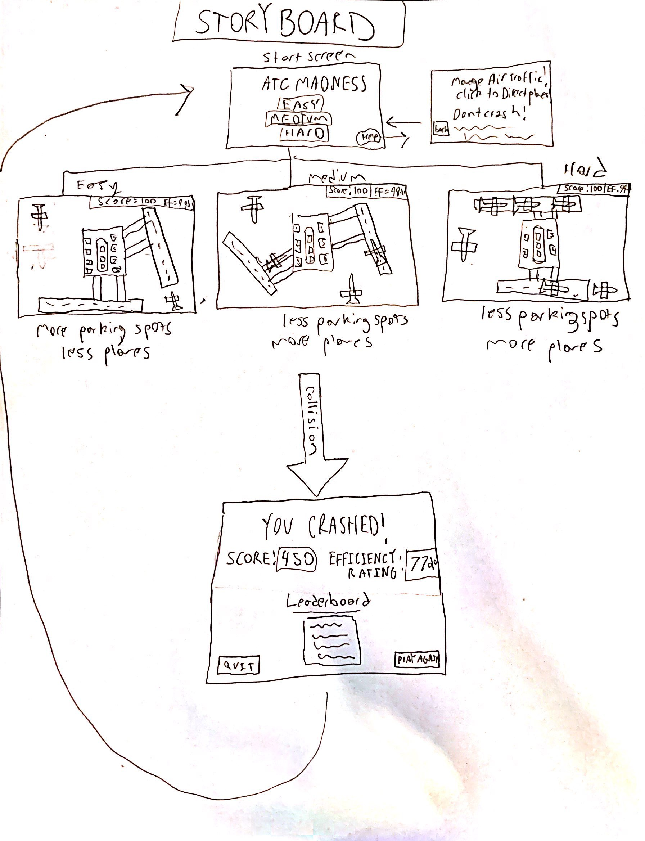

**TP2 Update:**

Changed design to allow for user to interact with airplanes more. User must drag mouse to change the path and manage multiple plane paths at once. Additionally, taxiways are maze like (not straight paths anymore) which adds complication to planes that are taxiing on the ground.

**TP3 Update:**

Added one more plane sprite. Changed background to include color backgrounds instead of photo backgrounds that caused lag. Changed name to ‘Plane Lander Madness’