Josue Gallardo

Antonio Rojas

Justin Yum

CIS 444

11/21/2022

Web Pages

1)

Home page

Sudo:

Page:

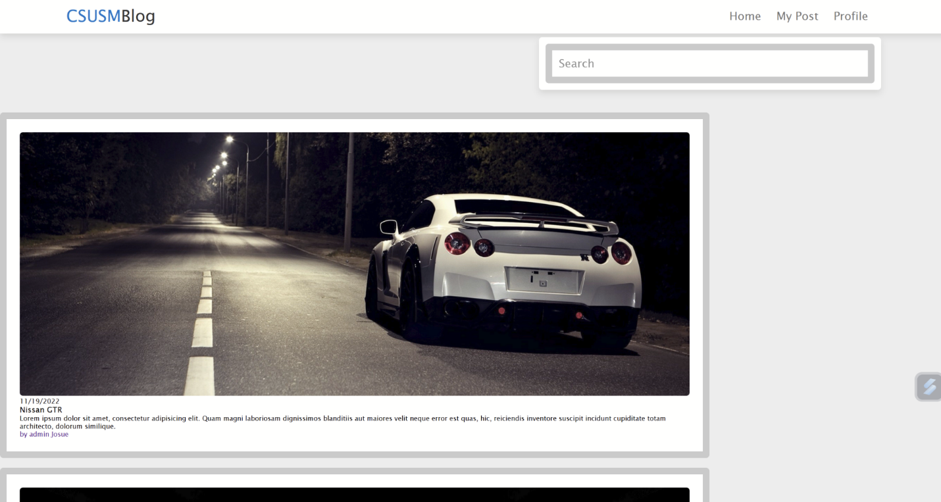

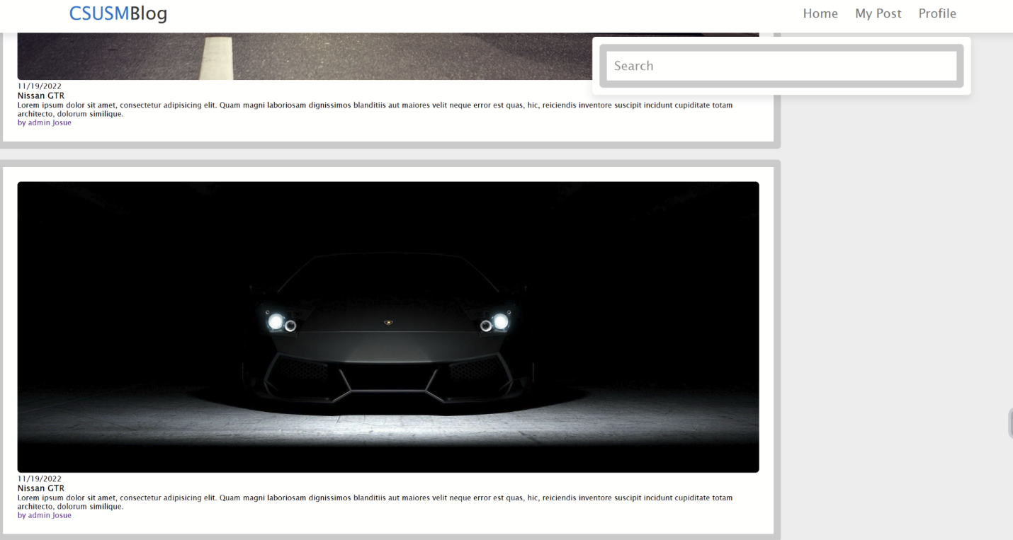

2)

Post individual content

Sudo:

Page:

3)

Create a post

Sudo:

Page:

