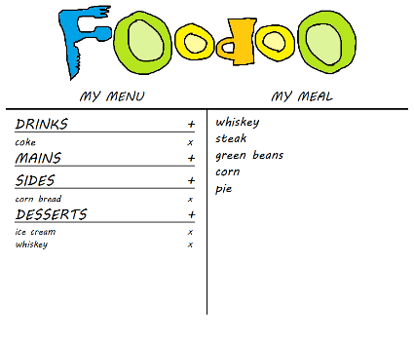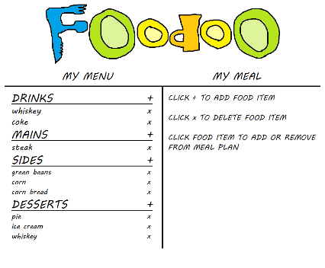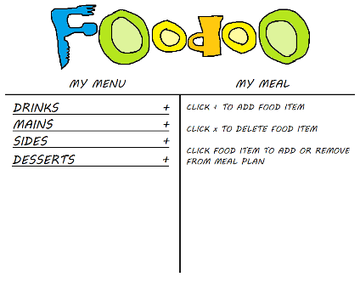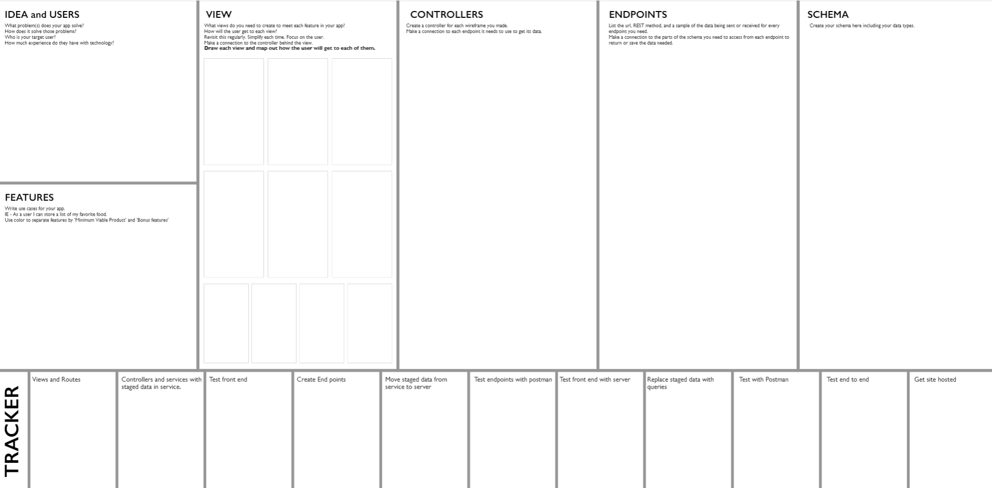

|  |  |  |
| --- | --- | --- |
| **Criteria** | **Each/Total** | **Me** |
| **Stateful component** | 5/15pts | 5 |
| **Stateless, display component** | 5/10pts | 10 |
| **Express Endpoint** | 2/8pts | 8 |
| **One endpoint that uses req.body** | 5/5pts | 5 |
| **Use a component more than once** | 5/10pts | 0 |
| **Parameters/Queries** | 2/6pts | 6 |
| **Full CRUD** | 5/5pts | 5 |
| **Controller File** | 5/5pts | 5 |
| **REST Method** | 5/5pts | 5 |
| **Promises (.then & .catch)** | 5/5pts | 5 |
| **Destructuring** | 2/6pts | 6 |
| **Remove Default Styling** | 2/2pts | 2 |
| **Change Site Title** | 2/2pts | 2 |
| **Flex Box** | 10/10pts | 10 |
| **Semantic Tags** | 2/6pts | 6 |
| **REQ’D** – Client/Server | REQ’D |  |
| **REQ’D** – Plan Approval | REQ’D |  |
| Total Points: | 100 | 80 |

ADD EDIT FOR FULL CRUD

68

a

Minimum features:

* Users can add/delete from list of available food
* Users can add/delete from list of available food added to meal plan

Bonus features:

* Users can edit their list items after adding it to their meal
* Users can share meal plan by clicking share button

Solves: Users can plan out a meal

How solves: Users input what foods they have available, and then pick from this list to put it all together into a meal plan.

Target User: People that want organization in their meal planning and like visual feedback before committing to a choice

User Exp. Req’d: Must be able to type and click.