*User Guide*

**License Generator**

release v0.1

Contents

Installation 3

On windows: 3

On linux (AMD64) 4

How to use: 5

Description 5

Buttons: 7

Menu: 8

License Generation 9

1. Create a key 9

**2.** Generate the license 10

3. Verify the license 11

# Installation

## On windows:

1. Download .exe file from [the repository](https://git.esempla.com/business/grm/license-generator/wikis/uploads/171047bfaa575722daaacf080506327b/LicenseGen-0.1.exe)
2. 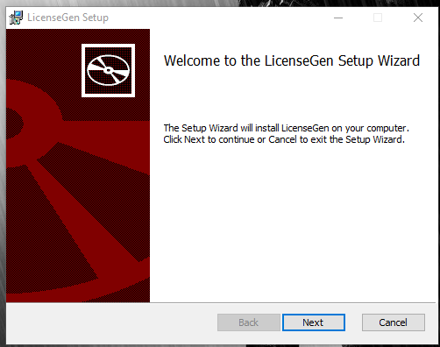Run the installer
3. 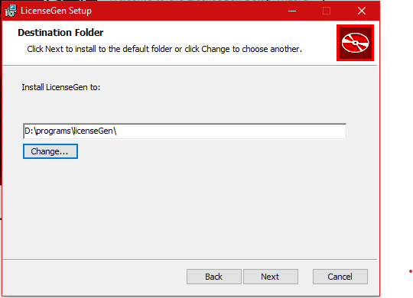Select the installation folder:
4. **Install**

## On linux (AMD64)

1. Download – amd64 - .deb file [from the repository](https://git.esempla.com/business/grm/license-generator/wikis/uploads/f5cbadfb395a754ff9a40d3e479f45ba/licensegen_0.1-1_amd64.deb)
2. Run the installer:

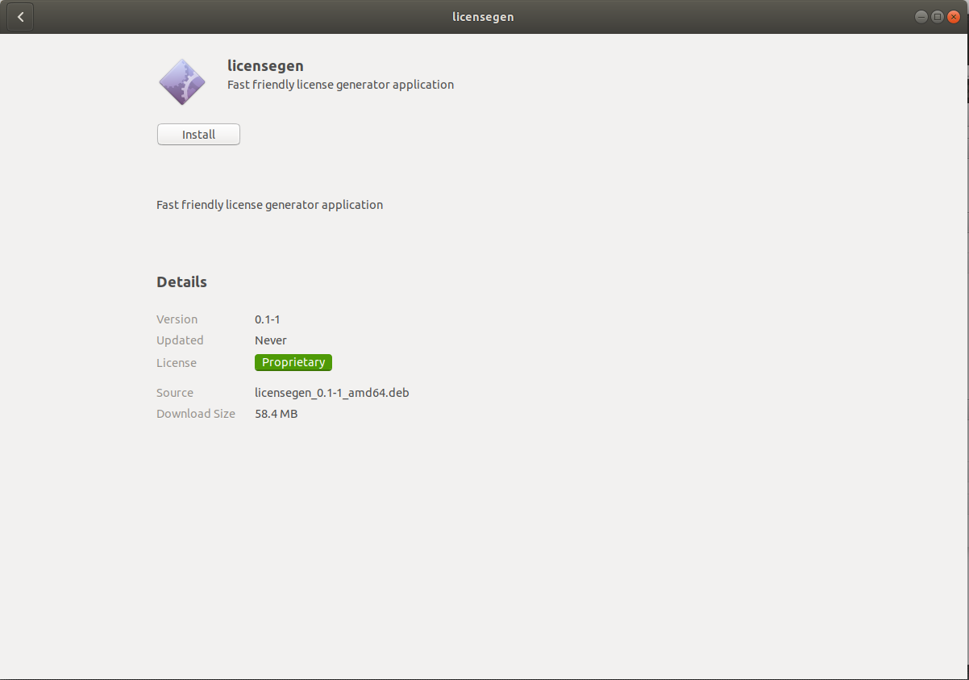

1. **Install**

# How to use:

## Description

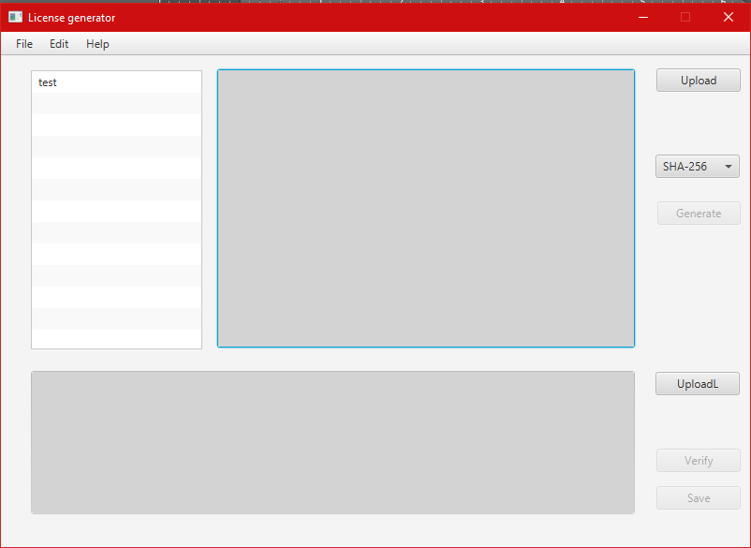

Figure 1:Main window

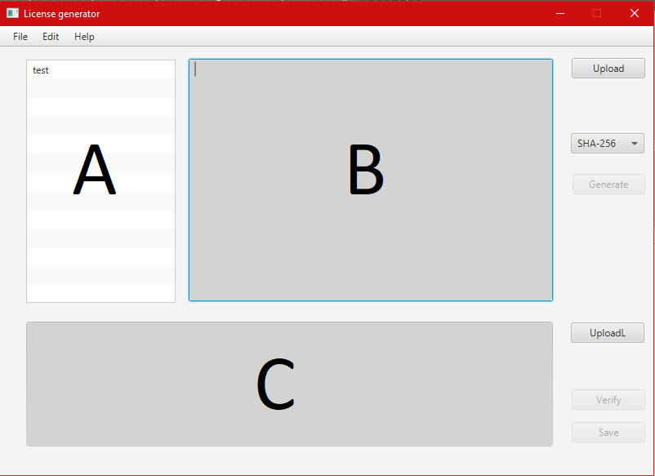

The **A area** is the section where all available keys are stored. When starting the program is search for the keys in the **Key** folder in the **.licenseGenerator** folder in the **User_Home** directory. When adding a new key, it will be displayed in the **A** **area** as well. The new generated keys automatically will be saved in the **Key** directory.

The **B area** is the section where the **text of the license** is written. The **text of the license** can be written in the section or can be **uploaded from a file**

**If the text written in this area isn’t formatted as a license, the Generate button will not be available to push.**

The **C area** is the section where the encrypted license will be shown.

## Buttons:

**Upload** – uploads the text of a license from a file

**Generate** – generates the encrypted license. **It will be unavailable if a key is not selected or the license text isn’t formatted as a license or a hash algorithm is not chosen (from choice Box)**

**UploadL** – uploads an encrypted license from a file (used to check if the file is an encrypted license or if It was encrypted with a specific key)

**Verify** – used to check if the license was encrypted with a specific key (a key from key list should be chosen)

**Save –** used to save the encrypted license in different formats (BIN or BASE64 or TXT)

## Menu:

1. File
   1. **New Key** – used to create a new key

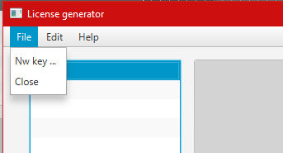

1. Edit
   1. **Show Dump Public key –** used to show the dump public key for the selected key
   2. **Save Dump Public key –** used to save the dump public key on the PC
   3. **Delete key –** used to delete a key (deleted keys can’t be restored )

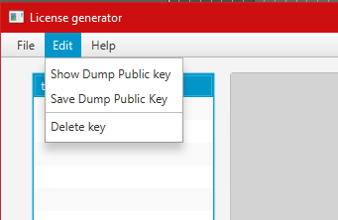

# License Generation

## Create a key

* 1. File -> New Key

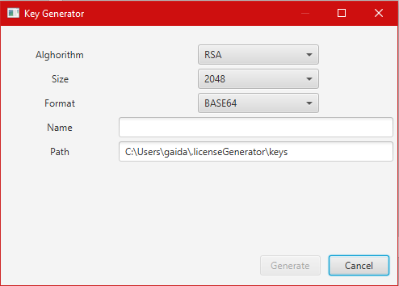

Figure 2: New key panel

* 1. Select the encryption algorithm
  2. Select the size of the key
  3. Select the format in which the key will be stored
  4. Name the key. **In Path will be shown the path for the new key.**
  5. 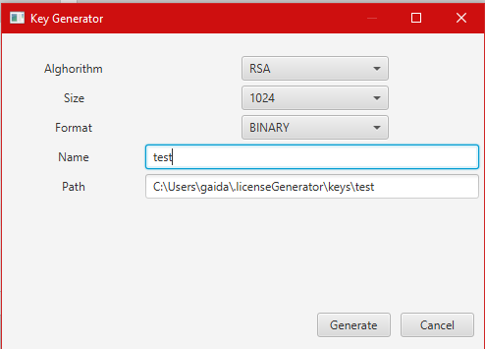**Generate**

## Generate the license

* 1. Write or upload a valid license

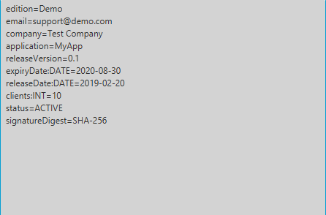

* 1. Select a hash algorithm (SHA-256, SHA-512) for choice box
  2. **Generate**

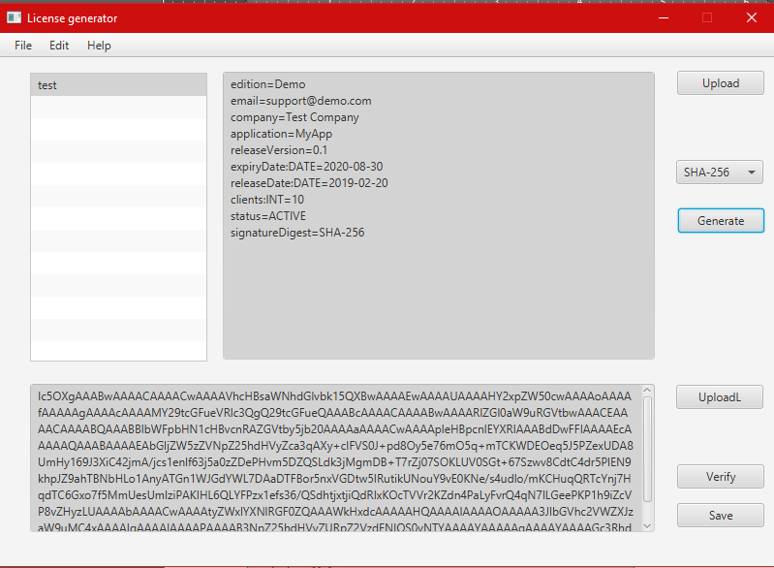

* 1. **Save** the license to a file (Available formats are .bin, .base64, .txt)

## Verify the license

the license can be uploaded with **UploadL** Button

* 1. Select a key.
  2. Click **Verify –** if the license is generated with the selected key, then it will cover in green, if not then in red