Problem 5.2.a):

The first regular fodo cell in the given lattice sits between 430 and 565 m from IP1. The basic straight cell (no bends) gives is plotted below:

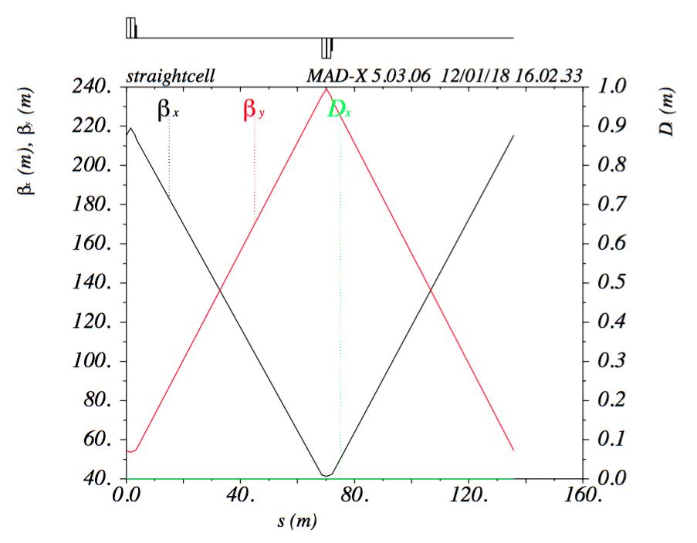

while the regular arc cell is plotted below:

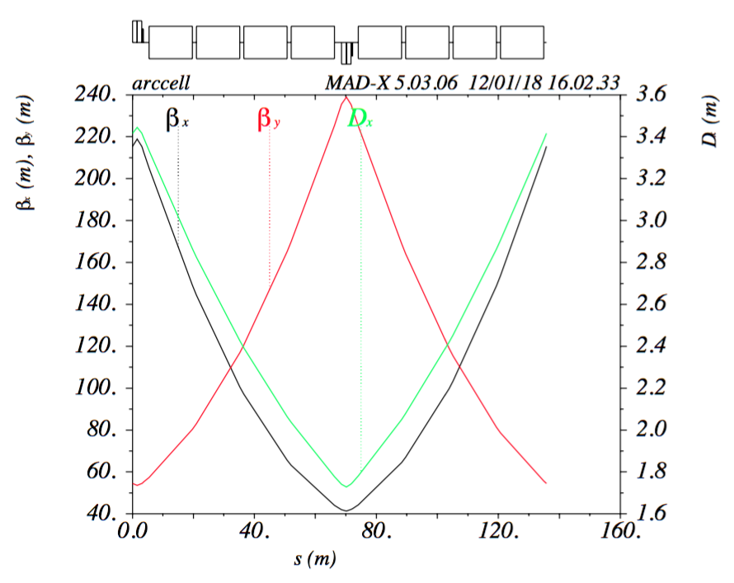

NOTE: the sextupoles following each dipole have been removed from the sequence, since they were OFF.

The source code is attached.

myJob.madx

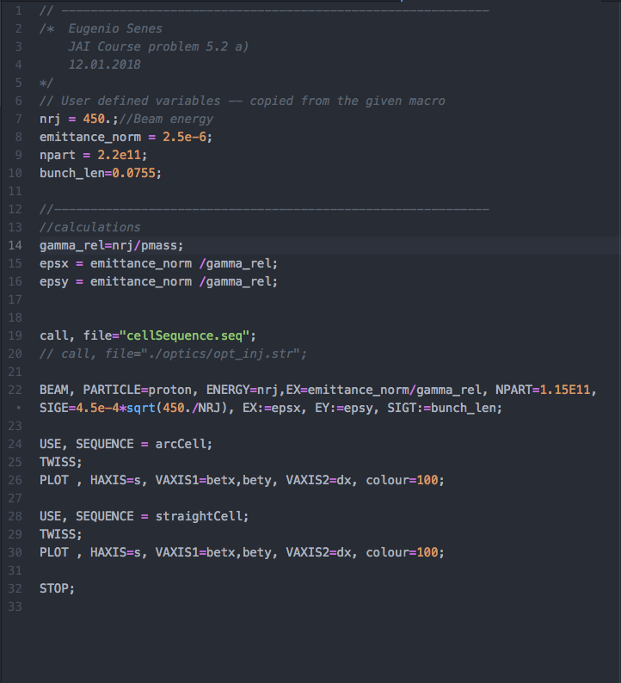

cellSequence.seq

