# Stock Market exchange report.

| Trade No | Company name | Cost Price of a Share | Number of Shares | Sales Price of a Share | Net Profit/Loss |
| --- | --- | --- | --- | --- | --- |
| 1 | A.H. Belo Corp. | $70 | 50 | $75 | Net Profit/Loss |
| 2 | Abercrombie & Fitch Company | $69 | 200 | $71 | Net Profit/Loss |
| 3 | Abm Industries Incorporated | $101 | 120 | $112 | Net Profit/Loss |
| 4 | ACA CAPITAL HOLDINGS | $170 | 20 | $172 | Net Profit/Loss |
| 5 | Accretive Health | $120 | 53 | $135 | Net Profit/Loss |
| 6 | Ace Limited | $90 | 73 | $85 | Net Profit/Loss |
| 7 | Advanced Micro Devices | $98 | 22 | $101 | Net Profit/Loss |
| 8 | Agco Corp. | $120 | 43 | $135 | Net Profit/Loss |
| 9 | Agl Resources | $130 | 84 | $132 | Net Profit/Loss |
| 10 | Agrium Inc. | $140 | 28 | $175 | Net Profit/Loss |
| 11 | Cabot Oil & Gas Corp. | $230 | 17 | $273 | Net Profit/Loss |
| 12 | Calix Inc | $354 | 35 | $343 | Net Profit/Loss |
| 13 | F.N.B. Corp. | $293 | 34 | $273 | Net Profit/Loss |
| 14 | Forestar Group Inc | $65 | 23 | $73 | Net Profit/Loss |
| 15 | Gabelli Utility Trust | $342 | 65 | $354 | Net Profit/Loss |
| 16 | Gamco Investors | $345 | 26 | $234 | Net Profit/Loss |
| 17 | Gannett Co. | $240 | 23 | $275 | Net Profit/Loss |
| 18 | Goodrich Corp. | $720 | 45 | $610 | Net Profit/Loss |
| 19 | M&F Worldwide Corp. | $470 | 83 | $435 | Net Profit/Loss |
| 20 | Macerich Company | $534 | 93 | $640 | Net Profit/Loss |
| 21 | Magna International | $843 | 27 | $820 | Net Profit/Loss |
| 22 | Mohawk Industries | $992 | 38 | $832 | Net Profit/Loss |
| 23 | Nabors Industries | $342 | 83 | $349 | Net Profit/Loss |
| 24 | Nalco Holding Company | $930 | 20 | $843 | Net Profit/Loss |
| 25 | Panhandle Royalty Company | $934 | 29 | $930 | Net Profit/Loss |
| 26 | Parkway Properties | $493 | 52 | $535 | Net Profit/Loss |
| 27 | Patriot Coal Corp. | $433 | 73 | $343 | Net Profit/Loss |
| 28 | Polo Ralph Lauren Corp. | $483 | 55 | $530 | Net Profit/Loss |
| 29 | Polyone Corp. | $918 | 44 | $958 | Net Profit/Loss |
| 30 | Post Properties | $281 | 83 | $332 | Net Profit/Loss |

# Northwind Database

**Database Diagram**

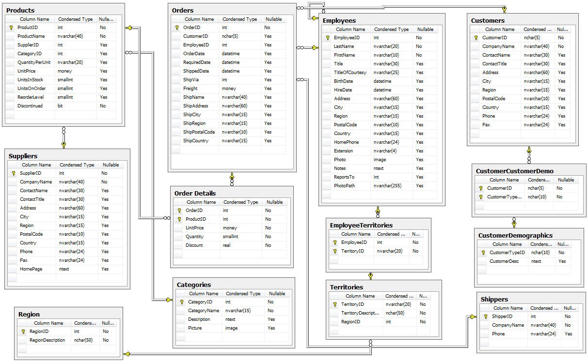

Figure(i) Database diagram of Northwind

The Northwind sample database (Northwind.mdb) is included with all versions of Access. It provides data you can experiment with and database objects that demonstrate features you might want to implement in your own databases.

It contains the following detailed information :

i). Suppliers/Vendors of Northwind – who supply to the company. You can refer **Figure (ii).**

ii). Customers of Northwind – who buy from Northwind.

iii). Employee details of Northwind traders – who work for Northwind. You can refer **Figure (iii).**

**Suppliers**

| **Supplier_ID** | **Company Name** | **Contact Name** | **Address** |
| --- | --- | --- | --- |
| 4 | Exotic Liquids | Charlotte Cooper | 49 Gilbert St. |
| 5 | New Orleans Cajun Delights | Shelley Burke | P.O. Box 78934 |
| 6 | Grandma Kelly's Homestead | Regina Murphy | 707 Oxford Rd. |
| 7 | Tokyo Traders | Yoshi Nagase | 9-8 Sekimai  Musashino-shi |
| 8 | Cooperativa de Quesos 'Las Cabras' | Antonio del Valle Saavedra | Calle del Rosal 4 |

## Tables Details

Northwind Database contains the following table:

|  |  |  |
| --- | --- | --- |
| **S.No.** | **Table name** | **Count** |
| 9. | Suppliers | 1 |
| 10. | Customers | 1 |
| 11. | Employees | 3 |
| 12. | Products | 1 |
| 13. | Inventory | 2 |
| 14. | Shippers | 1 |