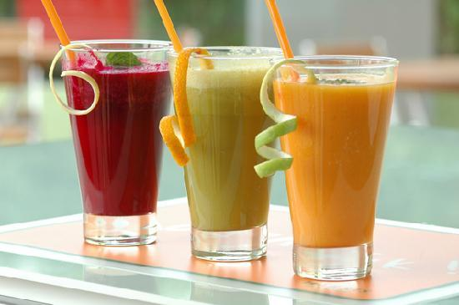

# John’s Juice Corner

John’s Juice corner was established in the year of 2002 by John. Initially it was started in a small shop. Today Juice corner has over 300 branches over USA. The secret behind this success story is the recipes of John’s Mother Angelica. She has discovered about 500 secret recipes which are all used by John.

|  |  |  |
| --- | --- | --- |
| **SNO** | **Product Name** | **Product Image** |
| **1** | **Apple Juice** | **//Apple Juice** |
| **2** | **Grape Juice** | **//Grape Juice** |
| **3** | **Hot Soup** | **//Hot Soup** |
| **4** | **Tender Coconut** | **//Tender Coconut** |
| **5** | **Vennila** | **//Vennila** |
| **6** | **Strawberry** | **//Strawberry** |
| **7** | **Cherry** | **//Cherry** |
| **8** | **Cone** | **//Cone** |