Adventure Works Cycles, the fictitious company on which the Adventure Works sample databases are based, is a large, multinational manufacturing company.

Product Overview



Figure I

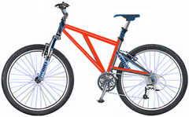

Figure II

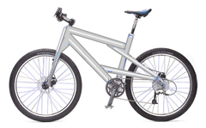

Figure III

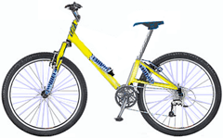

Figure IV