**CENG421 – Network Programming**

FINAL PROJECT

**Developing an FTP Server/Client with SSL(OpenSSL) Application**

**IBRAHIM ESER - 220206018**

**TURGUT KALFAOĞLU**

**Abstract**

This project aims to develop a File Transfer Protocol Server/Client Application securely. This security process will be obtained with Secure Sockets Layer (SSL) and Transport Layer Security (TLS). This server/client application sends a file from server to client. In this project, we will transfer a text and image file from server to client. We will use OpenSSL.

**Introduction**

One of the most used applications for file transfer is FTP. "File Transfer Protocol", or FTP, was developed as a file transfer protocol. It provides file transfer between two computers connected to the Internet. If you want to transfer your files to your website, you can do it easily thanks to the FTP application. It provides fast transfer of high-dimensional data between two computers. You can use the FTP application to download files as well as upload files.

Security is also the other important term for Network Applications. Many security protocols give us encrypted keys, and authentication information then we have the more secure client/server or peer-to-peer communication. OpenSSL is an open-source implementation of the SSL and TLS protocols. The main library built with the C programming language implements the basic encryption graph.

**Implementation of the Project**

1. **Required Tools**

**Installing GCC**

The first step is to get the C compiler, gcc, installed.

*sudo apt-get install build-essential*

or

*sudo apt-get install gcc*

**Installing OpenSSL**

OpenSSL can be tricky. You can try your distribution's package manager with the

following commands:

*sudo apt-get install openssl libssl-dev*

*#NOTE#*

*Since Linux distribution that I use in Virtualbox is constantly crashing, I have completed some of the processes I have done there through Windows Subsystem for Linux (WSL). Ubuntu and Debian WSL.*

1. **Creating Authentication Certificate for SSL**



1. **Developing an FTP server and an FTP client application.**
   1. **Compiling server and client**

**Compiling server side**

Compilation requires that the crypto and ssl libraries from the OpenSSL kit be linked in with

*gcc -o ftpserver ftpserver.c -lcrypto -lssl*

**Compiling client side**

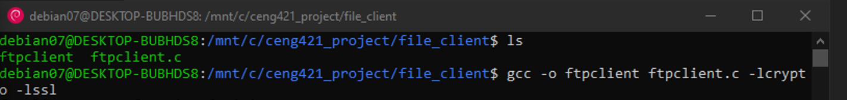

*gcc -o ftpclient ftpclient.c -lcrypto -lssl*

Running the server examples requires a PEM-style certificate. Running the server requires that the certificate be in the same directory as the server executable.

1. **Graphical user interface, text, application, chat or text message

   Description automatically generatedRunning FTP server/client app with OpenSSL**

*./ftpserver*

***./ftpclient [IP(Local Network)] [File at Server] [Destination File]***

*./ftpclient 127.0.0.1 text.txt /mnt/c/ceng421_project/file_client/new_text_1.txt*

*./ftpclient 127.0.0.1 image.txt /mnt/c/ceng421_project/file_client/new_image_1.txt*

**Resources**

**[1]** Davis, K., Turner, J. W., & Yocum, N. (2004). *The Definitive Guide to Linux Network Programming*. Apress.

**[2]** Winkle, L. V. (2019). *Hands-on network programming with C: Learn socket programming in C and write secure and optimized network code*. Packt Publishing.