CENG421 – Network Programming
FINAL PROJECT
Developing an FTP Server/Client with SSL(OpenSSL) Application
IBRAHIM ESER - 220206018
TURGUT KALFAOĞLU
Abstract
This project aims to develop a File Transfer Protocol Server/Client Application securely. This security process will be obtained with Secure Sockets Layer (SSL) and Transport Layer Security (TLS). This server/client application sends a file from server to client. In this project, we will transfer a text and image file from server to client. We will use OpenSSL.
Introduction
One of the most used applications for file transfer is FTP. "File Transfer Protocol", or FTP, was developed as a file transfer protocol. It provides file transfer between two computers connected to the Internet. If you want to transfer your files to your website, you can do it easily thanks to the FTP application. It provides fast transfer of high-dimensional data between two computers. You can use the FTP application to download files as well as upload files.
Security is also the other important term for Network Applications. Many security protocols give us encrypted keys, and authentication information then we have the more secure client/server or peer-to-peer communication. OpenSSL is an open-source implementation of the SSL and TLS protocols. The main library built with the C programming language implements the basic encryption graph.
Implementation of the Project
- Required Tools
Installing GCC
The first step is to get the C compiler, gcc, installed.
sudo apt-get install build-essential
or
sudo apt-get install gcc
Installing OpenSSL
OpenSSL can be tricky. You can try your distribution's package manager with the
following commands:
sudo apt-get install openssl libssl-dev

#NOTE#
Since Linux distribution that I use in Virtualbox is constantly crashing, I have completed some of the processes I have done there through Windows Subsystem for Linux (WSL). Ubuntu and Debian WSL.
- Creating Authentication Certificate for SSL

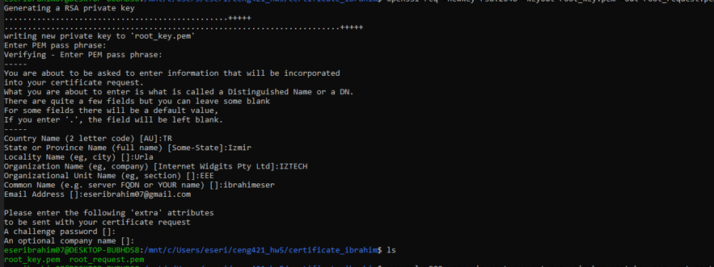
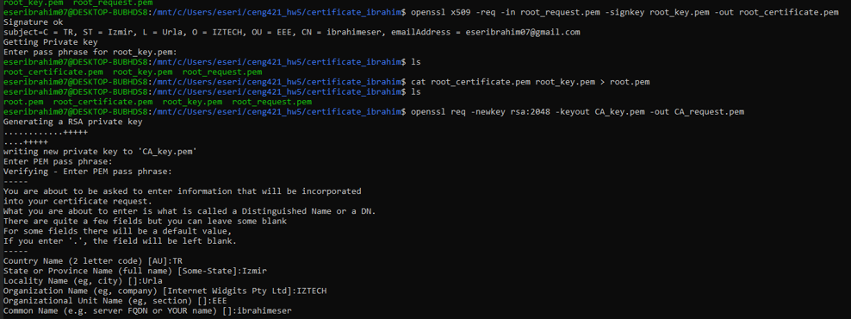
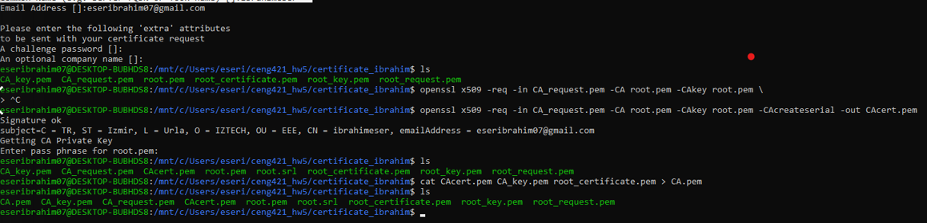

- Developing an FTP server and an FTP client application.
  - Compiling server and client
Compiling server side
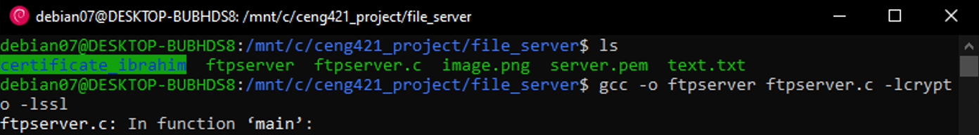
Compilation requires that the crypto and ssl libraries from the OpenSSL kit be linked in with
gcc -o ftpserver ftpserver.c -lcrypto -lssl
Compiling client side
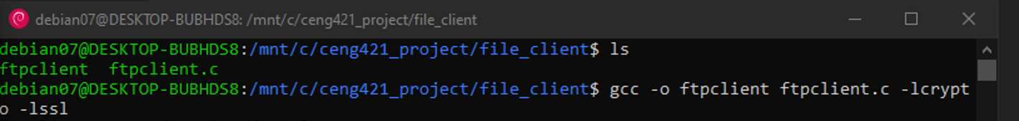
gcc -o ftpclient ftpclient.c -lcrypto -lssl
Running the server examples requires a PEM-style certificate. Running the server requires that the certificate be in the same directory as the server executable.
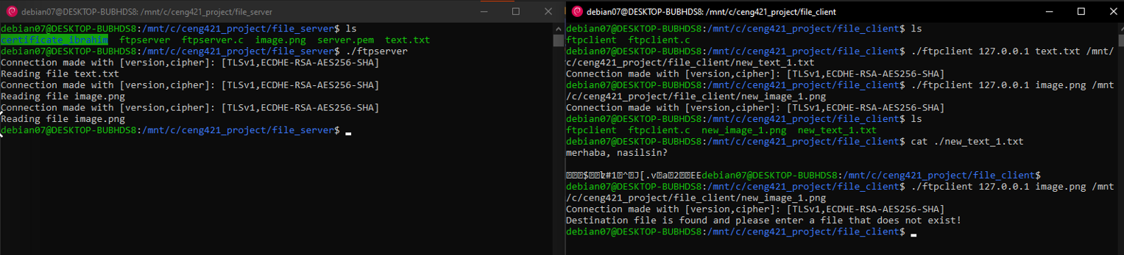
- Running FTP server/client app with OpenSSL

./ftpserver
./ftpclient [IP(Local Network)] [File at Server] [Destination File]
./ftpclient 127.0.0.1 text.txt /mnt/c/ceng421_project/file_client/new_text_1.txt
./ftpclient 127.0.0.1 image.txt /mnt/c/ceng421_project/file_client/new_image_1.txt

Resources
[1] Davis, K., Turner, J. W., & Yocum, N. (2004). The Definitive Guide to Linux Network Programming. Apress.
[2] Winkle, L. V. (2019). Hands-on network programming with C: Learn socket programming in C and write secure and optimized network code. Packt Publishing.

