Computer Vision Final Project Report

Author : Eser İnan Arslan

No : 1905482

Department : Computer Engineering

DataSets : “Baseline/highway” and “Baseline/pets”

**Subtractor parameters :**

history=80

varThreshold=40

detectShadows=True

**Frame Difference Parameters :**

Threshold : threshold(difference, 25, 255, cv2.THRESH_BINARY)

**GaussianBlur Parameters :**

(gray_frame, (5, 5), 0)

**Accuracy :**

In Frame differencing for highway

Accuracy: 0.4558492154268515

Frame differencing for pets

Accuracy: 0.5994759052212965

**Samples :**

***Highways***:

Input:

Frame Diff:

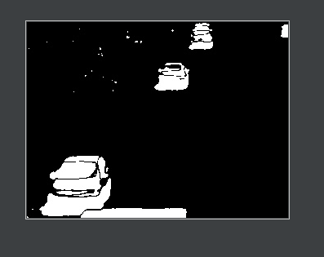

Median Filter:

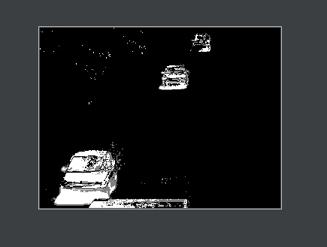

***Pets:***

Input:

Result:

