Write Manual Documentation Version LibreOffice Write: 7.2.5.2

Documentation module merge_docx

Define lang add extra module
If you want to define a language according to your criteria is optional
Inherit model and define function context_lang
Example 01:
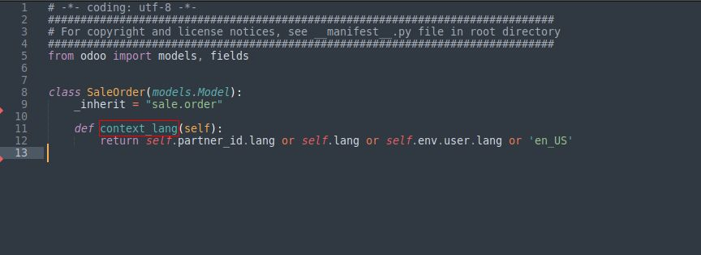
Example 02:
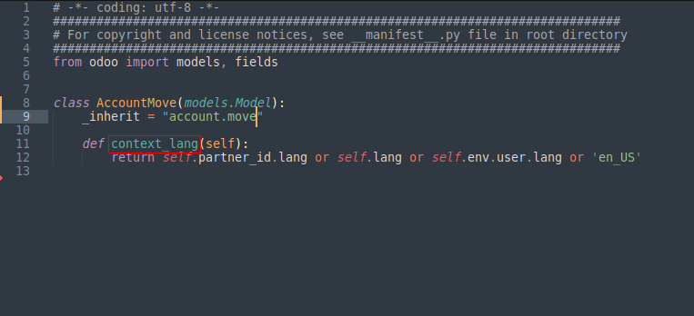
Three forms of translation
Lang is passed by context

01. Translate labels forms
Translate the label of the date_order field of the sale.order model add prefix bf_label_ before field name
Example: o.bf_label_date_order

02. Translate function _(‘Text to translate’)
First define the text to translate
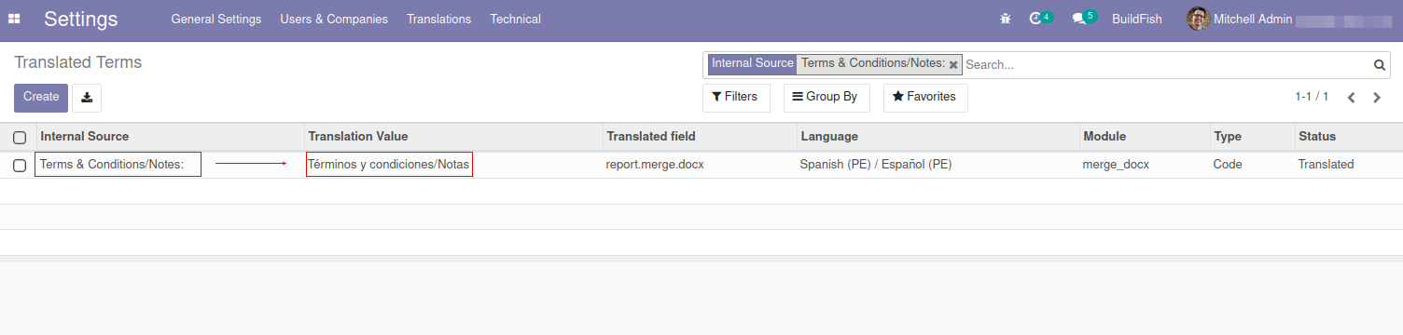
Example: _(‘Terms & Conditions/Notes:’)

03. Translate function _t(‘Name Translated field’)
Ideal for translating long texts
Search translated per field Translated field, Language & Type the language is passed by context and the code type is already defined

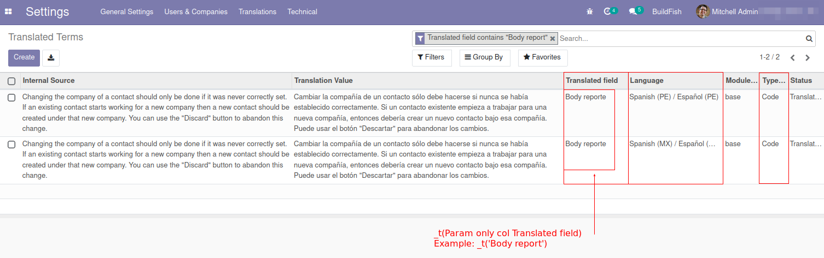
Example: _t(‘Body report’)

