Nucleic Acids Res. 2010 Aug;38(14):4856-67. Epub 2010 Mar 11.

Equilibrium conformational dynamics in an RNA tetraloop from massively parallel molecular dynamics.
DePaul AJ, Thompson EJ, Patel SS, Haldeman K, Sorin EJ.
Department of Chemistry & Biochemistry, California State University Long Beach, Long Beach, CA 90840-9401, USA.

Abstract
Conformational equilibrium within the ubiquitous GNRA tetraloop motif was simulated at the ensemble level, including 10 000 independent all-atom molecular dynamics trajectories totaling over 110 micros of simulation time. This robust sampling reveals a highly dynamic structure comprised of 15 conformational microstates. We assemble a Markov model that includes transitions ranging from the nanosecond to microsecond timescales and is dominated by six key loop conformations that contribute to fluctuations around the native state. Mining of the Protein Data Bank provides an abundance of structures in which GNRA tetraloops participate in tertiary contact formation. Most predominantly observed in the experimental data are interactions of the native loop structure within the minor groove of adjacent helical regions. Additionally, a second trend is observed in which the tetraloop assumes non-native conformations while participating in multiple tertiary contacts, in some cases involving multiple possible loop conformations. This tetraloop flexibility can act to counterbalance the energetic penalty associated with assuming non-native loop structures in forming tertiary contacts. The GNRA motif has thus evolved not only to readily participate in simple tertiary interactions involving native loop structure, but also to easily adapt tetraloop secondary conformation in order to participate in larger, more complex tertiary interactions.
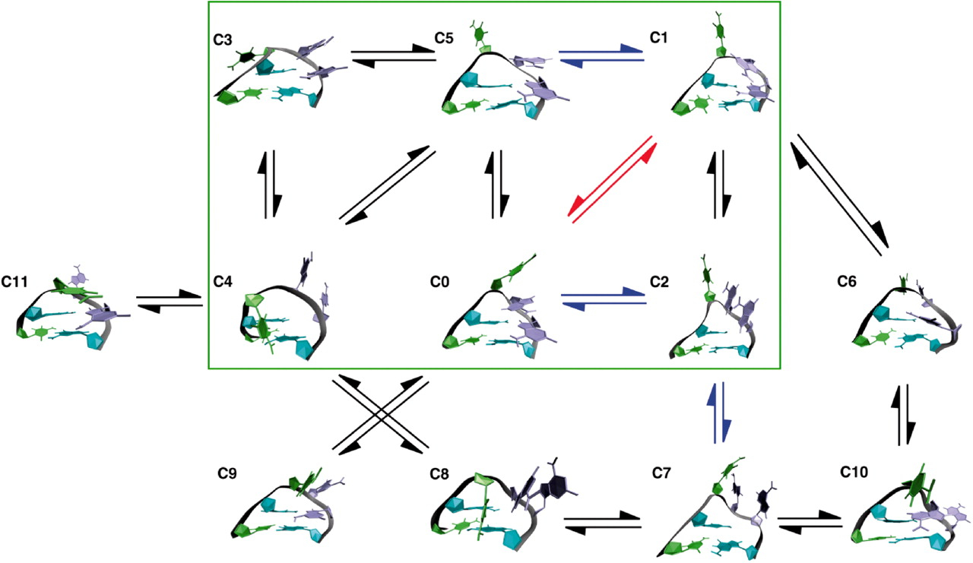

Portability of the GN(R)A Hairpin Loop Motif between RNA and DNA
Joshua M. Blose‡, Kenneth P. Lloyd§ and Philip C. Bevilacqua*‡
‡ Department of Chemistry, The Pennsylvania State University, University Park, Pennsylvania 16802
§ Department of Biochemistry and Molecular Pharmacology, University of Massachusetts, Worcester, Massachusetts 01605.
Present Address: School of Applied and Engineering Physics, Cornell University, Ithaca, NY 14853.
Biochemistry, 2009, 48 (37), pp 8787–8794
DOI: 10.1021/bi901038s
Hairpins are common nucleic acid secondary structures that serve many structural and functional roles. Recently, we reported that r(UNCG) and r(GNRA) hairpin families use molecular mimicry and electrostatic factors to attain exceptional thermodynamic stability with a CG closing base pair (cbp). Despite having very different overall folds, these tetraloops present the same functionalities and partial charges to the major groove edge of the CG cbp to achieve stability. Herein, we compare the r(GNRA) tetraloop family to the DNA triloop family d(GNA), which is also exceptionally stable with a CG cbp and possesses the same base pairing between the first and last positions of the loop. Nucleobase and functional group modifications were used to investigate interactions of d(GNA) loops with the cbp, which provided for comparison with similar substitutions in r(GNRA) hairpins. Interruption or deletion of loop−cbp interactions in d(GNA) was consistent with electrostatic interactions identified through nonlinear Poisson−Boltzmann (NLPB) calculations, and loop stability changed in a manner consistent with similar loop−cbp interactions for d(GNA) and r(GNRA) loops. We also compared the relationship of ΔG°37 and log[Na+] for d(GNA) and r(GNRA) loops and found a decreased dependence of stability on salt for both loop families when a CG cbp was present. The similarity of the loop−cbp interactions shows portability of this loop−cbp motif across polymer type and loop size and indicates convergence on similar molecular solutions for stability in RNA and DNA.

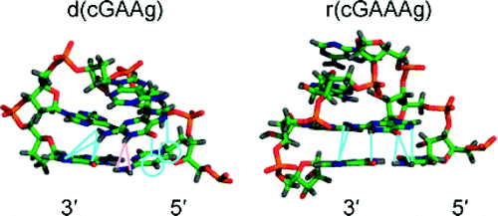

J Mol Biol. 2002 Apr 5;317(4):493-506.

RNA simulations: probing hairpin unfolding and the dynamics of a GNRA tetraloop.
Sorin EJ, Engelhardt MA, Herschlag D, Pande VS.
Department of Chemistry, Stanford University, Stanford, CA 94305-5080, USA.

Abstract
Simulations of an RNA hairpin containing a GNRA tetraloop were conducted to allow the characterization of its secondary structure formation and dynamics. Ten 10 ns trajectories of the folded hairpin 5'-GGGC[GCAA]GCCU-3' were generated using stochastic dynamics and the GB/SA implicit solvent model at 300 K. Overall, we find the stem to be a very stable subunit of this molecule, whereas multiple loop conformations and transitions between them were observed. These trajectories strongly suggest that extension of the C6 base away from the loop occurs cooperatively with an N-type-->S-type sugar pucker conversion in that residue and that similar pucker transitions are necessary to stabilize other looped-out bases. In addition, a short-lived conformer with an extended fourth loop residue (A8) lacking this stabilizing 2'-endo pucker mode was observed. Results of thermal perturbation at 400 K support this model of loop dynamics. Unfolding trajectories were produced using this same methodology at temperatures of 500 to 700 K. The observed unfolding events display three-state behavior kinetically (including native, globular, and unfolded populations) and, based on these observations, we propose a folding mechanism that consists of three distinct events: (i) collapse of the random unfolded structure and sampling of the globular state; (ii) passage into the folded region of configurational space as stem base-pairs form and gain helicity; and (iii) attainment of proper loop geometry and organization of loop pairing and stacking interactions. These results are considered in the context of current experimental knowledge of this and similar nucleic acid hairpins.
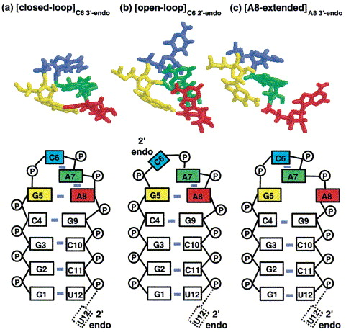

Biochemistry. 2000 Apr 18;39(15):4500-7.

Dynamics of the RNA hairpin GNRA tetraloop.
Menger M, Eckstein F, Porschke D.
Max-Planck-Institut für biophysikalische Chemie, D-37077 Göttingen, Germany.

Abstract
The dynamics of RNA hairpin tetraloops of the GNRA type [sequence G- any ribonucleotide (N)-purine (R)-A] was analyzed by fluorescence spectroscopy and by fluorescence-detected temperature-jump relaxation, using RNA oligomers with 2-aminopurine (2AP) substituted in two different positions of the loop sequence, Gp2APpApA (HP1) and GpAp2APpA (HP2), as indicator. The fluorescence of HP1 is much higher than that of HP2, indicating a lower degree of 2AP-stacking in HP1. Addition of Mg(2+) or Ca(2+) ions leads to an increase of fluorescence in HP1, whereas a decrease of fluorescence is observed in HP2. In both cases at least two ion-binding equilibria are required to fit titration data. T-jump experiments using fluorescence detection show a relaxation process with a time constant of 22 micros for HP1, whereas two relaxation processes with time constants 5 and 41 micros, are found for HP2. These results clearly demonstrate the existence of more than the single conformation state detected by NMR analysis. The T-jump amplitudes decrease with increasing bivalent ion concentration, indicating that one of the states is favored in the presence of bivalent ions. The loop relaxation processes are slower than standard stacking processes, probably because of activation barriers imposed by a restricted mobility of loop residues, and are assigned to a stacking rearrangement, probably between the 5' and the 3'-side. A similar process has been observed previously for the anticodon loop of tRNA(Phe). The rate constants of the transition are in the range of 10(4) s(-1) in the case of HP1. The data demonstrate the existence of structures that are not resolved by standard NMR because of fast exchange and are not found by X-ray analysis because of restrictions by crystal packing.
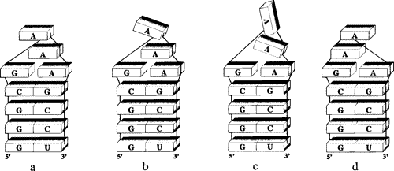

Figure 9 Schematic models of hairpin loop structures, shown for the loop sequence GAAA; loop residues L1 and L4 form the unusual G−A base pair. (a) 3‘-stacked conformation with full stacking; (b) 3‘-stack with unstacked residue L2; (c) conformation with unstacked residues L2 and L3; (d) 5‘-stacked conformation with full stacking.

J Biomol Struct Dyn. 1998 Dec;16(3):671-82.

Continuum solvent studies of the stability of RNA hairpin loops and helices.
Srinivasan J, Miller J, Kollman PA, Case DA.
Department of Molecular Biology, The Scripps Research Institute, La Jolla, CA 92037, USA.

Abstract
We apply continuum solvent models to investigate the relative stability of various conformational forms for two RNA sequences, GGAC(UUCG)GUCC and GGUG(UGAA)CACC. In the first part, we compare alternate hairpin conformations to explore the reliability of these models to discriminate between different local conformations. A second part looks at the hairpin-duplex conversion for the UUCG sequence, identifying major contributors to the thermodynamics of a much large scale transition. Structures were taken as snapshots from multi-nanosecond molecular dynamics simulations computed in a consistent fashion using explicit solvent and with long-range electrostatics accounted for using the Particle-Mesh Ewald procedure. The electrostatic contribution to solvation energies were computed using both a finite-difference Poisson-Boltzmann (PB) model and a pairwise Generalized Born model; non-electrostatic contributions were estimated with a surface-area dependent term. To these solvation free energies were added the mean solute internal energies (determined from a molecular mechanics potential) and estimates of the solute entropy (from a harmonic analysis). Consistent with experiment and with earlier solvated molecular dynamics simulations, the UUCG hairpin was found to prefer conformers close to a recent NMR structure determination in preference to those from an earlier NMR study. Similarly, results for the UGAA hairpin favored an NMR-derived structure over that to be expected for a generic GNRA hairpin loop. Experimental free energies are not known for the hairpin/duplex conversion, but must be close to zero since hairpins are seen in solution and duplexes in crystals; out calculations find a value near zero and illustrate the expected interplay of solvation, salt effects and entropy in affecting this equilibrium.

