**DEPARTMENT OF COMPUTER & SOFTWARE ENGINEERING**

**COLLEGE OF E&ME, NUST, RAWALPINDI**

**Subject: Digital Image Processing**

**Assignment # 02**

**SUBMITTED TO:**

**Lab Engineer**

**SUBMITTED BY:**

**Student Name: Eshmal Rumman**

**Reg # 413285**

**DE- 44 Dept CSE Syndicate B**

# **White Blood Cell Analysis and Classification**

**Flow Diagram**

**Feature Visualization**

**Confusion Matrix**

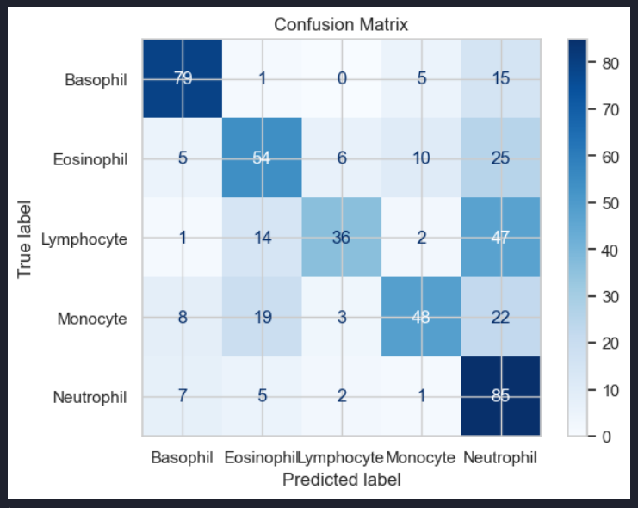

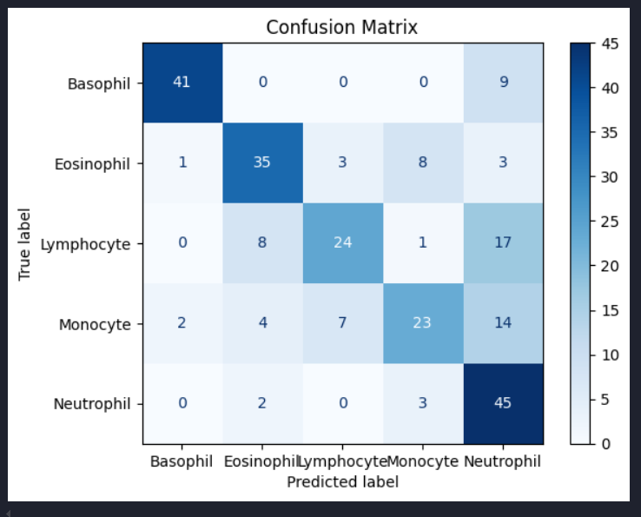

**Tabular Result**

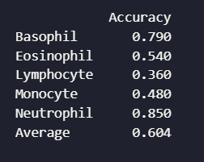

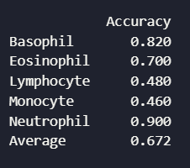

**Setbacks**

Initially used LBP to extract features and then visualize them. Got 255 features but all of them were overlapping a great deal due to which those features couldn’t be used for classification. Then shifted to K-Means clustering, the extracted features were overlapping as well but not as much as in the LBP. So in the end used K-Means Clustering and used the features to classify the WBCs.

**Code & Outputs**

|  |
| --- |
| import cv2 as cv  import numpy as np  import matplotlib.pyplot as plt  import os  from skimage.measure import label  import pandas as pd  import seaborn as sns  import imageio  from sklearn.metrics import confusion_matrix, accuracy_score, ConfusionMatrixDisplay |

|  |
| --- |
| Code |
| def load_images(input_path, output_path_g, output_path_r):      input_folder = input_path      output_folder_g = output_path_g      output_folder_r = output_path_r      for filename in os.listdir(input_folder):          if filename.lower().endswith('.jpg'):              img_path = os.path.join(input_folder, filename)              img = cv.imread(img_path)       # loads in BGR format              img = cv.resize(img, (256, 256))                # convert to RGB format              img_rgb = cv.cvtColor(img, cv.COLOR_BGR2RGB)                # convert to grayscale              img_gray = cv.cvtColor(img, cv.COLOR_BGR2GRAY)                # using median blur (great for salt-n-pepper noise) with kernel size 5              img_blur_g = cv.medianBlur(img_gray, 5)              img_blur_r = cv.medianBlur(img_rgb, 5)                # doing equalised histogram for contrast enhancement              img_eq_g = cv.equalizeHist(img_blur_g)                output_path = os.path.join(output_folder_g, filename)              cv.imwrite(output_path, img_eq_g)              output_path = os.path.join(output_folder_r, filename)              cv.imwrite(output_path, img_blur_r)              print(f"Processed and saved: {filename}")  load_images("E:\\6th Semester\\DIP\\Assignment 2\\A2_wbc_data\\wbc_data\\Train\\Neutrophil", "E:\\6th Semester\\DIP\\Assignment 2\\A2_wbc_data\\wbc_data\\outputGray\\Neutrophil", "E:\\6th Semester\\DIP\\Assignment 2\\A2_wbc_data\\wbc_data\\outputRGB\\Neutrophil")  load_images("E:\\6th Semester\\DIP\\Assignment 2\\A2_wbc_data\\wbc_data\\Train\\Monocyte", "E:\\6th Semester\\DIP\\Assignment 2\\A2_wbc_data\\wbc_data\\outputGray\\Monocyte", "E:\\6th Semester\\DIP\\Assignment 2\\A2_wbc_data\\wbc_data\\outputRGB\\Monocyte")  load_images("E:\\6th Semester\\DIP\\Assignment 2\\A2_wbc_data\\wbc_data\\Train\\Lymphocyte", "E:\\6th Semester\\DIP\\Assignment 2\\A2_wbc_data\\wbc_data\\outputGray\\Lymphocyte", "E:\\6th Semester\\DIP\\Assignment 2\\A2_wbc_data\\wbc_data\\outputRGB\\Lymphocyte")  load_images("E:\\6th Semester\\DIP\\Assignment 2\\A2_wbc_data\\wbc_data\\Train\\Eosinophil", "E:\\6th Semester\\DIP\\Assignment 2\\A2_wbc_data\\wbc_data\\outputGray\\Eosinophil", "E:\\6th Semester\\DIP\\Assignment 2\\A2_wbc_data\\wbc_data\\outputRGB\\Eosinophil")  load_images("E:\\6th Semester\\DIP\\Assignment 2\\A2_wbc_data\\wbc_data\\Train\\Basophil", "E:\\6th Semester\\DIP\\Assignment 2\\A2_wbc_data\\wbc_data\\outputGray\\Basophil", "E:\\6th Semester\\DIP\\Assignment 2\\A2_wbc_data\\wbc_data\\outputRGB\\Basophil") |
| Output |
|  |

|  |
| --- |
| Code |
| def kmeans_segmentation(image, k=8):      # Reshape image to a 2D array of pixels      pixel_values = image.reshape((-1, 3))      pixel_values = np.float32(pixel_values)      # Apply K-means clustering      _, labels, centers = cv.kmeans(pixel_values, k, None,                                      criteria=(cv.TERM_CRITERIA_EPS + cv.TERM_CRITERIA_MAX_ITER, 100, 0.2),                                      attempts=10, flags=cv.KMEANS_RANDOM_CENTERS)      labels = labels.flatten()      segmented_image = centers[labels].reshape(image.shape).astype(np.uint8)      return segmented_image, labels.reshape(image.shape[:2])  def extract_nucleus(image, label_map):      unique_labels = np.unique(label_map)      mean_intensity = [np.mean(image[label_map == label]) for label in unique_labels]      nucleus_label = unique_labels[np.argmin(mean_intensity)]      nucleus_mask = (label_map == nucleus_label).astype(np.uint8)      return nucleus_mask  def clean_nucleus(nucleus_mask):      labeled, num = label(nucleus_mask, return_num=True)      if num == 0:          return np.zeros_like(nucleus_mask)      sizes = [(labeled == i).sum() for i in range(1, num + 1)]      largest_label = np.argmax(sizes) + 1      return (labeled == largest_label).astype(np.uint8)  def extract_features(image, nucleus_mask):      # Compute area ratio      nucleus_area = np.sum(nucleus_mask)      total_area = image.shape[0] * image.shape[1]      area_ratio = nucleus_area / total_area      # Compute circularity      contours, _ = cv.findContours(nucleus_mask, cv.RETR_EXTERNAL, cv.CHAIN_APPROX_SIMPLE)      if contours:          largest_contour = max(contours, key=cv.contourArea)          perimeter = cv.arcLength(largest_contour, True)          circularity = (4 * np.pi * cv.contourArea(largest_contour)) / (perimeter ** 2 + 1e-5)      else:          circularity = 0      # Compute mean and standard deviation of RGB values      mask = nucleus_mask.astype(*bool*)      pixels = image[mask]      mean_rgb = np.mean(pixels, axis=0) if pixels.size > 0 else [0, 0, 0]      std_rgb = np.std(pixels, axis=0) if pixels.size > 0 else [0, 0, 0]      granularity = np.var(image[mask]) if pixels.size > 0 else 0      red_green_ratio = mean_rgb[0] / (mean_rgb[1] + 1e-5)      return {          "area_ratio": area_ratio,          "circularity": circularity,          "mean_r": mean_rgb[0],          "mean_g": mean_rgb[1],          "mean_b": mean_rgb[2],          "granularity": granularity,          "red_green_ratio": red_green_ratio      }    def process_images_and_save_csv(image_dir, output_csv, k=8):      data = []      for cell_type in os.listdir(image_dir):          cell_dir = os.path.join(image_dir, cell_type)          if not os.path.isdir(cell_dir):              continue          for file in os.listdir(cell_dir):              image_path = os.path.join(cell_dir, file)              image = cv.imread(image_path)              if image is None:                  print(f"Failed to load image: {file}")                  continue              # Step 1: K-means segmentation              segmented_image, label_map = kmeans_segmentation(image, k=8)              # Step 2: Extract nucleus              nucleus_mask = extract_nucleus(segmented_image, label_map)              # Step 3: Clean nucleus              cleaned_mask = clean_nucleus(nucleus_mask)              # Step 4: Extract features              features = extract_features(image, cleaned_mask)              features["label"] = cell_type              features["filename"] = file  # Add filename to keep track              data.append(features)      # Step 5: Save to CSV      df = pd.DataFrame(data)      df.to_csv(output_csv, index=False)      print(f"Features saved to: {output_csv}")  process_images_and_save_csv("E:\\6th Semester\\DIP\\Assignment 2\\A2_wbc_data\\wbc_data\\outputRGB", "E:\\6th Semester\\DIP\\Assignment 2\\A2_wbc_data\\wbc_data\\outputCSV\\output_features.csv") |
| Output |
|  |

|  |
| --- |
| Code |
| def plot_feature_vs_label(df, features):      sns.set(style="whitegrid")      num_features = len(features)        plt.figure(figsize=(6 * num_features, 5))        for i, feature in enumerate(features, 1):          plt.subplot(1, num_features, i)          sns.boxplot(x="label", y=feature, data=df, palette="Set2")          plt.title(f"{feature} vs WBC Type")          plt.xticks(rotation=45)        plt.tight_layout()      plt.show()  df = pd.read_csv("E:\\6th Semester\\DIP\\Assignment 2\\A2_wbc_data\\wbc_data\\outputCSV\\output_features.csv")  plot_feature_vs_label(df, ["area_ratio", "circularity", "mean_r", "granularity", "red_green_ratio"]) |
| Output |
|  |

|  |
| --- |
| Code |
| def classify_wbc(circularity, area_ratio, mean_r, granularity, red_green_ratio):      # Reference ranges based on visual boxplot analysis      wbc_profiles = {          "Lymphocyte": {              "circularity": (0.6, 0.9),              "area_ratio": (0.04, 0.07),              "mean_r": (110, 130),              "granularity": (1600, 2200),              "red_green_ratio": (3.5, 6.0)          },          "Eosinophil": {              "circularity": (0.45, 0.75),              "area_ratio": (0.03, 0.06),              "mean_r": (120, 150),              "granularity": (2000, 3000),              "red_green_ratio": (4.0, 6.5)          },          "Monocyte": {              "circularity": (0.3, 0.6),              "area_ratio": (0.06, 0.09),              "mean_r": (130, 160),              "granularity": (1600, 2500),              "red_green_ratio": (3.0, 6.0)          },          "Basophil": {              "circularity": (0.1, 0.35),              "area_ratio": (0.08, 0.12),              "mean_r": (85, 115),              "granularity": (1000, 1900),              "red_green_ratio": (1.5, 3.5)          },          "Neutrophil": {              "circularity": (0.35, 0.6),              "area_ratio": (0.03, 0.06),              "mean_r": (95, 125),              "granularity": (1400, 2200),              "red_green_ratio": (4.5, 7.0)          }      }      # Normalised range-based distance      def feature_diff(value, range_tuple):          low, high = range_tuple          if low <= value <= high:              return 0          elif value < low:              return (low - value) / (high - low)          else:              return (value - high) / (high - low)      features = {          "circularity": circularity,          "area_ratio": area_ratio,          "mean_r": mean_r,          "granularity": granularity,          "red_green_ratio": red_green_ratio      }      min_score = *float*('inf')      predicted_label = None      for label, profile in wbc_profiles.items():          score = sum(              feature_diff(features[feature], profile[feature])              for feature in features          )          if score < min_score:              min_score = score              predicted_label = label      return predicted_label      def classify_from_csv(csv_path, output_path=None):      df = pd.read_csv(csv_path)      # Check if the necessary features are present      required_cols = ["filename", "area_ratio", "circularity", "mean_r", "granularity", "red_green_ratio"]      if not all(col in df.columns for col in required_cols):          raise *ValueError*(f"CSV file must contain the following columns: {', '.join(required_cols)}")      # Apply classification row by row      df["predicted_label"] = df.apply(lambda row: classify_wbc(          row["circularity"],          row["area_ratio"],          row["mean_r"],          row["granularity"],          row["red_green_ratio"]      ), axis=1)      # Save the results if an output path is provided      if output_path:          df.to_csv(output_path, index=False)          print(f"Classification results saved to: {output_path}")      return df  csv_input = "E:\\6th Semester\\DIP\\Assignment 2\\A2_wbc_data\\wbc_data\\outputCSV\\output_features.csv"  csv_output = "E:\\6th Semester\\DIP\\Assignment 2\\A2_wbc_data\\wbc_data\\outputCSV\\classification_results.csv"  classified_df = classify_from_csv(csv_input, csv_output) |
| Output |
|  |

|  |
| --- |
| Code |
| def evaluate_predictions(csv_path, actual_label_col="label", predicted_label_col="predicted_label"):      df = pd.read_csv(csv_path)      if actual_label_col not in df.columns or predicted_label_col not in df.columns:          print(f"[ERROR] '{actual_label_col}' or '{predicted_label_col}' column not found in the CSV.")          return      y_true = df[actual_label_col]      y_pred = df[predicted_label_col]      # Confusion Matrix      cm = confusion_matrix(y_true, y_pred, labels=np.unique(y_true))      acc = accuracy_score(y_true, y_pred)      print(f"[INFO] Accuracy: {acc * 100:.2f}%")      disp = ConfusionMatrixDisplay(confusion_matrix=cm, display_labels=np.unique(y_true))      disp.plot(cmap=plt.cm.Blues)      plt.title("Confusion Matrix")      plt.show()  evaluate_predictions("E:\\6th Semester\\DIP\\Assignment 2\\A2_wbc_data\\wbc_data\\outputCSV\\classification_results.csv") |
| Output |
|  |

|  |
| --- |
| Code |
| def apply_padding(image, kernel_size, pad_value):      padding_size = kernel_size // 2      return cv.copyMakeBorder(image, padding_size, padding_size, padding_size, padding_size, cv.BORDER_CONSTANT, value=pad_value)  def rotated_lbp(img):      weights = np.array([1, 2, 4, 8, 16, 32, 64, 128])        lbpFinal = np.zeros_like(img, dtype=np.uint8)        kernel_size = 3      rep = np.zeros((kernel_size, kernel_size), dtype=np.uint8)        padded_img = apply_padding(img, kernel_size, 0)      height, width = img.shape        for i in range(height):          for j in range(width):              region = padded_img[i:i+kernel_size, j:j+kernel_size]              center_pixel = region[1, 1]                binary_values = (region >= center_pixel).astype(np.uint8)                neighbor_pixels = np.zeros(8, dtype=np.uint8)              ind1 = 0              for m in range(3):                  for n in range(3):                      if m == 1 and n == 1:                          continue                      neighbor_pixels[ind1] = binary_values[m, n]                      ind1 += 1                dif = np.abs(neighbor_pixels - center_pixel)              D = np.argmax(dif)              rotated = np.roll(binary_values, -D)                ind = 0              for k in range(3):                  for l in range(3):                      if k == 1 and l == 1:                          continue                      rep[k, l] = rotated[k, l] * weights[ind]                      ind += 1                lbpFinal[i, j] = np.sum(rep)        return lbpFinal    def extract_features_lbp(input_path):      data = []      num_bins = 256  # Define number of bins beforehand      for cell_type in os.listdir(input_path):          class_path = os.path.join(input_path, cell_type)          if not os.path.isdir(class_path):              print("??", class_path)              continue          for img_file in os.listdir(class_path):              img_path = os.path.join(class_path, img_file)              img = cv.imread(img_path, cv.IMREAD_GRAYSCALE)              if img is None:                  print("????", img_path)                  continue              # Apply LBP              lbp = rotated_lbp(img)              # Compute histogram (feature vector)              hist, _ = np.histogram(lbp.ravel(), bins=num_bins, range=(0, num_bins))                # Normalize histogram              hist = hist.astype("float")              hist /= (hist.sum() + 1e-6)              # Append to data              feature_row = [img_file] + *list*(hist) + [cell_type]              data.append(feature_row)              print(f"{img_file} – Histogram sum: {hist.sum()}")      if not data:          print("No data extracted. Check your folder paths or image read logic.")          return      # Construct column names based on num_bins      columns = ['filename'] + [f'lbp_{i}' for i in range(num_bins)] + ['label']        df = pd.DataFrame(data, columns=columns)      df.to_csv('E:\\6th Semester\\DIP\\Assignment 2\\A2_wbc_data\\wbc_data\\outputCSV\\lbp_features.csv', index=False)    extract_features_lbp("E:\\6th Semester\\DIP\\Assignment 2\\A2_wbc_data\\wbc_data\\outputGray")  df = pd.read_csv('E:\\6th Semester\\DIP\\Assignment 2\\A2_wbc_data\\wbc_data\\outputCSV\\lbp_features.csv')  # Plot one feature across all cell types  for i in range(2):  # First 10 LBP bins      plt.figure(figsize=(8, 4))      sns.boxplot(x='label', y=f'lbp_{i}', data=df)      plt.title(f'Boxplot of lbp_{i} by WBC Type')      plt.xticks(rotation=45)      plt.tight_layout()      plt.show()  # Example: Scatter plot for two features  sns.scatterplot(data=df, x='lbp_159', y='lbp_215', hue='label')  plt.title("Feature Distribution (lbp_20 vs lbp_45)")  plt.show() |
| Output |
|  |

|  |
| --- |
| Code |
| import pandas as pd  # Load your classification results  df = pd.read_csv("E:\\6th Semester\\DIP\\Assignment 2\\A2_wbc_data\\wbc_data\\outputCSV\\classification_results.csv")  # Create a confusion matrix grouped by true label  grouped = df.groupby('label')  # Calculate per class accuracy  per_class_accuracy = {}  for label, group in grouped:      correct = (group['label'] == group['predicted_label']).sum()      total = len(group)      accuracy = correct / total      per_class_accuracy[label] = round(accuracy, 4)  # Convert to DataFrame  accuracy_df = pd.DataFrame.from_dict(per_class_accuracy, orient='index', columns=['Accuracy'])  # Calculate average per-class accuracy (macro avg)  average_accuracy = accuracy_df['Accuracy'].mean()  accuracy_df.loc['Average'] = average_accuracy  # Save or print  print(accuracy_df) |
| Output |
|  |
| Code |
| def test_csv():      #load_images("E:\\6th Semester\\DIP\\Assignment 2\\A2_wbc_data\\wbc_data\\Test\\Basophil", "E:\\6th Semester\\DIP\\Assignment 2\\A2_wbc_data\\wbc_data\\oTg\\Basophil", "E:\\6th Semester\\DIP\\Assignment 2\\A2_wbc_data\\wbc_data\\oTr\\Basophil")      #load_images("E:\\6th Semester\\DIP\\Assignment 2\\A2_wbc_data\\wbc_data\\Test\\Neutrophil", "E:\\6th Semester\\DIP\\Assignment 2\\A2_wbc_data\\wbc_data\\oTg\\Neutrophil", "E:\\6th Semester\\DIP\\Assignment 2\\A2_wbc_data\\wbc_data\\oTr\\Neutrophil")      #load_images("E:\\6th Semester\\DIP\\Assignment 2\\A2_wbc_data\\wbc_data\\Test\\Eosinophil", "E:\\6th Semester\\DIP\\Assignment 2\\A2_wbc_data\\wbc_data\\oTg\\Eosinophil", "E:\\6th Semester\\DIP\\Assignment 2\\A2_wbc_data\\wbc_data\\oTr\\Eosinophil")      #load_images("E:\\6th Semester\\DIP\\Assignment 2\\A2_wbc_data\\wbc_data\\Test\\Lymphocyte", "E:\\6th Semester\\DIP\\Assignment 2\\A2_wbc_data\\wbc_data\\oTg\\Lymphocyte", "E:\\6th Semester\\DIP\\Assignment 2\\A2_wbc_data\\wbc_data\\oTr\\Lymphocyte")      #load_images("E:\\6th Semester\\DIP\\Assignment 2\\A2_wbc_data\\wbc_data\\Test\\Monocyte", "E:\\6th Semester\\DIP\\Assignment 2\\A2_wbc_data\\wbc_data\\oTg\\Monocyte", "E:\\6th Semester\\DIP\\Assignment 2\\A2_wbc_data\\wbc_data\\oTr\\Monocyte")        #process_images_and_save_csv("E:\\6th Semester\\DIP\\Assignment 2\\A2_wbc_data\\wbc_data\\oTr", "E:\\6th Semester\\DIP\\Assignment 2\\A2_wbc_data\\wbc_data\\outputCSV\\output_features_test.csv")        #csv_input = "E:\\6th Semester\\DIP\\Assignment 2\\A2_wbc_data\\wbc_data\\outputCSV\\output_features_test.csv"      #csv_output = "E:\\6th Semester\\DIP\\Assignment 2\\A2_wbc_data\\wbc_data\\outputCSV\\classification_results_test.csv"      #df = classify_from_csv(csv_input, csv_output)        evaluate_predictions("E:\\6th Semester\\DIP\\Assignment 2\\A2_wbc_data\\wbc_data\\outputCSV\\classification_results_test.csv")        # Create a confusion matrix grouped by true label      df = pd.read_csv("E:\\6th Semester\\DIP\\Assignment 2\\A2_wbc_data\\wbc_data\\outputCSV\\classification_results_test.csv")      grouped = df.groupby('label')      # Calculate per class accuracy      per_class_accuracy = {}      for label, group in grouped:          correct = (group['label'] == group['predicted_label']).sum()          total = len(group)          accuracy = correct / total          per_class_accuracy[label] = round(accuracy, 4)      # Convert to DataFrame      accuracy_df = pd.DataFrame.from_dict(per_class_accuracy, orient='index', columns=['Accuracy'])      # Calculate average per-class accuracy (macro avg)      average_accuracy = accuracy_df['Accuracy'].mean()      accuracy_df.loc['Average'] = average_accuracy      # Save or print      print(accuracy_df)    test_csv() |
| Output |
|  |