

ResQOn: A Personal Safety and Emergency Response Application

Central University of Karnataka
Department of Computer Science
Team Members: Dilshad, Nagveni, Eshwari, and Vivek

Abstract
Personal safety remains an important concern, particularly in emergency situations where a person may not have enough time or ability to manually communicate for help. This paper presents ResQon — A Personal Safety and Emergency Response Application, an automated, low-interaction emergency response system designed to reduce the number of actions required to initiate assistance. The proposed system follows a response chain of Trigger → Locate → Capture → Alert → Track, in which an emergency trigger initiates a sequence of protective actions. Depending on the configured trigger mechanism, the system can acquire the user's location, capture supporting evidence through the device camera and microphone, notify trusted contacts, and support continuous location tracking. The system is designed as an Android-based mobile application using Flutter and integrates smartphone capabilities such as GPS, camera, microphone, and communication services. By combining emergency triggering, location sharing, evidence collection, alert generation, and tracking into a coordinated workflow, ResQOn aims to provide more actionable information to trusted contacts during emergencies rather than relying only on a conventional SOS message. The proposed approach emphasizes rapid response, reduced user interaction, and extensibility for future emergency-response services. The paper discusses the system architecture, functional workflow, implementation approach, and potential applications of the proposed safety mechanism.

Keywords: women’s safety, emergency response, low-interaction system, SOS, GPS tracking, evidence capture, trusted contacts, mobile application, automated alert, and ResQOn.

1. Introduction
Women’s safety presents both a social and a technological challenge, especially when a person needs immediate help but cannot safely place a call or compose an emergency message. Many existing safety applications require a user to press an SOS control or complete several steps before assistance can be requested. In a critical event, however, extended interaction with a phone may be impractical.
Prior work on technology-supported women’s safety has considered smartphones, GPS, communication networks, sensors, and automated alert mechanisms. These applications show the value of sharing location, notifying emergency contacts, and collecting evidence. A remaining design need is a mechanism that can initiate and coordinate these responses with little user input.
This paper proposes ResQOn, a low-interaction emergency-response system for women’s safety. Its guiding idea is “Minimum Interaction → Maximum Response.” Rather than using a trigger solely to send an SOS message, ResQOn organizes the response as Trigger → Locate → Capture → Alert → Track.
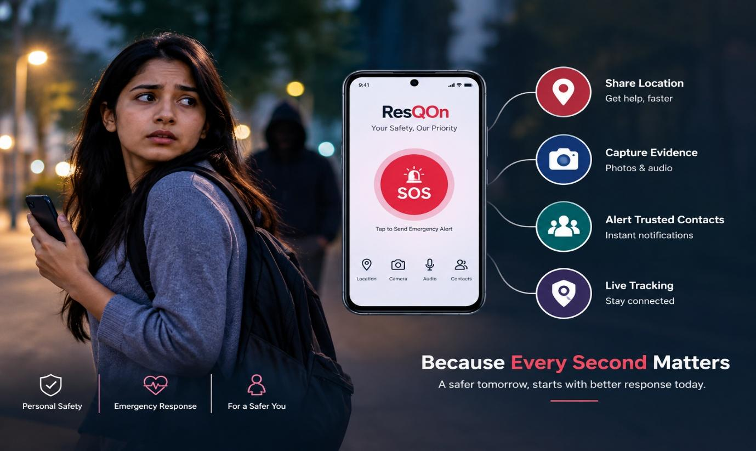
After activation, the proposed system can determine the user’s location, gather supporting material through the phone camera and microphone, inform trusted contacts, and continue to share location information. The aim is to reduce the user’s effort while giving trusted contacts information that is useful for responding to the event.
ResQOn is conceived as an Android application built with Flutter and drawing on device features such as GPS, camera, microphone, accelerometer, and communication services. These capabilities are treated as parts of one emergency process, not as unrelated safety features.
The following sections review related studies, describe the proposed system and its architecture, outline the implementation approach, and discuss the evaluation. Potential benefits and limitations of a low-interaction response mechanism are also considered.

2. Related Work
Studies of technology-enabled women’s safety increasingly examine smartphones, Internet of Things (IoT) devices, GPS, communication networks, and automated emergency support. Together, this work informs the design of mobile systems intended to assist users in emergency circumstances.
2.1 IoT-Based Women’s Safety
The systematic literature review “The Role of IoT in Woman’s Safety: A Systematic Literature Review” examines the use of IoT technologies for improving women’s safety.
The review describes sensors, GPS, GSM, and intelligent systems that may detect emergencies or support a response. It emphasizes reducing reliance on manual interaction and strengthening automated assistance. This broad technology perspective is relevant to integrated safety-system design. [1]
2.2 SAKHI Women Safety Application
The SAKHI study describes a smartphone safety application with emergency activation, location sharing, emergency contacts, and video recording. Video may be retained and shared through a cloud-based mechanism, adding information to an alert. The study illustrates how smartphone sensors and multimedia functions can be combined to assist women in emergencies. [2]
2.3 Mobile-Based Safety Application with Real-Time Data
This work presents a mobile safety application using GPS tracking, emergency contacts, SMS, and real-time data streaming. It enables location and emergency details to be sent to predefined contacts, demonstrating the practical role of real-time location and communication technologies in mobile safety applications. [3]
2.4 Research Gap
The reviewed work establishes the importance of GPS-based sharing, emergency communication, real-time tracking, and evidence capture. In many cases, however, these capabilities are separate functions or require users to begin several actions themselves.
ResQOn responds by placing these functions within one low-interaction workflow. Its Trigger → Locate → Capture → Alert → Track sequence is intended to organize response activities after an emergency trigger, instead of treating an SOS notification as a standalone event. The design seeks to reduce user input while supplying trusted contacts with location and contextual details that may support a faster response.

References
[1] The Role of IoT in Woman’s Safety: A Systematic Literature Review, IEEE Access, 2023.
[2] Development of A Women Safety Smartphone Application- SAKHI, IEEE, 2023.
[3] Research and Development of a Mobile Based Women Safety Application with Real-Time Database and Data-Stream Network, IEEE, 2017.

3. Proposed System
ResQOn is proposed as an automated emergency-response system that requires limited interaction and is intended to assist women in emergencies. Its principal objective is to initiate several response activities from one trigger, thereby reducing the actions demanded of the user.
The design follows the principle “Minimum Interaction → Maximum Response.” When an emergency trigger is activated or detected, the system coordinates several actions rather than stopping at a conventional SOS notification.
3.1 System Workflow
The proposed emergency-response workflow consists of five major stages:
Trigger → Locate → Capture → Alert → Track
- An emergency is initiated through a supported mechanism. This trigger begins the automated response workflow.
- Once triggered, the system retrieves the user’s current geographic position through the smartphone GPS. The resulting location can be expressed as a link suitable for use with mapping services.
- The device camera and microphone may collect supporting material, including photographs or audio recordings, during the emergency.
- Emergency details are sent to predefined trusted contacts. The message may include the user’s identity, location, and references to material that was collected.
- During an active event, location sharing can continue so that trusted contacts may observe changes in the user’s position.

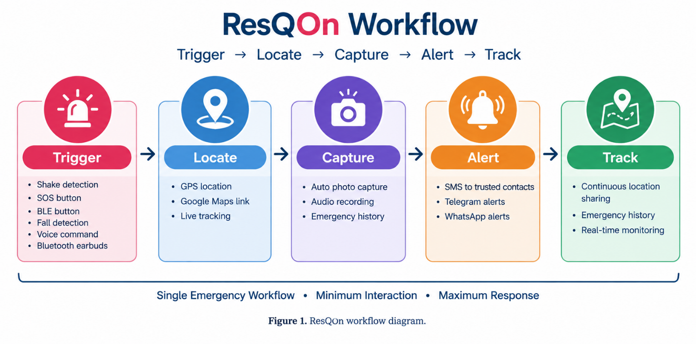

3.2 Low-Interaction Emergency Response
The low-interaction design is a central feature of the proposal. Repeated use of a smartphone can be difficult or unsafe in a stressful event; ResQOn therefore seeks to start a coordinated response from a single trigger. Figure 1 represents this process as Trigger → Locate → Capture → Alert → Track.
The design links location sharing, evidence capture, notification, and tracking into a single response chain. Consequently, trusted contacts may receive an alert together with context that helps them interpret the situation.
3.3 Proposed Mobile Application
ResQOn is proposed as an Android application implemented with Flutter. It uses GPS, camera, microphone, and other available device inputs for emergency detection and response.
Its modular architecture is intended to accommodate future emergency-response services. Possible extensions include backend services and a dashboard for trusted contacts or responders to manage emergency events and their history.
3.4 Objective of the Proposed System
The main objectives of ResQOn are:
- To reduce the interaction required to initiate emergency assistance.
- To automatically acquire and share emergency location information.
- To support collection of contextual evidence during an emergency.
- To notify predefined trusted contacts through available communication mechanisms.
- To support continued location tracking during an emergency.
- To combine multiple emergency-response actions into a single coordinated workflow.
Accordingly, ResQOn is intended to do more than transmit an SOS message. It creates an automated response chain that can provide trusted contacts with quicker, more actionable information.
4. System Architecture and Design
ResQOn uses a mobile emergency-response architecture in which the smartphone serves as the main sensing and communication device. It connects emergency detection, location acquisition, evidence capture, notification, and tracking in one workflow.
4.1 Architectural Components
The major components of the proposed architecture are:
- User Interface: Provides access to emergency and safety-related functions.
- Emergency Trigger Module: Detects or receives an emergency action from the user or supported device input.
- Device-Side Workflow Controller: Coordinates the sequence of actions after an emergency trigger.
- Location Module: Uses GPS to obtain the user's geographical position.
- Evidence Module: Uses the smartphone camera and microphone to collect supporting evidence.
- Alert Module: Prepares and sends emergency information to configured trusted contacts through supported communication services.
- Tracking Module: Supports continued sharing of location information during an active emergency.
- Trusted Contacts: Receive emergency alerts and relevant information to assist the user.
4.2 Emergency Response Architecture
An emergency trigger starts the process, after which the workflow controller manages the remaining operations. The location module first attempts to obtain a GPS position, while the evidence module can collect relevant multimedia through the device camera and microphone.
The resulting emergency information is supplied to the alert mechanism. An alert may contain user identity or context, GPS coordinates, a map-ready link, and references to available evidence. Trusted contacts can use these details to interpret the emergency and decide on an appropriate response.
The tracking component can keep sharing location while an emergency remains active, making the process a connected response flow rather than a single notification.
4.3 System Flow
The overall system can be represented as:
Emergency Trigger
↓
Workflow Controller
↓
GPS Location Acquisition
↓
Evidence Capture
↓
Emergency Alert
↓
Trusted Contacts
Continuous Location Tracking
Together, these operations form a coordinated emergency-response chain that delivers location and contextual details with the initial alert.

4.4 Technology Architecture
The proposed Android application uses Flutter and accesses smartphone hardware and software functions, including GPS, camera, microphone, accelerometer, mobile network, and Internet connectivity.
Communication services may transmit emergency alerts, and map services may present the user’s location. The design also leaves room for backend services and a centralized dashboard for managing emergency events.
4.5 Design Principle
The central design principle of ResQOn is:
Minimum Interaction → Maximum Response
By coordinating several actions after a trigger, the architecture applies this principle to reduce interaction during a critical event while increasing the useful information delivered to trusted contacts.
5. Implementation and Technologies Used
ResQOn is designed as an Android emergency-response application. Its implementation combines mobile application development, device hardware, and communication services to support an integrated response workflow.
5.1 Mobile Application Development
Flutter provides the framework for the Android application. A device-side workflow coordinates the separate emergency-response functions.
5.2 Location Detection
During an emergency, the system uses the phone’s Global Positioning System (GPS) to obtain geographic coordinates. These coordinates can be transformed into a map-ready link that helps trusted contacts locate the user approximately.
5.3 Emergency Trigger Mechanisms
ResQOn is designed to support multiple mechanisms for initiating an emergency response. These include:
- SOS button
- Shake detection
- Bluetooth Low Energy (BLE) button
- Fall detection
- Bluetooth earbuds
- Voice-based emergency command
These alternatives are intended to reduce dependence on a conventional manual SOS interaction.
5.4 Evidence Collection
The phone camera and microphone may obtain supporting information during an emergency: the camera can take photographs and the microphone can record audio. This material can add context for trusted contacts alongside the alert.
5.5 Emergency Communication
The system is intended to send emergency details to configured trusted contacts through supported communication services. Information may include user identity or context, GPS coordinates, a map-ready link, and references to collected evidence.
Depending on configuration and connectivity, the communication layer may use SMS, Telegram, and WhatsApp.
5.6 Tracking
After activation, ResQOn can continue location sharing so trusted contacts can follow the user’s position throughout an active emergency, rather than receiving only the initial location.
5.7 Security and Evidence Integrity
The design considers security for emergency data and collected evidence. The SRS proposes encryption for stored data and secure communication, as well as SHA-256 hashing of captured evidence so the integrity of stored or transmitted material can be checked.
These measures remain proposed design elements and require separate evaluation before they are reported as implementation results.
5.8 Hardware and Software Requirements
The major hardware capabilities required by the system include:
- GPS
- Camera
- Microphone
- Accelerometer
- Mobile network
- Internet connectivity
The software environment includes:
- Android platform
- Flutter
- Google Maps services
- Telegram Bot API
- WhatsApp communication services
- SQLite for local data
- Firebase for backup or synchronization
- Android SMS functionality
Together, these technologies allow ResQOn to combine emergency triggering, location acquisition, evidence collection, communication, and tracking in one mobile application.
6. System Working and Emergency Response Process
ResQOn operates through a coordinated sequence of emergency-response actions. The design converts a single trigger into several actions intended to assist the user and inform trusted contacts.
6.1 Emergency Trigger
The workflow starts when an available trigger mechanism is used. Depending on configuration, the trigger may come from an SOS button, shake detection, a BLE button, fall detection, Bluetooth earbuds, or a voice command.
The trigger acts as the starting point for the emergency-response workflow.
6.2 Location Acquisition
After receiving a trigger, the system attempts to obtain the user’s current GPS location. The geographic coordinates are then used to prepare location information for trusted contacts.
This information identifies where the user was when the emergency response began.
6.3 Evidence Capture
The system may use the camera and microphone to collect supporting evidence. Photographs and audio recordings can provide additional context about the emergency.
This evidence supplements the alert; it does not replace the alert itself.
6.4 Emergency Alert
Once the needed information has been prepared, the system sends an alert through supported communication methods to the user’s predefined trusted contacts.
The alert can contain information such as:
- User identity or emergency context
- Current GPS coordinates
- Map-ready location information
- References to available evidence
The goal is to give trusted contacts information that is more actionable than a basic emergency message.
6.5 Location Tracking
For a continuing emergency, the system can keep sharing location updates. Trusted contacts can then observe movement instead of relying only on the location recorded when the event was triggered.

6.6 Complete Response Chain
The complete working process can therefore be represented as:
Trigger
↓
Locate
↓
Capture
↓
Alert
↓
Track
This sequence expresses the central ResQOn concept. Instead of asking users to activate each safety function individually, the proposed system coordinates multiple actions after an emergency trigger.

6.7 Expected Benefit
The proposed workflow is intended to reduce interaction under stressful conditions and improve the information available to trusted contacts. It brings emergency activation, location, evidence, notification, and tracking into one approach to mobile emergency assistance.

7. Results and Evaluation
The ResQOn prototype was assessed for its ability to coordinate the major stages of the proposed workflow, from emergency activation through location acquisition, evidence capture, alert preparation, and tracking.

7.1 Functional Evaluation
The main functions considered during the evaluation are:
Function | Evaluation Objective
Emergency Trigger | Verify that an emergency response can be initiated
Location Acquisition | Verify that the device can obtain the user's location
Evidence Capture | Verify camera and microphone-based evidence collection
Emergency Alert | Verify that emergency information can be communicated to trusted contacts
Location Tracking | Verify continued location sharing during an active emergency

Evaluation follows the Trigger → Locate → Capture → Alert → Track workflow. Completion of these stages indicates that the components can operate together as a coordinated emergency-response process.
7.2 Response Workflow Evaluation
The system was examined by activating an emergency with an available trigger and observing the subsequent actions. After activation, the application attempts to obtain location information and collect supporting evidence, then prepares the resulting information for communication to trusted contacts.
This process illustrates ResQOn’s main aim: to reduce the separate actions expected from the user while coordinating several emergency-response functions.
7.3 Observations
The prototype indicates that smartphone capabilities can be combined in a single emergency-response workflow. Location establishes geographic context, captured evidence can add situational detail, and alerting and tracking carry the response beyond the original trigger.
The usefulness of these functions nevertheless depends on conditions such as GPS availability, Internet or mobile-network connectivity, device permissions, battery state, and the availability of configured communication services.
7.4 Evaluation Limitation
The present evaluation is functional in nature and makes no claim about response-time, accuracy, or reliability percentages. Controlled experiments across multiple test scenarios are needed before quantitative performance results can be reported.
Overall, the evaluation supports the feasibility of ResQOn as a low-interaction workflow that brings together triggering, location, evidence, alerting, and tracking.
8. Advantages and Limitations
8.1 Advantages
As an integrated emergency-response solution, the proposed ResQOn system offers several potential advantages:
- Low User Interaction:
Following a trigger, the design coordinates multiple response functions so fewer actions are required from the user in an emergency.
- Integrated Emergency Response:
ResQOn places triggering, location acquisition, evidence capture, alerting, and tracking in one workflow.
- Real-Time Location Information:
GPS-based sharing can tell trusted contacts the user’s current geographic position.
- Supporting Evidence:
Photographs and audio captured by the phone camera and microphone may supply additional emergency context.
- Trusted Contact Notification:
Configured trusted contacts can receive emergency details through supported communication methods.
- Continuous Tracking:
Tracking can provide trusted contacts with updated location information while an emergency remains active.
- Extensibility:
Future versions may add backend services, dashboards, and additional emergency-response integrations.
8.2 Limitations
The proposed system also has important limitations:
- GPS Dependency:
Location availability and accuracy can vary with the environment and device conditions.
- Network Dependency:
Poor or unavailable connectivity can disrupt Internet-based communication and location sharing.
- Device Permissions:
Android permissions are required before the camera, microphone, location, and related functions can operate.
- Battery Dependency:
Continuous GPS use, tracking, and evidence capture can increase battery consumption.
- Communication Service Dependency:
The availability and reliability of external communication services can affect whether alerts are delivered.
- False Triggers:
Automated or sensor-based mechanisms may produce unintended emergency events and need appropriate validation.
- Platform Dependency:
The application is designed mainly for Android and is subject to the platform’s capabilities and restrictions.
These constraints show the need for further testing and optimization to strengthen reliability and practical usability across different environmental and emergency conditions.

9. Future Scope
ResQOn offers a starting point for more comprehensive and intelligent emergency-response systems. Future versions could consider several enhancements.
- Backend Integration:
A dedicated backend could centrally manage emergency events, user information, alerts, and location data.
- Trusted-Contact Dashboard:
A web or mobile dashboard could give trusted contacts a consolidated view of current and earlier emergencies, including available location and evidence information.
- Improved Emergency Detection:
Artificial intelligence and machine-learning methods could be studied for identifying emergency conditions from sensor and contextual data.
- Wearable Device Integration:
Smartwatches and other wearables could offer additional ways to begin an emergency response.
- Secure Evidence Storage:
Cloud storage with appropriate encryption and access controls could be explored for preserving emergency evidence securely.
- Additional Communication Services:
Additional channels and emergency-response services could improve the availability of notifications.
- Multilingual Support:
Multiple language options could improve accessibility for users with different linguistic backgrounds.
- Advanced Emergency Analytics:
Historical emergency data could be examined for patterns that inform the design and reliability of later response mechanisms.
Future development should improve reliability, security, usability, and response effectiveness without losing the central principle of minimum interaction and maximum response.
10. Conclusion
This paper presented ResQOn, a personal safety and emergency-response application designed as an automated, low-interaction system with a particular focus on women’s safety. It addresses the limitation of conventional emergency applications that can require several manual actions by organizing multiple response activities within one workflow.
ResQOn is built around Trigger → Locate → Capture → Alert → Track. Once an emergency trigger occurs, the proposed system can obtain location, collect supporting evidence, send emergency details to trusted contacts, and continue location sharing. Coordinating these functions is intended to make emergency information more useful and actionable.
The architecture shows how widely available smartphone features, including GPS, camera, microphone, sensors, and communication services, may be combined in an integrated safety application. Practical constraints remain, including network access, GPS accuracy, permissions, battery use, and dependence on communication services.
ResQOn therefore provides a basis for continued work on automated mobile emergency-response systems. Future development can strengthen backend infrastructure, evidence security, intelligent detection, wearable support, and the range of response services while retaining “Minimum Interaction → Maximum Response.”

References
[1] The Role of IoT in Woman’s Safety: A Systematic Literature Review, IEEE Access, 2023.
IEEE Xplore
(https://ieeexplore.ieee.org/document/10058949/?utm_source=chatgpt.com)
[2] Development of A Women Safety Smartphone Application- SAKHI, IEEE, 2023.
IEEE Xplore
(https://ieeexplore.ieee.org/document/10176701/?utm_source=chatgpt.com)
[3] Research and Development of a Mobile Based Women Safety Application with Real-Time Database and Data-Stream Network, IEEE, 2017.
IEEE Xplore
(https://doi.org/10.1109/ICCPCT.2017.8074261?utm_source=chatgpt.com)

