svm

heatmap

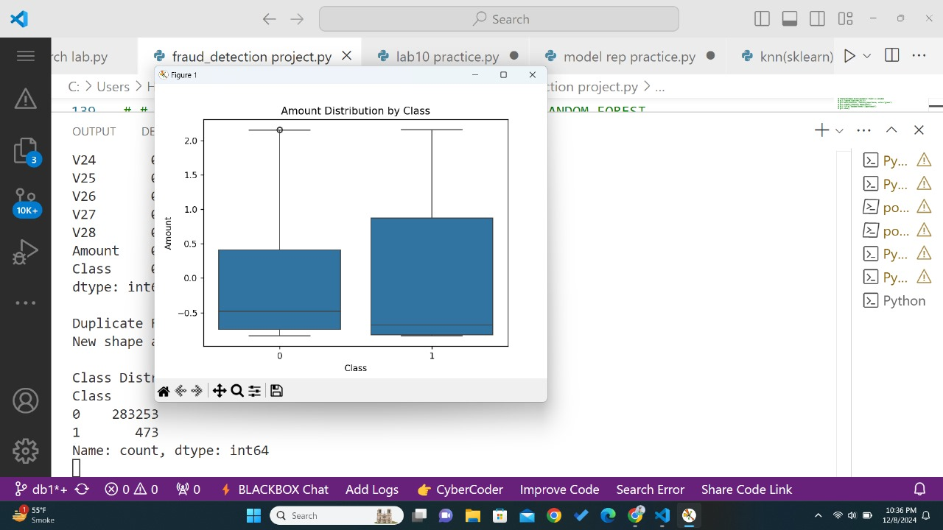

Logistic

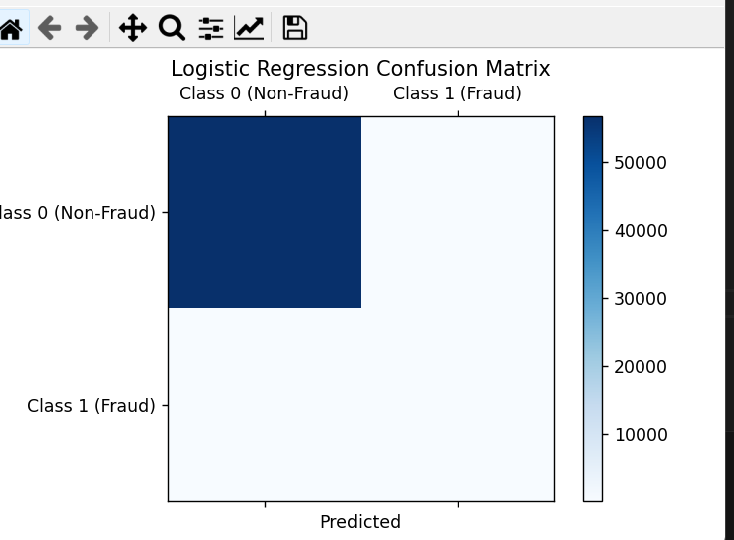

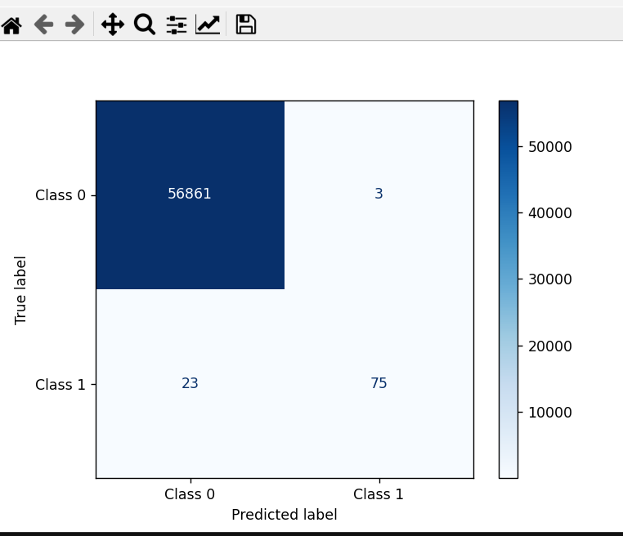

Outputs

ZIP file found. Extracting...

Extraction complete!

Dataset found. Loading...

Data loaded successfully!

Time V1 V2 V3 ... V27 V28 Amount Class

0 0.0 -1.359807 -0.072781 2.536347 ... 0.133558 -0.021053 149.62 0

1 0.0 1.191857 0.266151 0.166480 ... -0.008983 0.014724 2.69 0

2 1.0 -1.358354 -1.340163 1.773209 ... -0.055353 -0.059752 378.66 0

3 1.0 -0.966272 -0.185226 1.792993 ... 0.062723 0.061458 123.50 0

4 2.0 -1.158233 0.877737 1.548718 ... 0.219422 0.215153 69.99 0

[5 rows x 31 columns]

<class 'pandas.core.frame.DataFrame'>

RangeIndex: 284807 entries, 0 to 284806

Data columns (total 31 columns):

# Column Non-Null Count Dtype

--- ------ -------------- -----

0 Time 284807 non-null float64

1 V1 284807 non-null float64

2 V2 284807 non-null float64

3 V3 284807 non-null float64

4 V4 284807 non-null float64

5 V5 284807 non-null float64

6 V6 284807 non-null float64

7 V7 284807 non-null float64

8 V8 284807 non-null float64

9 V9 284807 non-null float64

10 V10 284807 non-null float64

11 V11 284807 non-null float64

12 V12 284807 non-null float64

13 V13 284807 non-null float64

14 V14 284807 non-null float64

15 V15 284807 non-null float64

16 V16 284807 non-null float64

17 V17 284807 non-null float64

18 V18 284807 non-null float64

19 V19 284807 non-null float64

20 V20 284807 non-null float64

21 V21 284807 non-null float64

22 V22 284807 non-null float64

23 V23 284807 non-null float64

24 V24 284807 non-null float64

25 V25 284807 non-null float64

26 V26 284807 non-null float64

27 V27 284807 non-null float64

28 V28 284807 non-null float64

29 Amount 284807 non-null float64

30 Class 284807 non-null int64

dtypes: float64(30), int64(1)

memory usage: 67.4 MB

None

Time 0

V1 0

V2 0

V3 0

V4 0

V5 0

V6 0

V7 0

V8 0

V9 0

V10 0

V11 0

V12 0

V13 0

V14 0

V15 0

V16 0

V17 0

V18 0

V19 0

V20 0

V21 0

V22 0

V23 0

V24 0

V25 0

V26 0

V27 0

V28 0

Amount 0

Class 0

dtype: int64

Duplicate Rows: 1081

New shape after removing duplicates: (283726, 31)

Training Naive Bayes Model

Result by Naive Bayes:

Accuracy: 0.95

[[53840 2811]

[ 16 79]]

precision recall f1-score support

0 1.00 0.95 0.97 56651

1 0.03 0.83 0.05 95

accuracy 0.95 56746

macro avg 0.51 0.89 0.51 56746

weighted avg 1.00 0.95 0.97 56746

Best Parameters for Naive Bayes: {'var_smoothing': 0.6551285568595523}

Optimized Naive Bayes Accuracy: 0.9859902019525605

Training Logistic Regression Model

Logistic Regression Results

Accuracy: 0.98

[[55451 1200]

Training Logistic Regression Model

Logistic Regression Results

Accuracy: 0.98

[[55451 1200]

Logistic Regression Results

Accuracy: 0.98

[[55451 1200]

Accuracy: 0.98

[[55451 1200]

Accuracy: 0.98

[[55451 1200]

[[55451 1200]

[ 15 80]]

[ 15 80]]

precision recall f1-score support

0 1.00 0.98 0.99 56651

1 0.06 0.84 0.12 95

accuracy 0.98 56746

macro avg 0.53 0.91 0.55 56746

weighted avg 1.00 0.98 0.99 56746

Cross Validation Scores for Logistic Regression: 1.00 ± 0.00

Best Parameters for Logistic Regression: {'solver': 'liblinear', 'penalty': 'l2', 'max_iter': 500, 'C': 1.151395399326447}

Optimized Logistic Regression Accuracy: 0.9991717477883904

Training Random Forest Model

Random Forest Results:

Accuracy: 1.00

Precision: 0.96

Recall: 0.77

F1-Score: 0.85

Confusion Matrix:

[[56861 3]

[ 23 75]]

Classification Report:

precision recall f1-score support

0 1.00 1.00 1.00 56864

1 0.96 0.77 0.85 98

accuracy 1.00 56962

macro avg 0.98 0.88 0.93 56962

weighted avg 1.00 1.00 1.00 56962

Grid Search Best Hyperparameters:

{'bootstrap': True, 'max_depth': 20, 'min_samples_leaf': 2, 'min_samples_split': 5, 'n_estimators': 100}