BEST SHORTEST ROUTE
DATA STRUCTURE COURSE PROJECT REPORT

Submitted By
Student Name | Student ID
Rafi Shariar | 0242310005101054
Mahmudul Hasan | 0242310005101093
Nafisa Tasneem Esha | 0242310005101084
Asif Ahamed | 0242310005101431

Course: Data Structure
Department of Computer Science and Engineering
Daffodil International University
Dhaka, Bangladesh

Declaration
This report documents the academic project “Best Shortest Route” developed for the Data Structure course at Daffodil International University. The original submitted report identifies the four project members listed on the title page. This portfolio-ready edition reorganizes the original material into a clearer engineering report and accompanies a cleaned, reproducible GitHub implementation.
Important reproducibility note: the original report contains the source code and example outputs, but it does not include the complete original road-edge data file. The GitHub package therefore includes a clearly labelled demo graph so the program can run end-to-end. The demo data must not be represented as the original full academic distance dataset.

Contents
1. Introduction
1.1 Background
1.2 Motivation
1.3 Objectives
1.4 Scope and Limitations
1.5 Project Outcomes
2. Proposed Methodology and Architecture
2.1 Requirements
2.2 Graph Representation
2.3 Dijkstra Shortest-Path Method
2.4 Data Structures
2.5 System Workflow
2.6 Repository Structure
3. Implementation and Results
3.1 Implementation
3.2 Key Code Components
3.3 Example Results
3.4 Complexity and Reliability
4. Engineering Considerations
4.1 Modularity and Maintainability
4.2 Data and Ethical Considerations
4.3 Team Context
5. Conclusion and Future Work
5.1 Conclusion
5.2 Future Work

1. Introduction

1.1 Background
Finding a suitable route between two locations is a classic real-world graph problem. The original project was designed to help a user choose a shortest route between listed locations in Dhaka by representing locations as graph vertices and road connections as weighted edges. The program reports both the route sequence and the approximate total distance.
The academic implementation is written in C++ and uses a graph data structure with Dijkstra’s shortest-path algorithm. Location information and road-distance data are loaded from text files, allowing the route network to be modified without rewriting the complete program.

1.2 Motivation
When multiple routes exist between two points, selecting a shorter route manually can be confusing and time-consuming. The project demonstrates how a fundamental data-structure concept can address this problem computationally. It also provides a practical setting for applying adjacency lists, maps, sets, arrays/vectors, shortest-path computation, and path reconstruction.

1.3 Objectives
- Represent listed locations and road connections as a weighted graph.
- Accept a source and destination from the user.
- Compute the shortest available route using Dijkstra’s algorithm.
- Display both the route sequence and approximate travel distance.
- Organize listed locations in a user-friendly alphabetical form.
- Allow repeated route queries during a single program run.

1.4 Scope and Limitations
The original report limits the project to a static set of major locations in Dhaka. Distances are stored locally and are not connected to live traffic, road-condition, or mapping services. Therefore, the result should be interpreted as a shortest path within the stored graph rather than as a real-time navigation recommendation.
Travel time is not estimated because traffic conditions, vehicle type, road conditions, and other dynamic factors are outside the project scope. The original report also notes that additional locations and road alternatives could improve coverage.

1.5 Project Outcomes
The project demonstrates an end-to-end graph application: data loading, graph construction, shortest-path computation, route reconstruction, formatted output, and repeated queries. It also shows how a relatively small command-line program can connect core Data Structure concepts with a recognizable travel-planning problem.

2. Proposed Methodology and Architecture

2.1 Requirements
The system requires a list of named locations, a weighted set of connections, and two user inputs: the current location and the desired destination. The functional output is the minimum stored distance and the corresponding route. The repository implementation keeps these concerns separate through two data files and a C++ route-planning module.

2.2 Graph Representation
Each location is represented as a vertex and each stored connection is represented as an undirected weighted edge. The implementation uses an adjacency list because it stores only the connections that exist, making it appropriate for a sparse route network. A name-to-index map supports location lookup, while the graph stores destination indices and edge weights.
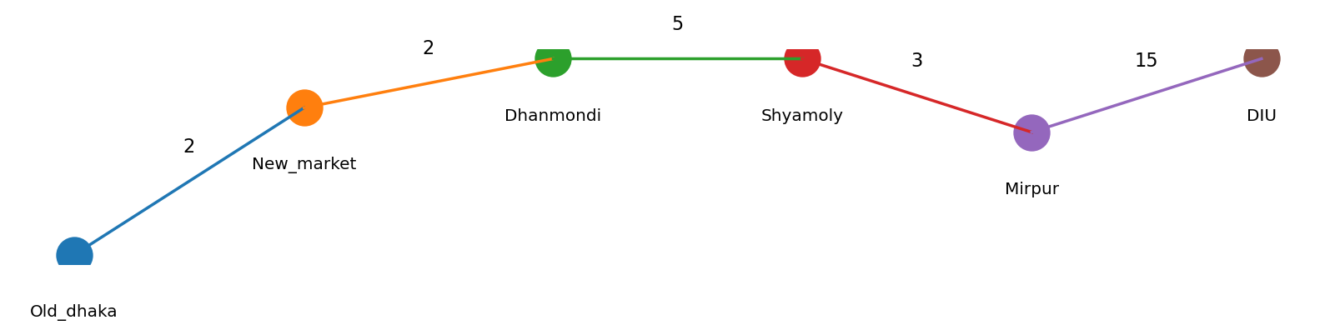
Figure 2.1. Example subgraph used in the reproducible demo dataset. Edge values are distances in kilometres.

2.3 Dijkstra Shortest-Path Method
Dijkstra’s algorithm is used because all stored road distances are non-negative. Starting from the source, the algorithm repeatedly expands the currently best-known vertex and relaxes adjacent edges. A distance array records the best known cost, and a parent array records how each vertex was reached. The parent information is then traced backwards from the destination to reconstruct the final route.
1. Set all distances to infinity and the source distance to zero.
2. Insert the source into the priority queue.
3. Remove the vertex with the smallest current distance.
4. Relax every outgoing edge and update the parent when a shorter distance is found.
5. Stop when the destination is finalized or the queue becomes empty.
6. Reconstruct the route by following parent links from destination to source.

2.4 Data Structures
Data Structure | Purpose | Use in Project
Adjacency list | Graph storage | Stores connected locations and road distances.
Vector | Dynamic sequence | Stores graph edges, names, distances, and parent values.
Map | Key-value lookup | Maps a location name to its numeric vertex ID.
Priority queue | Minimum-distance selection | Selects the next best vertex efficiently in Dijkstra’s algorithm.
Parent vector | Path reconstruction | Rebuilds the shortest route after computation.

2.5 System Workflow
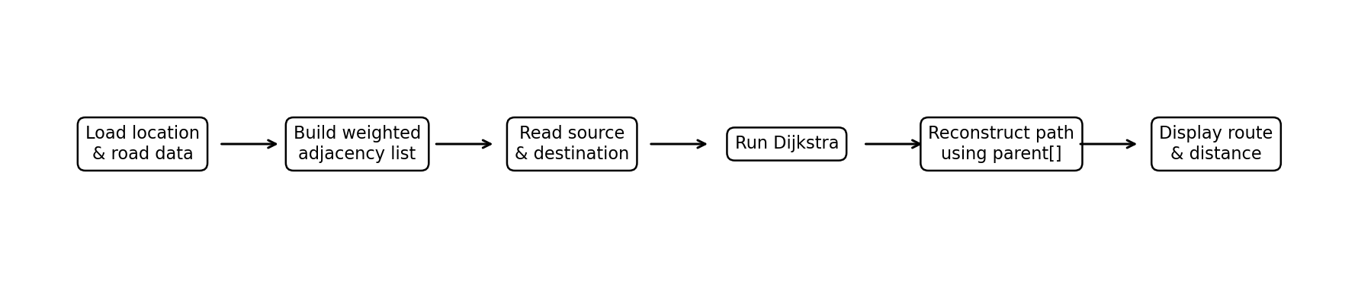
Figure 2.2. Overall route-computation workflow.

2.6 Repository Structure
Best-Shortest-Route/
├── src/main.cpp
├── data/map_set.txt
├── data/data.txt
├── report/Best_Shortest_Route_Project_Report.docx
├── report/Best_Shortest_Route_Project_Report.pdf
├── report/original/DS_report.pdf
├── CMakeLists.txt
├── README.md
└── .gitignore

3. Implementation and Results

3.1 Implementation
The GitHub-ready implementation keeps the original academic design—C++, an adjacency-list graph, Dijkstra’s algorithm, and parent-based path reconstruction—while replacing machine-specific file paths with repository-relative paths. It also adds input validation and a priority queue to make the shortest-path selection more efficient and portable.

3.2 Key Code Components
The `loadLocations` function reads location IDs and names, `loadRoads` constructs the weighted undirected graph, `shortestPath` performs Dijkstra’s algorithm, and `printRoute` displays the recovered vertex sequence. The main loop shows the available locations and accepts repeated user queries.
priority_queue<pair<int,int>, vector<pair<int,int>>, greater<pair<int,int>>> pq;
dist[source] = 0;
pq.push({0, source});
while (!pq.empty()) {
auto [currentDist, u] = pq.top();
pq.pop();
if (currentDist != dist[u]) continue;
for (const auto &edge : graph[u]) {
int nextDist = currentDist + edge.distance;
if (nextDist < dist[edge.to]) {
dist[edge.to] = nextDist;
parent[edge.to] = u;
pq.push({nextDist, edge.to});
}
}
}

3.3 Example Results
The original project report includes two command-line examples. These examples demonstrate both path reconstruction and distance reporting. The GitHub demo dataset is constructed so these two documented totals can be reproduced.
Source | Destination | Documented Route | Distance
Dhanmondi | DIU | Dhanmondi -> Shyamoly -> Mirpur -> DIU | 23 km
Old_dhaka | Mirpur | Old_dhaka -> New_market -> Dhanmondi -> Shyamoly -> Mirpur | 12 km

3.4 Complexity and Reliability
With the priority-queue implementation included in the GitHub package, the shortest-path phase runs in O((V + E) log V) time for V vertices and E edges, with O(V + E) graph storage. The result is deterministic for a fixed dataset. Reliability is limited by the quality and completeness of the stored road graph, so the program does not claim to replace a live navigation service.

4. Engineering Considerations

4.1 Modularity and Maintainability
The repository separates source code, input data, documentation, and build configuration. Relative paths make the project easier to clone and run on another machine. The route-planning operations are grouped into a class, while location and edge data remain external so the network can be updated without recompiling the algorithmic logic.

4.2 Data and Ethical Considerations
The program works with approximate static distance data. Presenting these values as live or guaranteed travel distances would be misleading. The portfolio repository therefore labels the included edge file as demo data because the original complete edge list was not present in the uploaded report. This distinction preserves the academic project’s concept without overstating the provenance of the reconstructed dataset.

4.3 Team Context
The original report lists four team members: Rafi Shariar, Mahmudul Hasan, Nafisa Tasneem Esha, and Asif. The report does not provide a detailed task-by-task contribution breakdown, so this polished edition does not assign individual implementation claims that are not supported by the source material.

5. Conclusion and Future Work

5.1 Conclusion
Best Shortest Route demonstrates the practical use of graph data structures and Dijkstra’s algorithm for route selection. The project accepts two listed locations, computes the shortest available path within the stored graph, and reports both the path and approximate distance. Its main educational value lies in translating abstract concepts—vertices, weighted edges, relaxation, and parent tracking—into an interactive C++ application.

5.2 Future Work
- Add more locations and alternative road connections.
- Extend coverage beyond Dhaka to other parts of Bangladesh.
- Replace static distances with a verified and updateable geographic dataset.
- Add estimated travel time when reliable dynamic traffic data are available.
- Develop a graphical or web interface for improved usability.
- Integrate map APIs in a future version, clearly separating external live data from the academic demo dataset.

Appendix A - Reproducibility Note
The original submitted PDF is included in `report/original/DS_report.pdf`. The GitHub-ready source code and polished report are designed to be easy to inspect and run. Because the original edge dataset was not included in the uploaded report, the repository does not claim that its demo `data.txt` is the historical submission dataset.

