
--Total Volume & Revenue: What is the total number of patients and the overall total billing amount generated across all records?
Output:

Insights:

--Patients by Medical Condition: Which medical conditions have the highest total number of patient admissions?


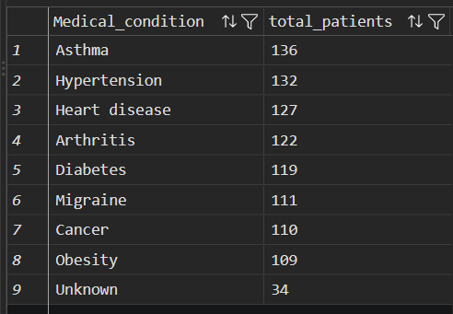
Insights

--Billing by Admission Type: What are the total and average billing amounts for each admission type (Emergency, Elective, Urgent)?


Insights:

--Top Hospitals by Patient Volume: Which top 5 hospitals handle the largest number of patient admissions?

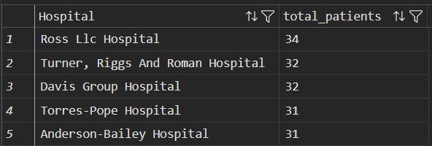

INSIGHTS:

--Patient Distribution by Gender: How is the total patient population distributed across different genders?



Insights

--Billing by Insurance Provider: Which insurance providers handle the highest total billing revenue?

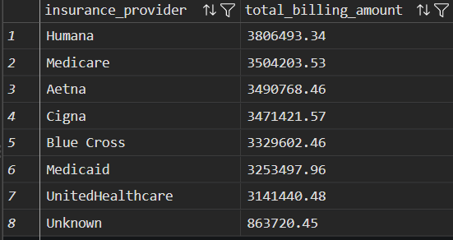
Insights:

