Web Development Task1 Reflection

By: Eshaal Malik, 23I-0732

Manually-created website:
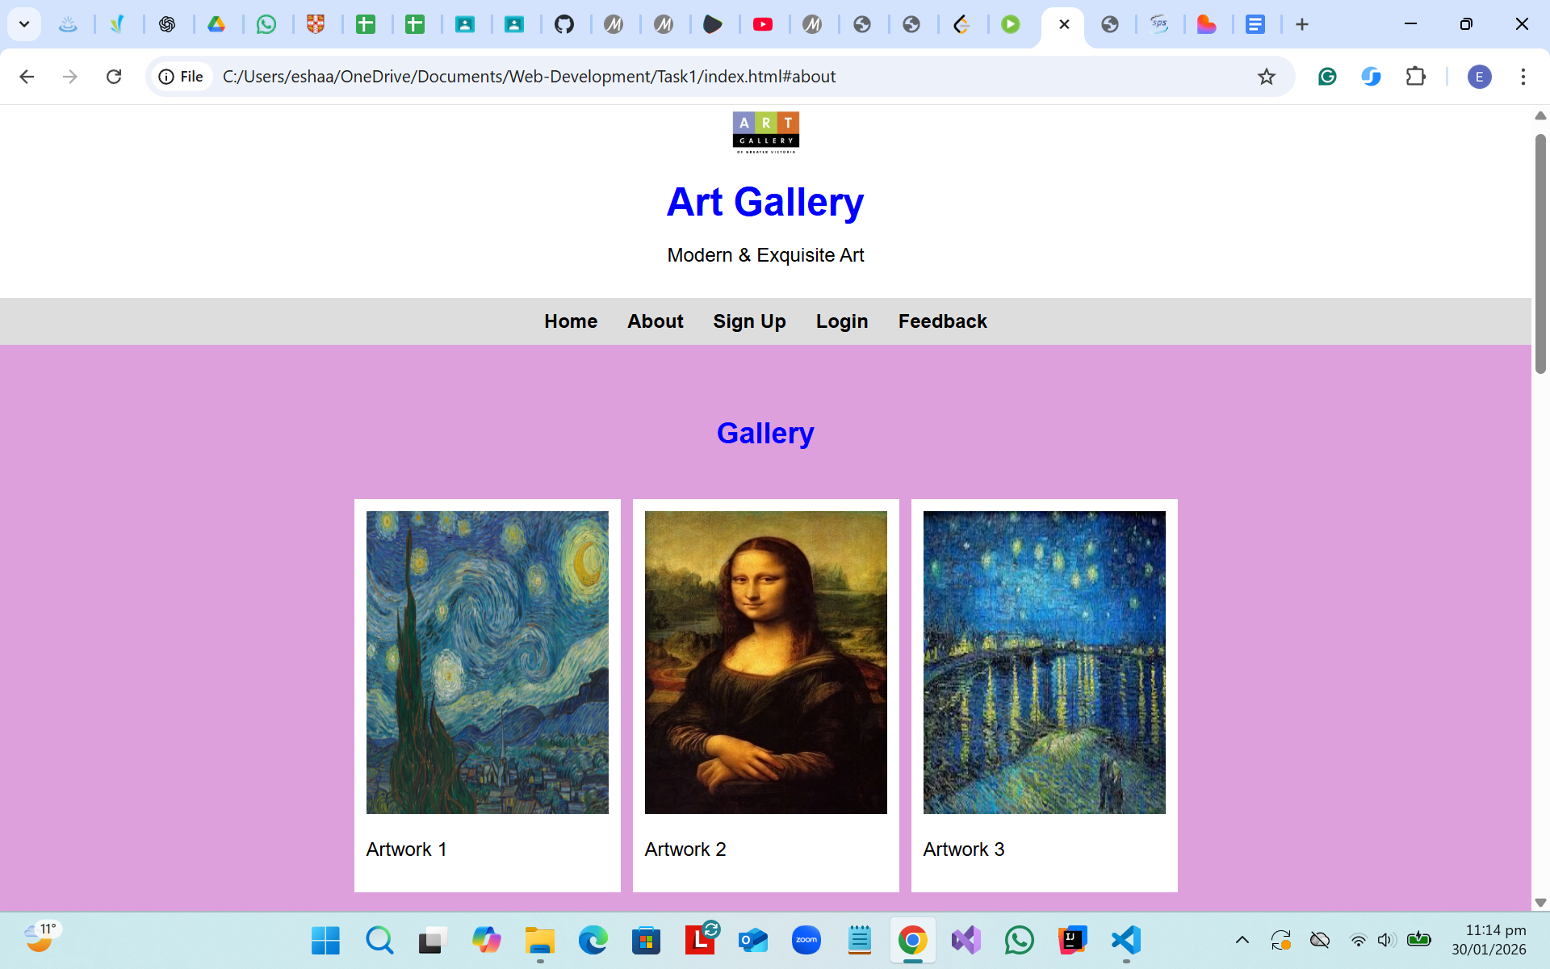
AI-prompted website:
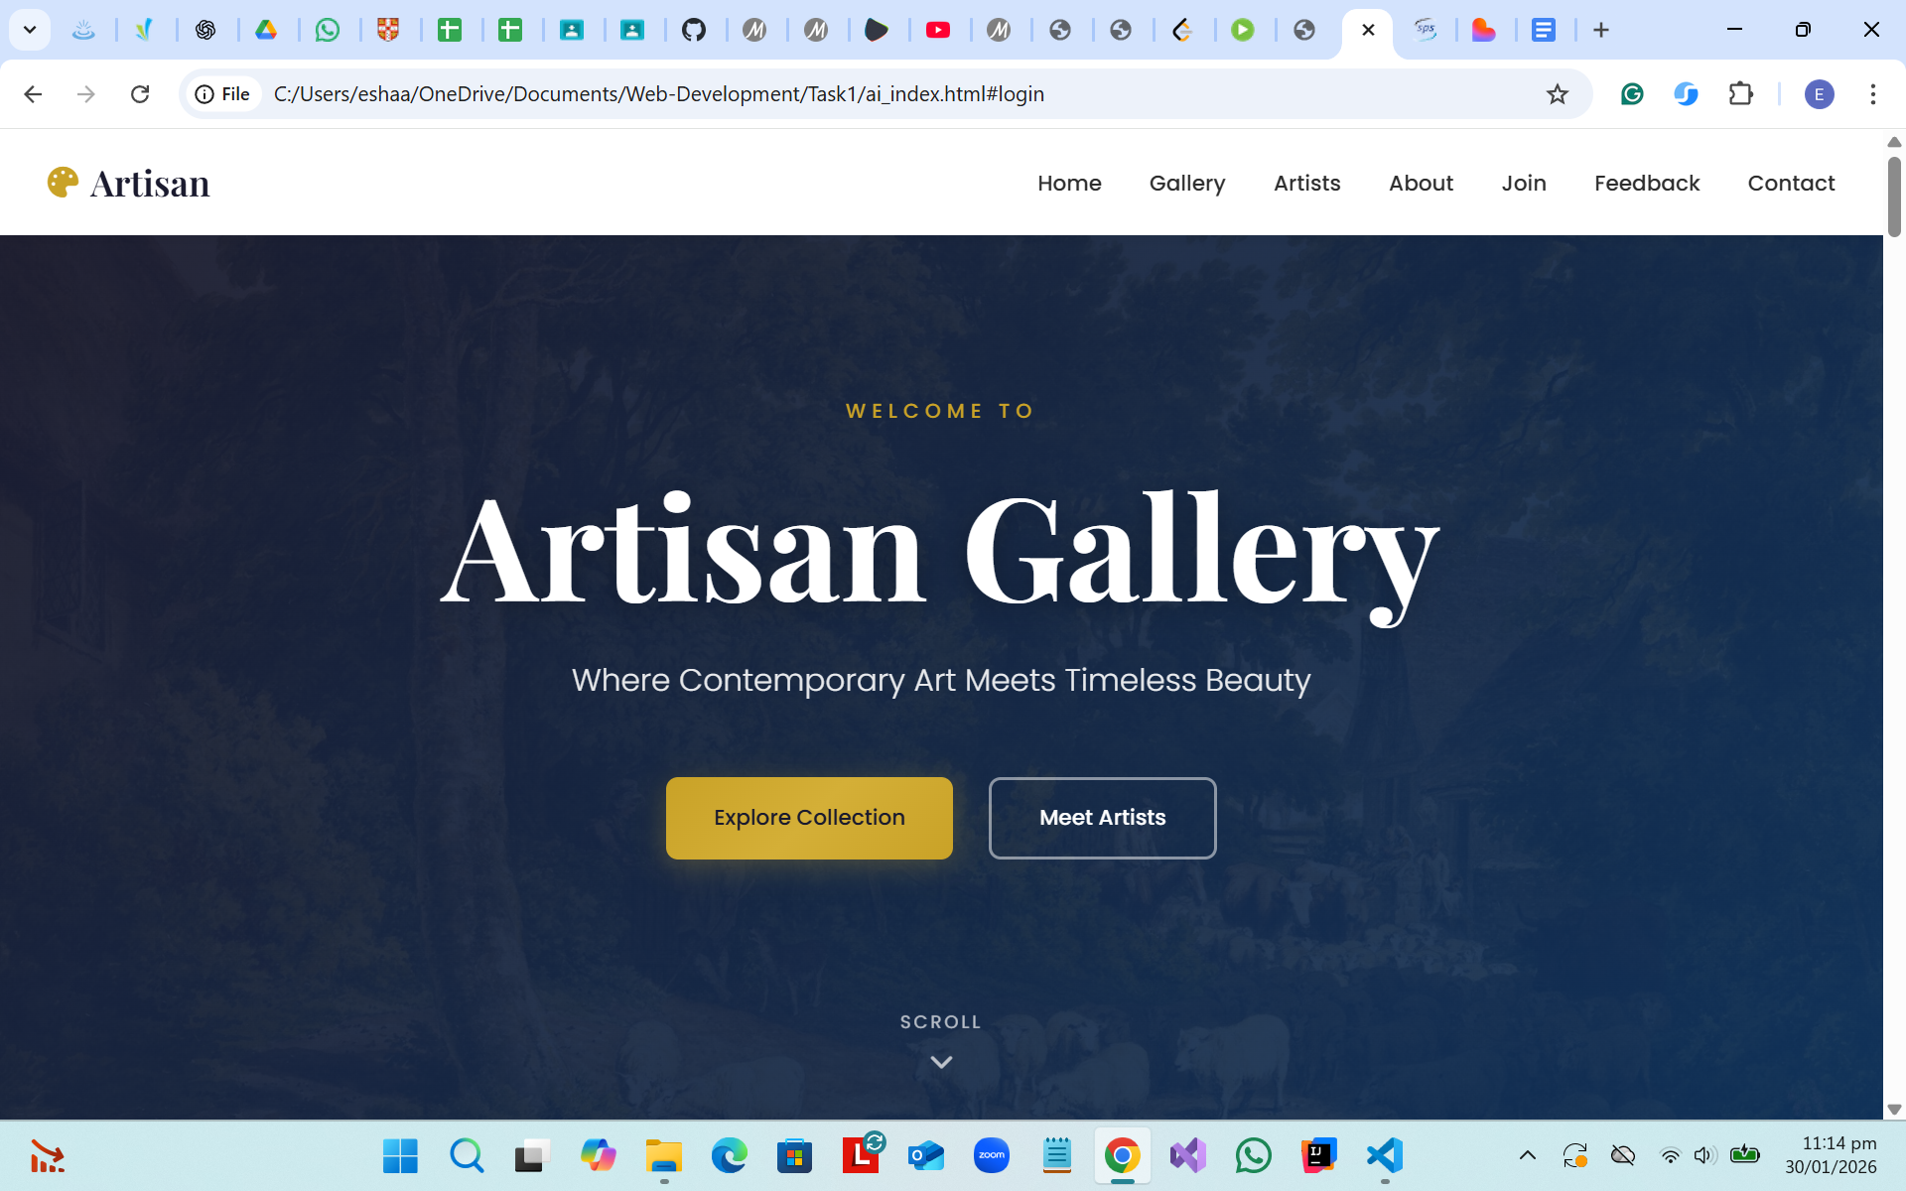

Prompt Used for the AI-Generated Website:
Create a modern, responsive single-page Art Gallery website using only one HTML file and one external CSS file. Use semantic HTML elements such as header, nav, main, section, article, and footer. The website should include a fixed navigation bar, hero section, image gallery, artists section, about section, sign-up form, feedback form with dropdowns, and a contact section with icons. Use Google Fonts, Font Awesome icons, hover effects, and responsive design with media queries. Do not use JavaScript or frameworks. The design should look professional, creative, and suitable for an academic comparison with a manually coded HTML/CSS website.

Analysis & Comparison
What Was Observed
The AI-generated website was more visually detailed and had a complex structure compared to the manually created version. It included advanced CSS features such as gradients, shadows, and responsive layouts. The overall design appeared more professional and similar to real-world gallery websites.
Differences Between the Two Versions
The manual version focused on basic layout and functionality, making it easier to understand for beginners. The AI version, however, included more complex layouts, modern styling, better spacing, and additional content. This made the AI version more visually engaging, aesthetic, and polished.
What Was Learned
This comparison showed that HTML and CSS alone can create high-quality, professional websites if used effectively. It also demonstrated how AI-generated code can be used as a learning reference to better understand design practices and improve manual coding skills.

Proof of Git Commits for Manual Version:
