IOLAB

Flask Lab – 1

Feb 24, 2016

This is an introductory lab session to get you setup with Flask, and build a basic web application.

Step 1: Install Flask

* sudo pip install flask
* If you have Anaconda, you have Flask [http://conda.pydata.org/docs/using/envs.html#create-an-environment]

Step 2: Create your Flask project

* Your directory structure should look like this

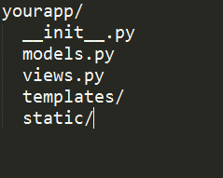

* Create your own , or navigate to bcourses and download the scaffold we created for you
* Run your server – navigate to your project directory and
  + python run.py
* You should see something like

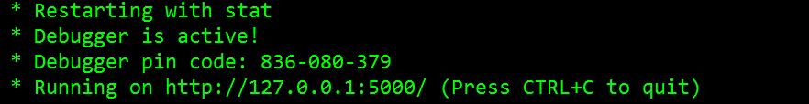

Step 3: Check if everything worked okay

* Navigate to <http://localhost:5000> and see if “Hello world” shows up

Part II – Web App

Create a basic form page, and record all data that is submitted through it. Save the information on a local file.

* Landing page is a form {name, email, address…etc.}
  + http://www.w3schools.com/html/html_forms.asp
* User submits > Save data to a text file(CSV)
  + https://docs.python.org/2/tutorial/inputoutput.html#reading-and-writing-files
* **Bonus credits**
  + Try writing to an Excel file