Game Design Document

Fill up the Following document

1. Write the title of your project.

Crossing Mania

1. What is the goal of the game?

The character has to cross the road and collect coins and gems to win a car.

1. Write a brief story of your game?

The character has to cross the road not get hit by the cars, collect coins and gems to earn a car at the end of the game. The character has 3 lives. The character has to collect a certain number of coins or gems to end the game and claim its prize.

1. Which are the playing characters of this game?

* Playing characters are the ones which respond to the user based on the input from the user
* Cars, monkeys, dinos, wizards etc, are the playing characters in the game.

|  |  |  |
| --- | --- | --- |
| Number | Character Name | What can this character do? |
| 1 | man | He can walk straight or sideways using the arrow keys. |
| 2 | woman | She can walk straight or sideways using the arrow keys. |
| 3 |  |  |
| 4 |  |  |
| 5 |  |  |
| 6 |  |  |
| 7 |  |  |
| 8 |  |  |

1. Which are the Non Playing Characters of this game?

* Non Playing characters are the ones which don't have an action or a behaviour when the user interacts with the game.
* Hurdles, stones, bananas, coins, etc are non playing characters in the game.

|  |  |  |
| --- | --- | --- |
| Number | Character Name | What can this character do? |
| 1 | Trees |  |
| 2 | Coins | Collected by the characters. |
| 3 | Gems | Collected by the characters. |
| 4 | Cars | Cars are the obstacles. If hit by a car the character loses a life |
| 5 |  |  |
| 6 |  |  |
| 7 |  |  |
| 8 |  |  |

Draw your imagination of this game. What does this game look like?

* Draw the game either on your computer or on paper,
* Add images of scenes of the game to show each of the playing and non-playing characters at least once.

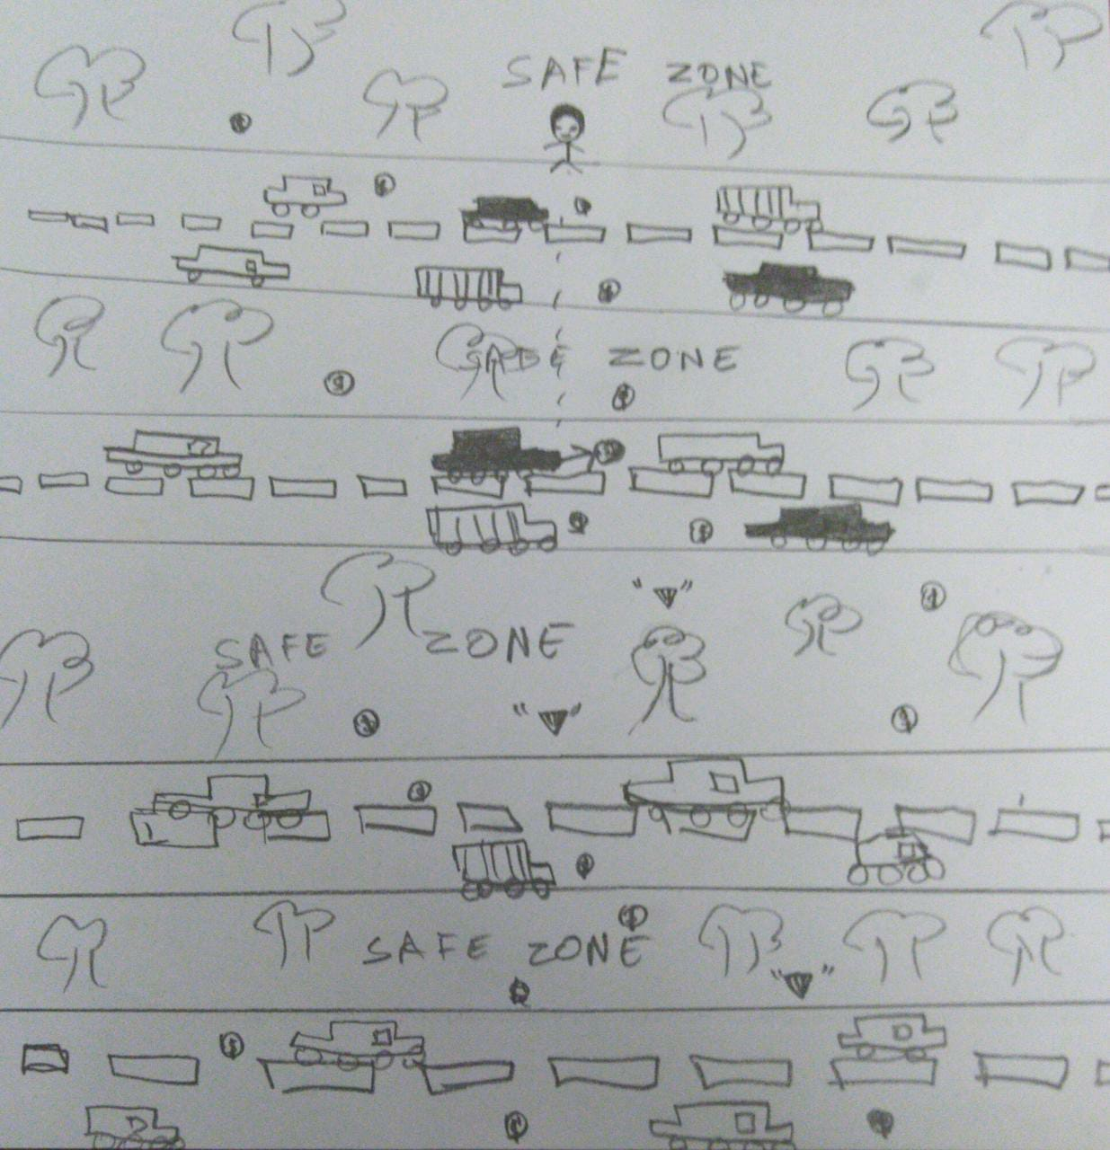

How do you plan to make your game engaging?

By challenging the character to cross the road and not get hit by a car to finish the game to claim the special prize.